**Computer Vision-Based Method for Quantifying Iron-Related Defects in Silicon Solar Cell**

Oleg Olikh, Oleksii Zavhorodnii, Yulia Perets

*Taras Shevchenko National University of Kyiv, 64/13, Volodymyrska Street, Kyiv, 01601, Ukraine*

olegolikh@knu.ua

**SUPPLEMENTARY MATERIAL**

I. *Initial hyperparameter search space*

Abbreviations:

ENB7:CL - EfficientNetB7, classifier layer output (1000-D).

ENB7:FE - EfficientNetB7, feature extractor output (2560-D).

ENB7:FE:P - EfficientNetB7, feature extractor output with PCA reduction (39-D).

MNV2:CL - MobileNetV2, classifier layer output (1000-D).

MNV2:FE - MobileNetV2, feature extractor output (1280-D).

MNV2:FE:P - MobileNetV2, feature extractor output with PCA reduction (124-D).

NAS:CL - NASNetLarge, classifier layer output (1000-D).

NAS:CL:P - NASNetLarge, classifier layer output with PCA reduction (30-D).

NAS:FE - NASNetLarge, feature extractor output (4032-D).

R152:CL - ResNet152V2, classifier layer output (1000-D).

R152:FE - ResNet152V2, feature extractor output (2048-D).

XCP:CL - Xception, classifier layer output (1000-D).

XCP:FE - Xception, feature extractor output (2048-D).

YL:FE1 - YOLOv4 (CSPDarknet53 backbone), raw feature extractor (top layer, 86528-D).

YL:FE1:P - YOLOv4 (CSPDarknet53 backbone), raw feature extractor with PCA (137-D).

YL:FE2 - CSPDarknet53 backbone, raw feature extractor (top & penultimate layers, 433640-D).

YL:FE2:P - CSPDarknet53 backbone, raw feature extractor with PCA (142-D).

YL:FP1 - YOLOv4, global average pooled features from the top layer (512-D).

YL:FP2 - YOLOv4, concatenated pooled features from the top & penultimate layers (1024-D)

Table S1. Hyperparameter space for RF

|  |  |
| --- | --- |
| Hyperparameter | Values |
| # estimators | [100; 1200] |
| max depth | [10; 95] |
| min samples leaf | [1; 15] |
| min samples split | [2; 16] |
| bootstrap | True, False |
| max features | 'log2', 'sqrt', [0.05; 1.0] |

Table S2. Hyperparameter space for GB

|  |  |
| --- | --- |
| Hyperparameter | Values |
| # estimators | [100; 1200] |
| max depth | [15; 90] |
| min samples leaf | [1; 15] |
| min samples split | [2, 16] |
| learning rate | [10-3, 10-1] |
| max features | 'log2', 'sqrt', [0.05; 1.0] |

Table S3. Hyperparameter space for SVR

|  |  |
| --- | --- |
| Hyperparameter | Values |
| kernel | linear, poly, rbf, sigmoid |
| Degree* | [2; 6] |
| C0 | [0; 15] |
| Tolerance | [10-6; 10-2] |
| C | [10-2; 15] |
| Epsilon | [10-3; 1] |
| * for poly kernel only | |

Table S4. Hyperparameter space for XGB

|  |  |
| --- | --- |
| Hyperparameter | Values |
| booster | gbtree, gblinear, dart |
| max depth* | [2, 10] |
| min split loss* | [0; 5] |
| min child weight* | [0; 5] |
| subsample* | [0.1; 1.0] |
| сolsample by tree* | [0.1; 1.0] |
| # estimators | [200; 1700] |
| learning rate | [10-5; 1] |
| L1 | [10-9; 1] |
| L2 | [10-8; 1] |
| * for all boosters except gblinear | |

Table S5. Hyperparameter space for DNN

|  |  |
| --- | --- |
| Hyperparameter | Values |
| hidden layers configuration | Pipe, Trapezium, Triangle, Butterfly, Fir |
| # nodes for first hidden layer | 10 |
| # hidden layers | 5 |
| batch size | 25 |
| activation function | ReLu, sigmoid, tanh, SELU, ELU |
| optimizer | SGD, RMSprop, Adam, Adadelta, Adagrad, Adamax, Nadam, Ftrl |
| learning rate | [10-5; 10-2] |
| # epochs | 1000 |
| weight initializer | Xavier Normal, Xavier Uniform, He Normal, He Uniform, Random Normal, Random Uniform |
| Regularizer | None, L1, L2 |
| RegRate* | [10-5; 10-1] |
| DropoutNeeded | True, False |
| DropRate** | [0.2; 0.5] |
| LayerNormNeed | True, False |
| *for Regularizer ≠ None  **for DropoutNeeded = True | |

II. *Selected hyperparameter combinations*

Table S6. Chosen hyperparameter combinations for RF models

|  |  |  |  |  |  |  |
| --- | --- | --- | --- | --- | --- | --- |
| Visual Model | Hyperparameter | | | | | |
| # estimators | max depth | min sample split | min sample leaf | max features | bootstrap |
| ENB7:CL | 750 | 35 | 3 | 2 | 0.2 | False |
| ENB7:FE | 900 | 40 | 4 | 2 | 0.2 | False |
| ENB7:FE:P | 460 | 54 | 4 | 1 | 1 | True |
| MNV2:CL | 450 | 20 | 4 | 1 | 0.1 | False |
| MNV2:FE | 460 | 50 | 3 | 1 | 0.05 | False |
| MNV2:FE:P | 500 | 85 | 5 | 3 | 0.5 | False |
| NAS:CL | 395 | 59 | 2 | 1 | 0.2 | False |
| NAS:CL:P | 1175 | 70 | 2 | 1 | 0.4 | False |
| NAS:FE | 750 | 10 | 2 | 1 | 0.1 | False |
| R152:CL | 640 | 40 | 4 | 2 | 0.4 | False |
| R152:FE | 367 | 38 | 2 | 1 | sqrt | False |
| XCP:CL | 640 | 90 | 2 | 1 | 0.2 | False |
| XCP:FE | 820 | 48 | 4 | 1 | 0.1 | False |
| YL:FP1 | 960 | 75 | 4 | 1 | 0.4 | False |
| YL:FP2 | 650 | 70 | 2 | 1 | 0.2 | False |
| YL:FE2:P | 475 | 45 | 3 | 1 | 0.5 | False |
| YL:FE1:P | 425 | 45 | 10 | 1 | 0.5 | False |

Table S7. Chosen hyperparameter combinations for GB models

|  |  |  |  |  |  |  |
| --- | --- | --- | --- | --- | --- | --- |
| Visual Model | Hyperparameter | | | | | |
| # estimators | max depth | min sample split | min sample leaf | max features | LR |
| ENB7:CL | 750 | 20 | 7 | 11 | 0.1 | 3.4e-02 |
| ENB7:FE | 750 | 50 | 6 | 9 | 0.3 | 4.2e-02 |
| ENB7:FE:P | 680 | 25 | 4 | 15 | 1 | 3.9e-02 |
| MNV2:CL | 1100 | 40 | 10 | 3 | sqrt | 1.0e-02 |
| MNV2:FE | 890 | 50 | 12 | 2 | sqrt | 1.4e-02 |
| MNV2:FE:P | 575 | 60 | 4 | 12 | 0.6 | 2.8e-02 |
| NAS:CL | 850 | 70 | 13 | 15 | 0.3 | 4.8e-02 |
| NAS:CL:P | 675 | 80 | 11 | 13 | 0.4 | 3.8e-02 |
| NAS:FE | 650 | 67 | 5 | 3 | 0.1 | 1.3e-02 |
| R152:CL | 700 | 55 | 8 | 1 | 0.4 | 1.1e-01 |
| R152:FE | 640 | 85 | 3 | 7 | sqrt | 2.3e-02 |
| XCP:CL | 470 | 25 | 2 | 6 | sqrt | 5.2e-02 |
| XCP:FE | 760 | 75 | 10 | 4 | 0.1 | 2.9e-02 |
| YL:FP1 | 1160 | 75 | 2 | 8 | 0.1 | 3.9e-02 |
| YL:FP2 | 900 | 54 | 3 | 6 | 0.2 | 2.3e-02 |
| YL:FE2:P | 750 | 55 | 4 | 7 | 0.4 | 1.9e-02 |
| YL:FE1:P | 850 | 55 | 2 | 10 | 0.7 | 1.2e-02 |

Table S8. Chosen hyperparameter combinations for XGB models

|  |  |  |  |  |  |  |  |  |  |  |
| --- | --- | --- | --- | --- | --- | --- | --- | --- | --- | --- |
| Visual Model | Hyperparameter | | | | | | | | | |
| booster | max depth | min split loss | min child weight | sub  sample | сolsample bytree | # estimators | LR | L1 | L2 |
| ENB7:CL | gblinear | 3 | -- | -- | -- | -- | 1080 | 1.1e-1 | 1.8e-7 | 8.4e-4 |
| ENB7:FE | gblinear | 3 | -- | -- | -- | -- | 1150 | 3.2e-1 | 3.8e-8 | 2.6e-3 |
| ENB7:FE:P | gblinear | 3 | -- | -- | -- | -- | 1640 | 1.6e-1 | 5.9e-9 | 1.4e-2 |
| MNV2:CL | gblinear | 3 | -- | -- | -- | -- | 1040 | 7.0e-2 | 5.7e-7 | 3.1e-3 |
| MNV2:FE | gblinear | 3 | -- | -- | -- | -- | 600 | 1.4e-1 | 6.1e-8 | 1.9e-2 |
| MNV2:FE:P | gblinear | 3 | -- | -- | -- | -- | 1150 | 7.4e-2 | 1.0e-8 | 1.0e-1 |
| NAS:CL | gblinear | 3 | -- | -- | -- | -- | 1050 | 2.6e-1 | 9.9e-9 | 2.3e-3 |
| NAS:CL:P | gblinear | 3 | -- | -- | -- | -- | 800 | 3.8e-2 | 5.0e-9 | 1.4e-2 |
| NAS:FE | gblinear | 3 | -- | -- | -- | -- | 700 | 6.9e-2 | 8.5e-9 | 6.1e-2 |
| R152:CL | gbtree | 8 | 7.9e-3 | 5.7e-1 | 0.4 | 0.9 | 825 | 2.2e-2 | 1.9e-8 | 3.3e-3 |
| R152:FE | gblinear | 6 | -- | -- | -- | -- | 500 | 4.4e-1 | 1.1e-8 | 1.5e-2 |
| XCP:CL | gblinear | 3 | -- | -- | -- | -- | 550 | 2.0e-1 | 1.4e-6 | 1.7e-4 |
| XCP:FE | gblinear | 3 | -- | -- | -- | -- | 390 | 2.2e-1 | 3.7e-6 | 9.9e-2 |
| YL:FP1 | gblinear | 3 | -- | -- | -- | -- | 520 | 9.4e-2 | 4.7e-5 | 2.0e-2 |
| YL:FP2 | gblinear | 3 | -- | -- | -- | -- | 650 | 1.7e-1 | 8.1e-9 | 1.9e-2 |
| YL:FE2:P | gbtree | 5 | 6.4e-2 | 3.6 | 0.9 | 0.5 | 1275 | 8.1e-3 | 1.9e-8 | 4.9e-3 |
| YL:FE1:P | gbtree | 2 | 3.2e-1 | 2.5 | 0.8 | 0.9 | 525 | 3.5e-2 | 2.1e-8 | 6.7e-3 |

Table S9. Chosen hyperparameter combinations for SVR models

|  |  |  |  |  |  |
| --- | --- | --- | --- | --- | --- |
| Visual Model | Hyperparameter | | | | |
| kernel | C0 | Tolerance | C | Epsilon |
| ENB7:CL | linear | 7.79 | 6.9e-06 | 2.5 | 2.2e-05 |
| ENB7:FE | linear | 8.29 | 3.0e-05 | 2.6 | 3.5e-05 |
| ENB7:FE:P | linear | 10.57 | 8.4e-04 | 13.7 | 2.9e-04 |
| MNV2:CL | rbf | 6.80 | 3.9e-04 | 10.9 | 9.6e-05 |
| MNV2:FE | linear | 6.54 | 4.9e-04 | 6.7 | 7.1e-05 |
| MNV2:FE:P | linear | 7.31 | 5.2e-04 | 4.6e-03 | 8.7e-04 |
| NAS:CL | linear | 6.60 | 4.9e-04 | 4.6 | 1.5e-04 |
| NAS:CL:P | rbf | 7.17 | 5.5e-03 | 11.7 | 1.5e-04 |
| NAS:FE | linear | 5.31 | 6.5e-04 | 5.9 | 2.6e-05 |
| R152:CL | linear | 6.66 | 4.2e-03 | 2.3 | 5.4e-05 |
| R152:FE | linear | 6.65 | 1.3e-04 | 5.2 | 1.4e-04 |
| XCP:CL | rbf | 8.27 | 7.2e-03 | 13.8 | 3.5e-04 |
| XCP:FE | linear | 11.24 | 2.5e-03 | 9.1 | 3.8e-04 |
| YL:FP1 | rbf | 12.61 | 2.4e-03 | 6.9 | 5.6e-05 |
| YL:FP2 | rbf | 8.30 | 1.9e-04 | 9.2 | 1.4e-05 |
| YL:FE1 | linear | 8.62 | 5.3e-04 | 7.9 | 1.6e-05 |
| YL:FE2 | rbf | 11.5 | 2.3e-05 | 4.6 | 6.3e-06 |
| YL:FE2:P | linear | 9.18 | 3.9e-03 | 2.2 | 2.4e-04 |
| YL:FE1:P | rbf | 7.04 | 2.7e-03 | 2.6 | 2.5e-04 |

Table S10. Chosen hyperparameter combinations for DNN models

|  |  |  |  |  |  |  |  |  |  |
| --- | --- | --- | --- | --- | --- | --- | --- | --- | --- |
| Visual Model | Hyperparameter | | | | | | | | |
| LR | optimizer | activ. func. | w.  init. | Regul. | RegRate | Drop.  Need. | Drop.  Rate | LayerNorm. |
| ENB7:CL | 3.0e-03 | Adam | ELU | HN | None | -- | False | -- | True |
| ENB7:FE | 1.4e-03 | Adamax | SELU | RN | L2 | 1.0e-03 | False | -- | True |
| ENB7:FE:P | 1.4e-04 | Nadam | SELU | RU | L2 | 1.0e-03 | False | -- | True |
| MNV2:CL | 2.4e-03 | Nadam | SELU | RN | L2 | 1.7e-03 | True | 0.5 | True |
| MNV2:FE | 2.8e-03 | Nadam | ELU | RN | None | -- | False | -- | False |
| MNV2:FE:P | 1.3e-04 | Adam | tanh | RU | L2 | 6.4e-04 | True | 0.4 | False |
| NAS:CL | 1.4e-04 | Adamax | sigmoid | XU | None | -- | False | -- | False |
| NAS:CL:P | 3.9e-04 | Nadam | tanh | RU | None | -- | False | -- | True |
| NAS:FE | 4.4e-04 | Nadam | SELU | RU | None | -- | False | -- | True |
| R152:CL | 3.3e-04 | Adamax | ELU | RN | L2 | 2.2e-03 | False | -- | True |
| R152:FE | 1.1e-03 | Nadam | ReLu | HN | None | -- | False | -- | True |
| XCP:CL | 1.5e-04 | Adamax | ReLu | HU | L1 | 9.7e-04 | False | -- | True |
| XCP:FE | 2.1e-04 | Nadam | sigmoid | XN | L2 | 8.5e-04 | False | -- | True |
| YL:FP1 | 5.2e-05 | Adam | tanh | RU | None | -- | False | -- | True |
| YL:FP2 | 6.9e-04 | Adam | SELU | RU | None | -- | False | -- | True |
| YL:FE2:P | 4.1e-04 | Adam | sigmoid | XN | L1 | 1.3e-04 | True | 0.2 | True |
| YL:FE1:P | 4.3e-04 | RMSprop | ELU | XU | L1 | 5.4e-05 | False | -- | True |

Table S1. Summary of used pretrained CNN models and feature extraction variants

|  |  |  |  |  |
| --- | --- | --- | --- | --- |
| Base model | Model type | Feature processing | Output dimension | Model Label |
| EfficientNetB7 | Classifier | None | 1000 | ENB7:CL |
|  | Feature extractor | None | 2560 | ENB7:FE |
|  |  | PCA | 39 | ENB7:FE:P |
| MobileNetV2 | Classifier | None | 1000 | MNV2:CL |
|  | Feature extractor | None | 1280 | MNV2:FE |
|  |  | PCA | 124 | MNV2:FE:P |
| NASNetLarge | Classifier | None | 1000 | NAS:CL |
|  |  | PCA | 30 | NAS:CL:P |
|  | Feature extractor | None | 4032 | NAS:FE |
| ResNet152V2 | Classifier | None | 1000 | R152:CL |
|  | Feature extractor | None | 2048 | R152:FE |
| Xception | Classifier | None | 1000 | XCP:CL |
|  | Feature extractor | None | 2048 | XCP:FE |
| YOLOv4  (CSPDarknet53) | Feature extractor  (raw, top layer) | None | 86528 | YL:FE1 |
|  |  | PCA | 137 | YL:FE1:P |
| CSPDarknet53  (YOLO backbone) | Feature extractor  (raw, top & penultimate layers) | None | 433640 | YL:FE2 |
|  |  | PCA | 142 | YL:FE2:P |
|  | Feature extractor  (pooled, top layer) | None | 512 | YL:FP1 |
|  | Feature extractor  (pooled, top & penultimate layers) | None | 1024 | YL:FP2 |

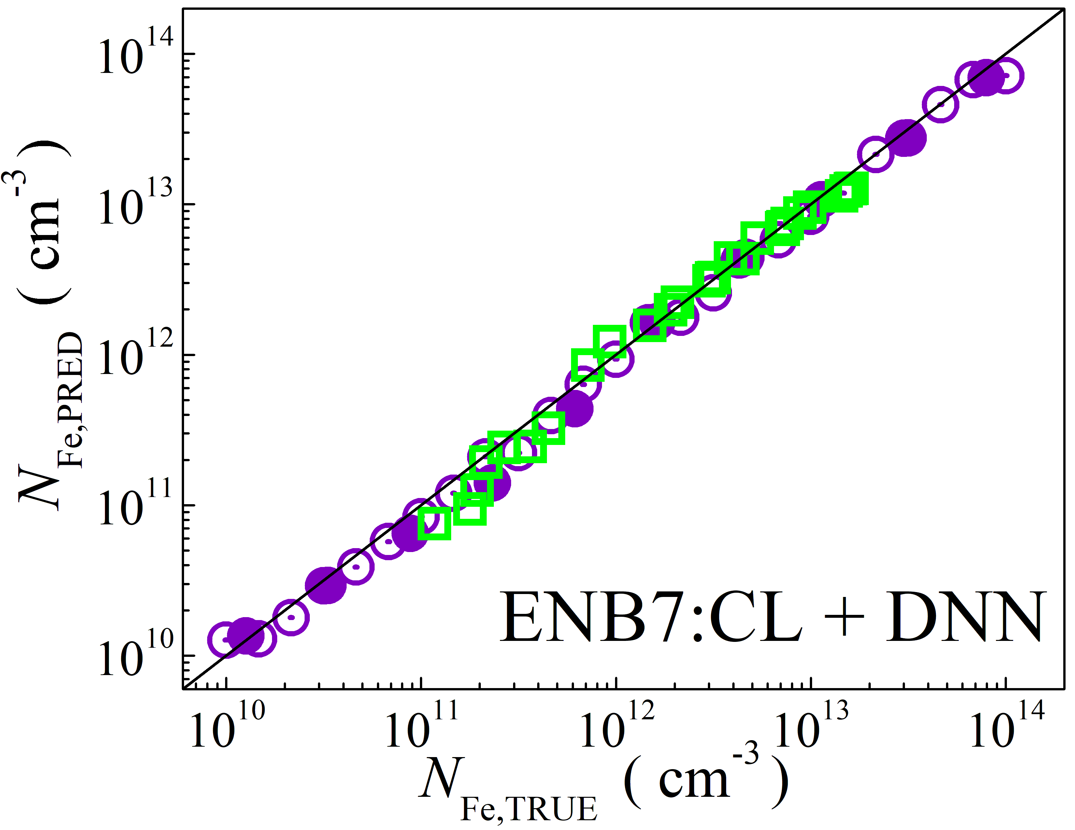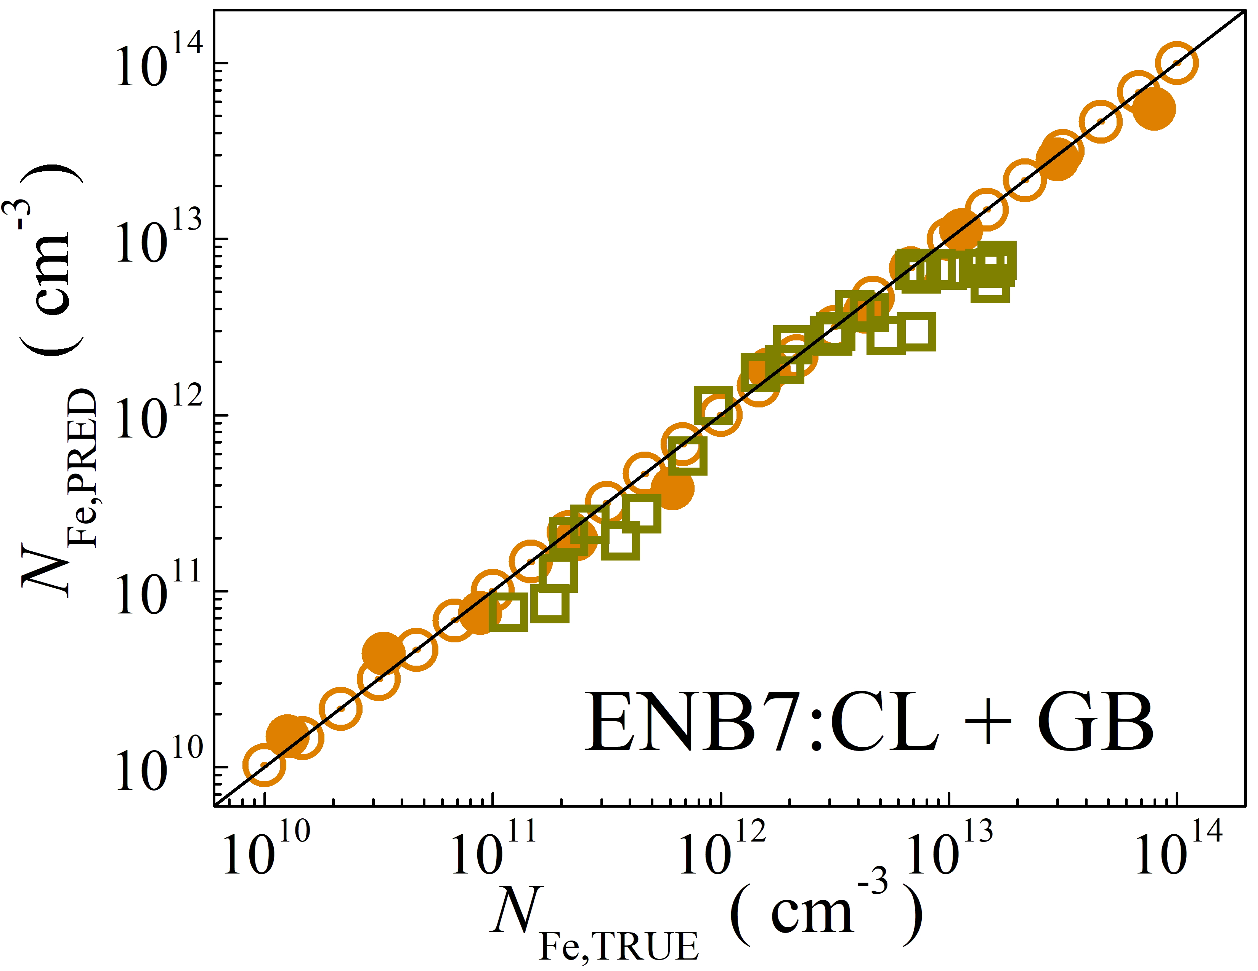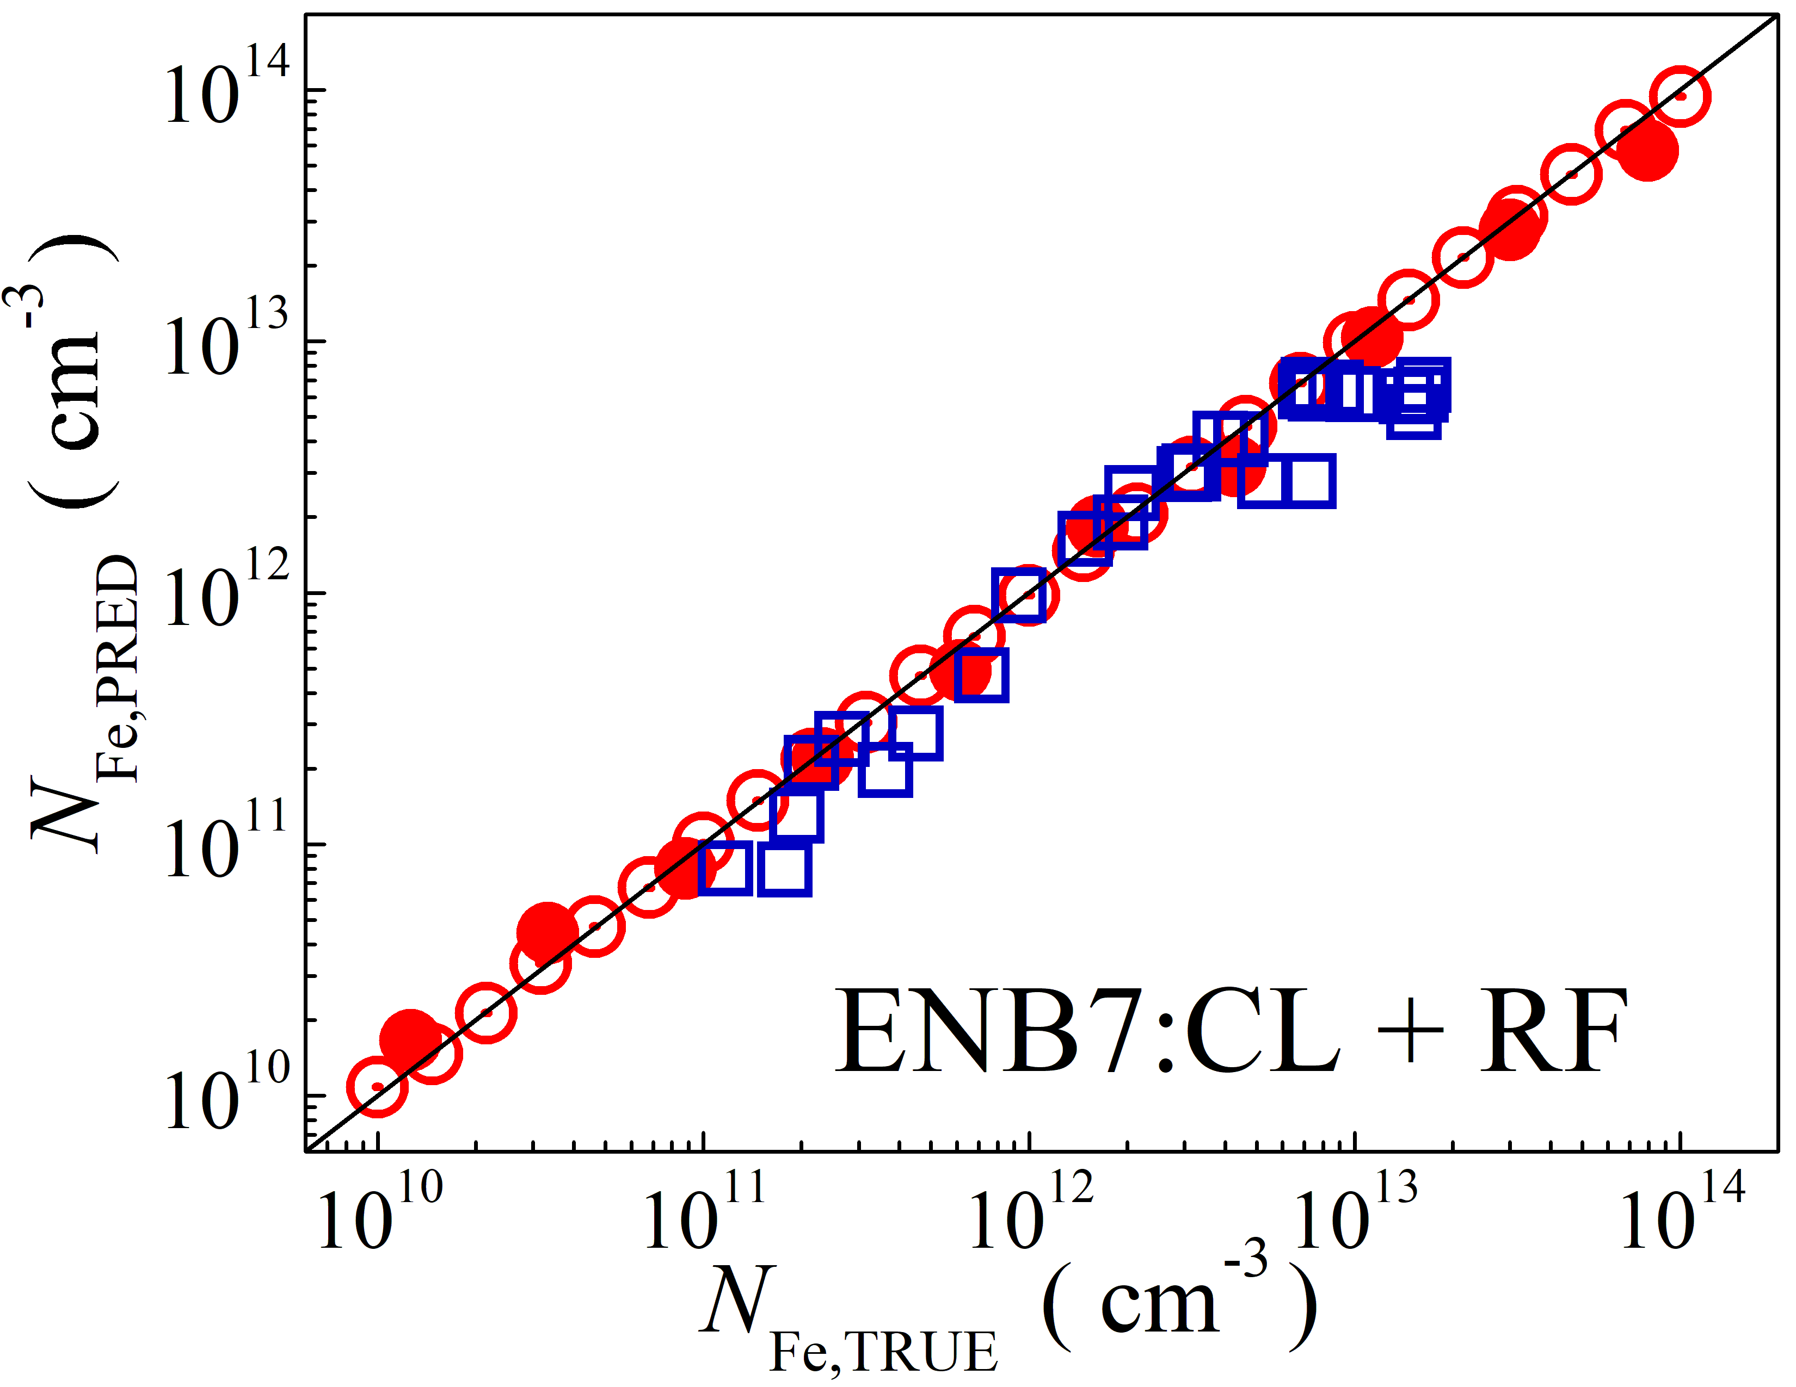

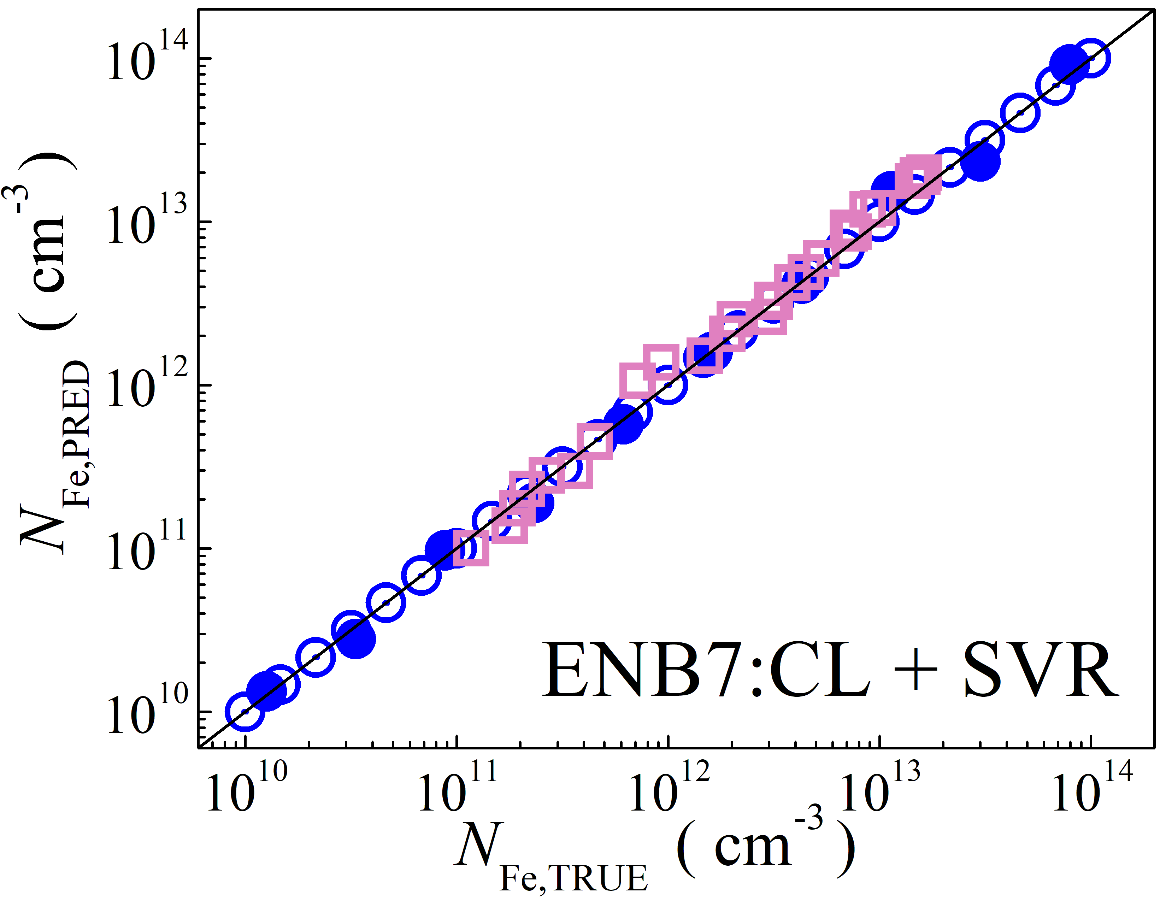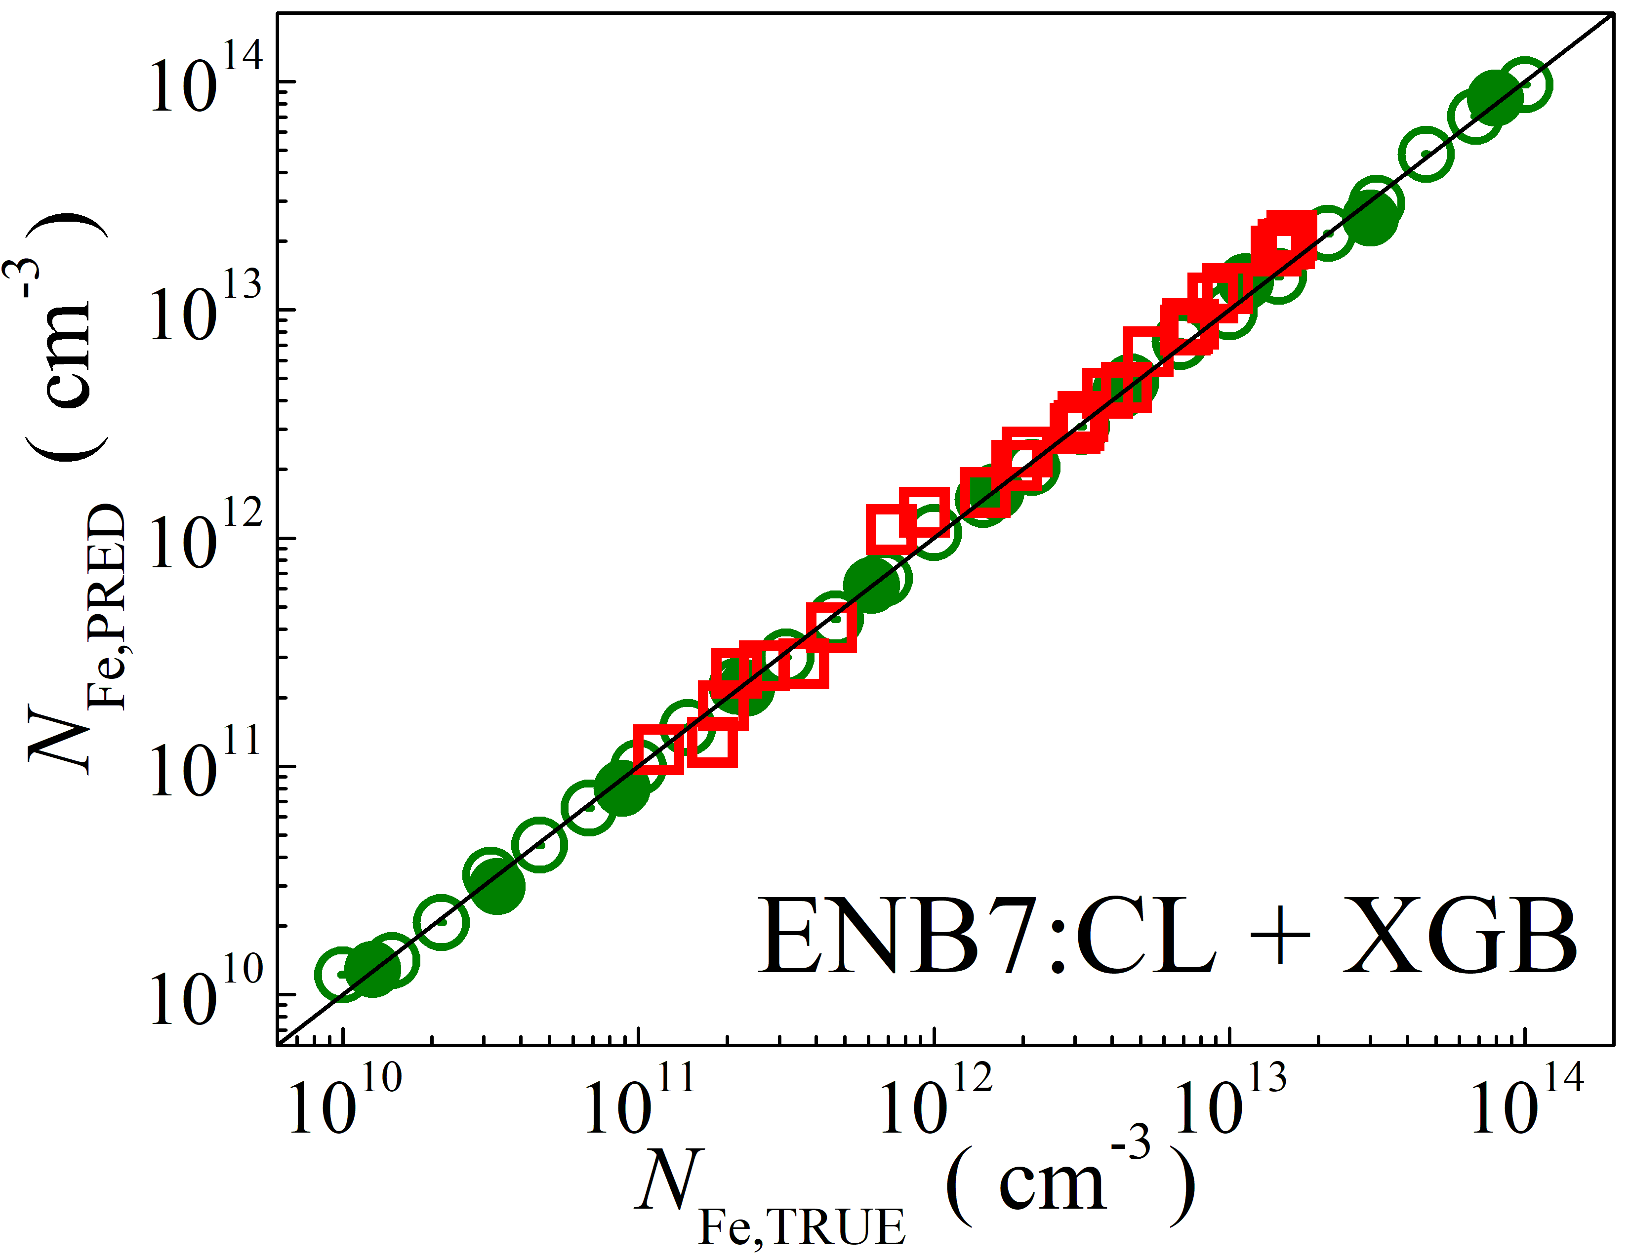

Fig. S1. Scatter plots compare reference iron concentrations $N_{Fe,TRUE}$ with ML-predicted values $N_{Fe,PRED}$ using feature vectors extracted from the classifier layer of EfficientNetB7 visual model. The ML algorithms include DNN (green and purple), GB (dark yellow and yellow), RF (red and blue), SVR (blue and pink), and XGB (green and red). Symbols represent different datasets: open circles — training data (simulated), filled circles — test data (simulated), and open squares — test data from experimental measurements. The black lines are the identified lines serving as the references.

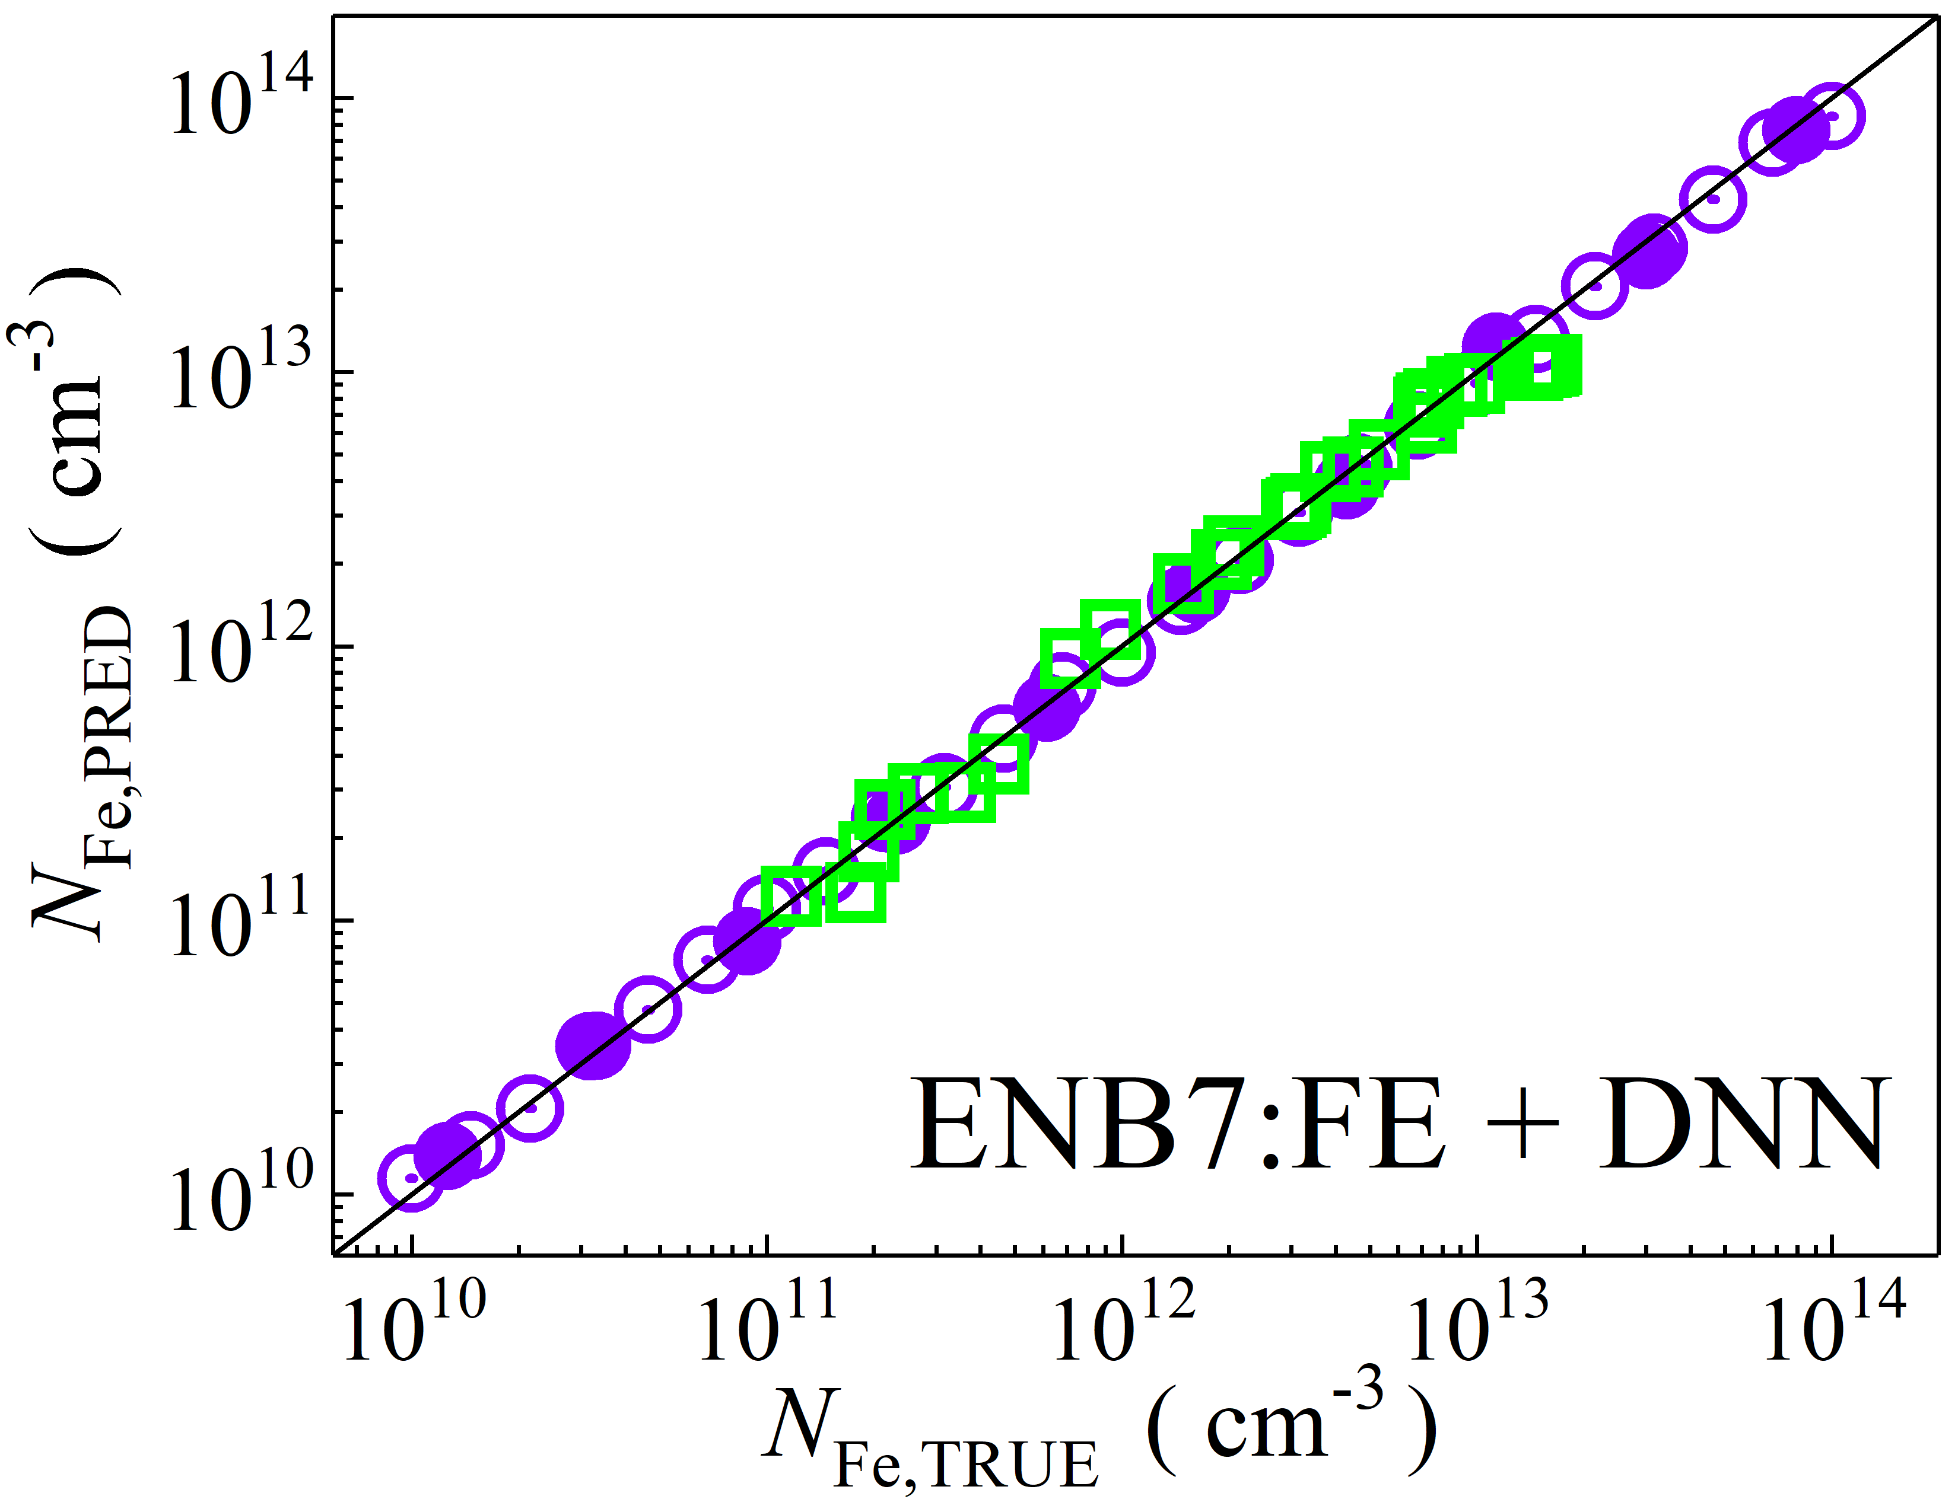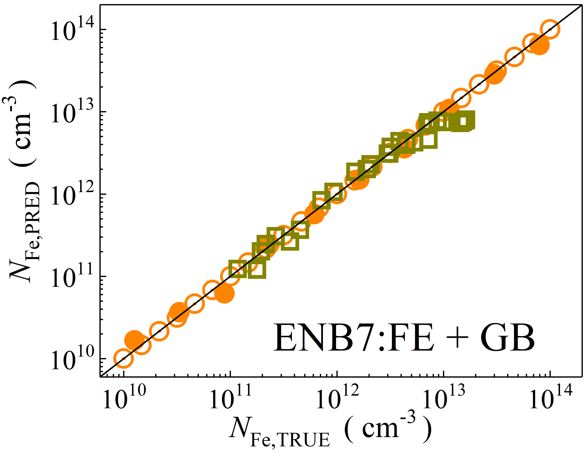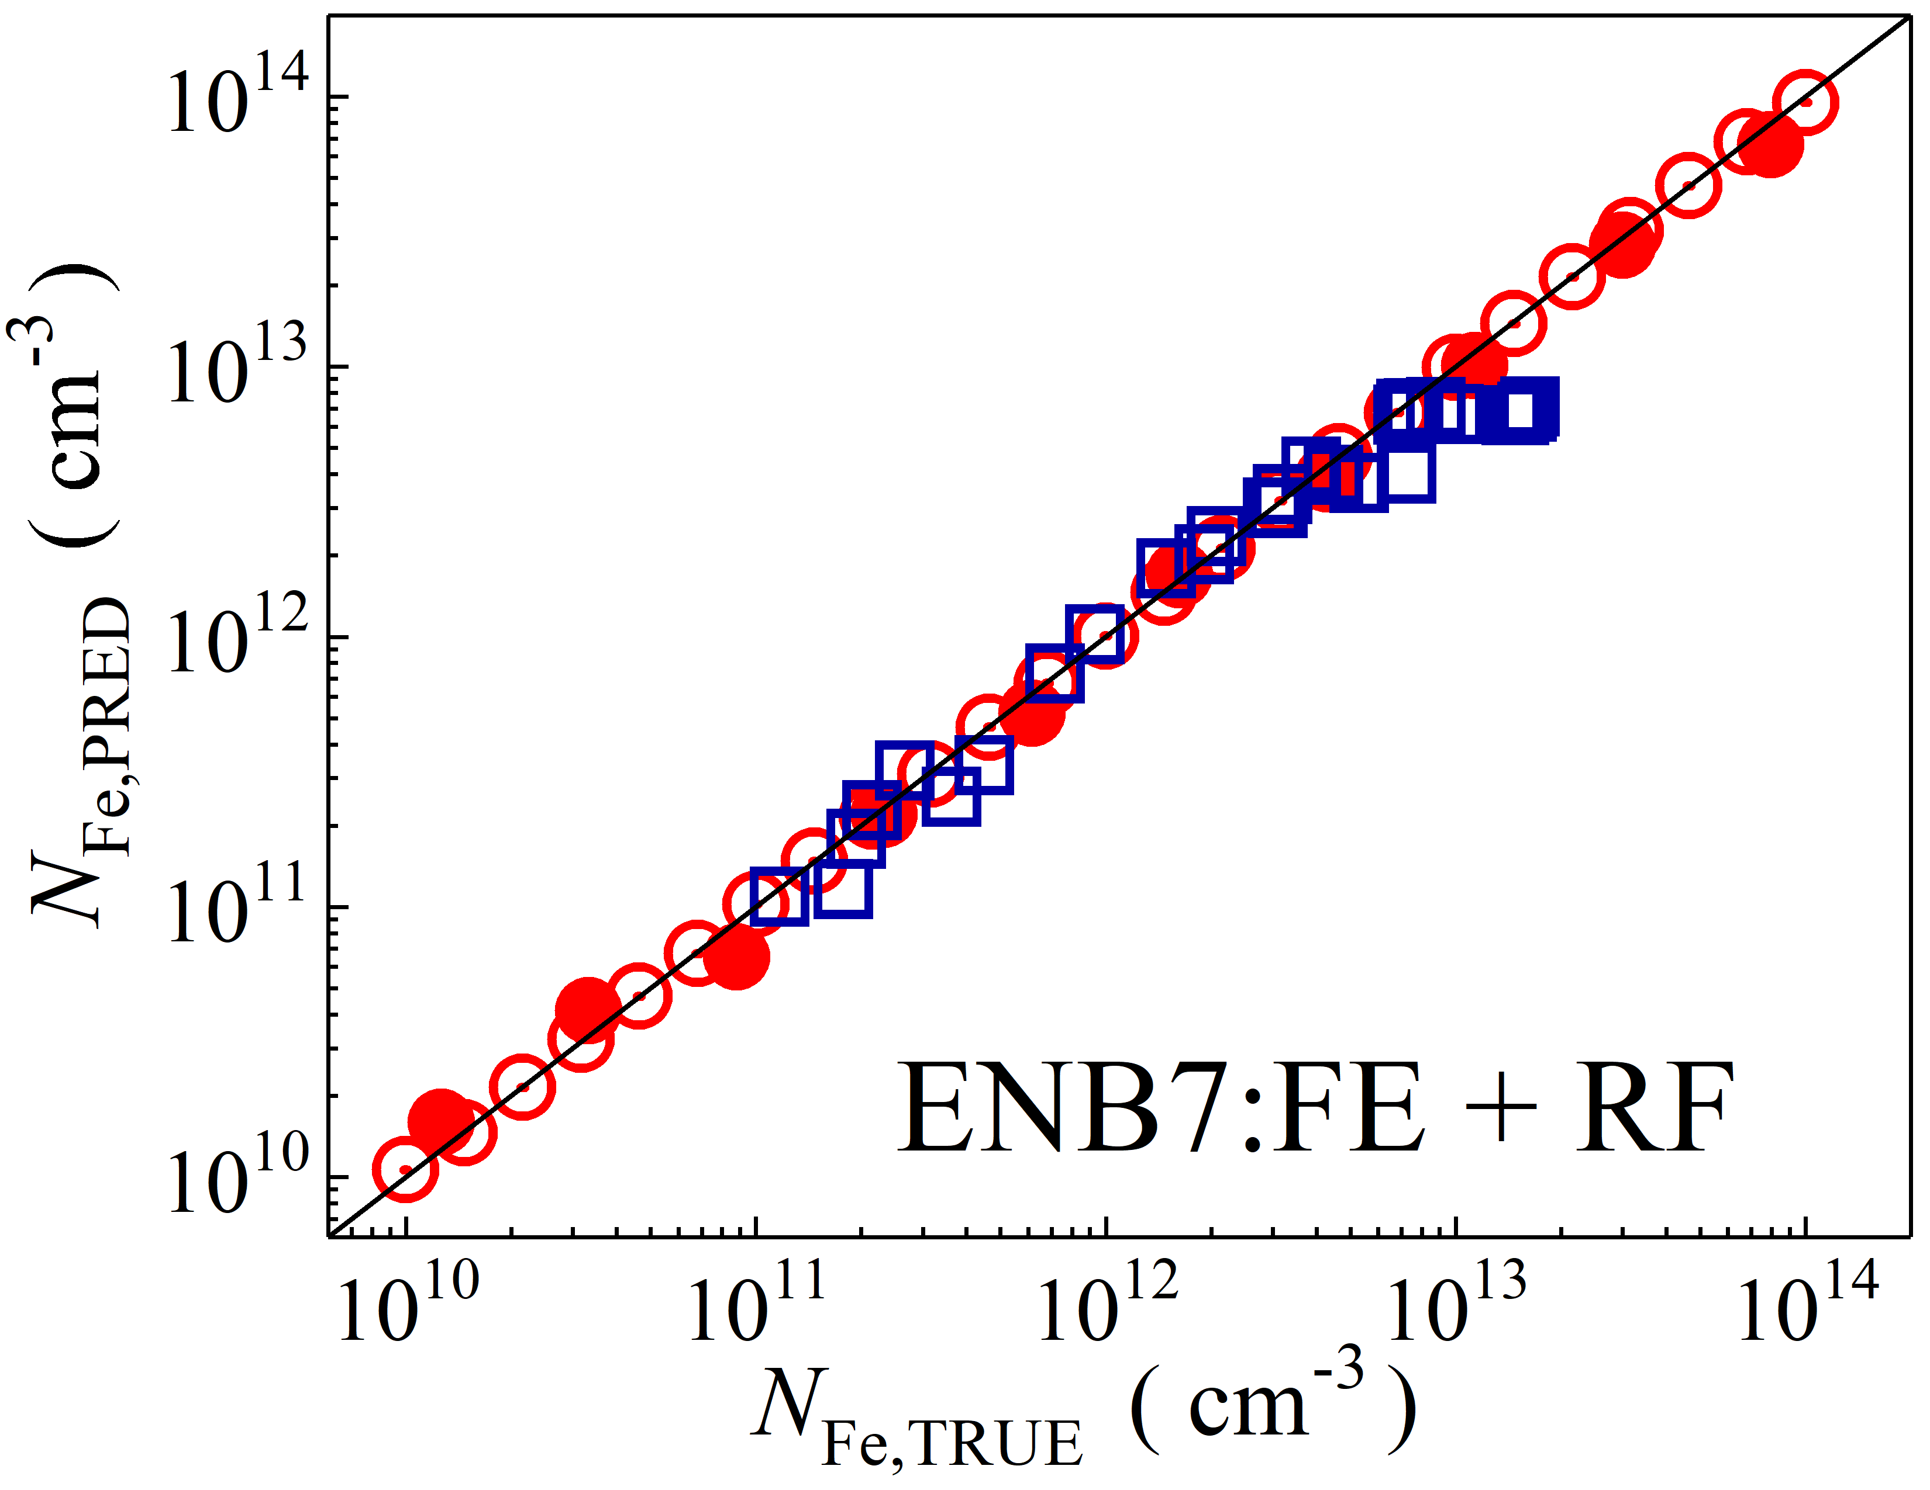

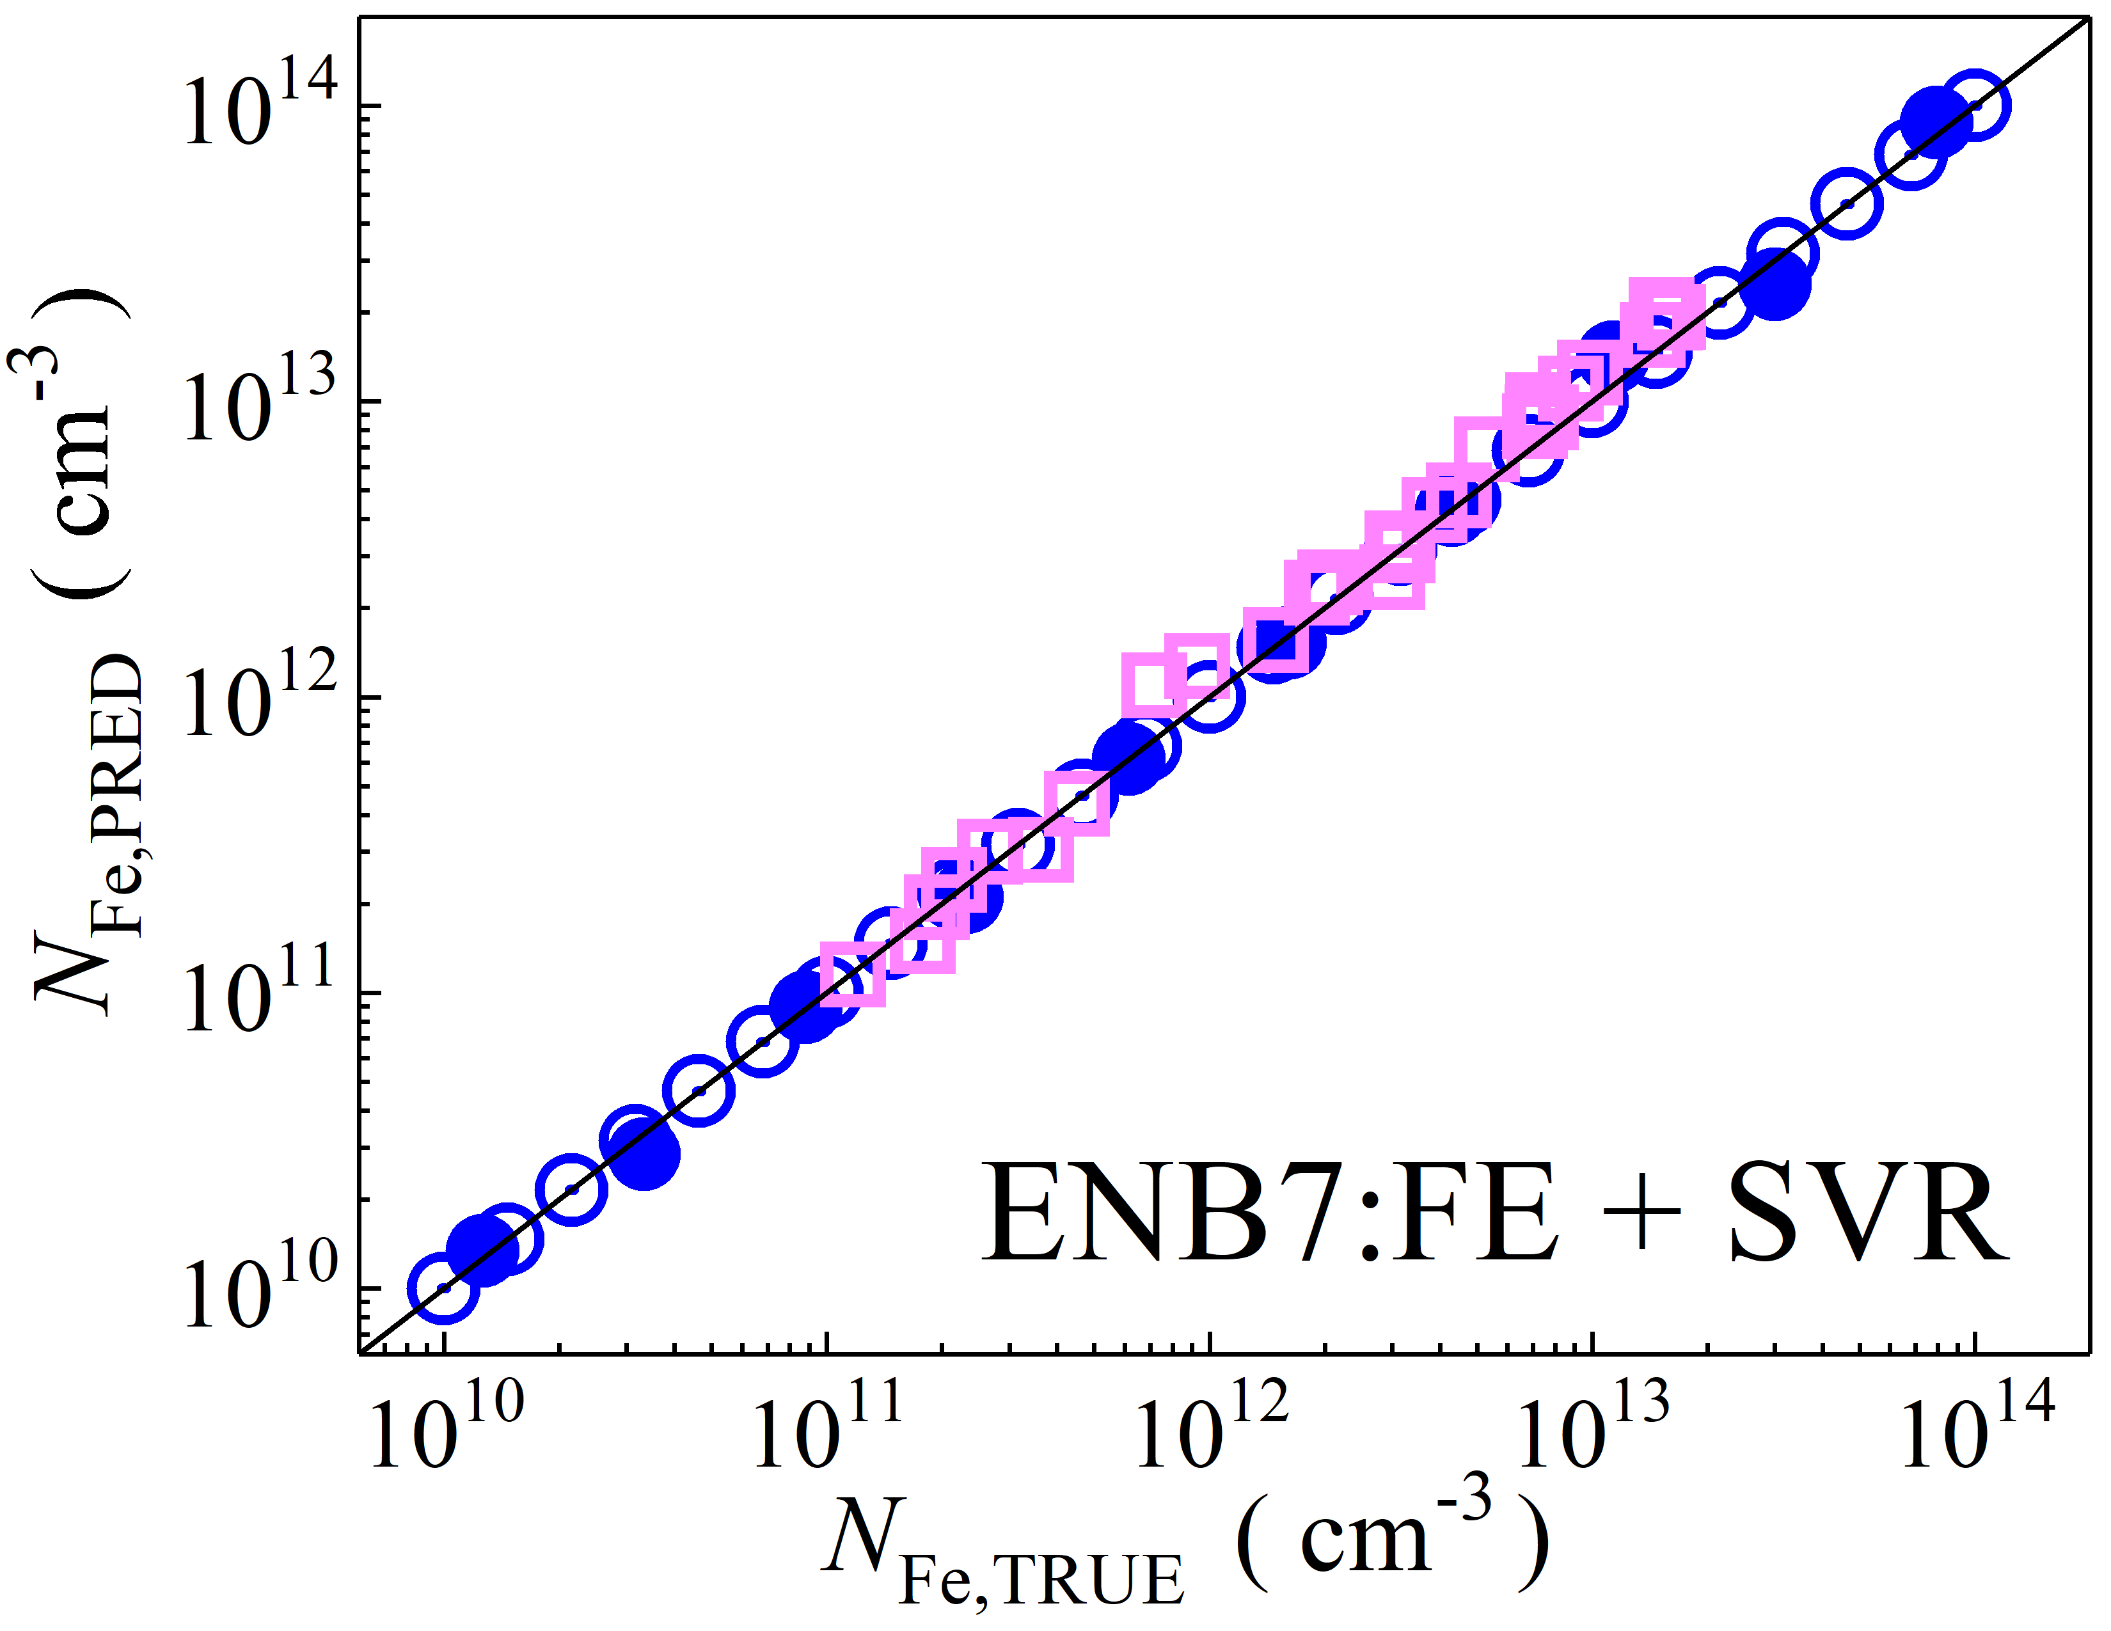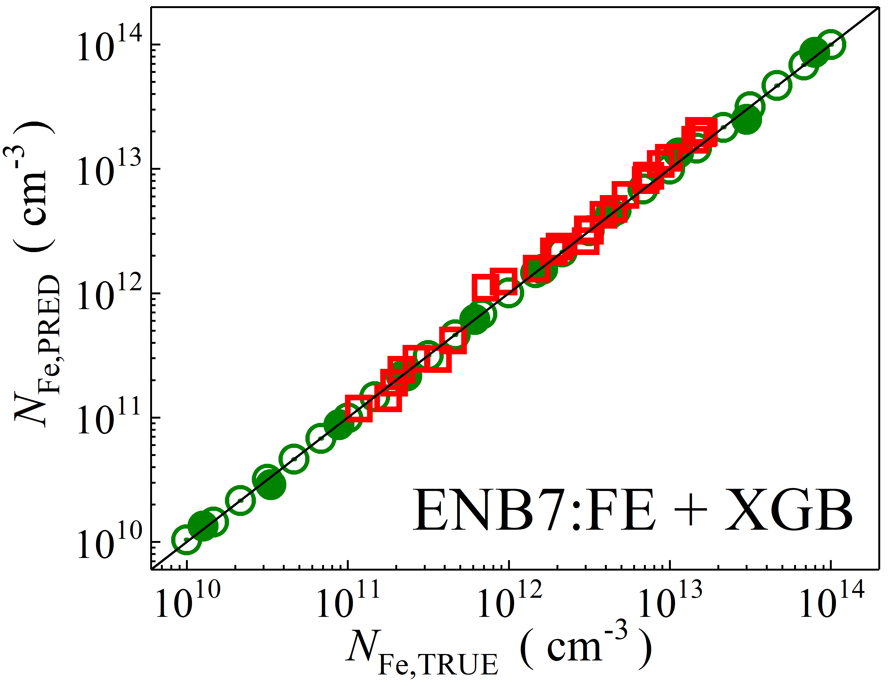

Fig. S2. Scatter plots compare reference iron concentrations $N_{Fe,TRUE}$ with ML-predicted values $N_{Fe,PRED}$ using feature vectors extracted from the feature extractor layer of EfficientNetB7 visual model. The ML algorithms include DNN (green and purple), GB (dark yellow and yellow), RF (red and blue), SVR (blue and pink), and XGB (green and red). Symbols represent different datasets: open circles — training data (simulated), filled circles — test data (simulated), and open squares — test data from experimental measurements. The black lines are the identified lines serving as the references.

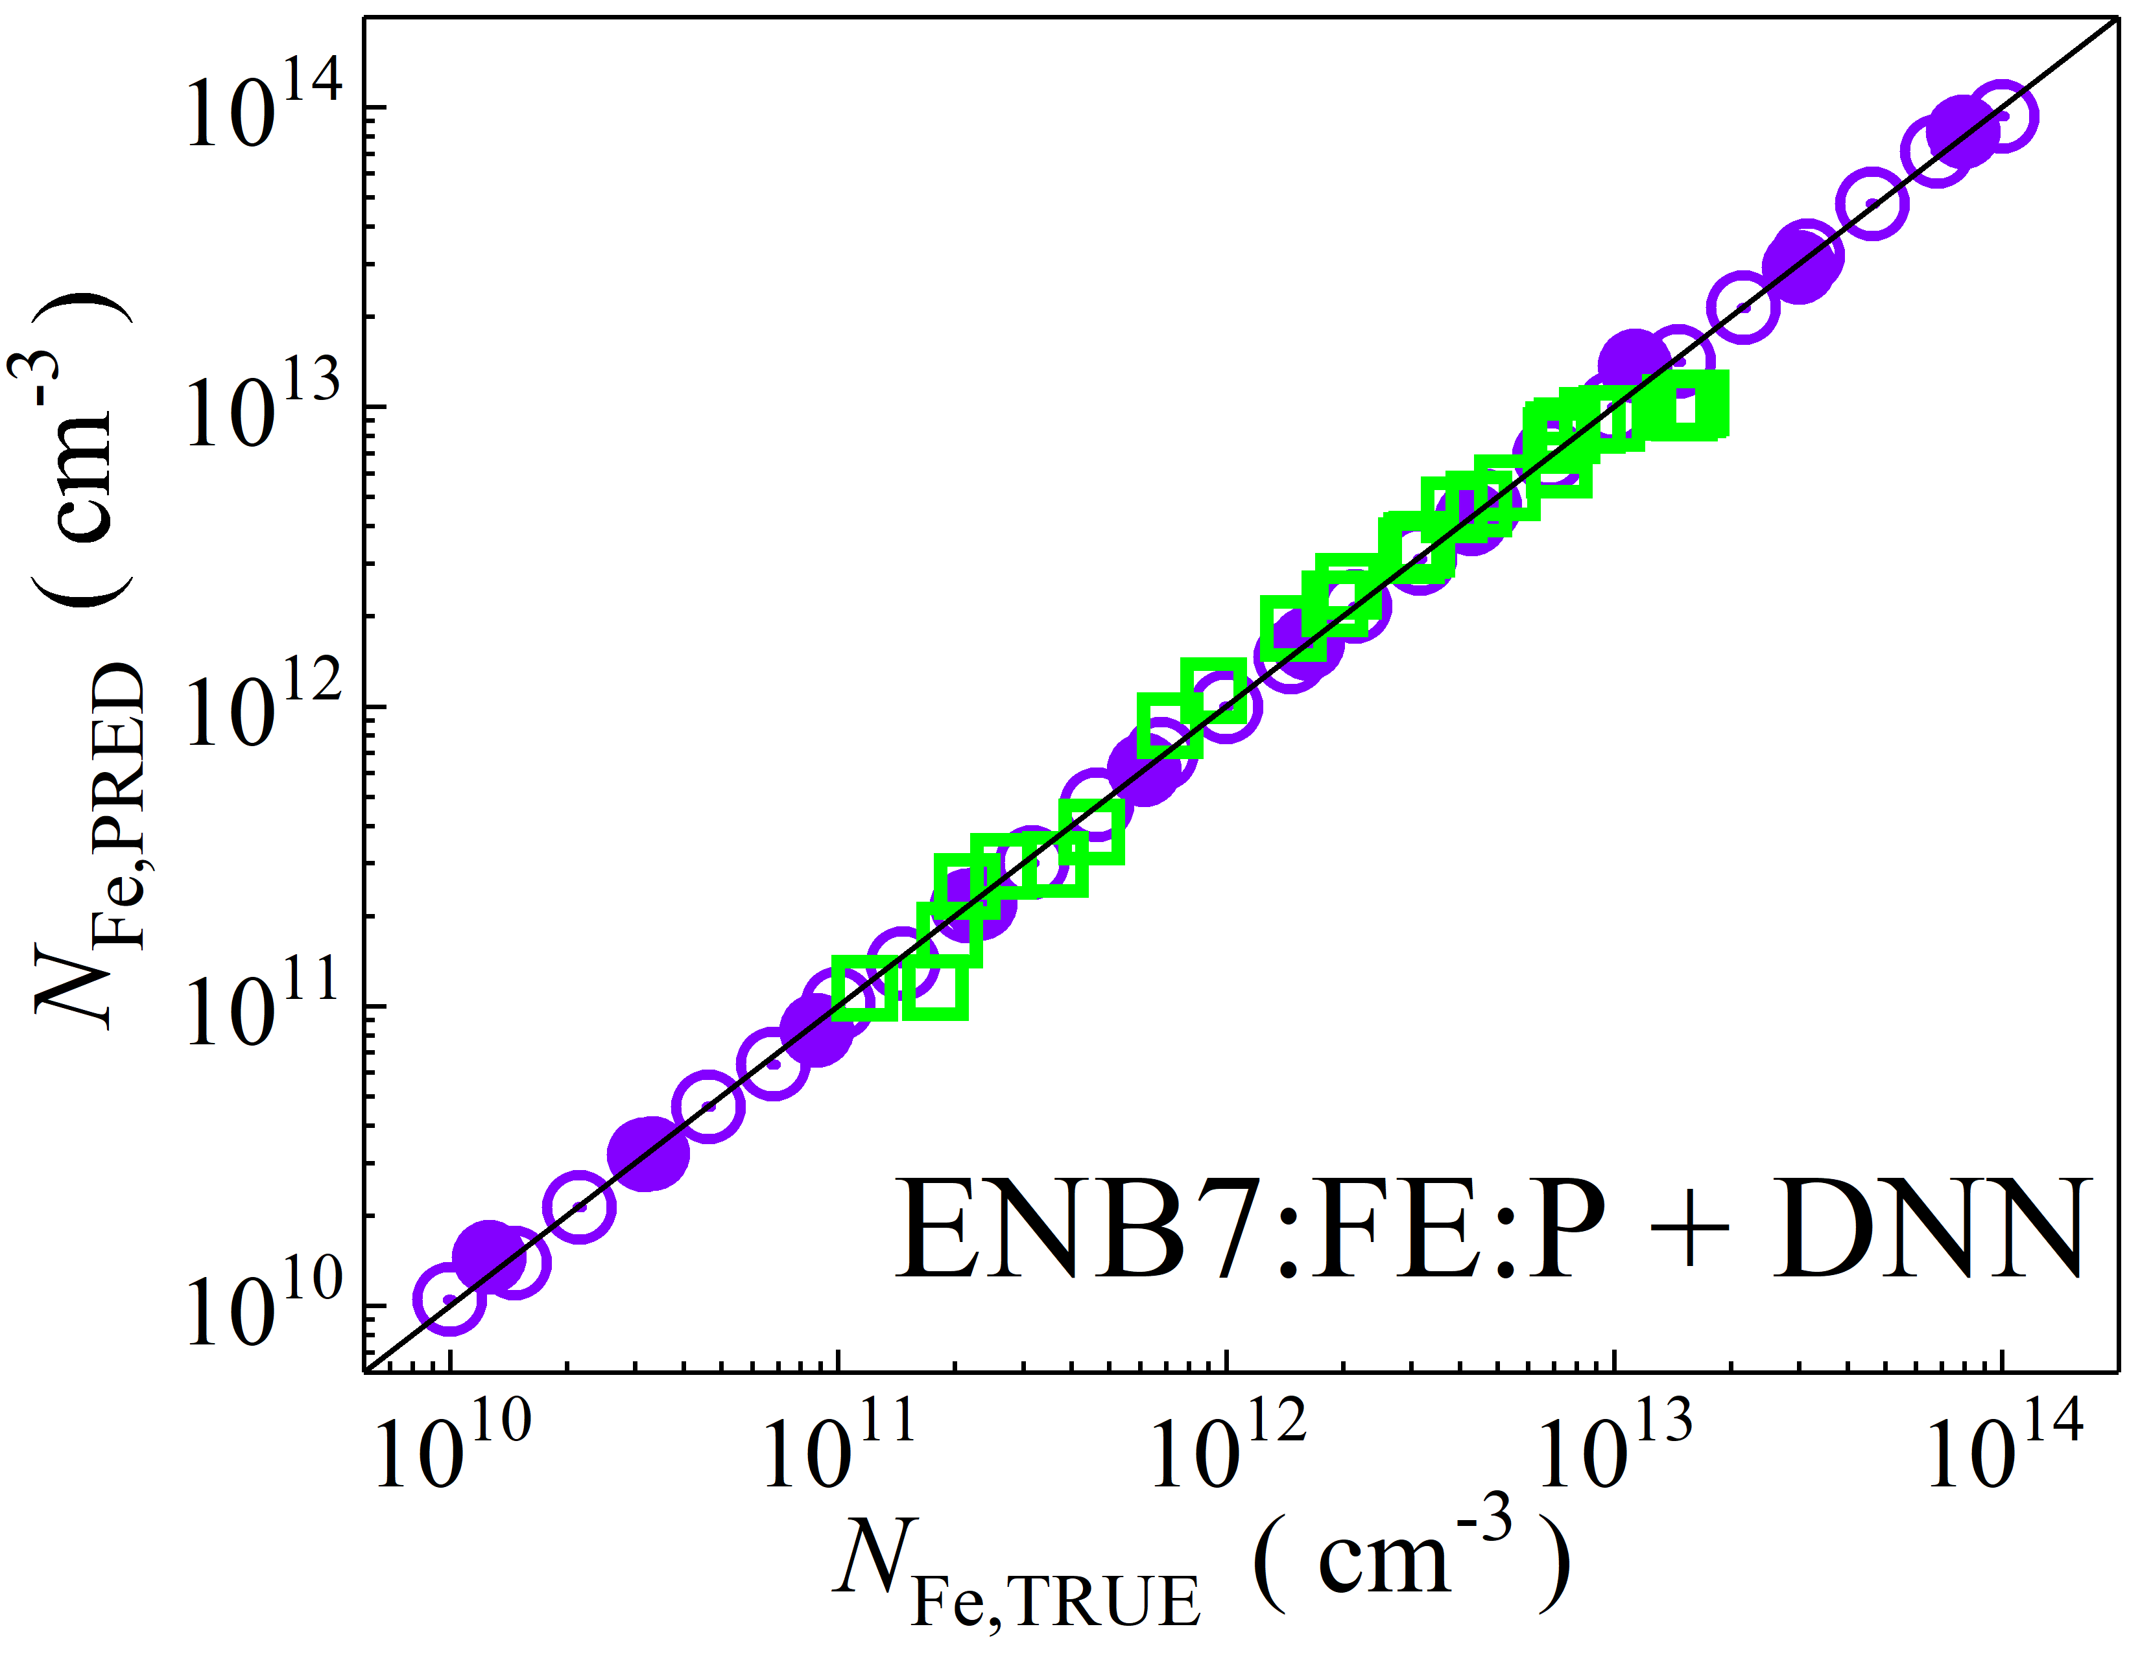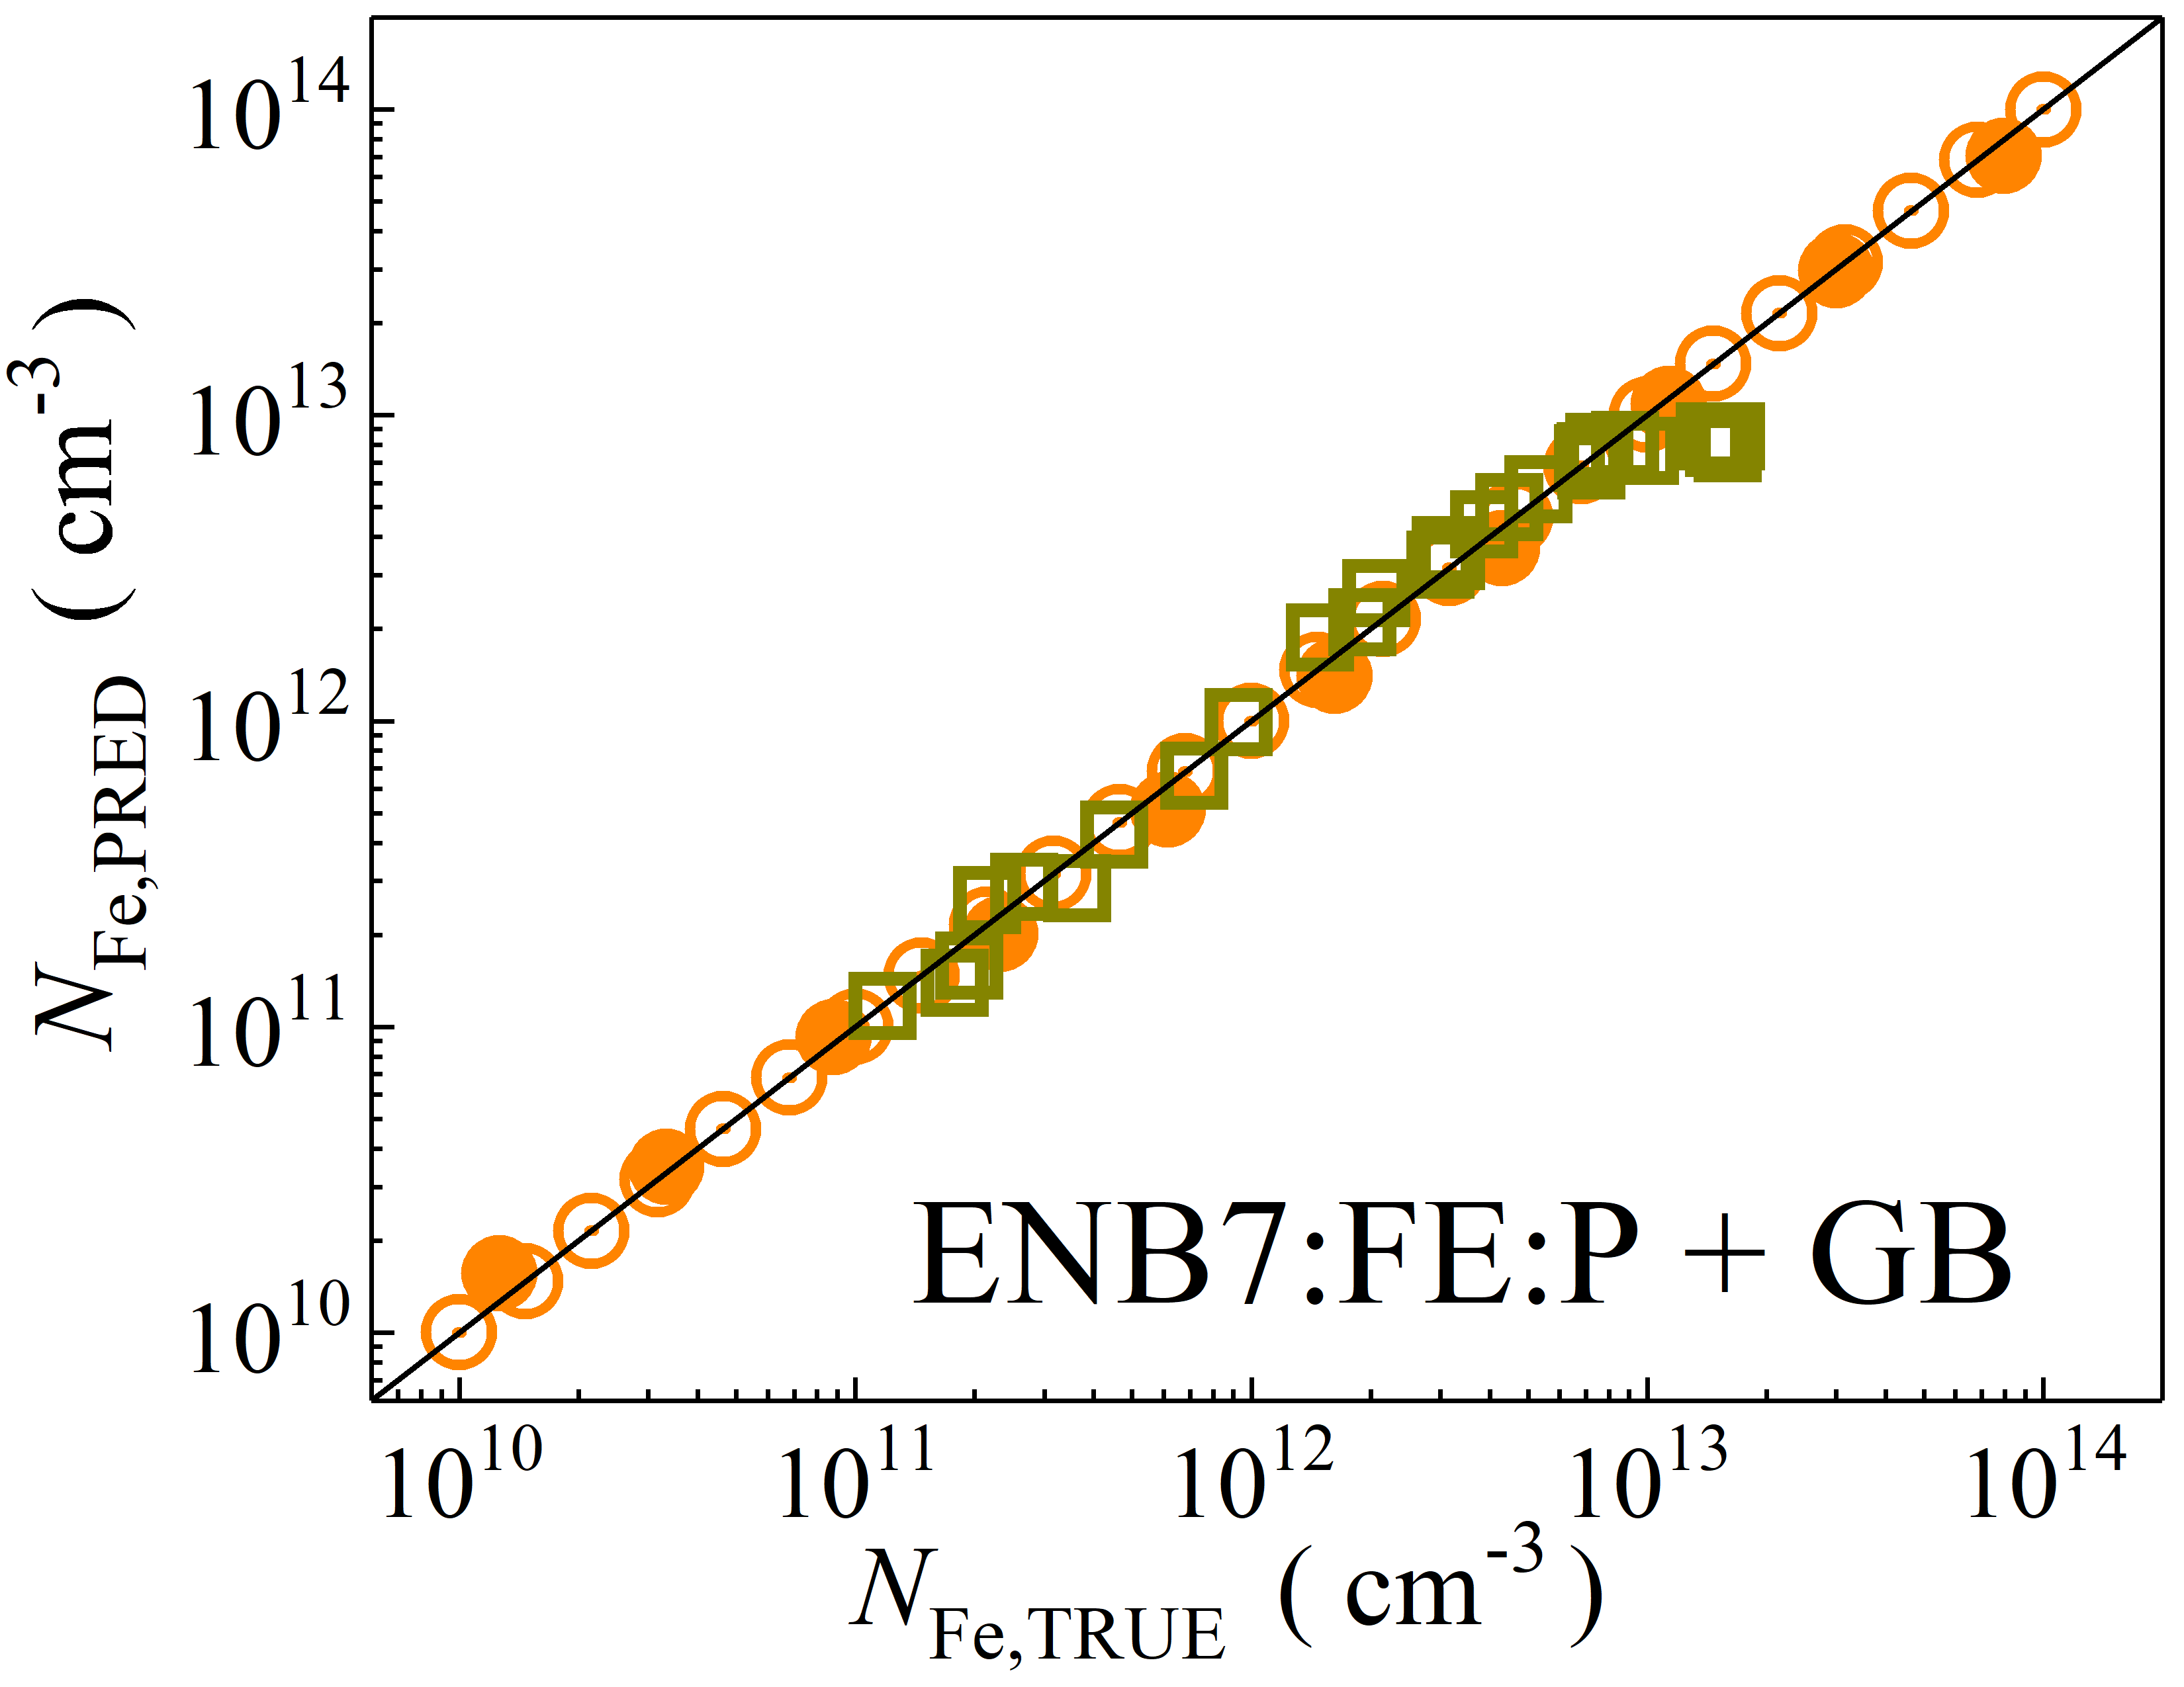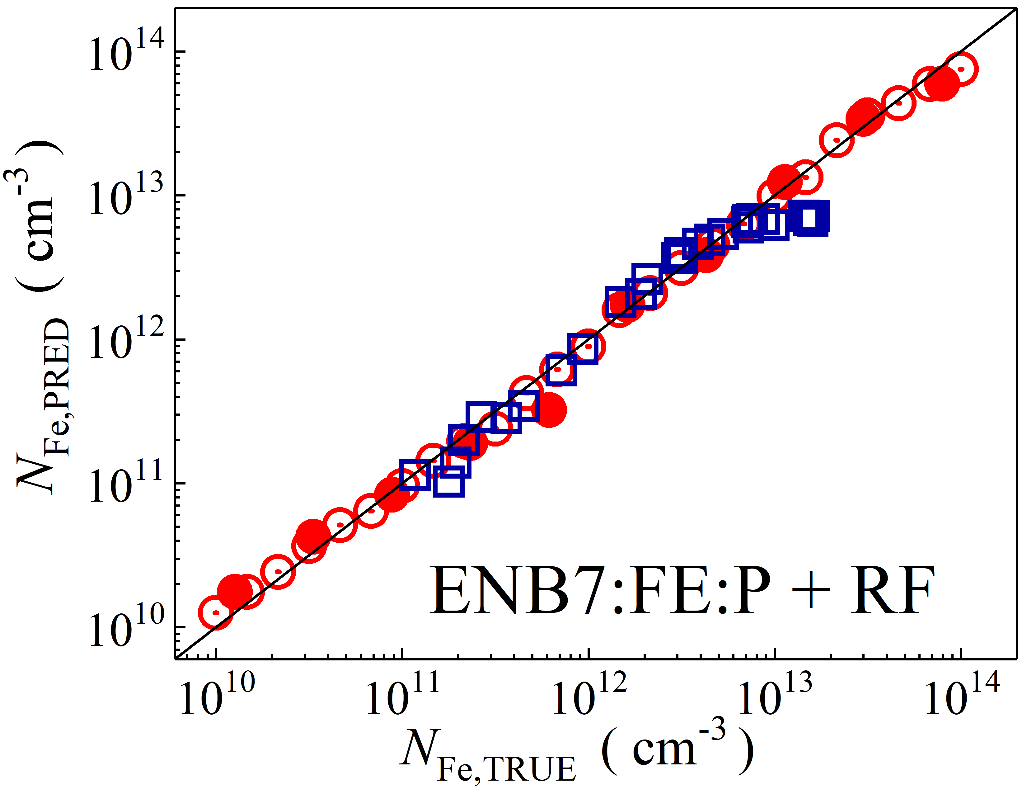

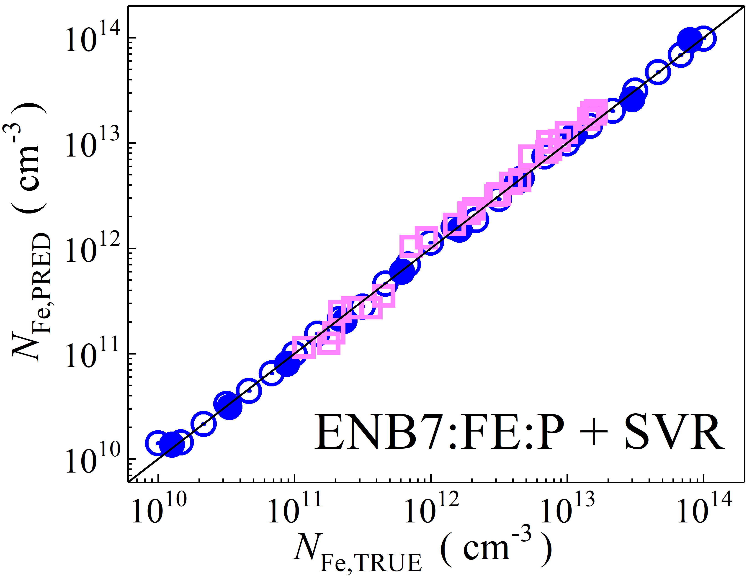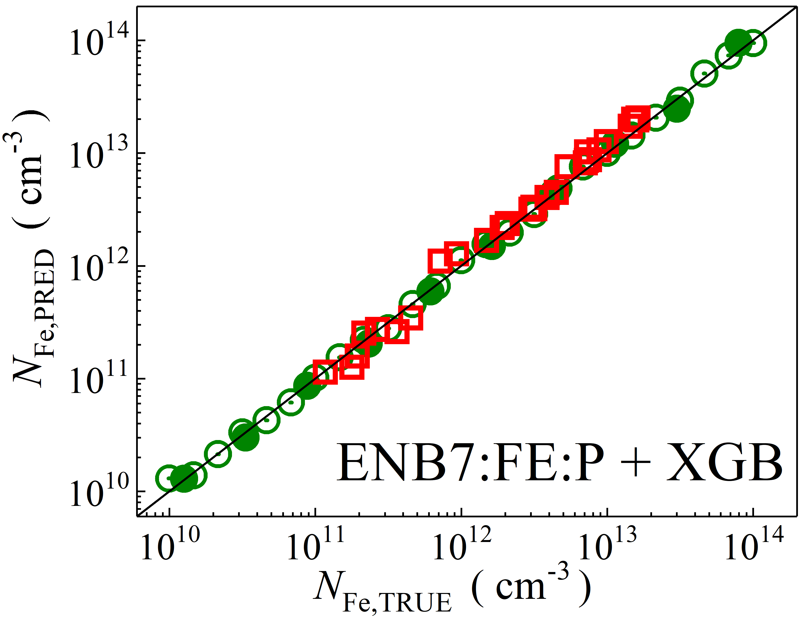

Fig. S3. Scatter plots compare reference iron concentrations $N_{Fe,TRUE}$ with ML-predicted values $N_{Fe,PRED}$ using feature vectors extracted from the feature extractor layer with PCA reduction of EfficientNetB7 visual model. The ML algorithms include DNN (green and purple), GB (dark yellow and yellow), RF (red and blue), SVR (blue and pink), and XGB (green and red). Symbols represent different datasets: open circles — training data (simulated), filled circles — test data (simulated), and open squares — test data from experimental measurements. The black lines are the identified lines serving as the references.

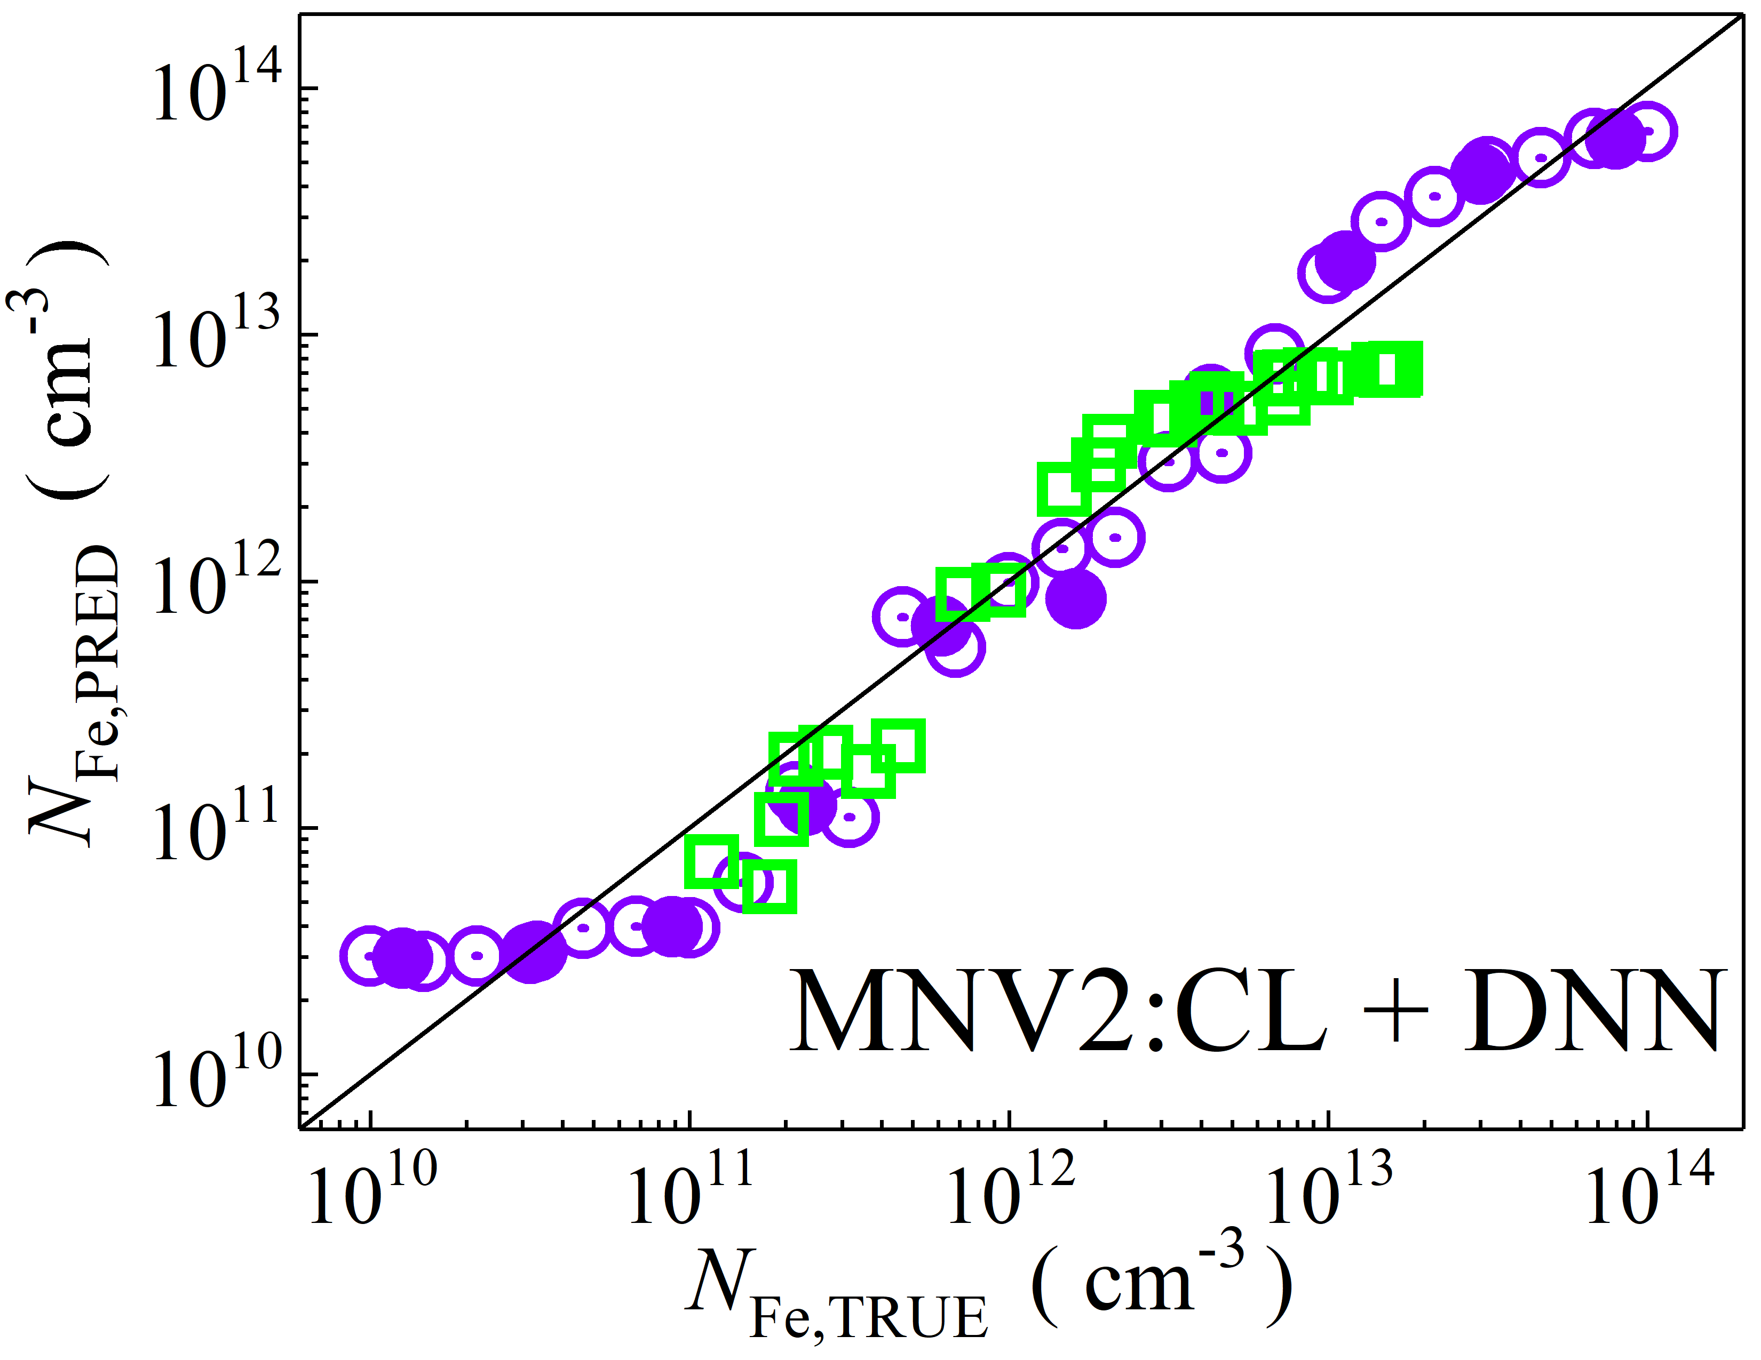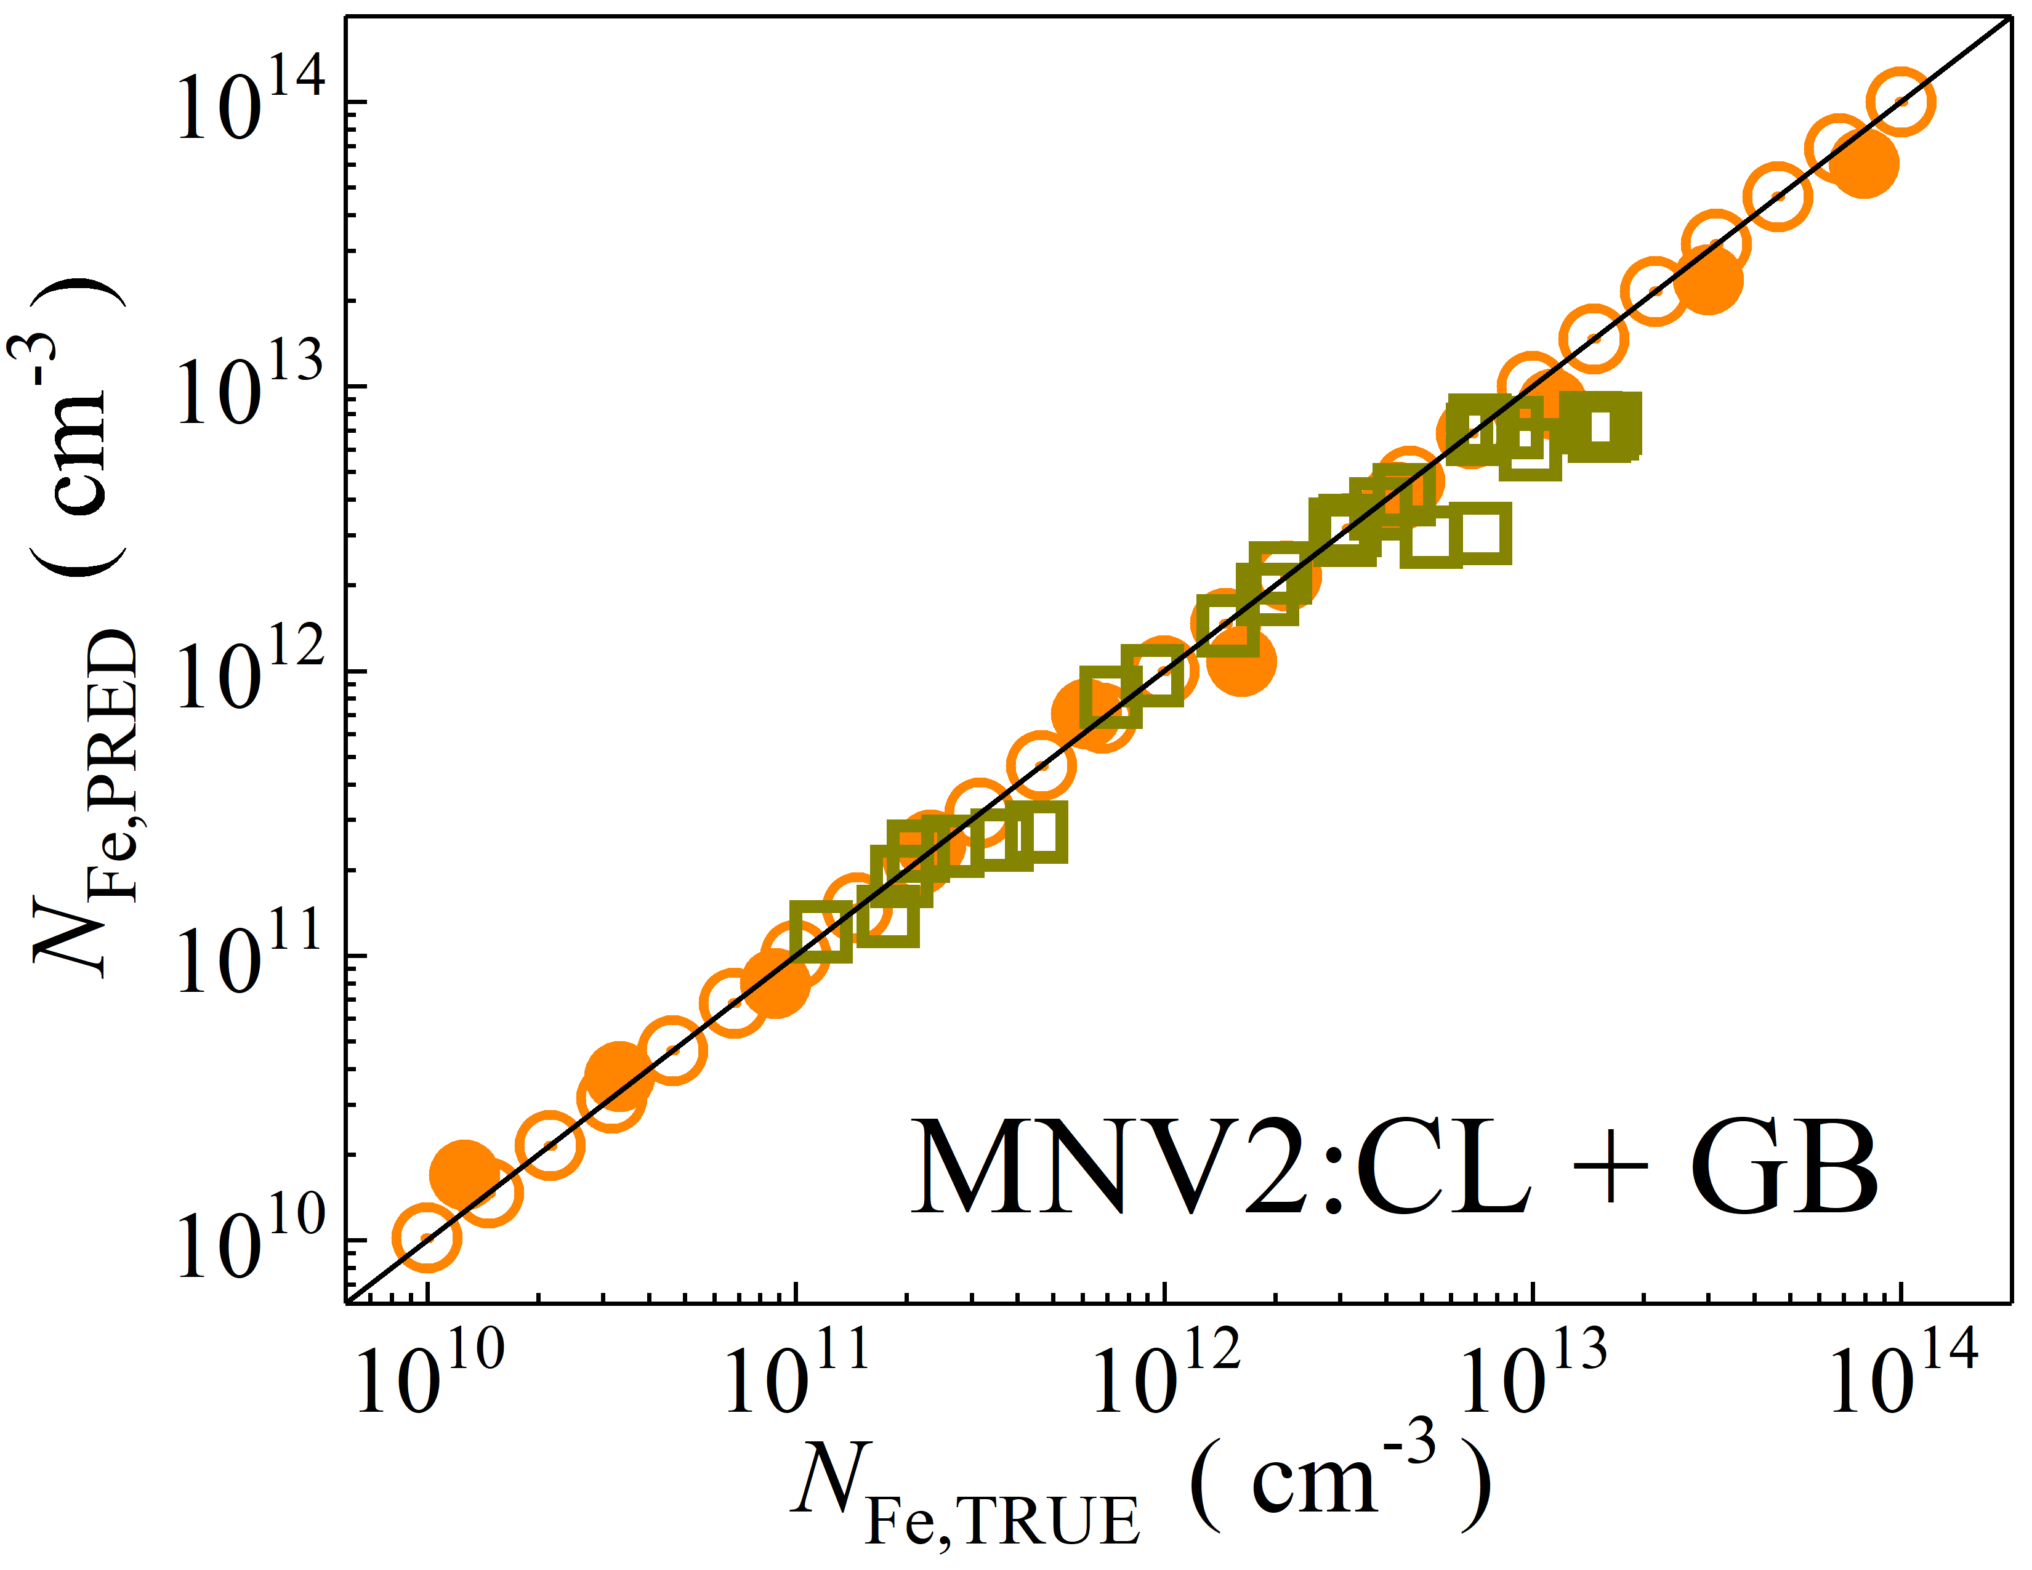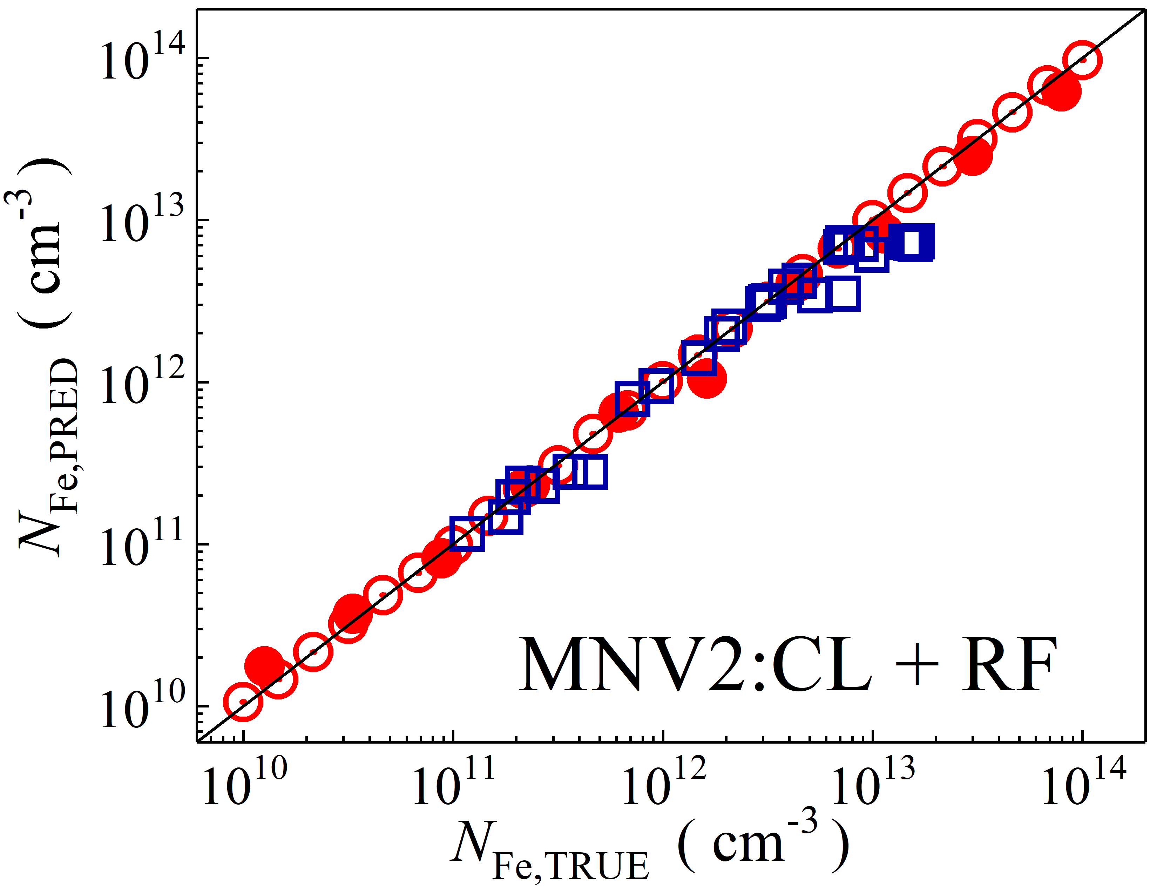

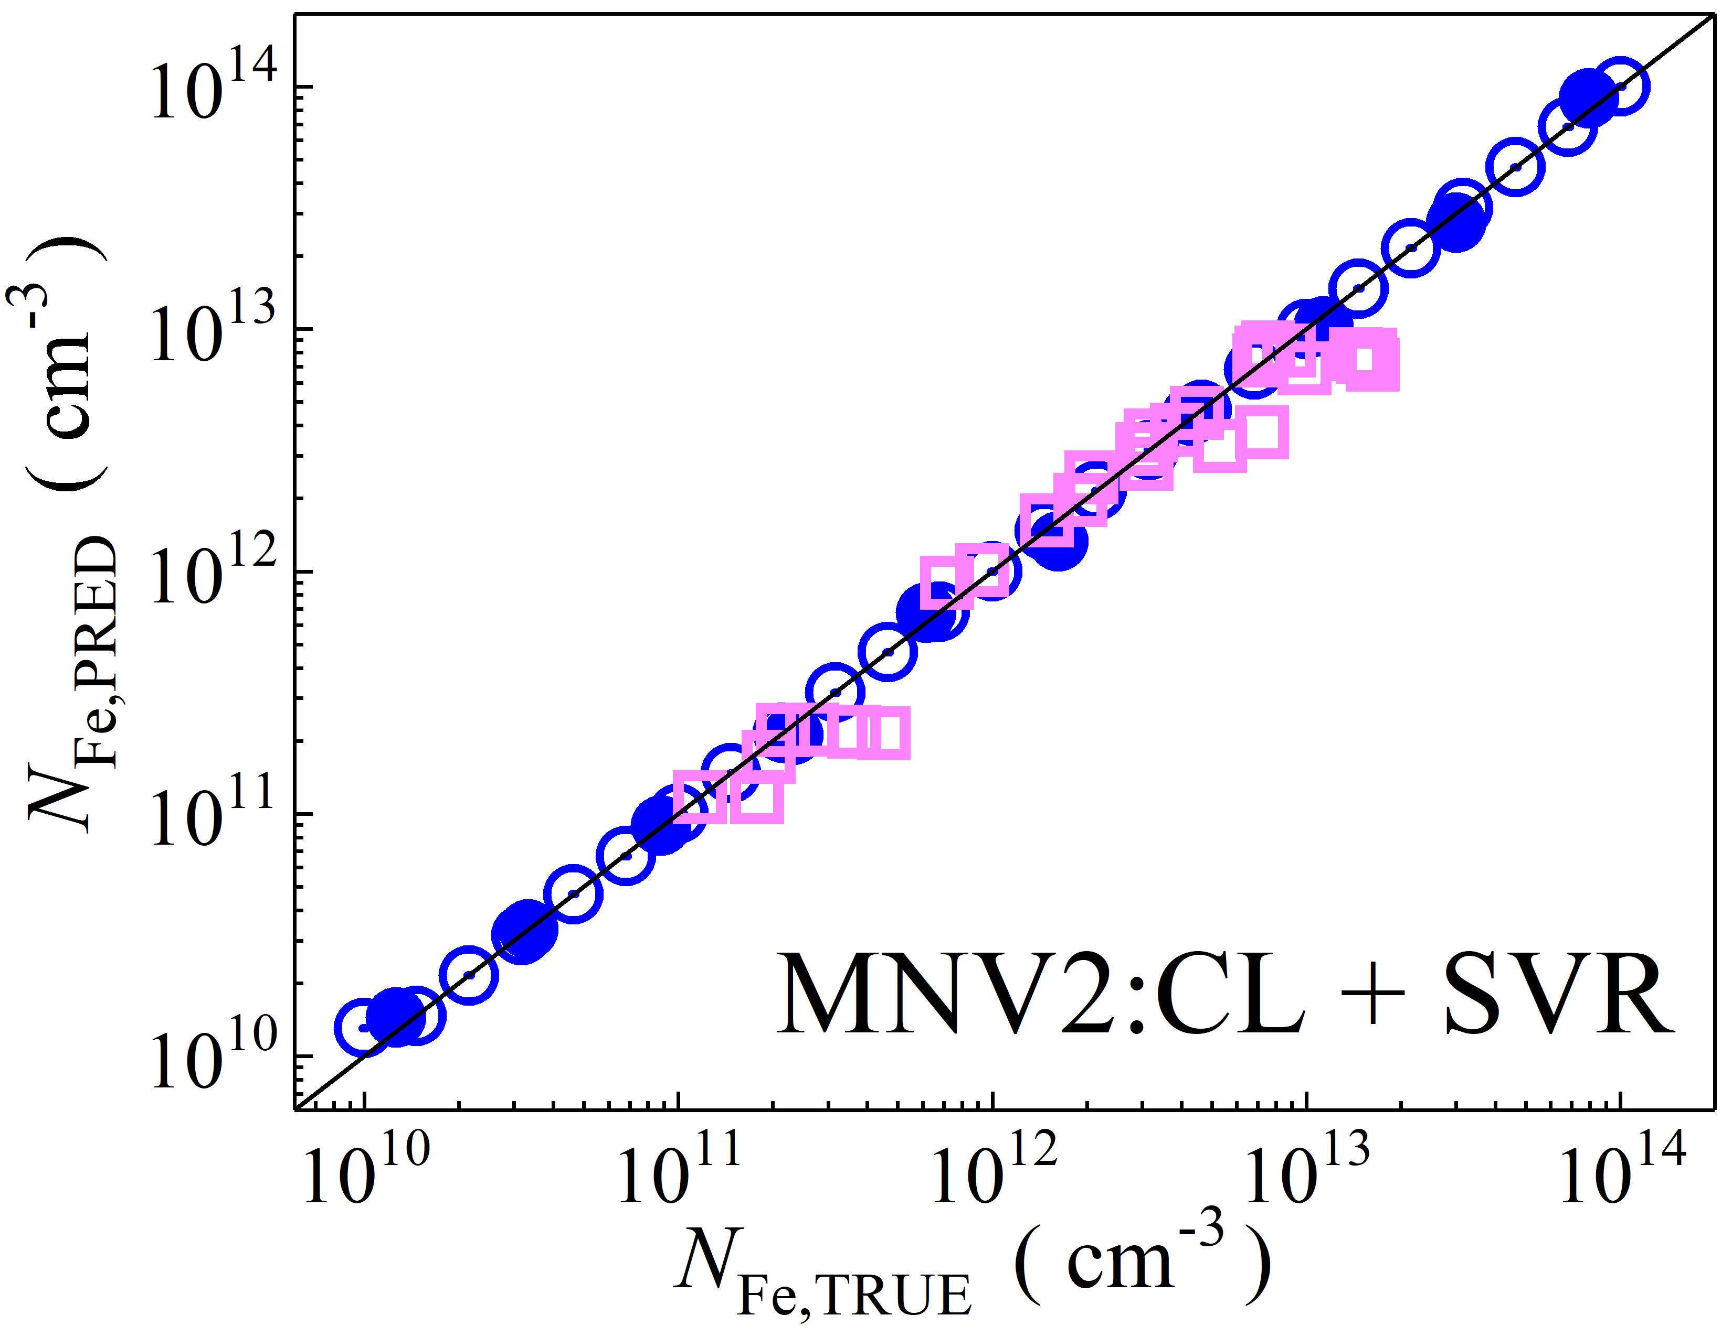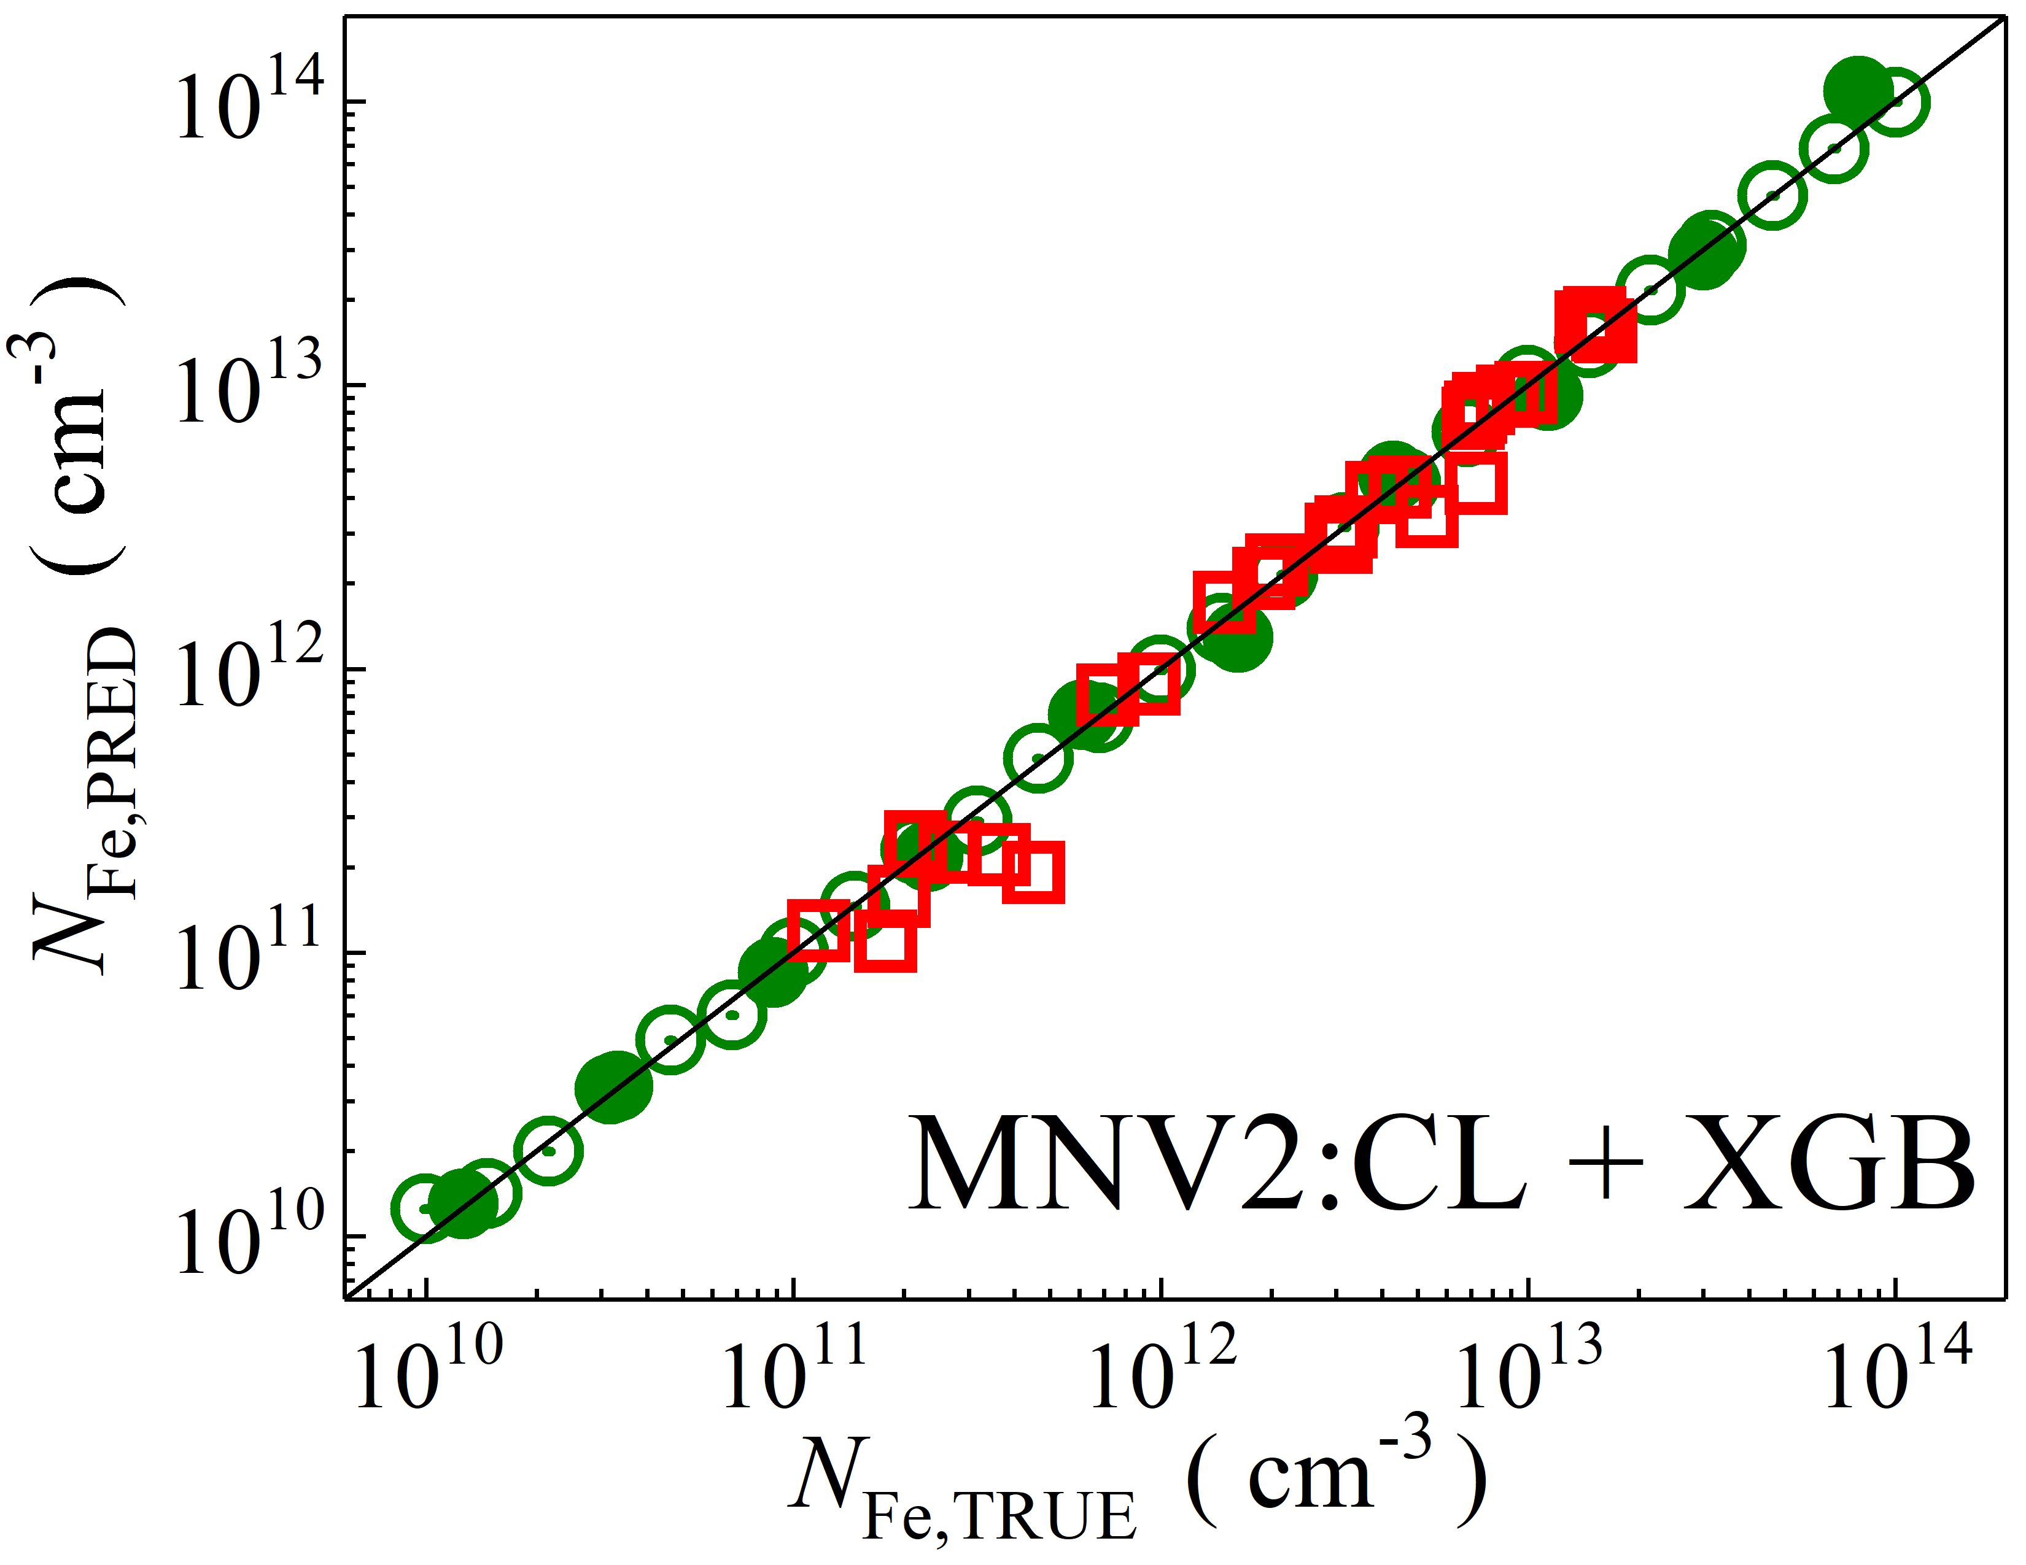

Fig. S4. Scatter plots compare reference iron concentrations $N_{Fe,TRUE}$ with ML-predicted values $N_{Fe,PRED}$ using feature vectors extracted from the classifier layer of MobileNetV2 visual model. The ML algorithms include DNN (green and purple), GB (dark yellow and yellow), RF (red and blue), SVR (blue and pink), and XGB (green and red). Symbols represent different datasets: open circles — training data (simulated), filled circles — test data (simulated), and open squares — test data from experimental measurements. The black lines are the identified lines serving as the references.

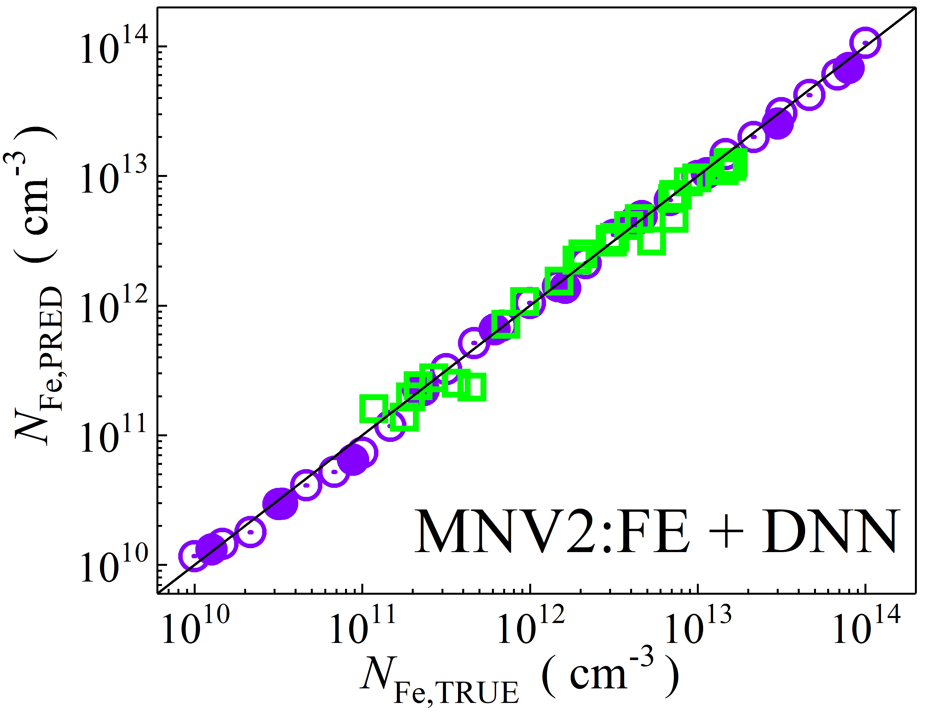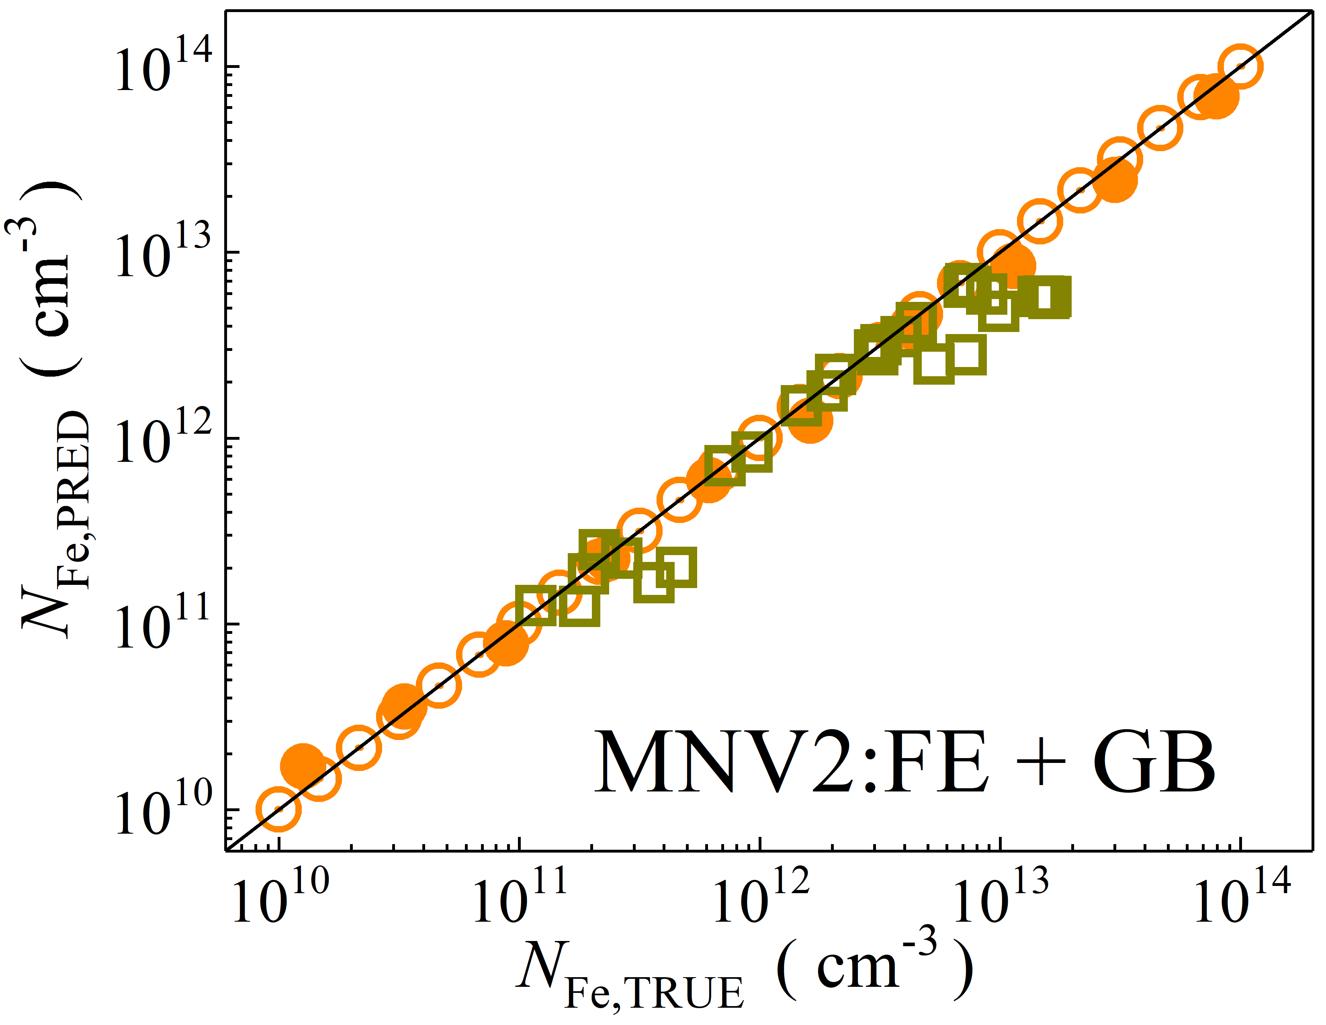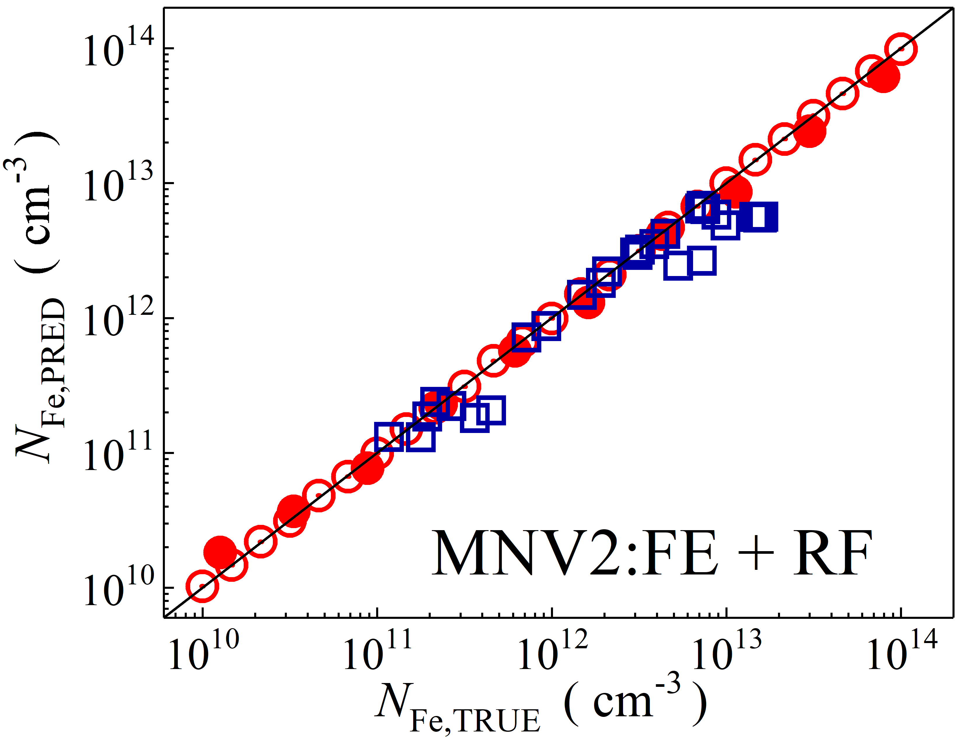

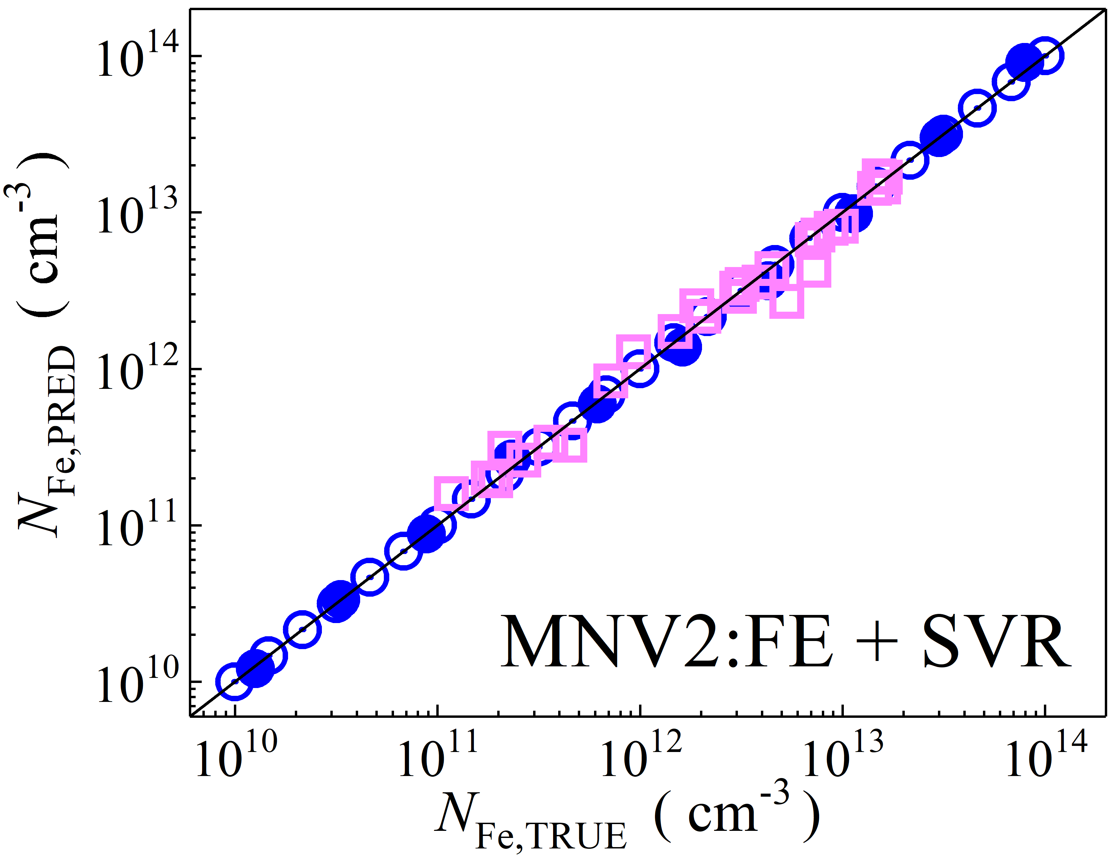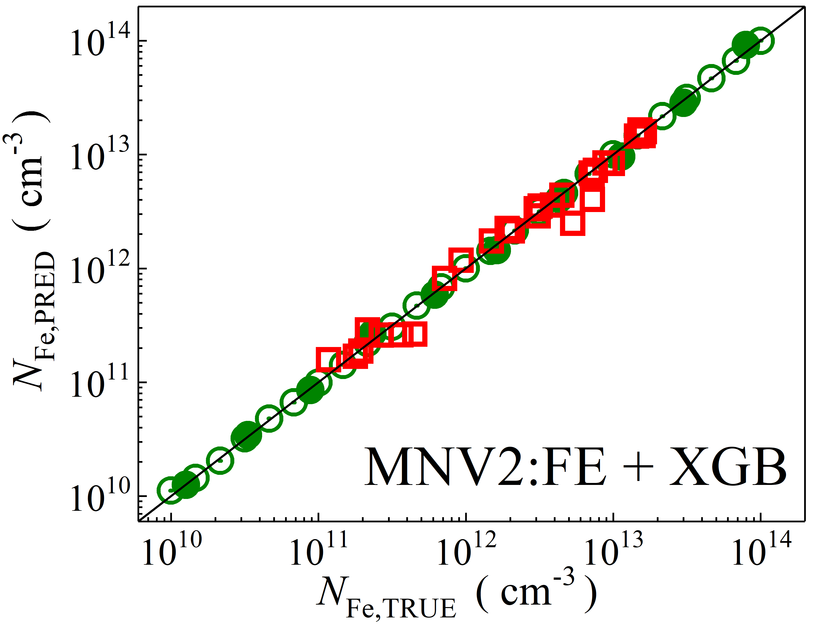

Fig. S5. Scatter plots compare reference iron concentrations $N_{Fe,TRUE}$ with ML-predicted values $N_{Fe,PRED}$ using feature vectors extracted from the feature extractor layer of MobileNetV2 visual model. The ML algorithms include DNN (green and purple), GB (dark yellow and yellow), RF (red and blue), SVR (blue and pink), and XGB (green and red). Symbols represent different datasets: open circles — training data (simulated), filled circles — test data (simulated), and open squares — test data from experimental measurements. The black lines are the identified lines serving as the references.

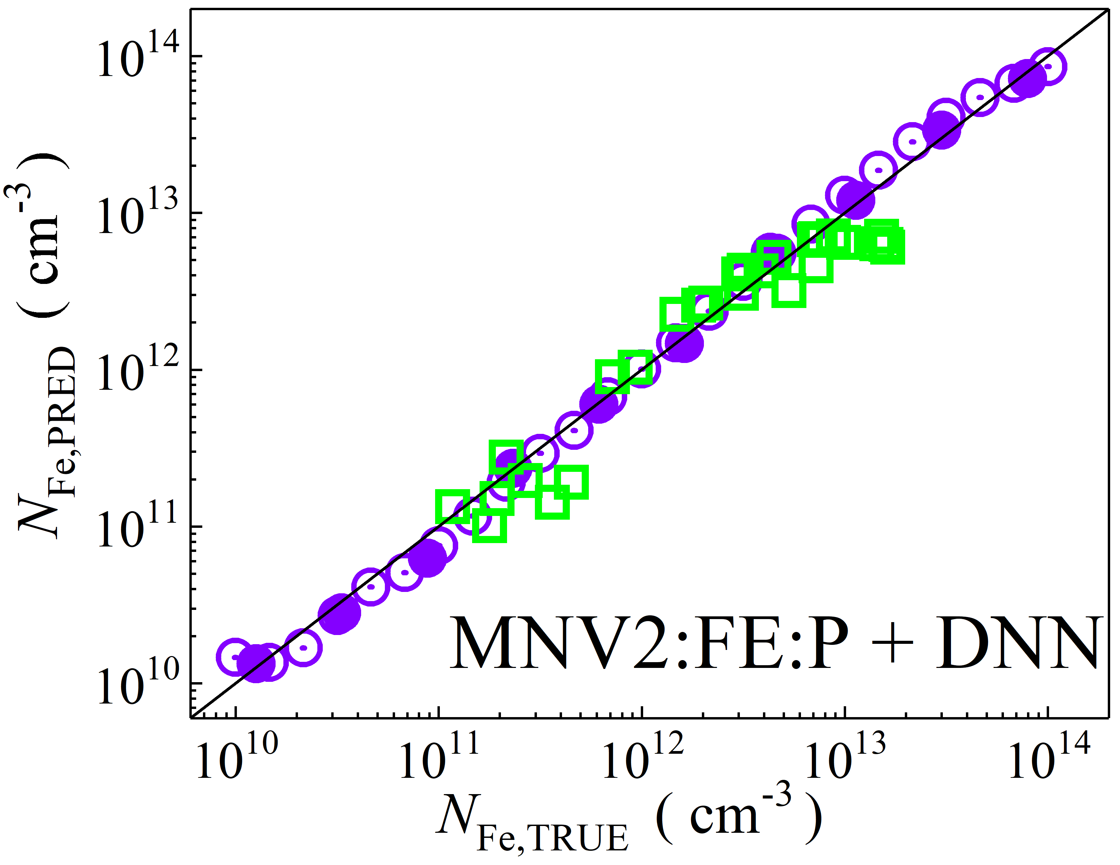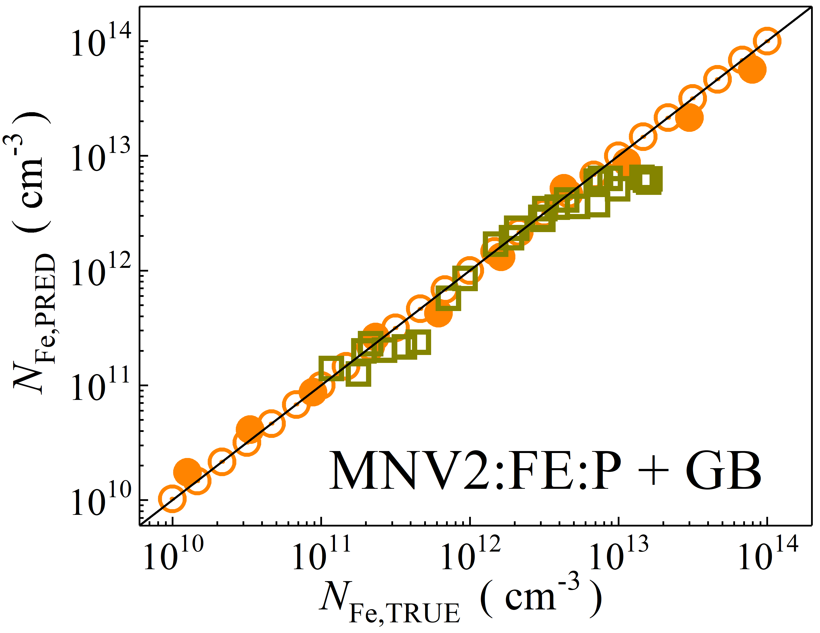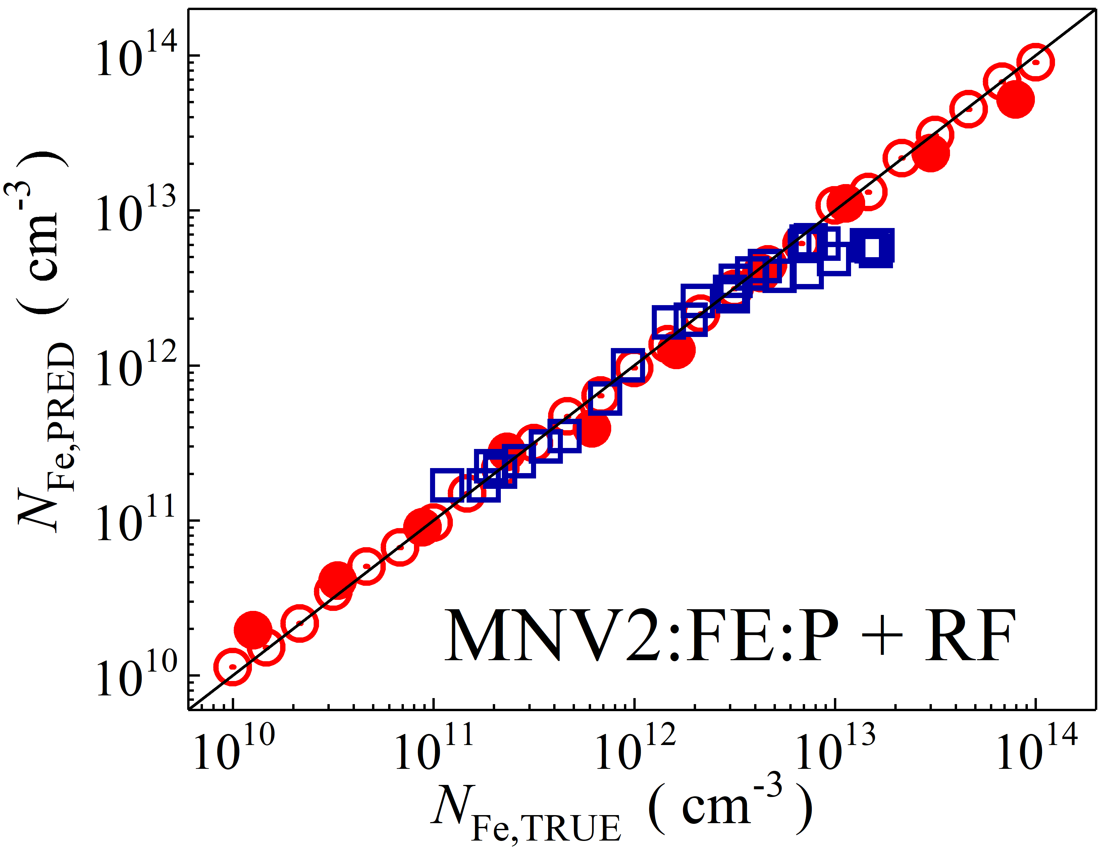

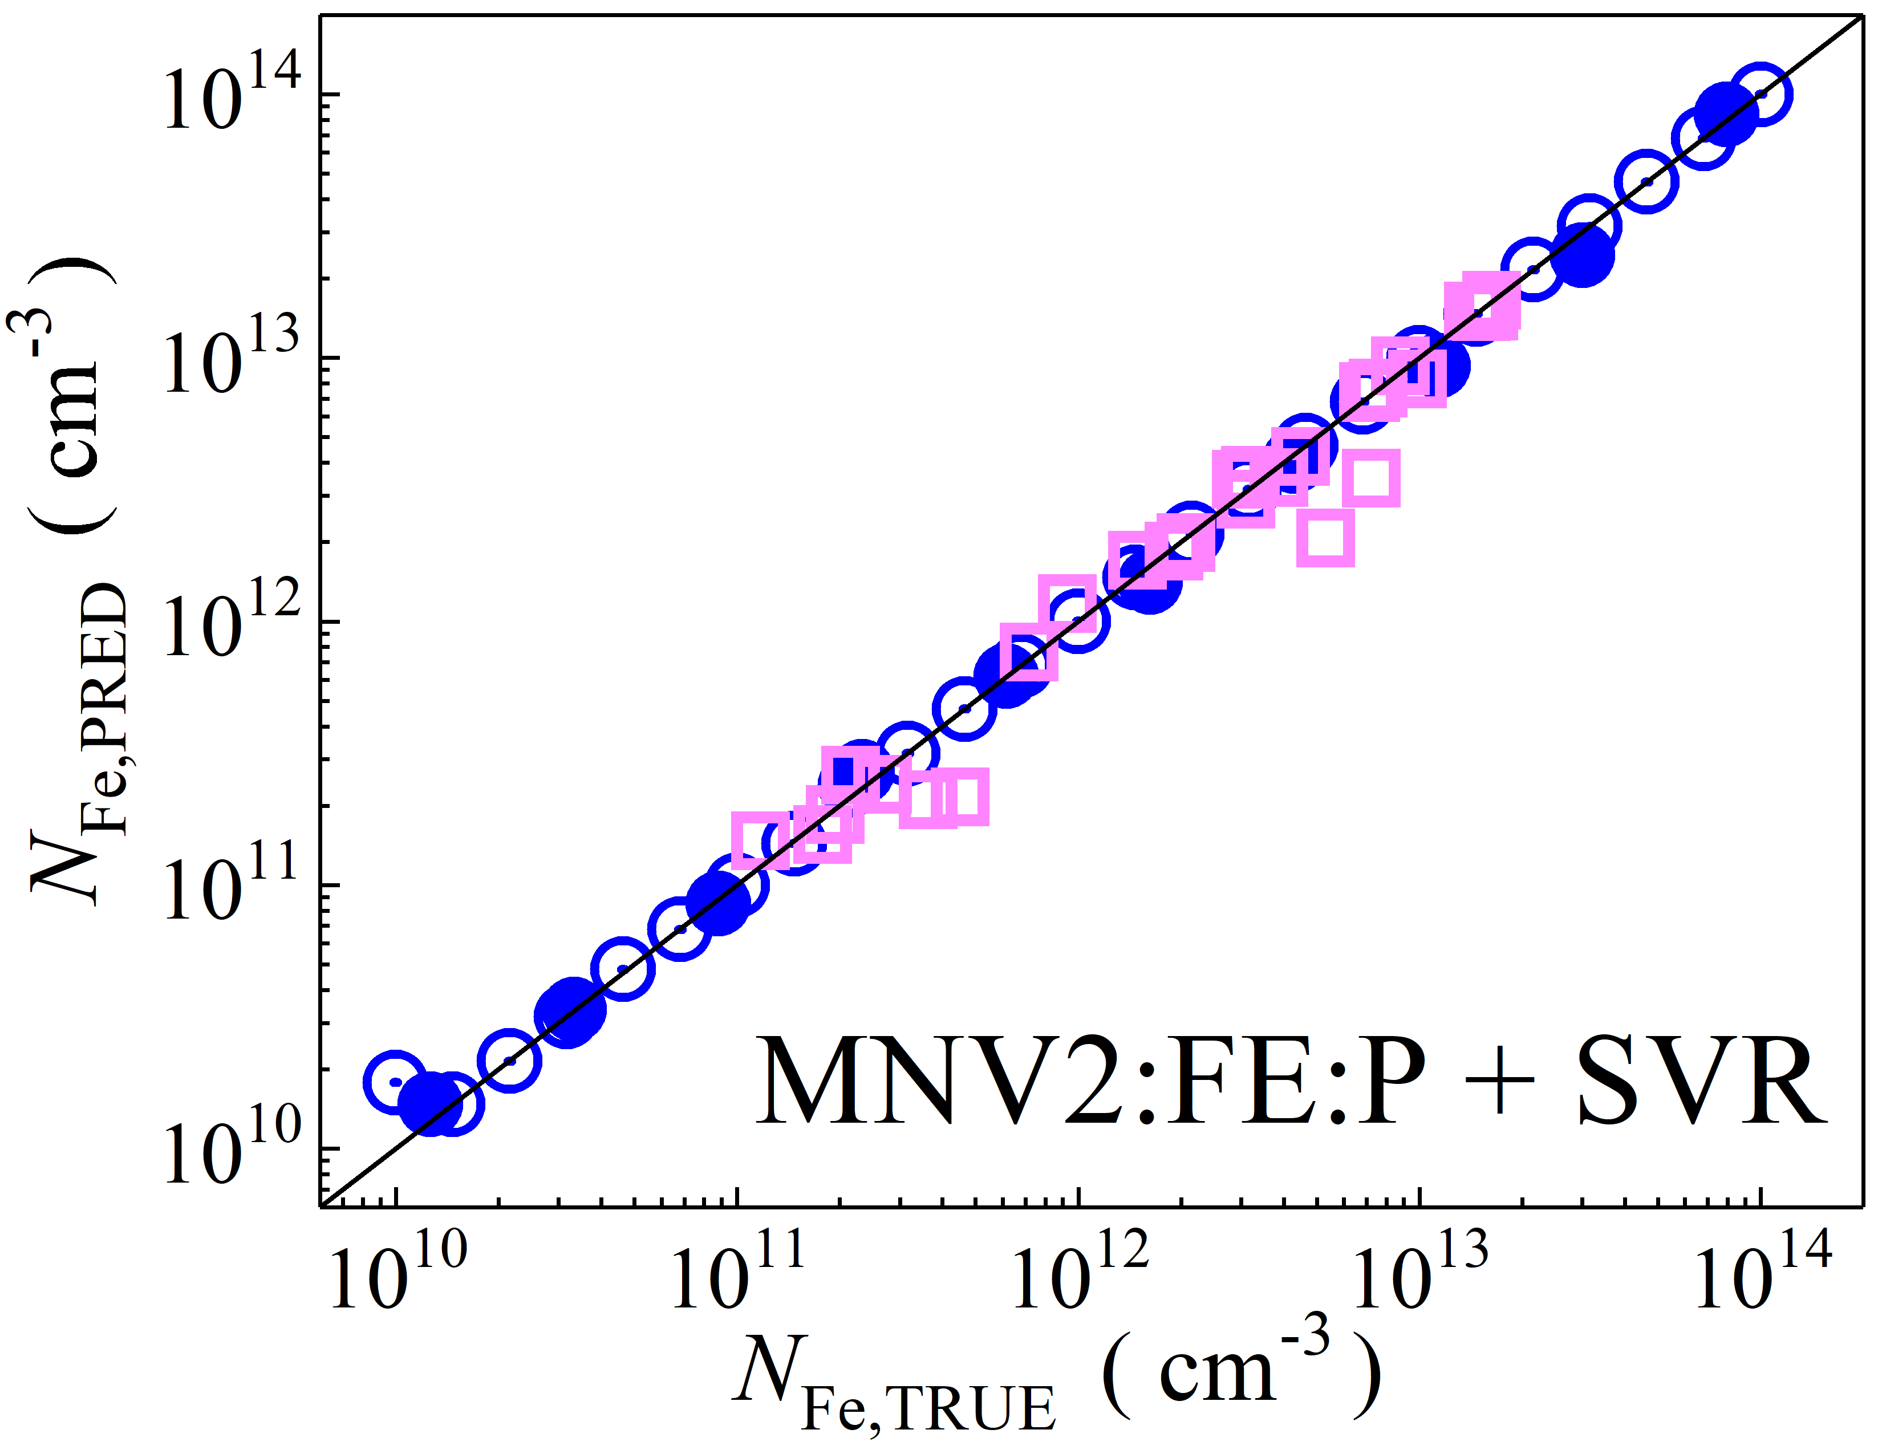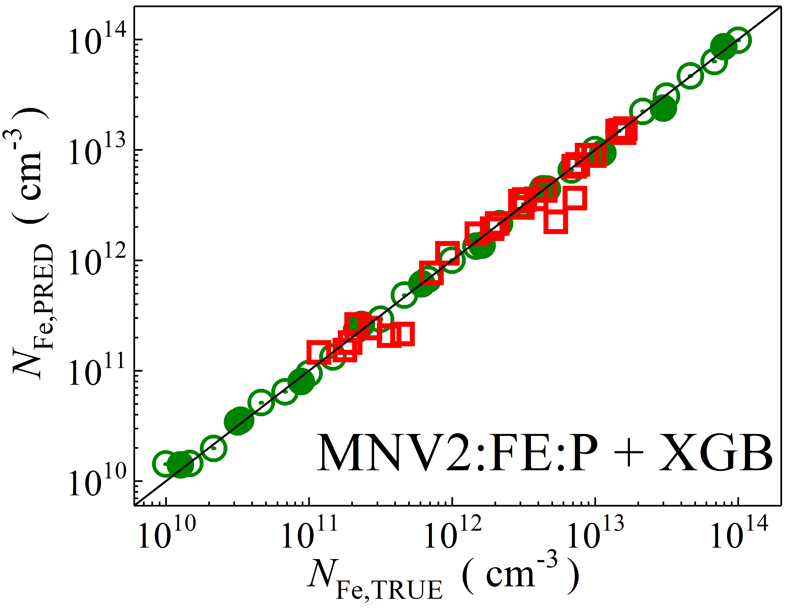

Fig. S6. Scatter plots compare reference iron concentrations $N_{Fe,TRUE}$ with ML-predicted values $N_{Fe,PRED}$ using feature vectors extracted from the feature extractor layer with PCA reduction of MobileNetV2 visual model. The ML algorithms include DNN (green and purple), GB (dark yellow and yellow), RF (red and blue), SVR (blue and pink), and XGB (green and red). Symbols represent different datasets: open circles — training data (simulated), filled circles — test data (simulated), and open squares — test data from experimental measurements. The black lines are the identified lines serving as the references.

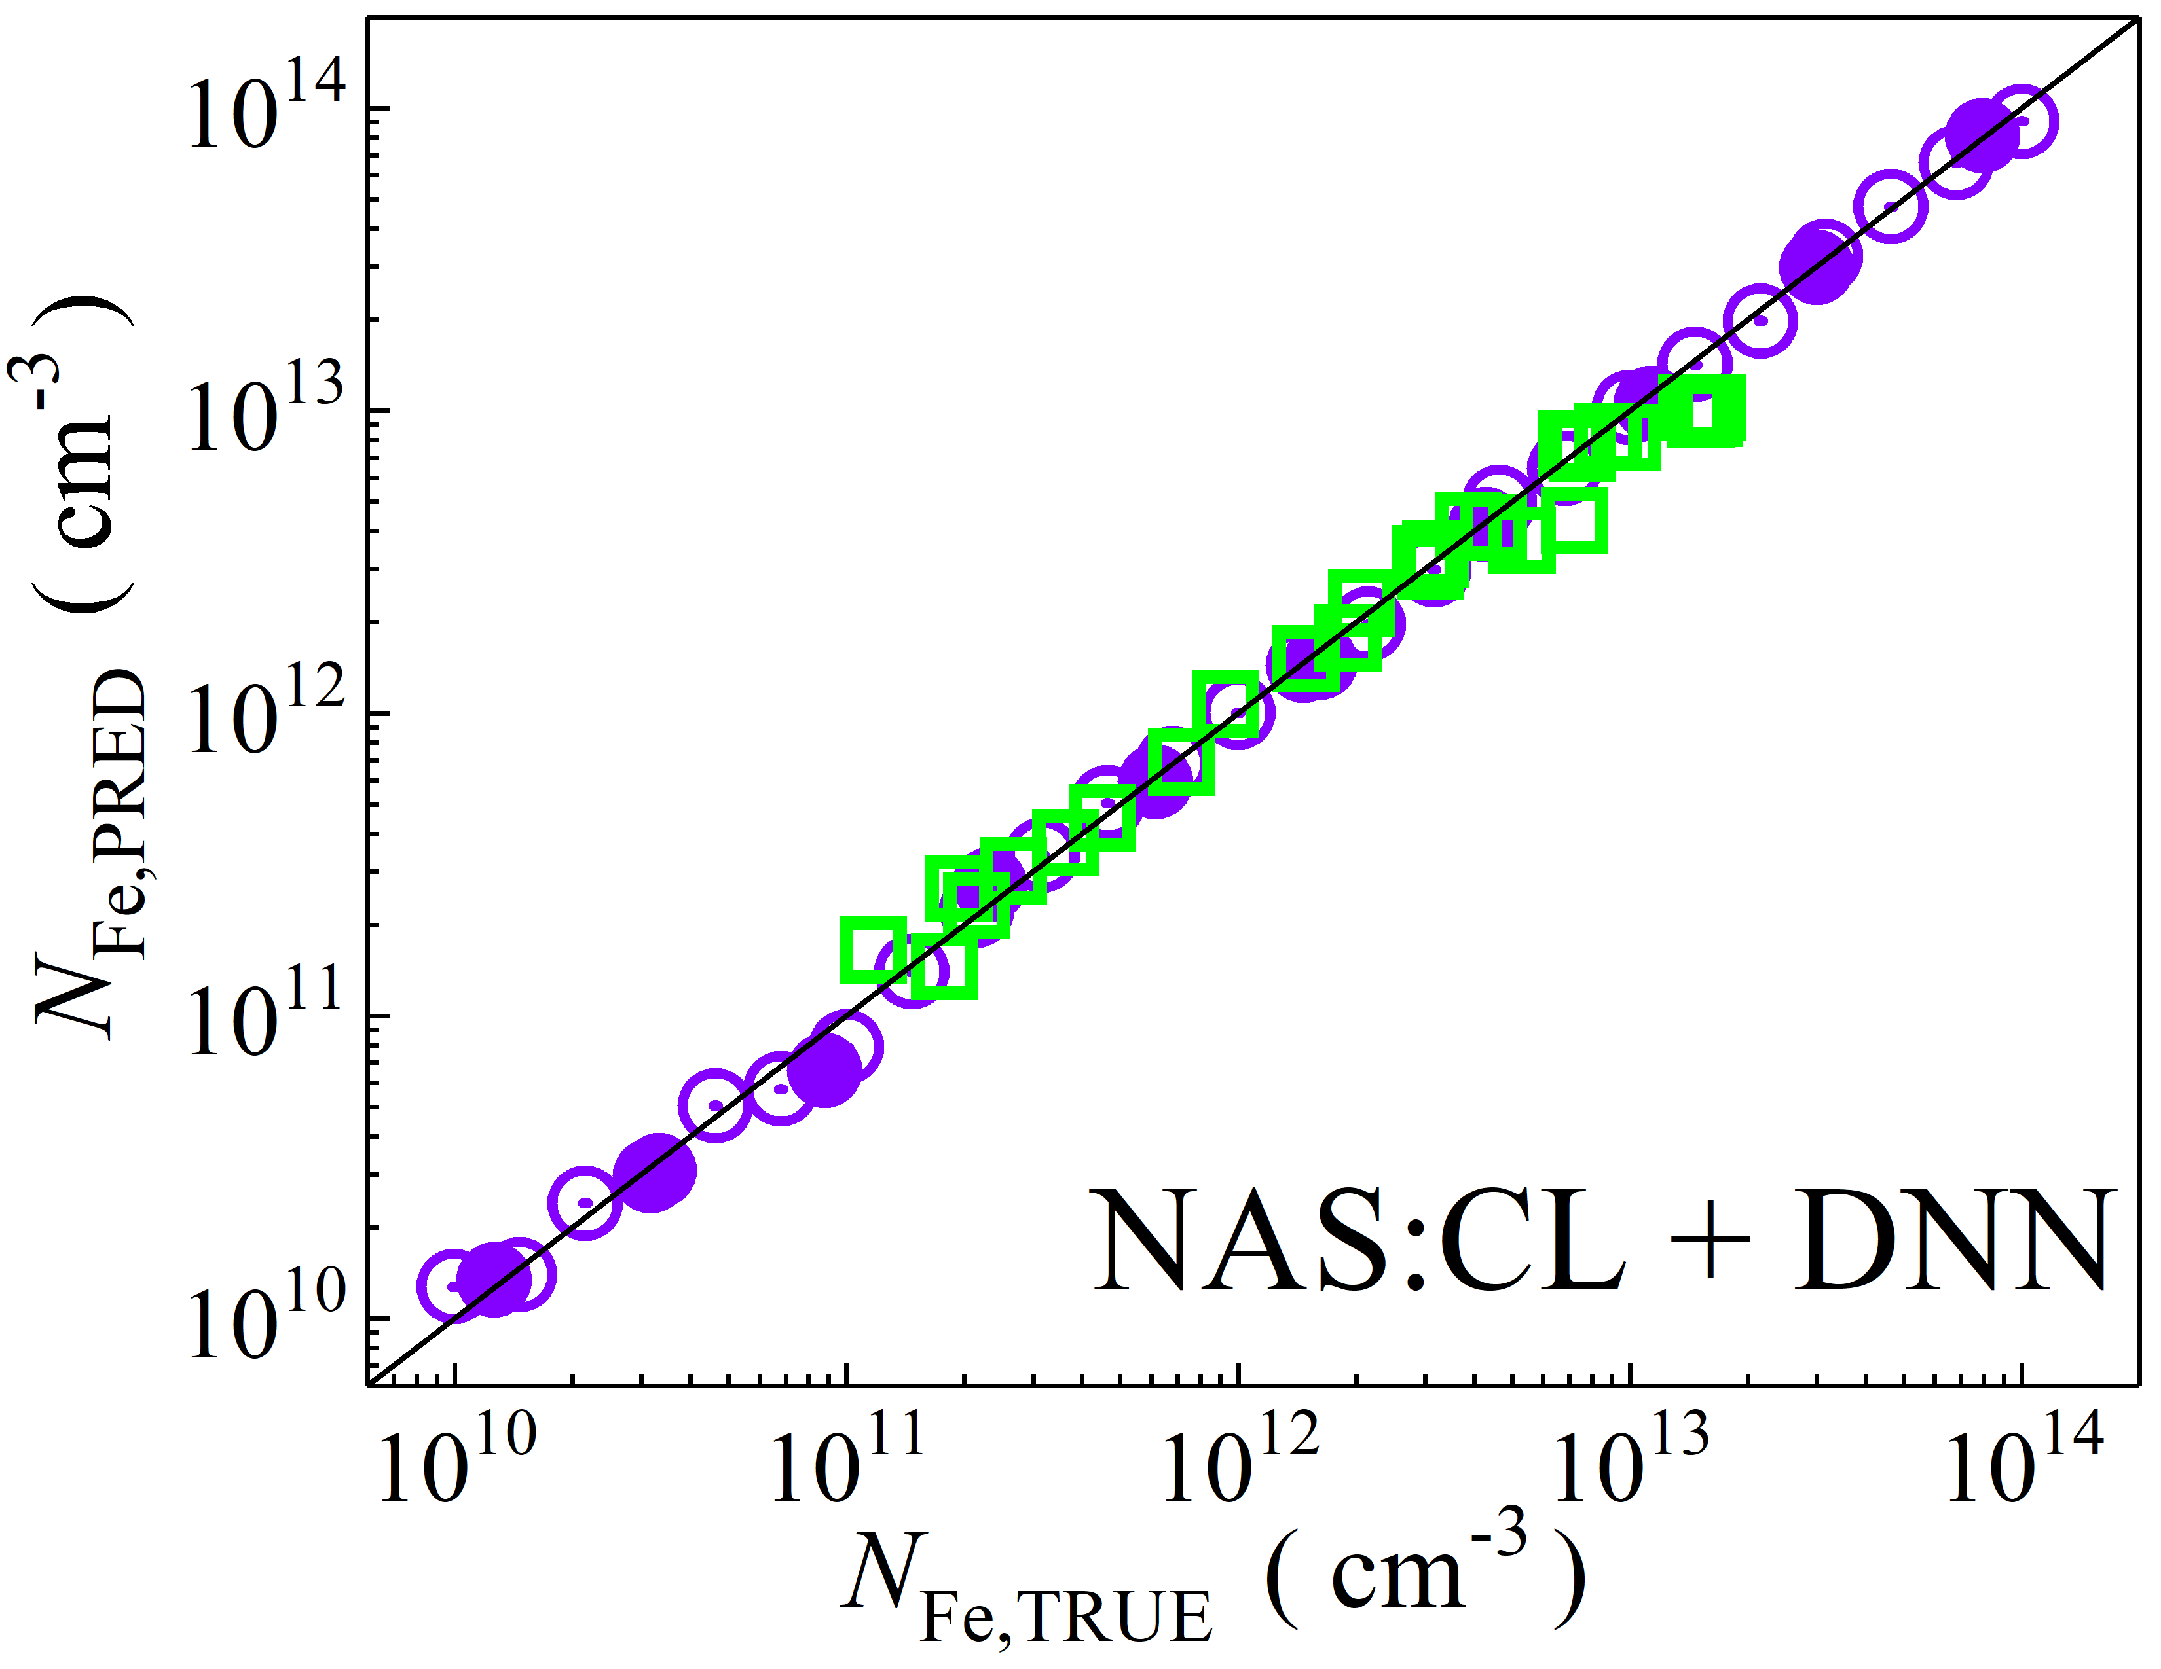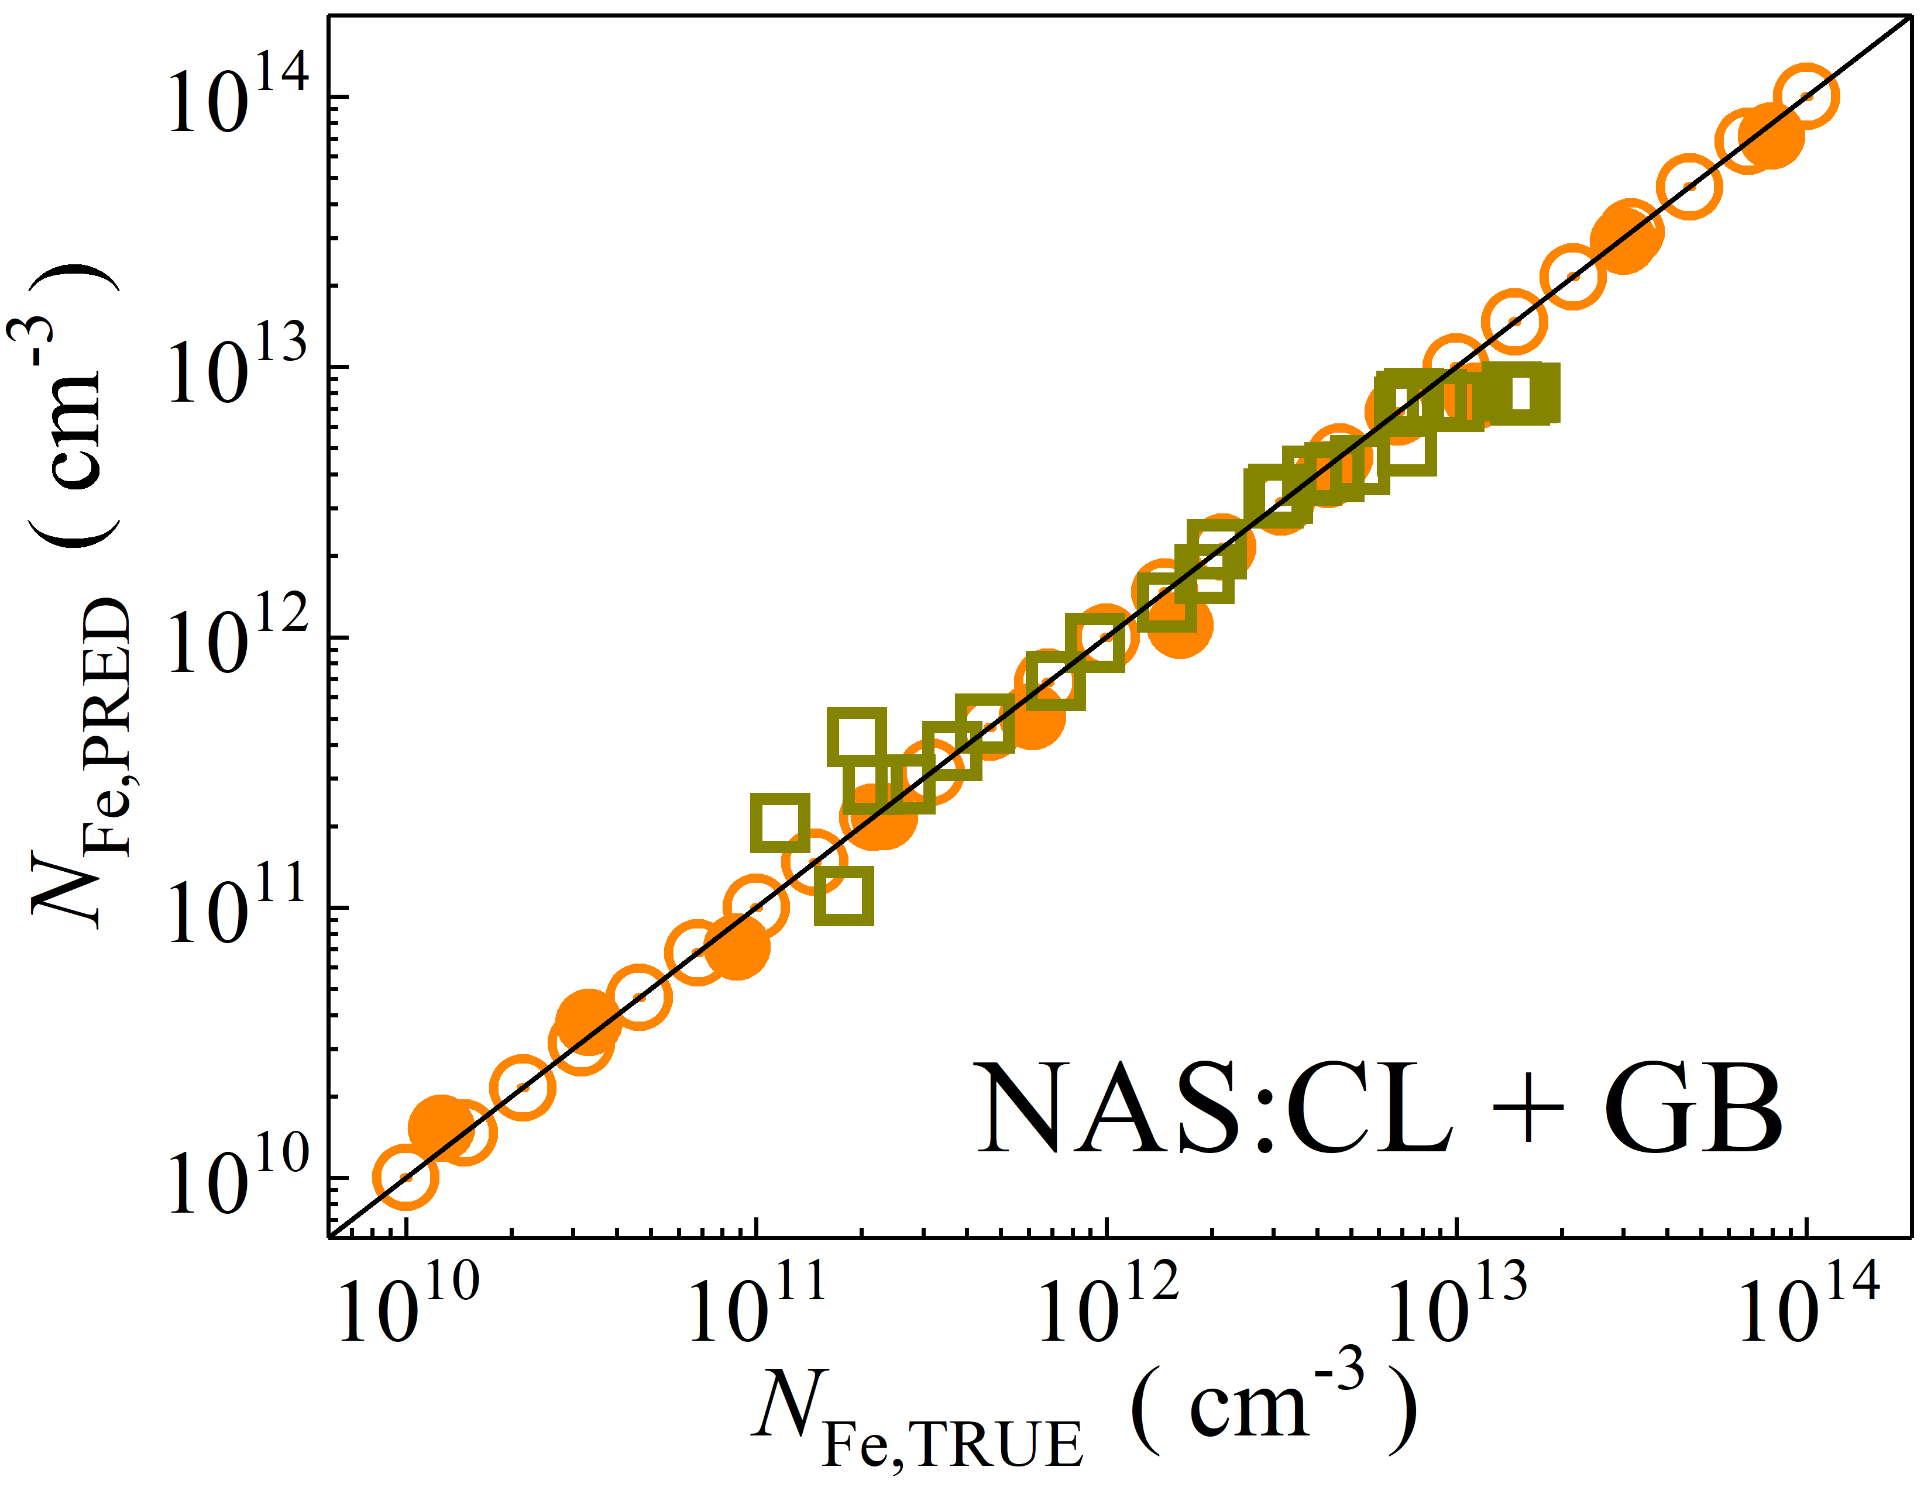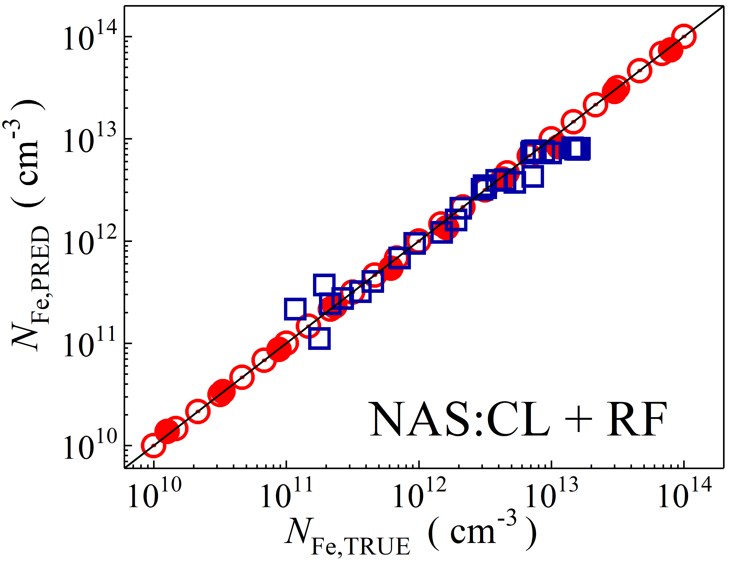

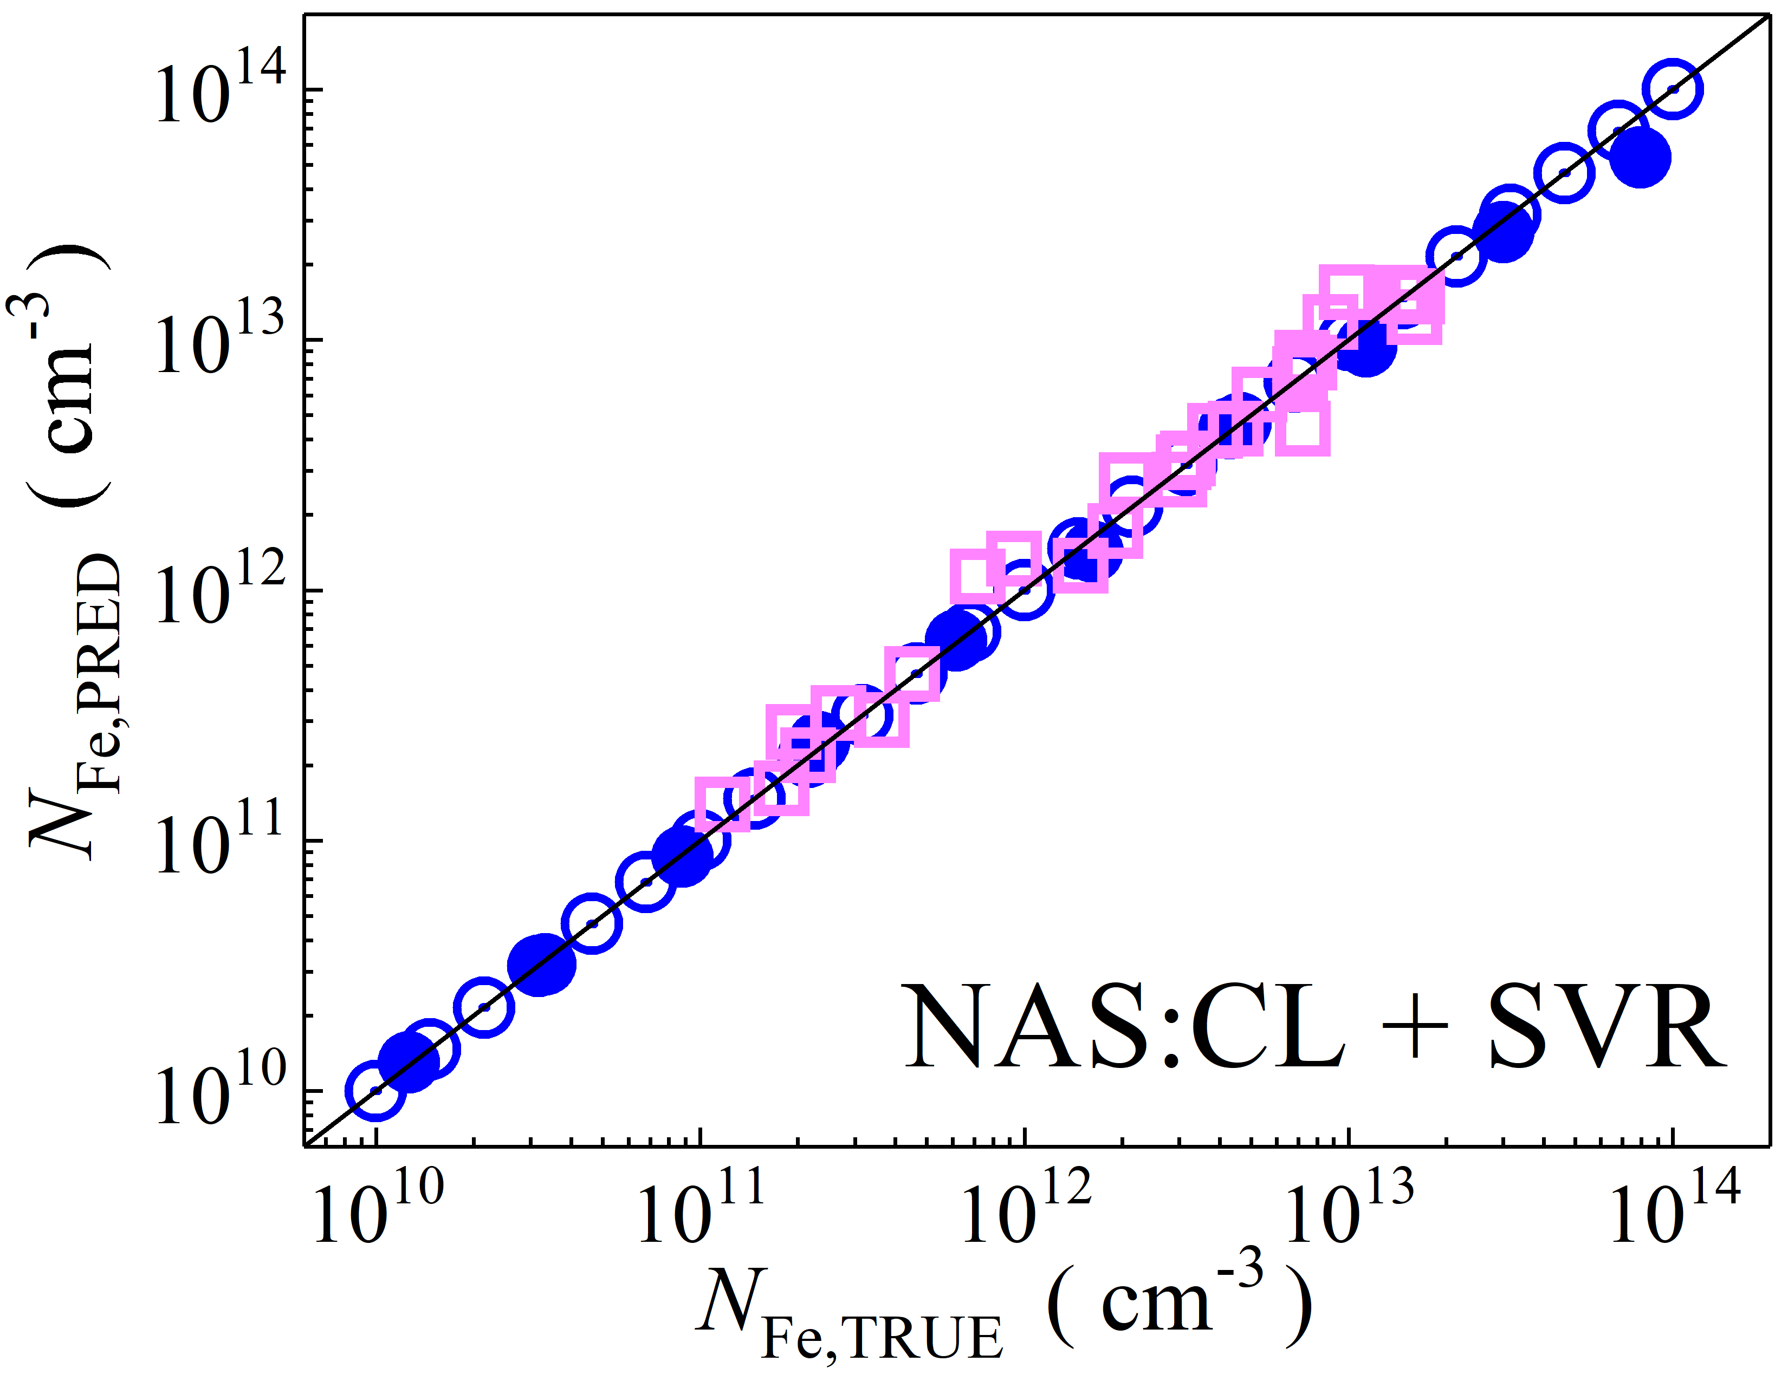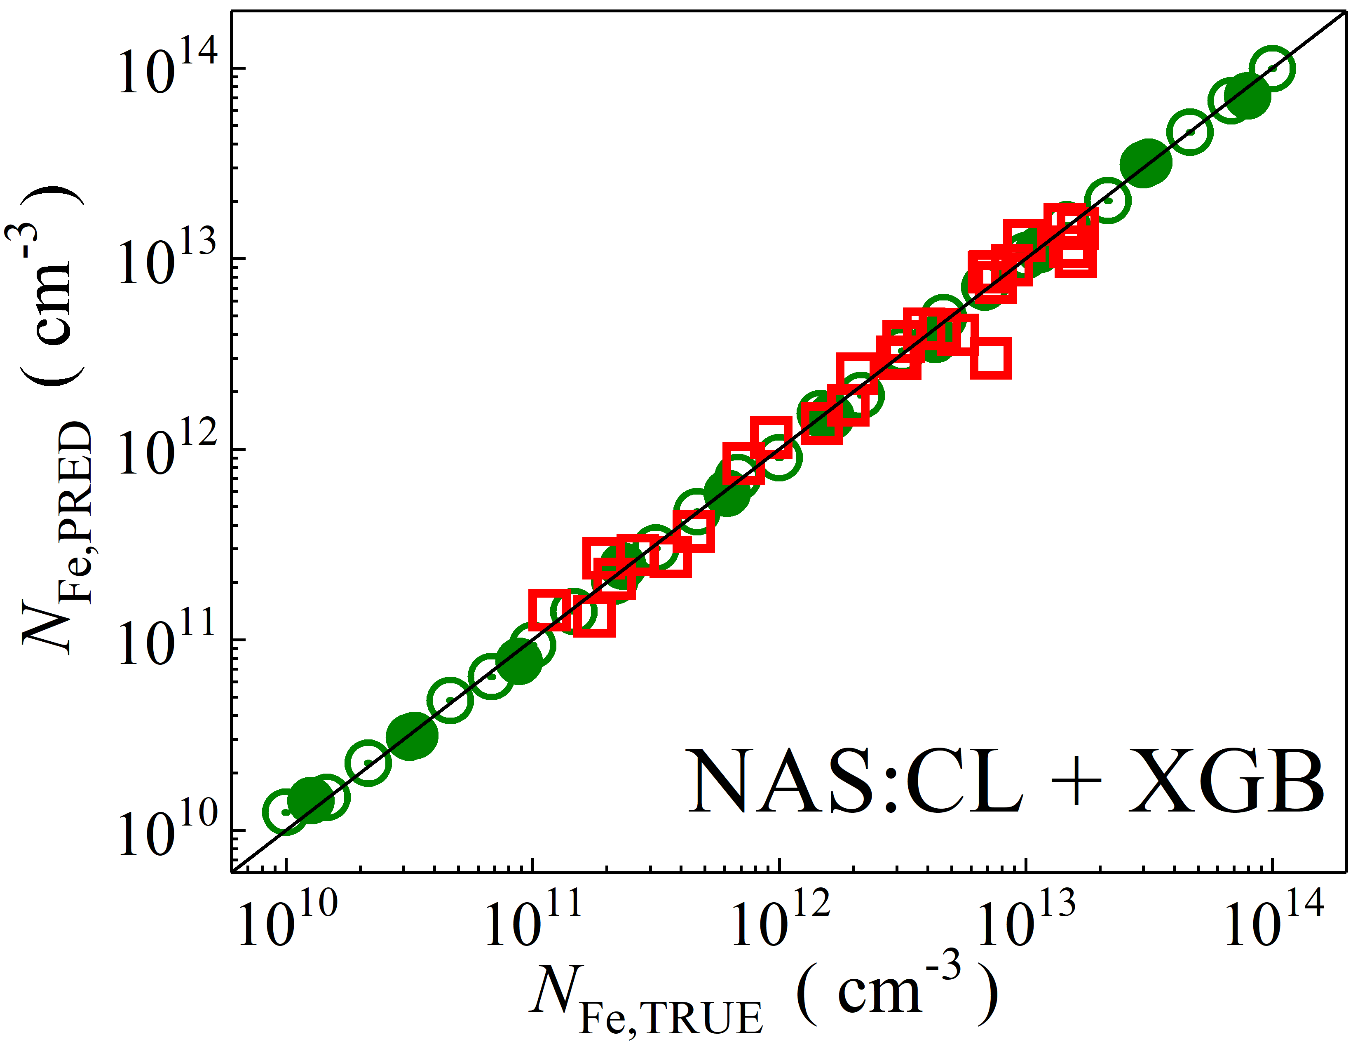

Fig. S7. Scatter plots compare reference iron concentrations $N_{Fe,TRUE}$ with ML-predicted values $N_{Fe,PRED}$ using feature vectors extracted from the classifier layer of NASNetLarge visual model. The ML algorithms include DNN (green and purple), GB (dark yellow and yellow), RF (red and blue), SVR (blue and pink), and XGB (green and red). Symbols represent different datasets: open circles — training data (simulated), filled circles — test data (simulated), and open squares — test data from experimental measurements. The black lines are the identified lines serving as the references.

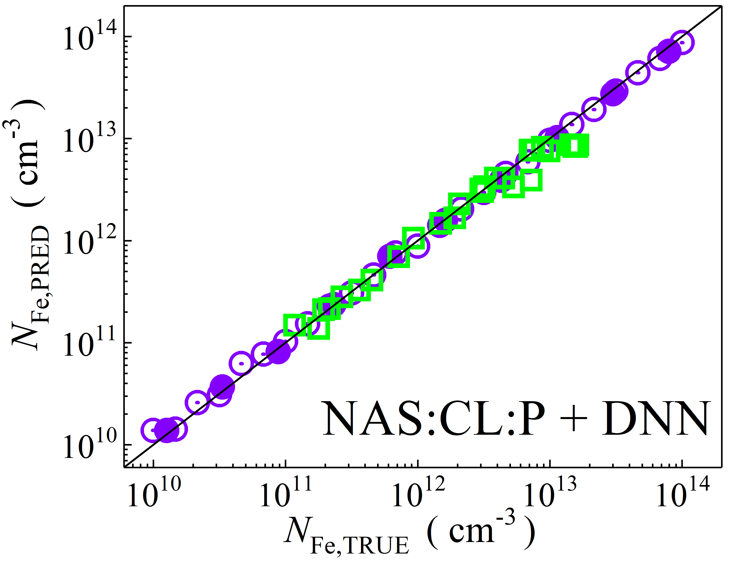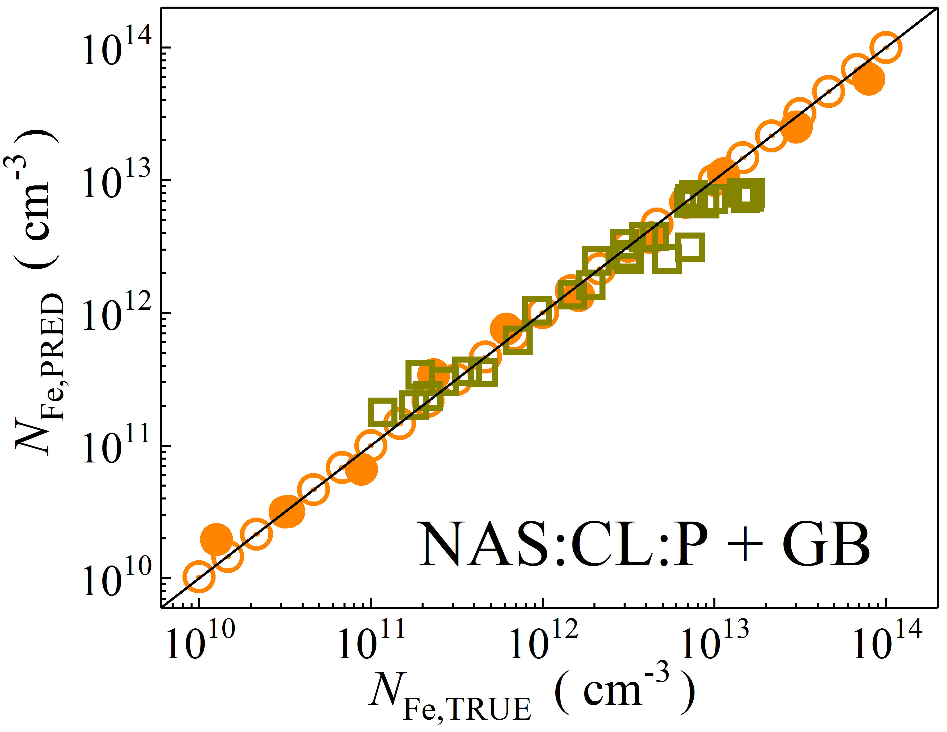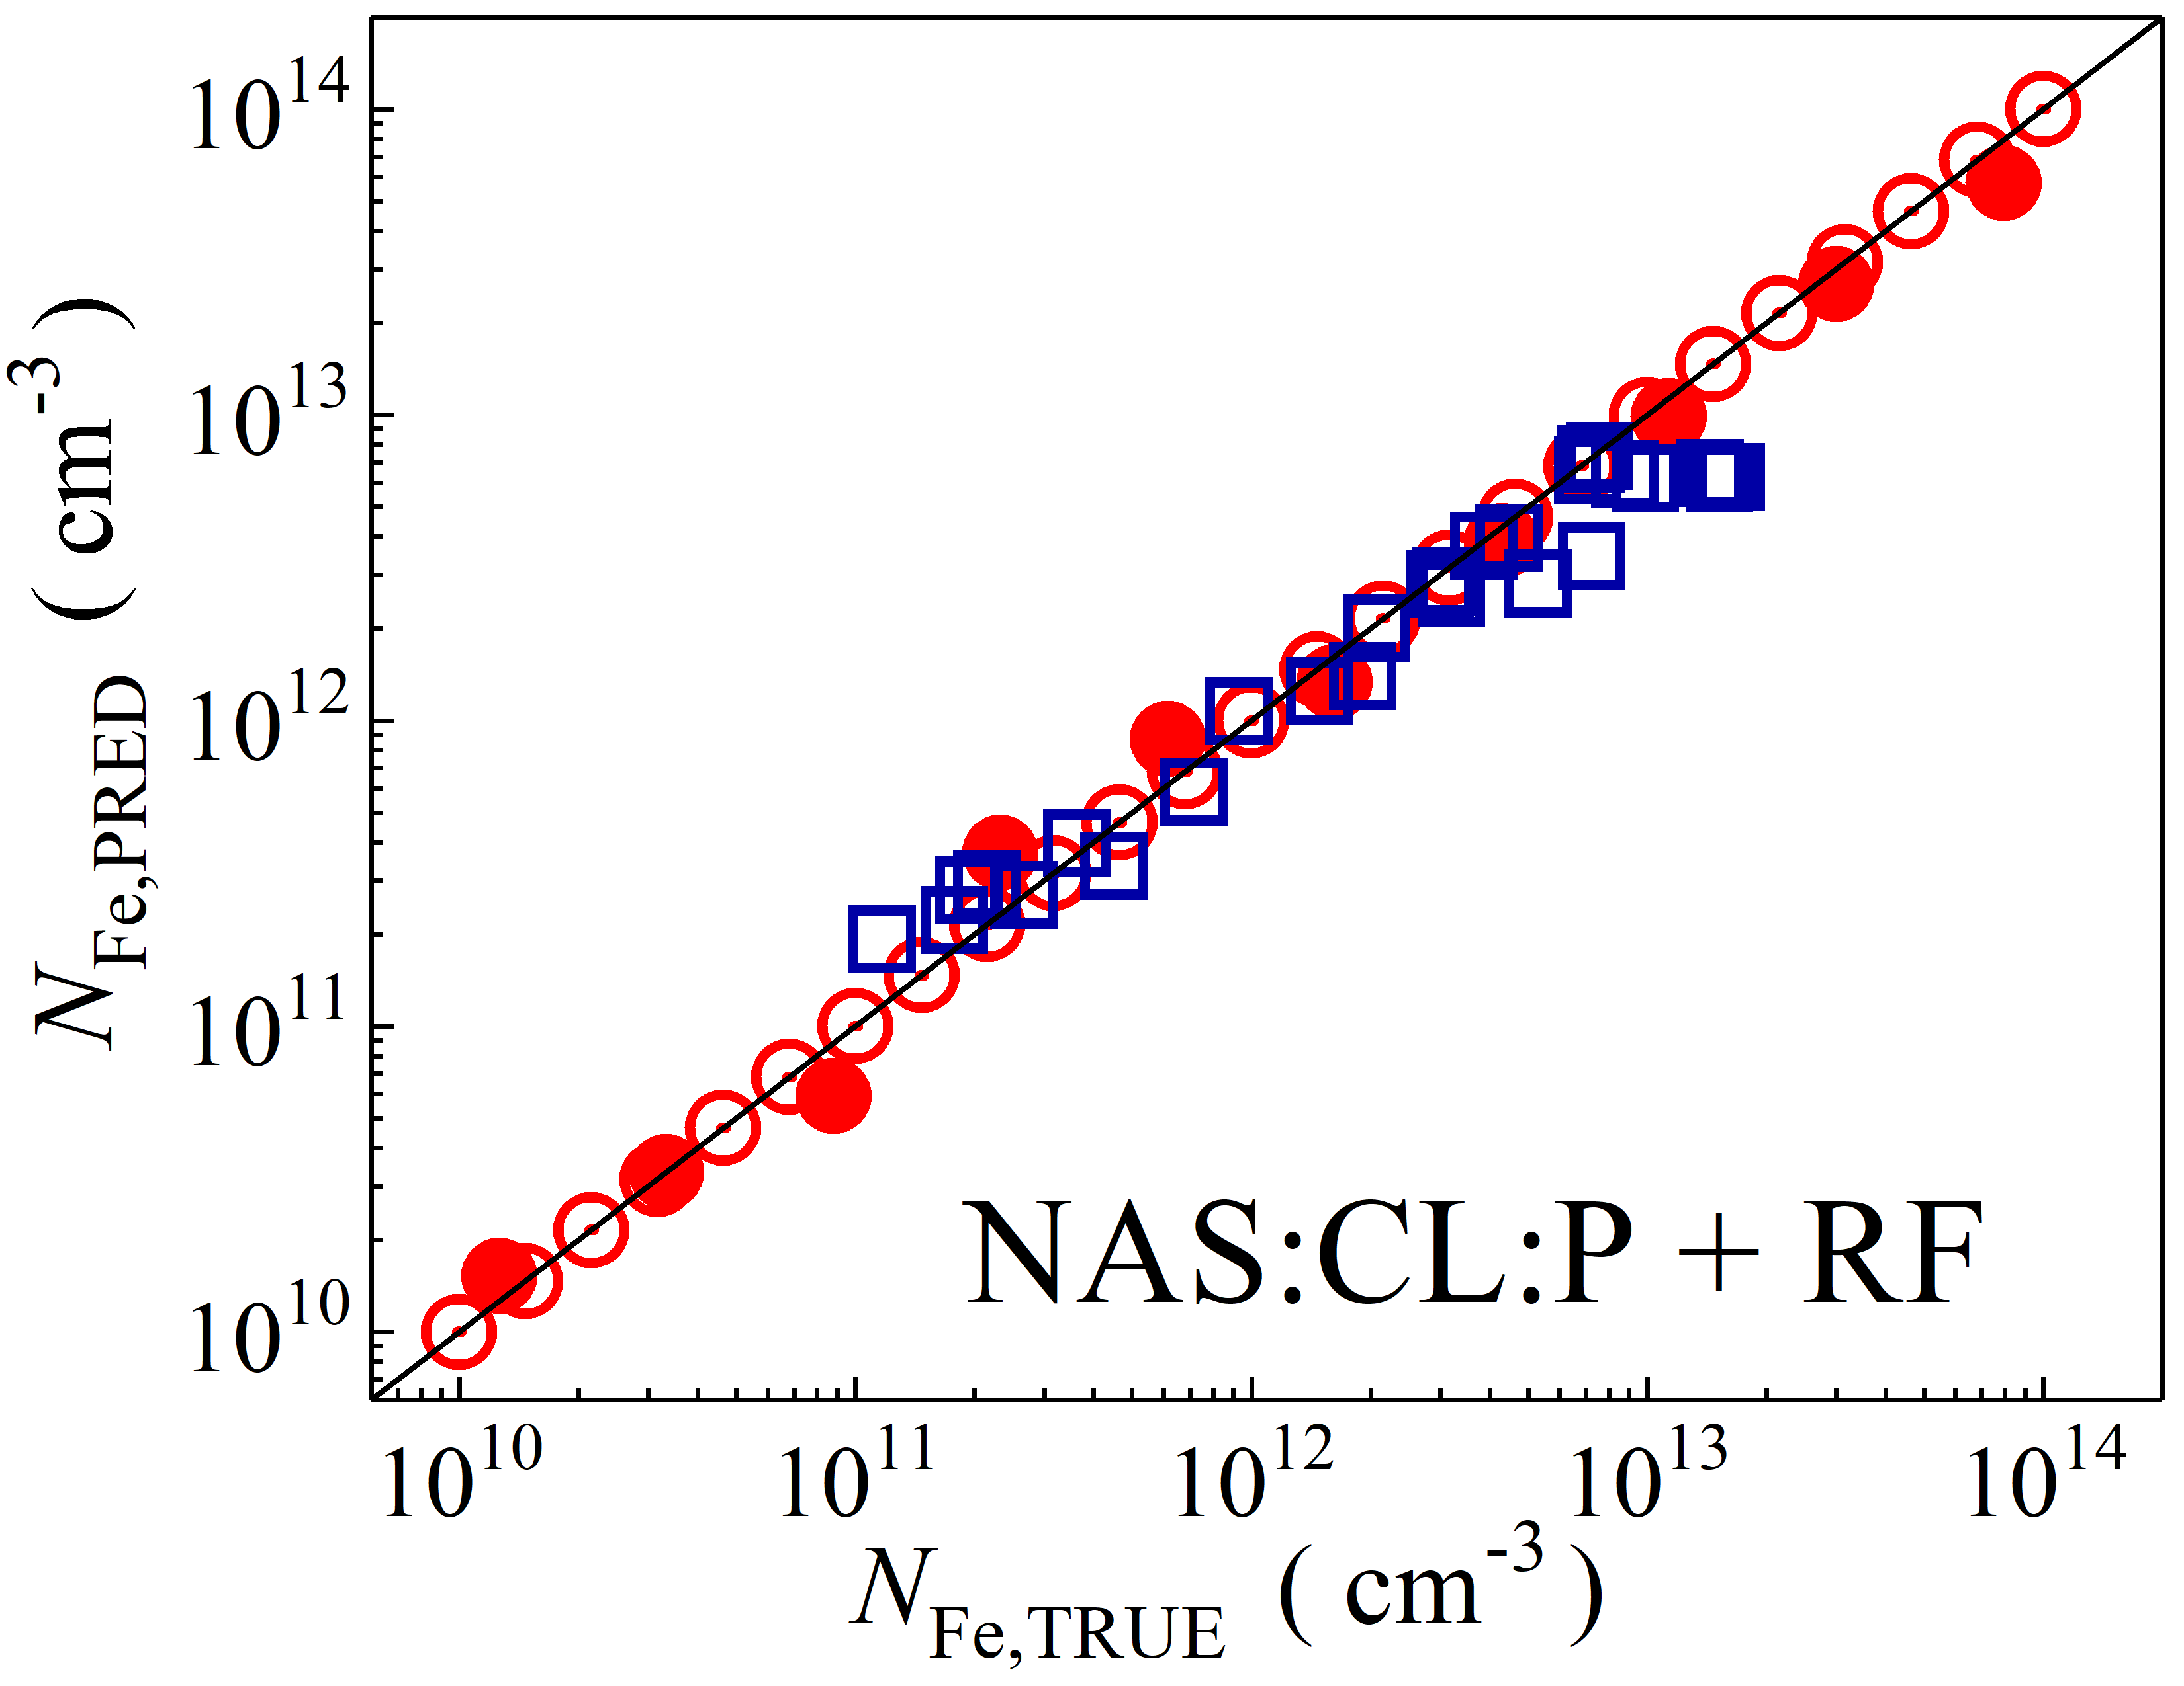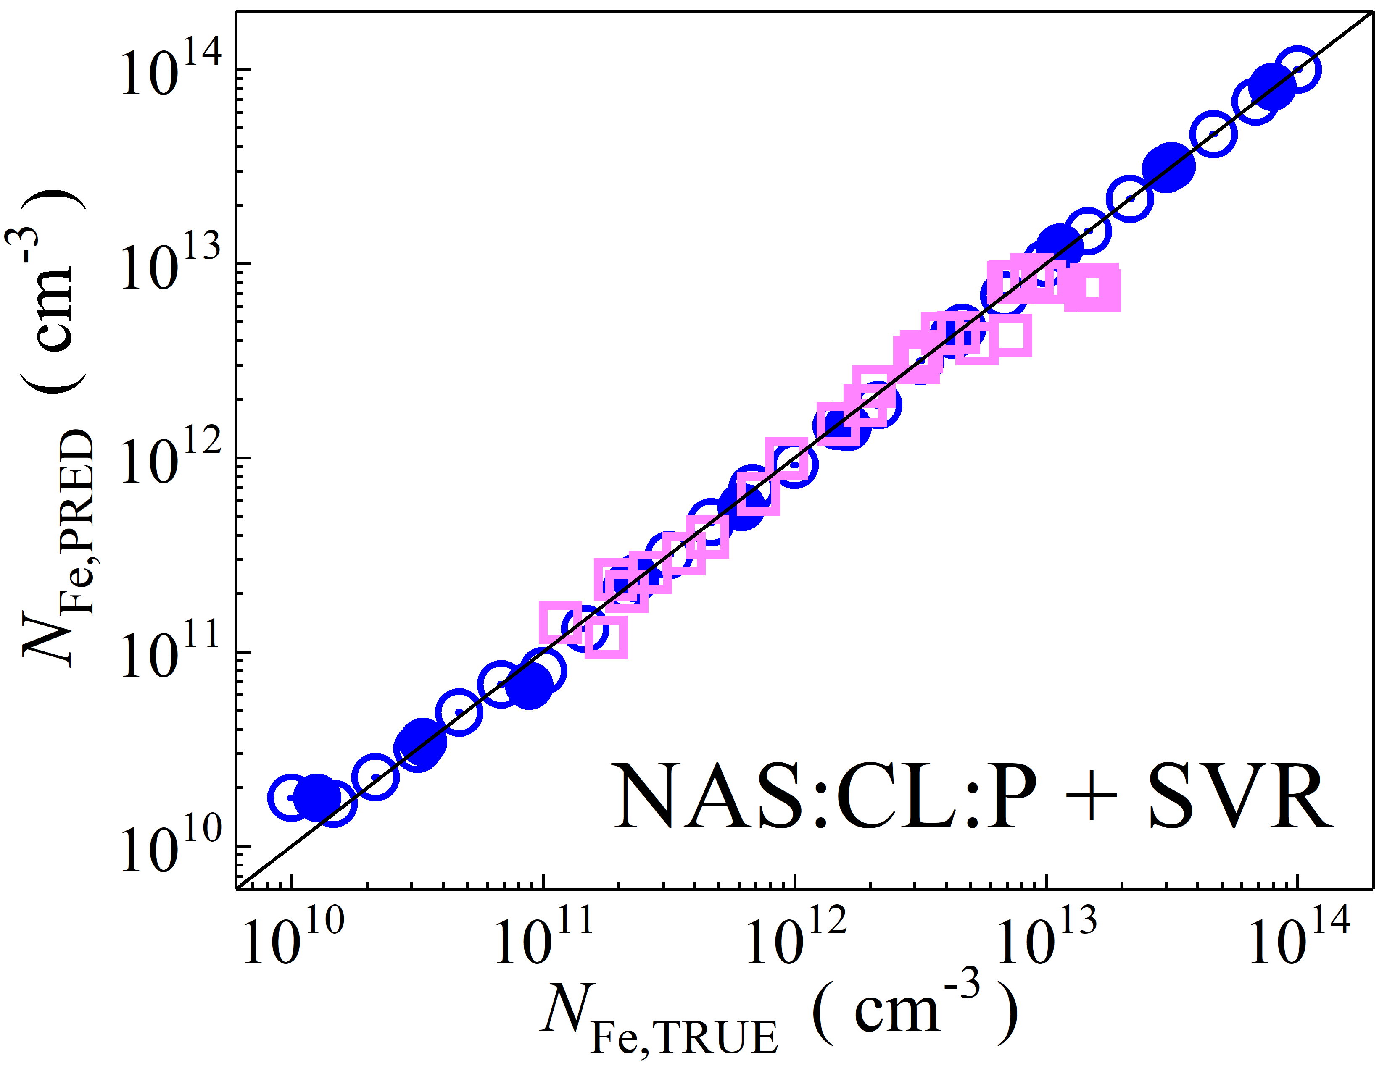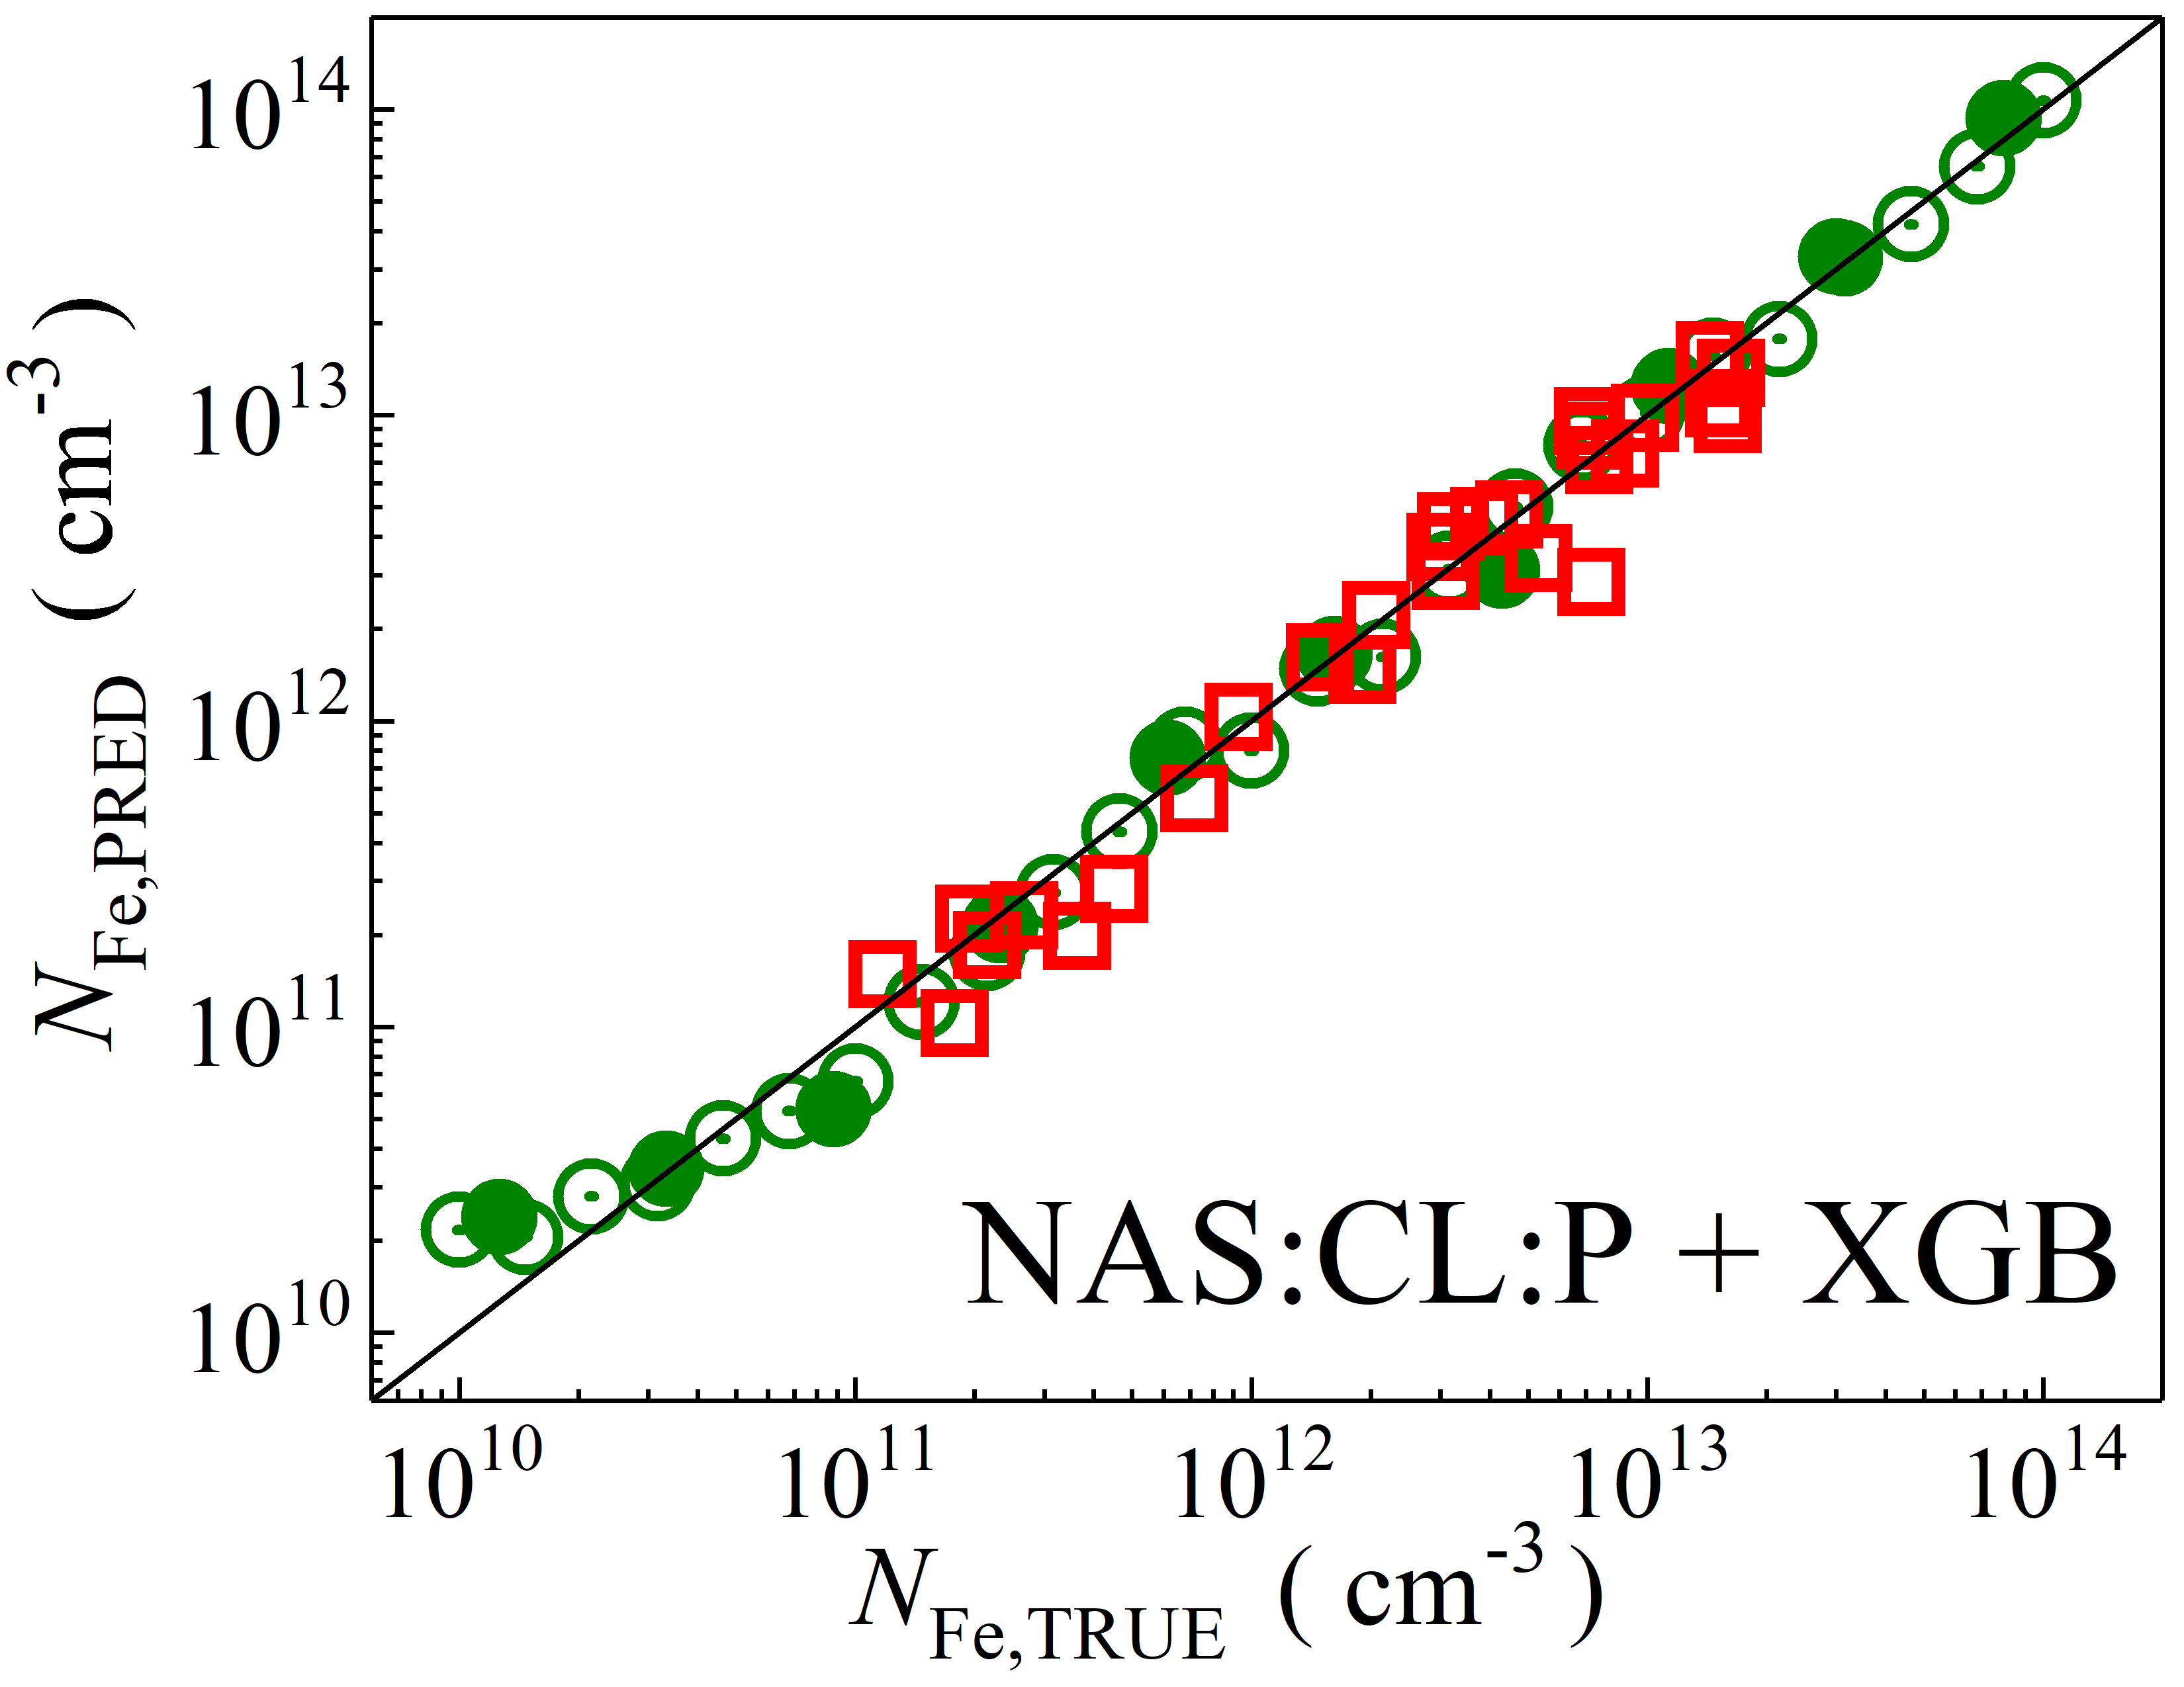

Fig. S8. Scatter plots compare reference iron concentrations $N_{Fe,TRUE}$ with ML-predicted values $N_{Fe,PRED}$ using feature vectors extracted from the classifier layer with PCA reduction of NASNetLarge visual model. The ML algorithms include DNN (green and purple), GB (dark yellow and yellow), RF (red and blue), SVR (blue and pink), and XGB (green and red). Symbols represent different datasets: open circles — training data (simulated), filled circles — test data (simulated), and open squares — test data from experimental measurements. The black lines are the identified lines serving as the references.

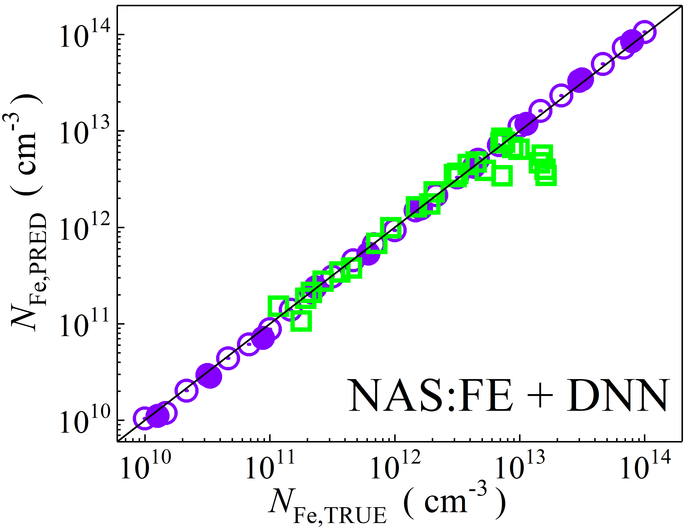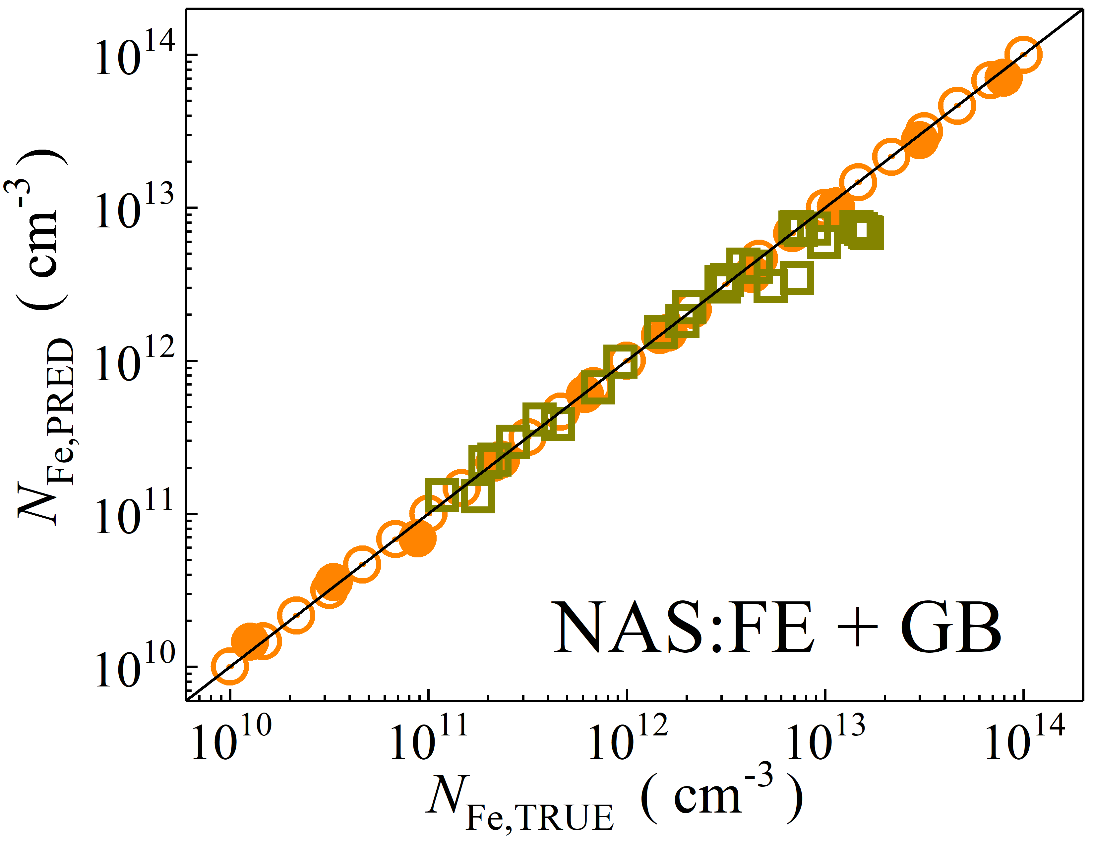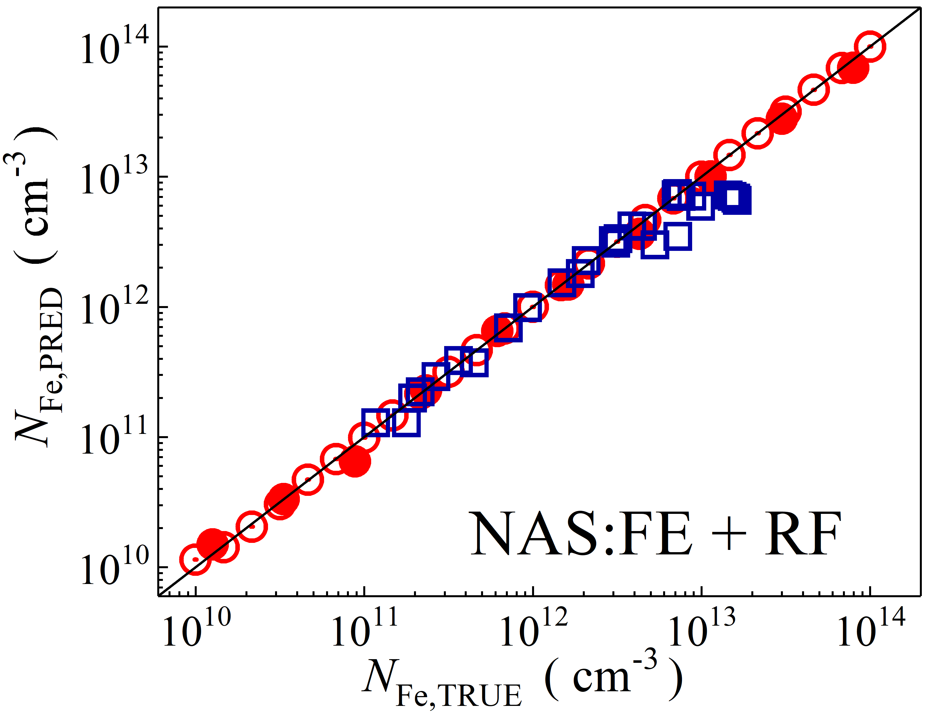

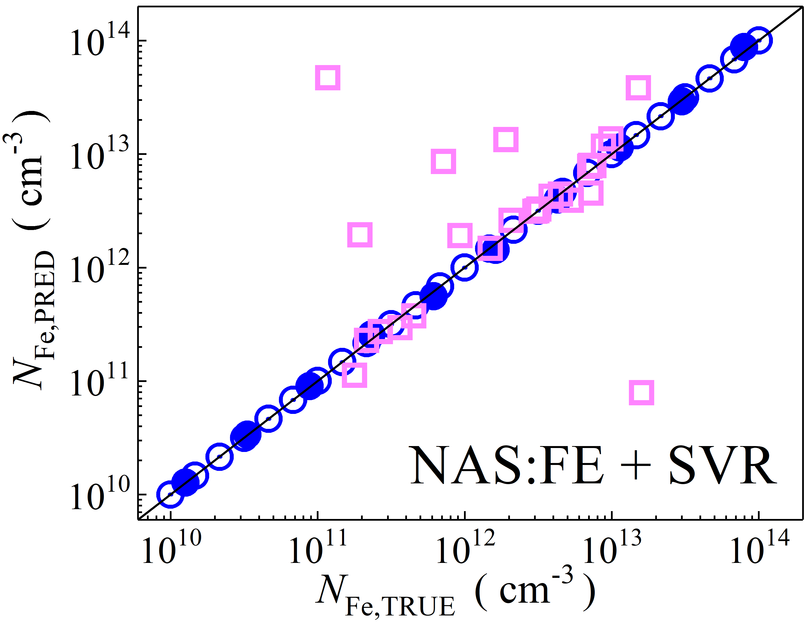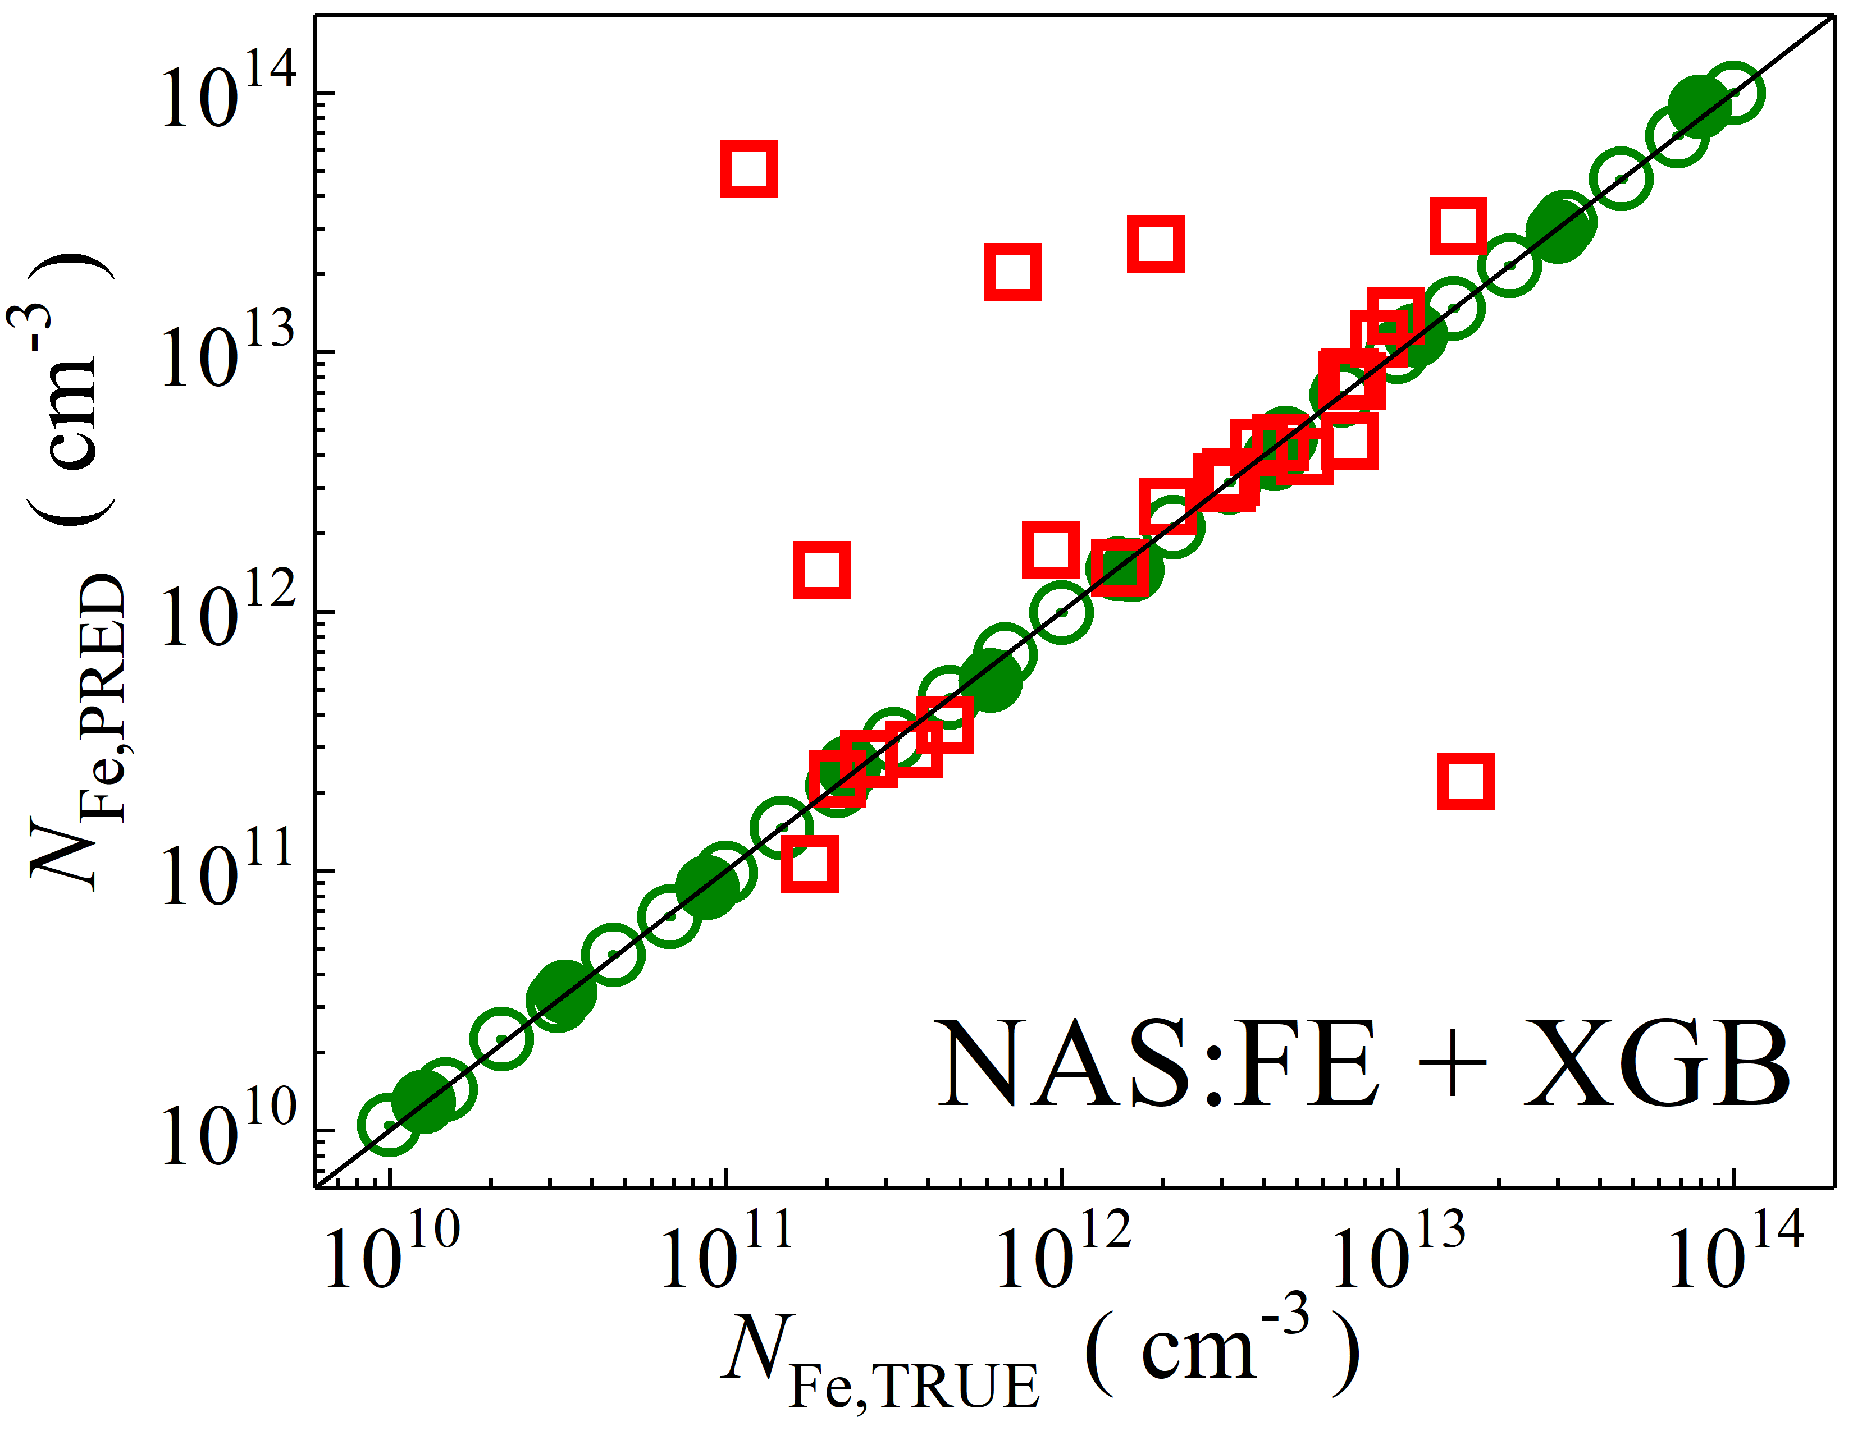

Fig. S9. Scatter plots compare reference iron concentrations $N_{Fe,TRUE}$ with ML-predicted values $N_{Fe,PRED}$ using feature vectors extracted from the feature extractor layer of NASNetLarge visual model. The ML algorithms include DNN (green and purple), GB (dark yellow and yellow), RF (red and blue), SVR (blue and pink), and XGB (green and red). Symbols represent different datasets: open circles — training data (simulated), filled circles — test data (simulated), and open squares — test data from experimental measurements. The black lines are the identified lines serving as the references.

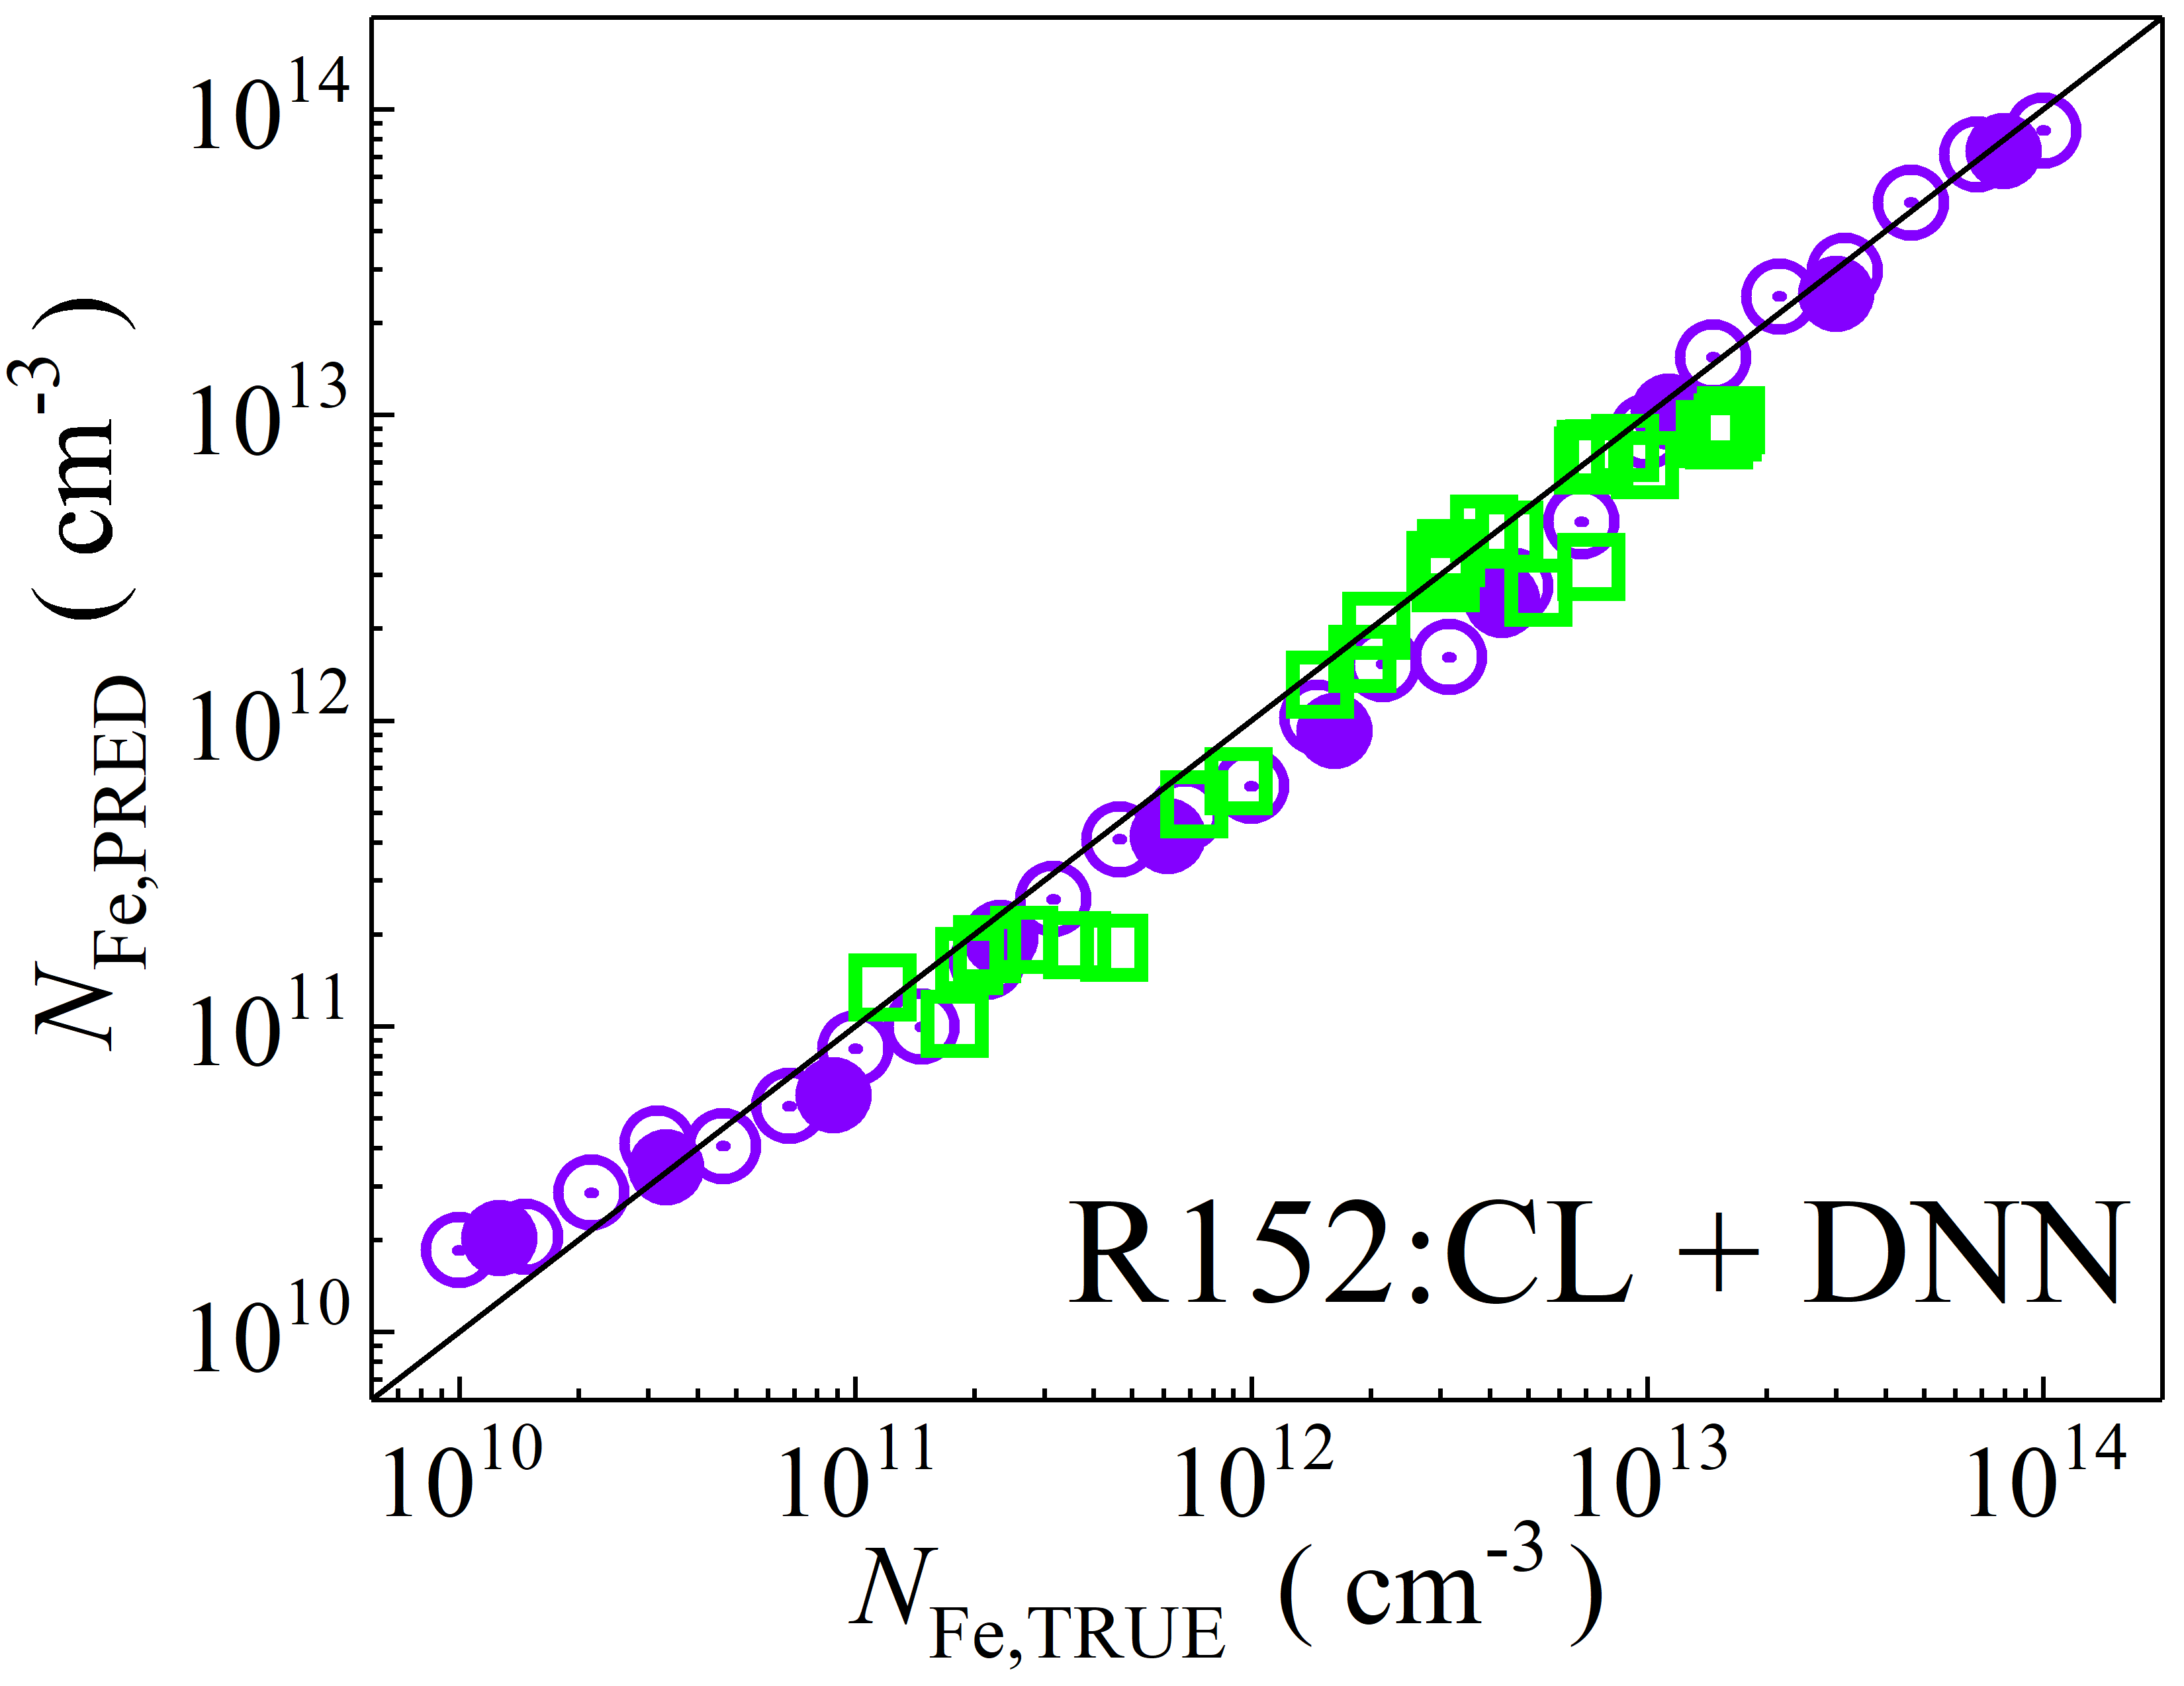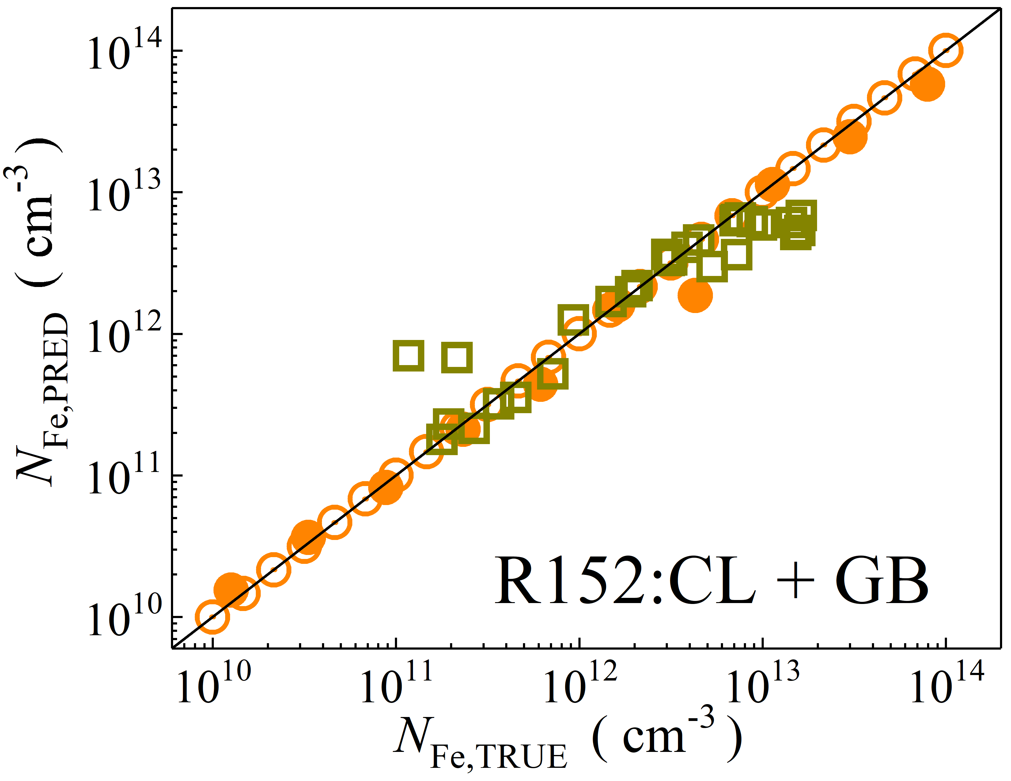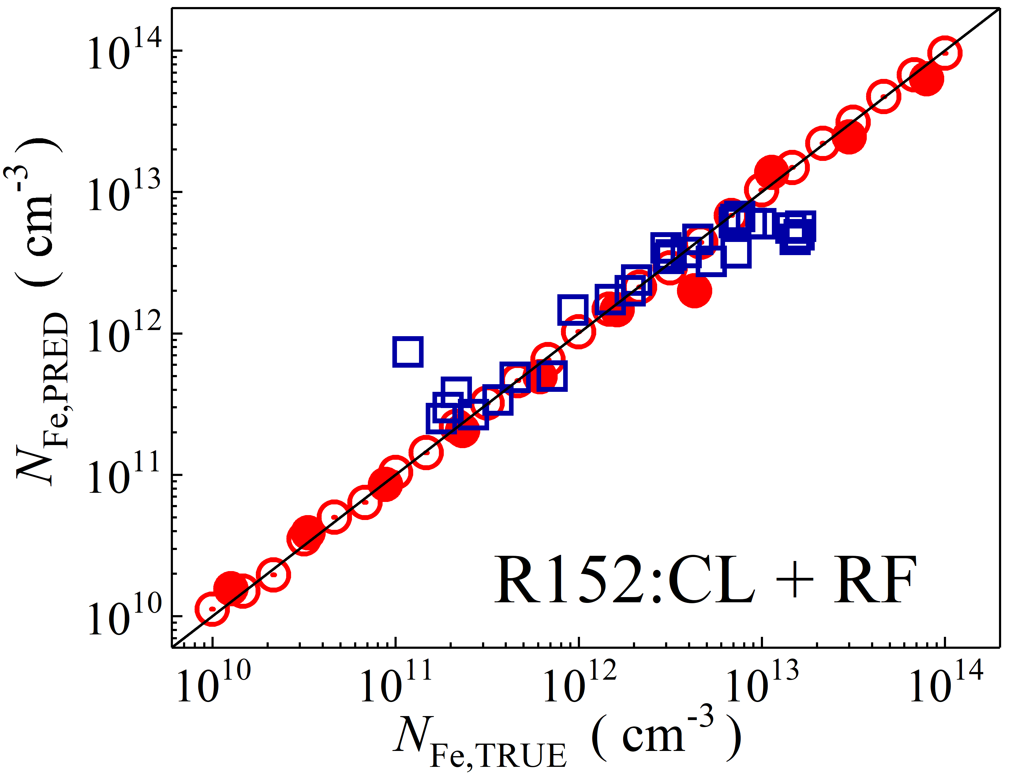

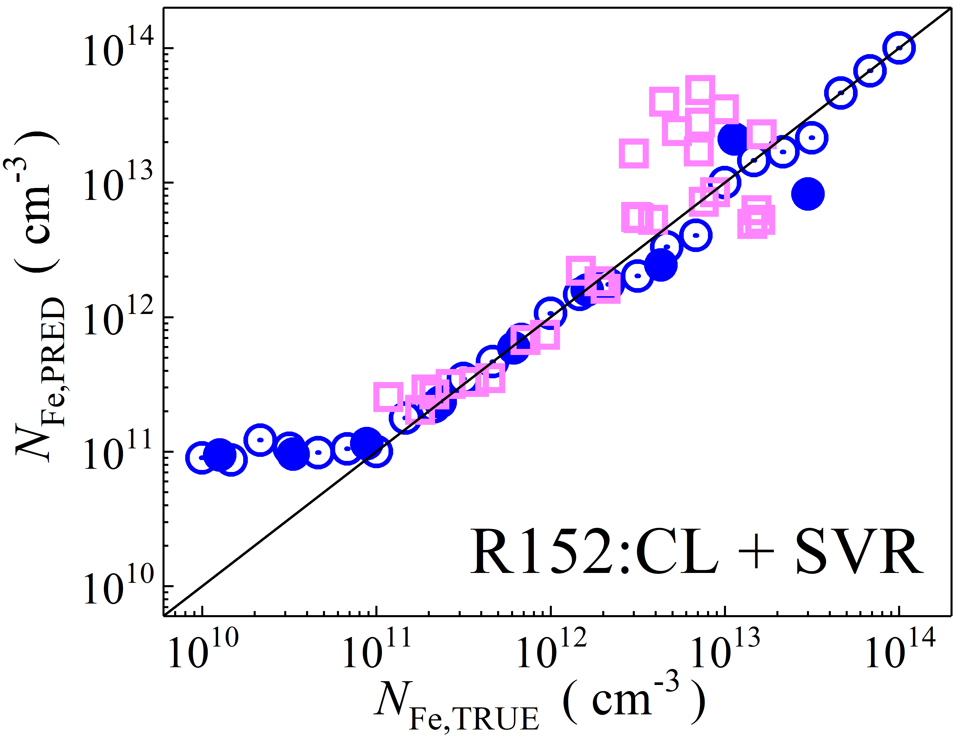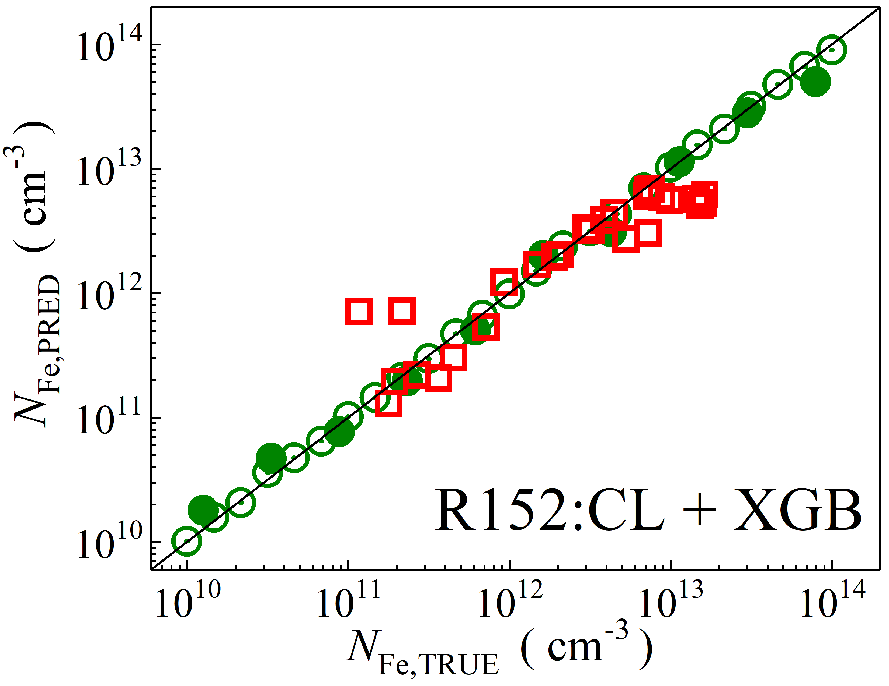

Fig. S10. Scatter plots compare reference iron concentrations $N_{Fe,TRUE}$ with ML-predicted values $N_{Fe,PRED}$ using feature vectors extracted from the classifier layer of ResNet152V2 visual model. The ML algorithms include DNN (green and purple), GB (dark yellow and yellow), RF (red and blue), SVR (blue and pink), and XGB (green and red). Symbols represent different datasets: open circles — training data (simulated), filled circles — test data (simulated), and open squares — test data from experimental measurements. The black lines are the identified lines serving as the references.

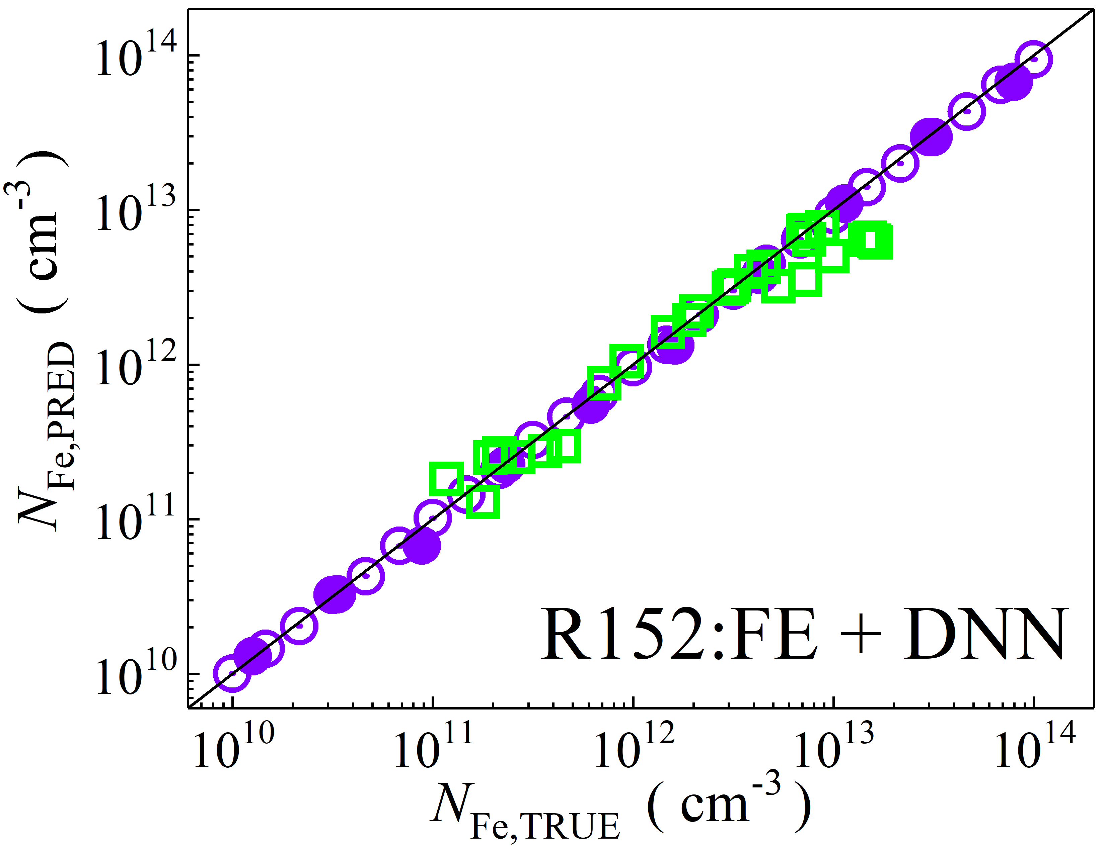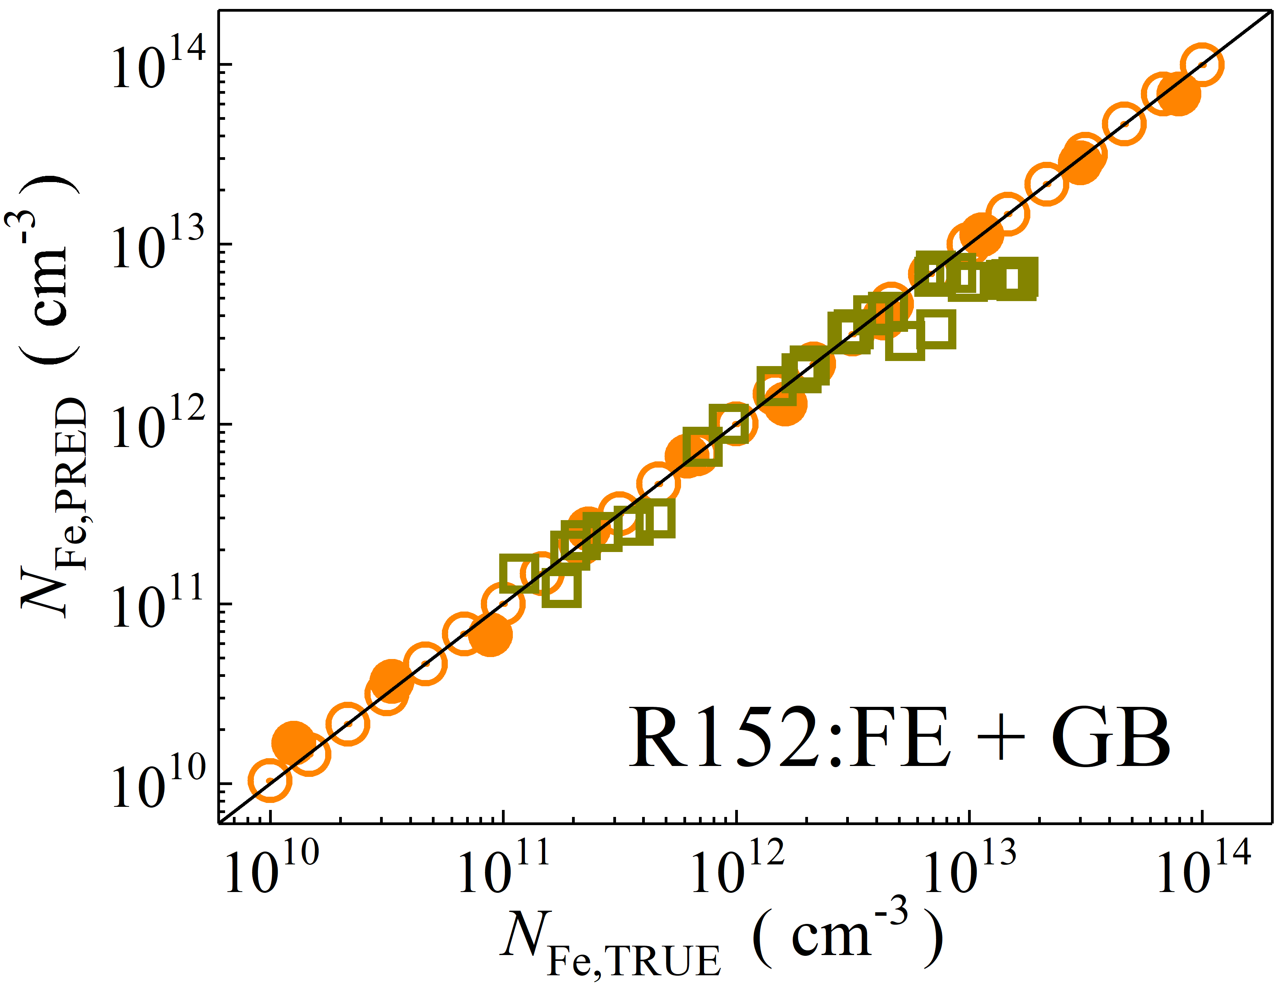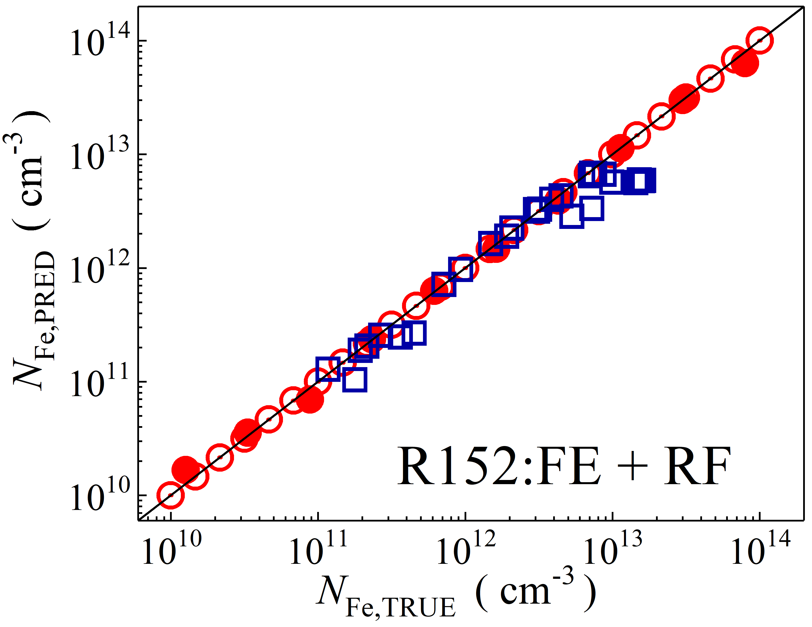

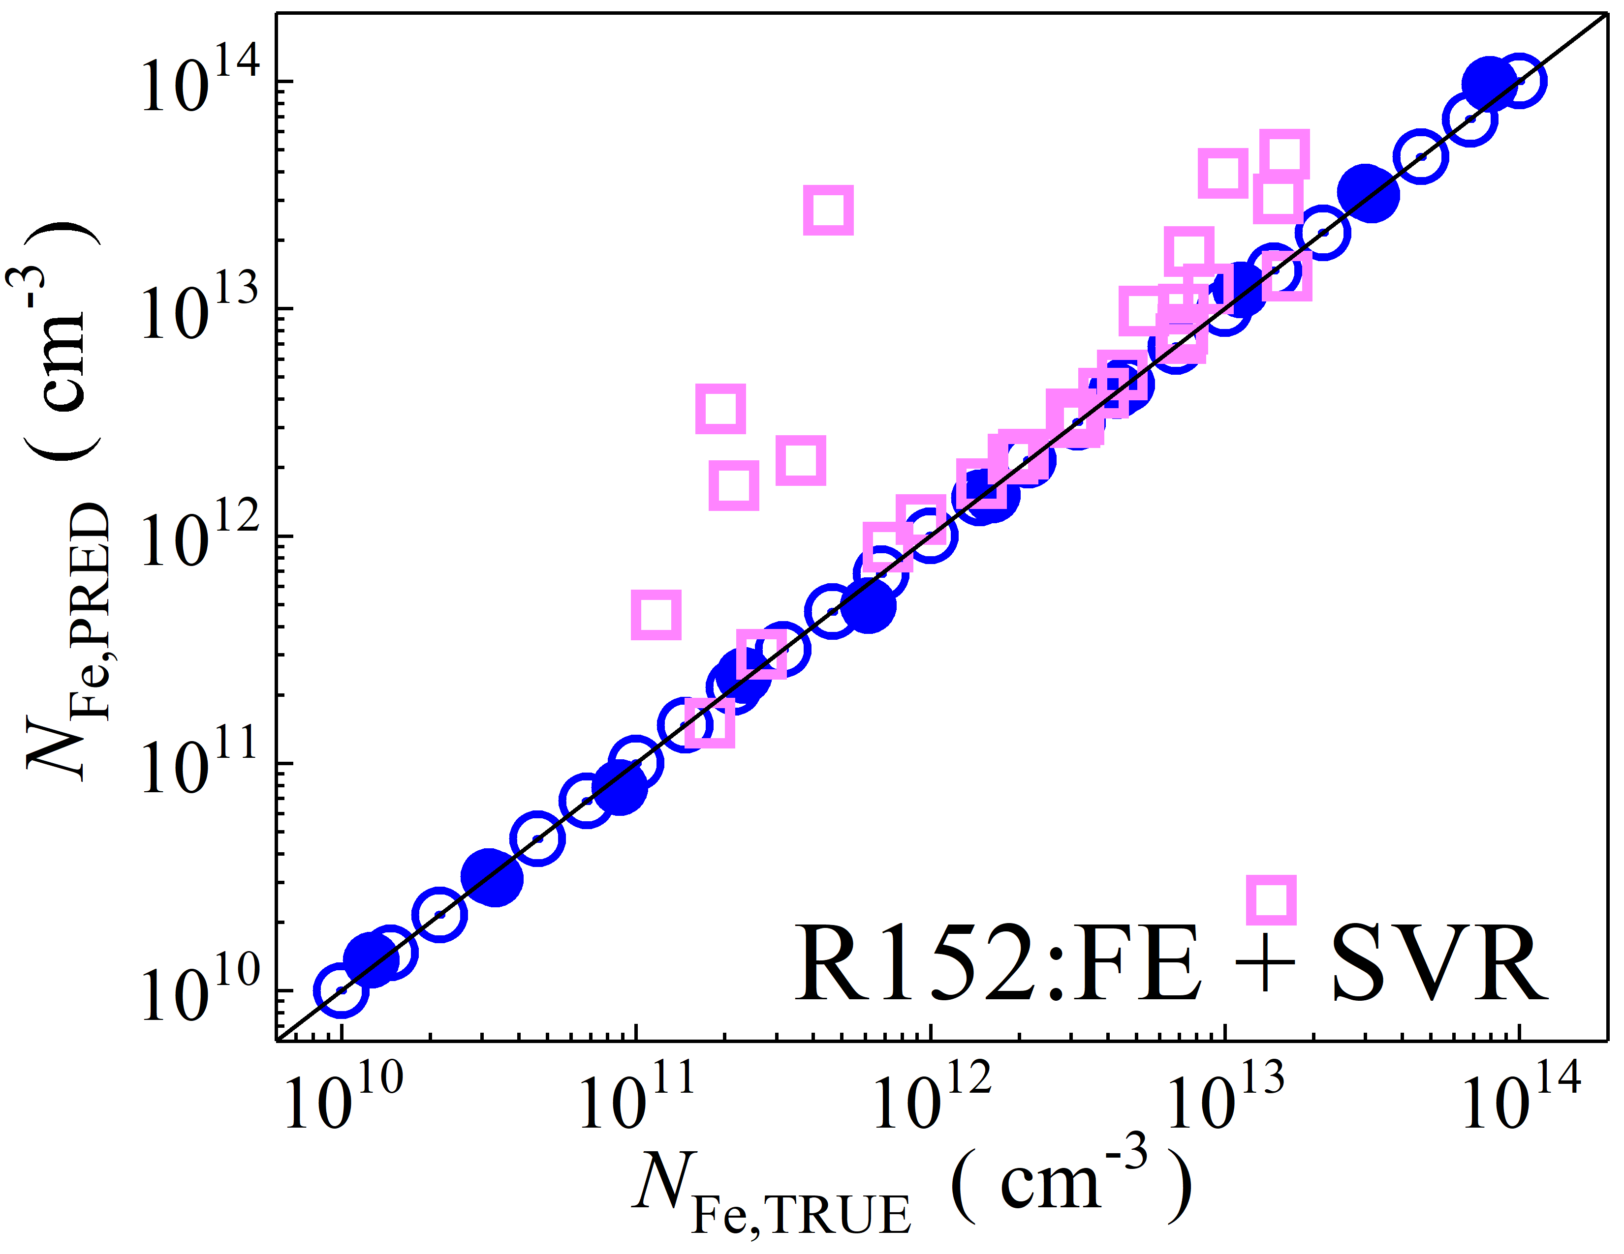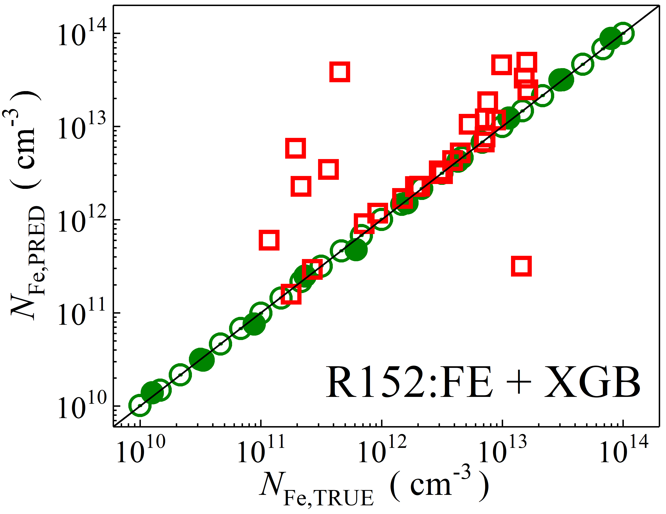

Fig. S11. Scatter plots compare reference iron concentrations $N_{Fe,TRUE}$ with ML-predicted values $N_{Fe,PRED}$ using feature vectors extracted from the feature extractor layer of ResNet152V2 visual model. The ML algorithms include DNN (green and purple), GB (dark yellow and yellow), RF (red and blue), SVR (blue and pink), and XGB (green and red). Symbols represent different datasets: open circles — training data (simulated), filled circles — test data (simulated), and open squares — test data from experimental measurements. The black lines are the identified lines serving as the references.

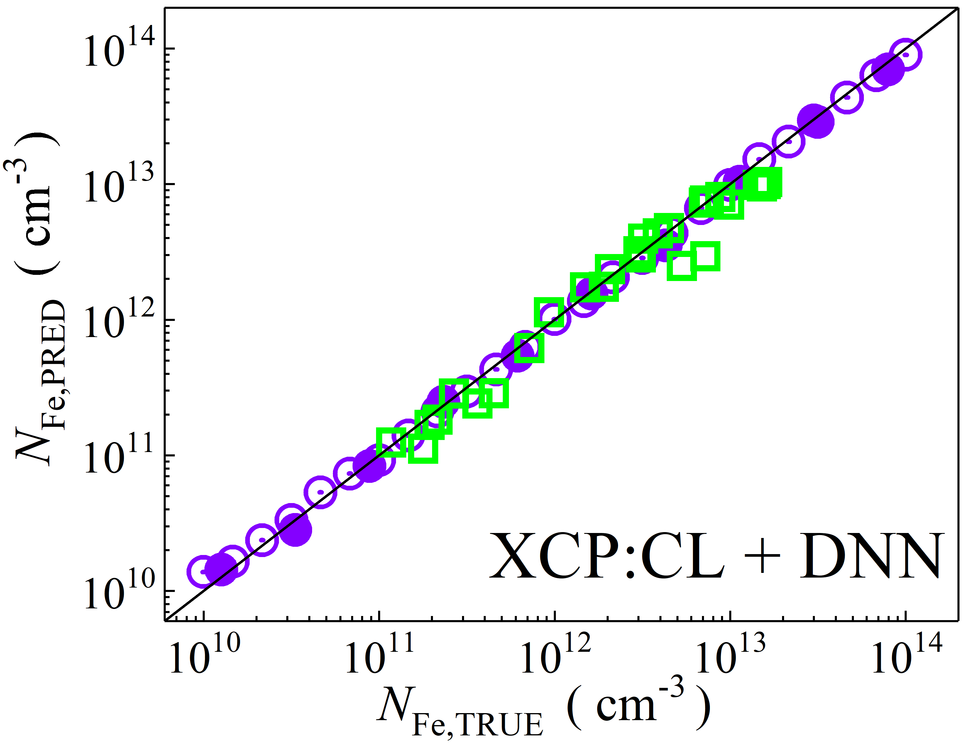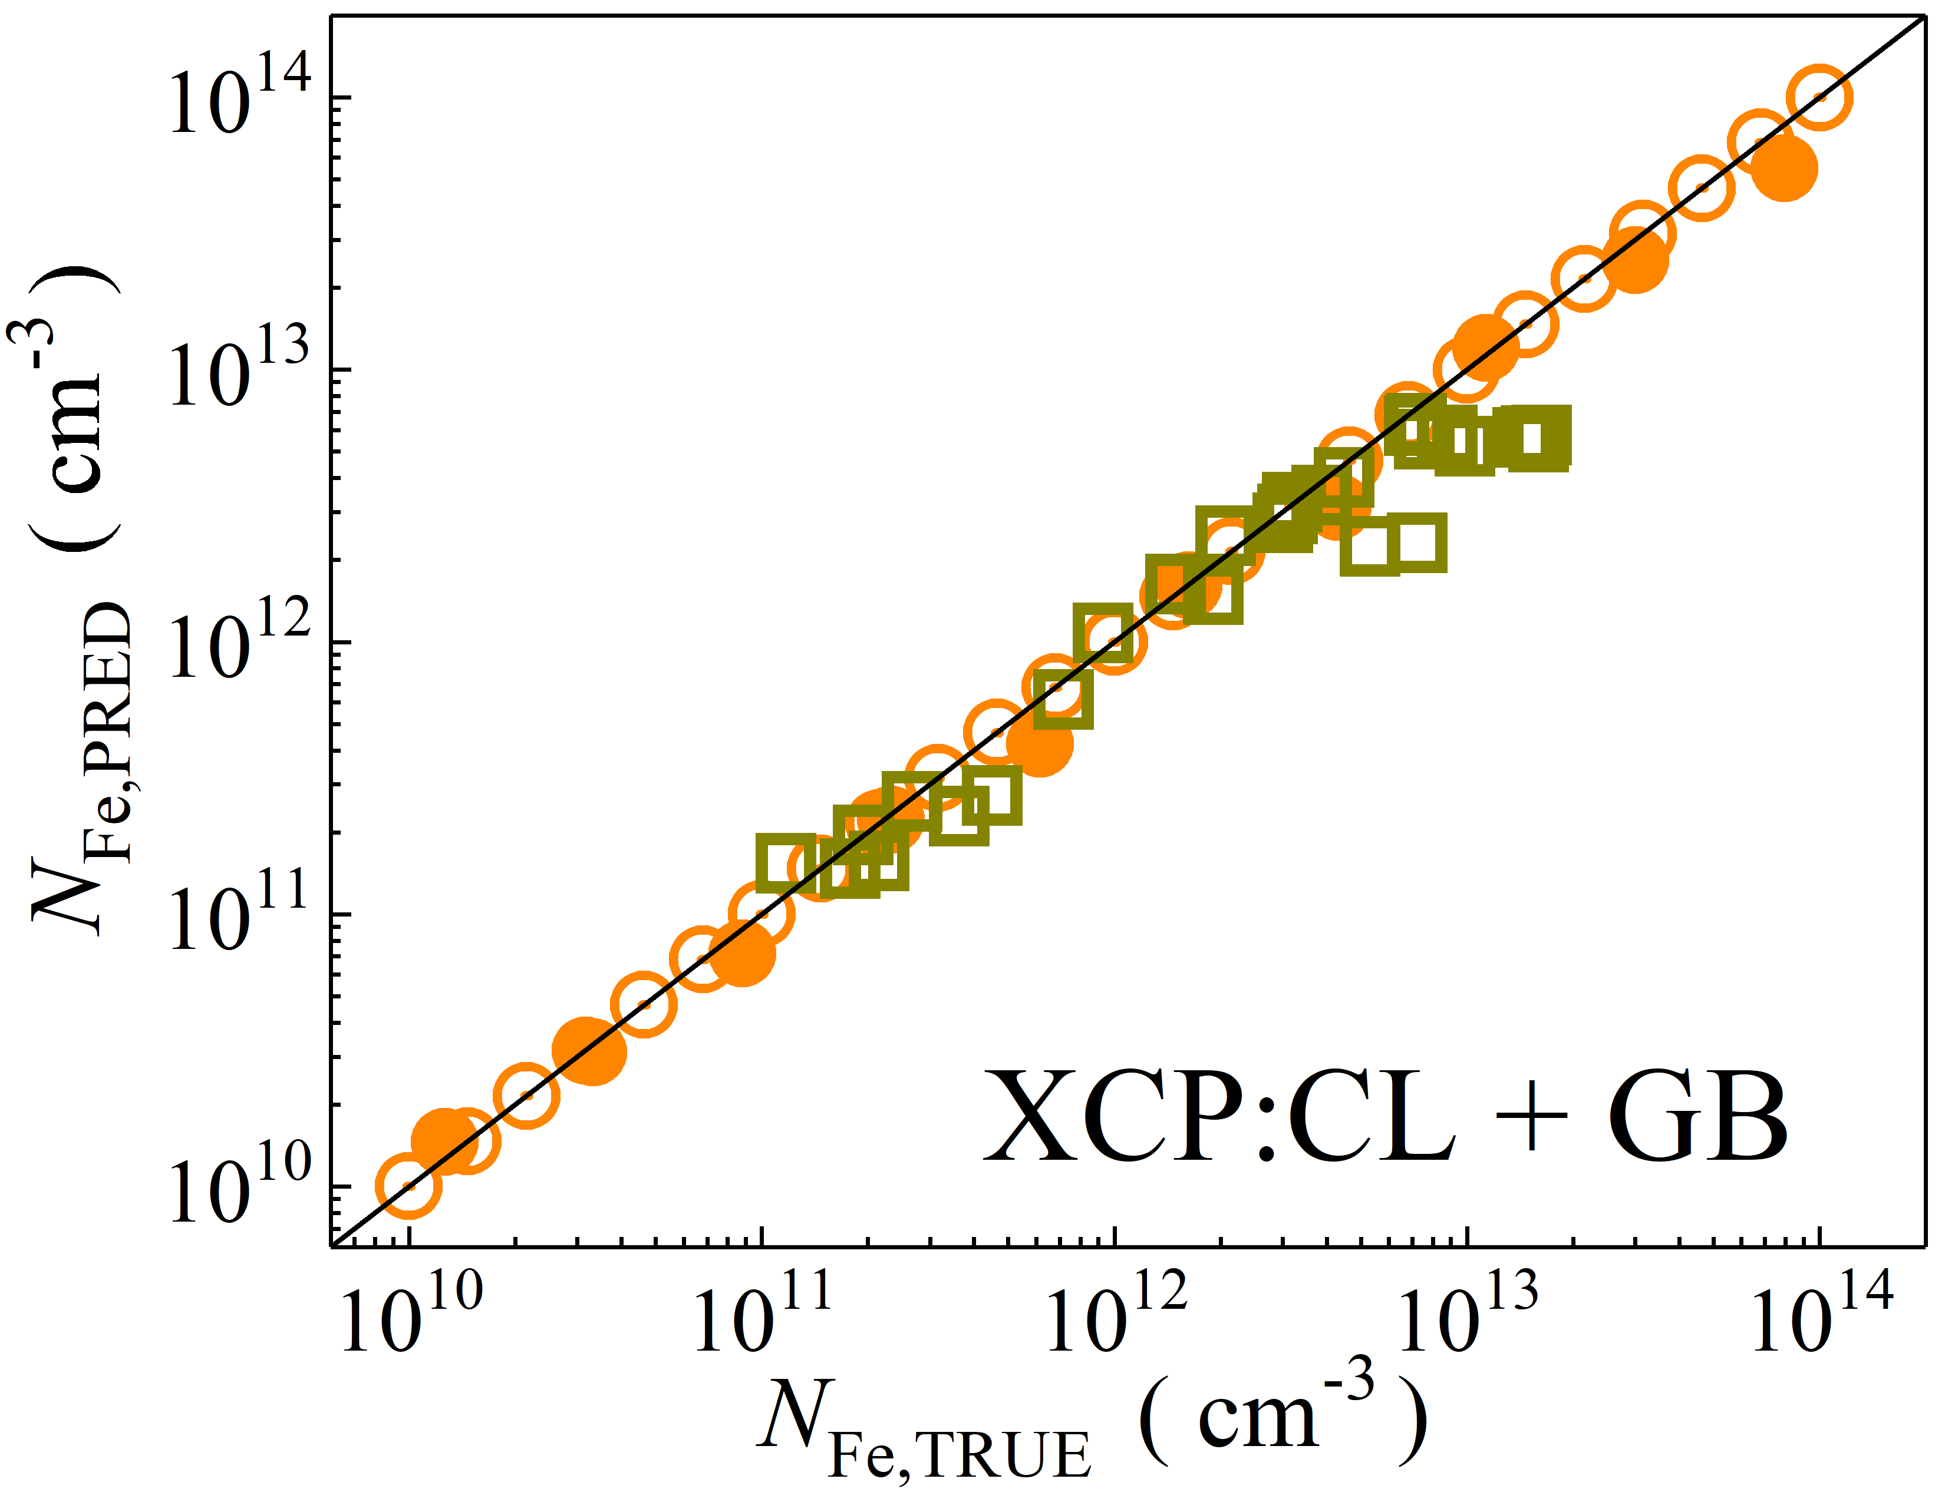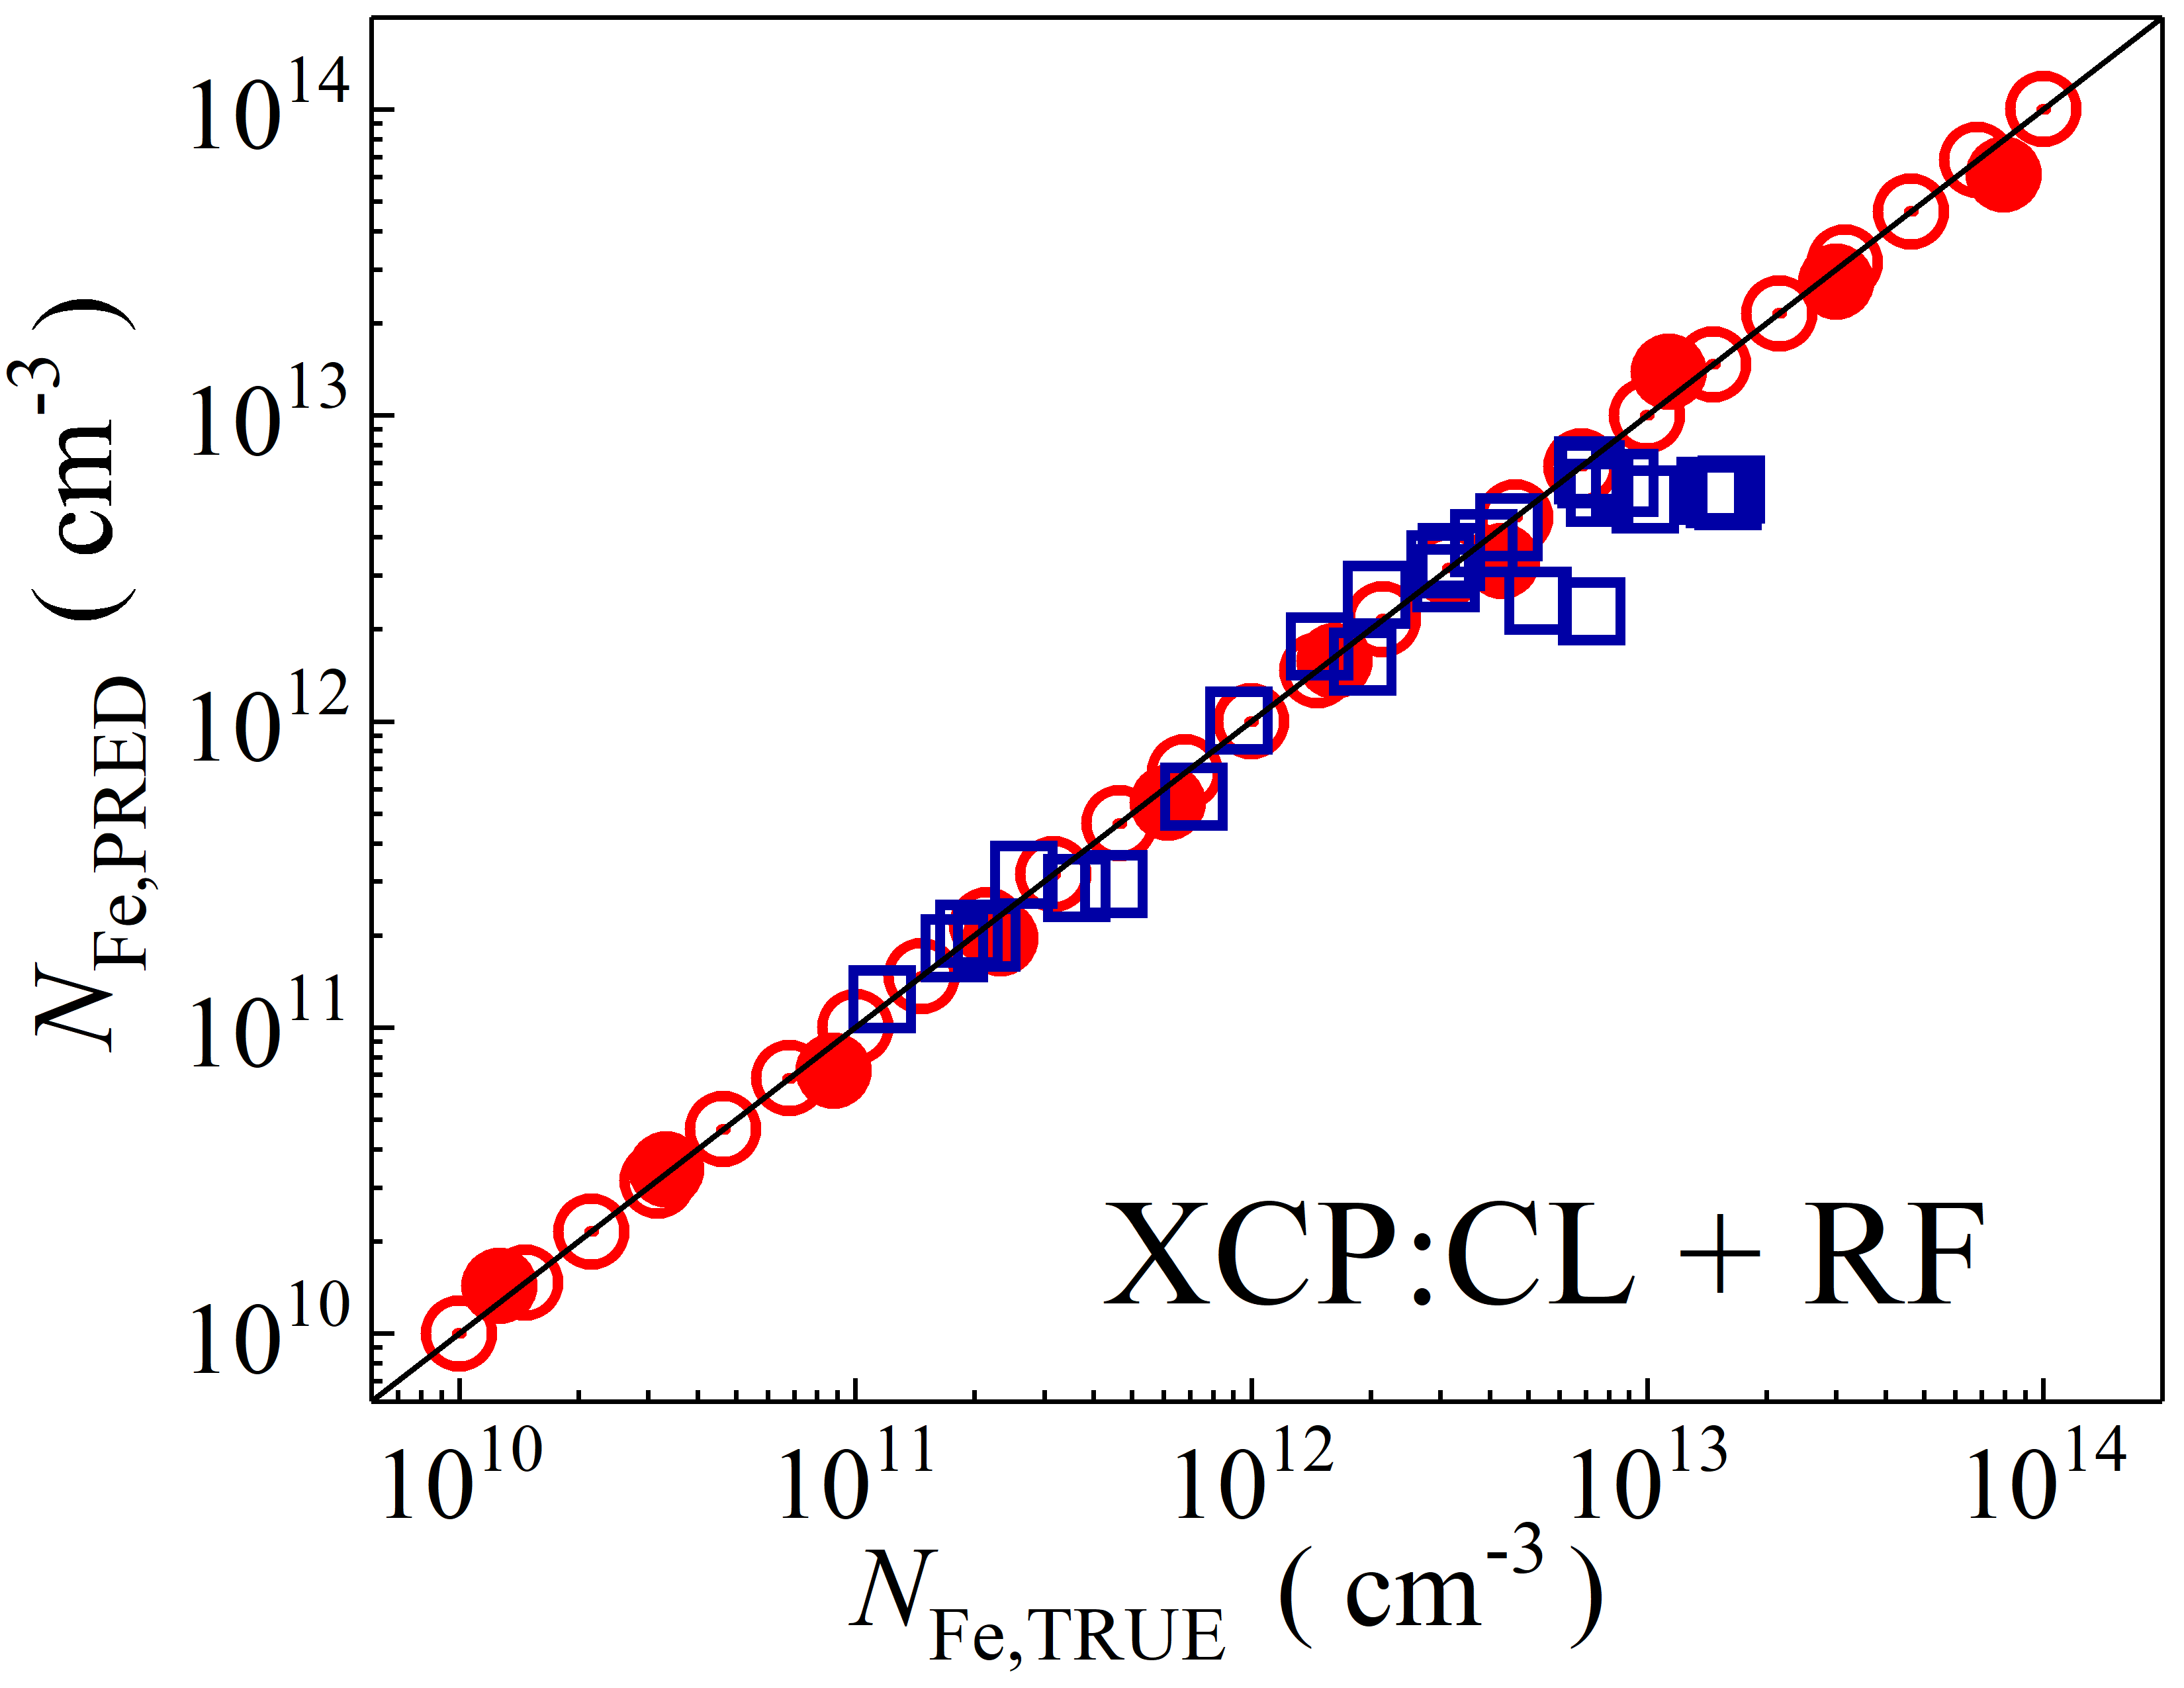

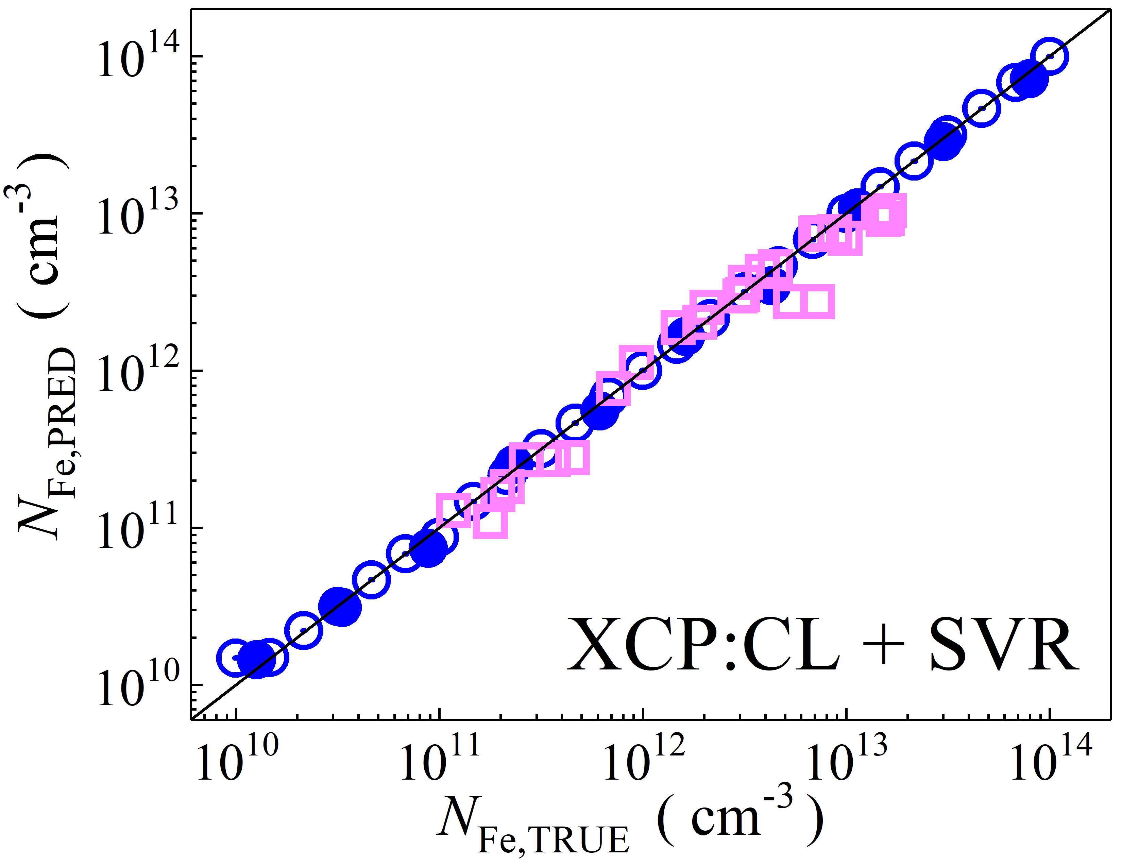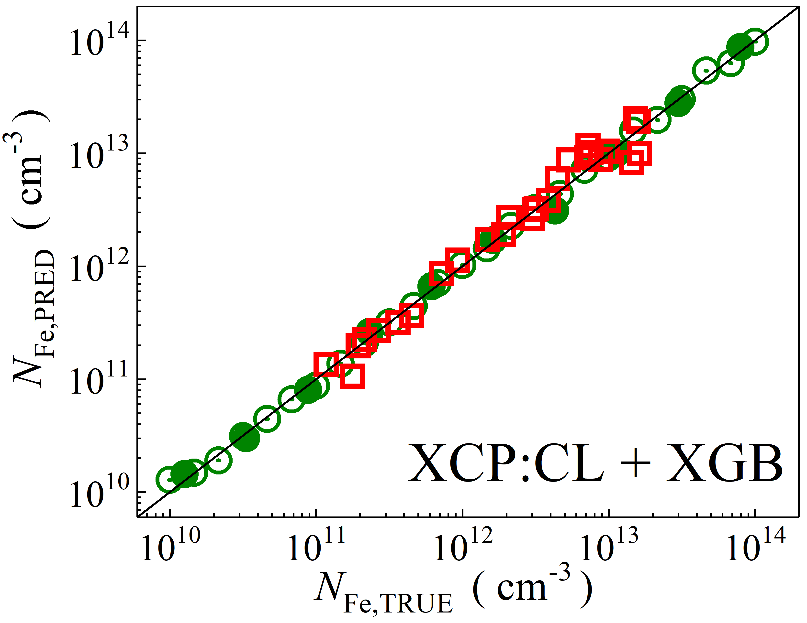

Fig. S12. Scatter plots compare reference iron concentrations $N_{Fe,TRUE}$ with ML-predicted values $N_{Fe,PRED}$ using feature vectors extracted from the classifier layer of Xception visual model. The ML algorithms include DNN (green and purple), GB (dark yellow and yellow), RF (red and blue), SVR (blue and pink), and XGB (green and red). Symbols represent different datasets: open circles — training data (simulated), filled circles — test data (simulated), and open squares — test data from experimental measurements. The black lines are the identified lines serving as the references.

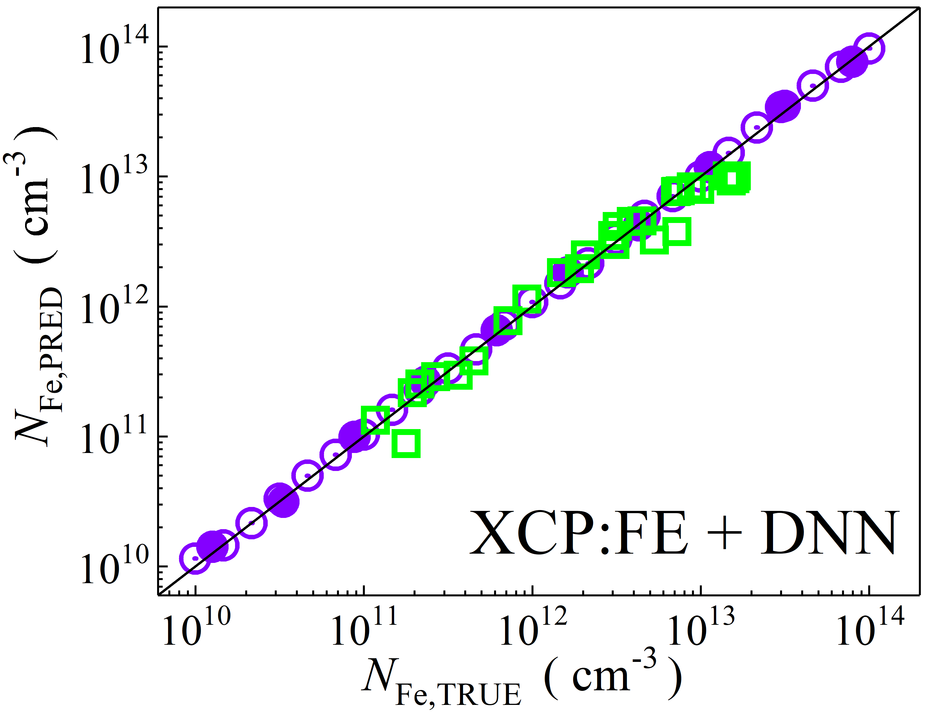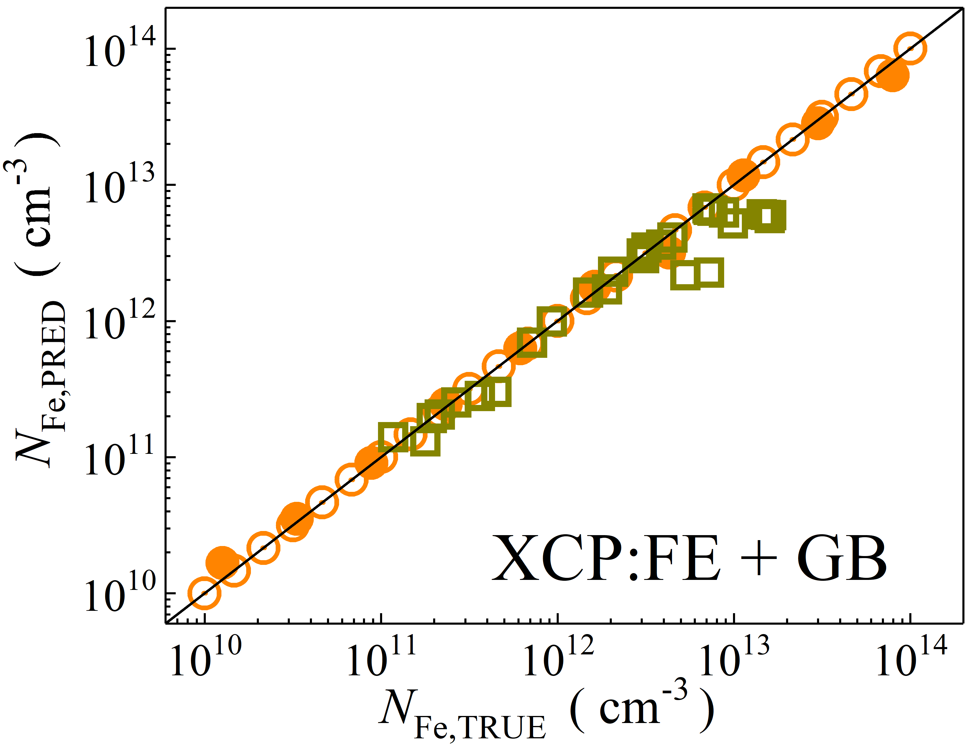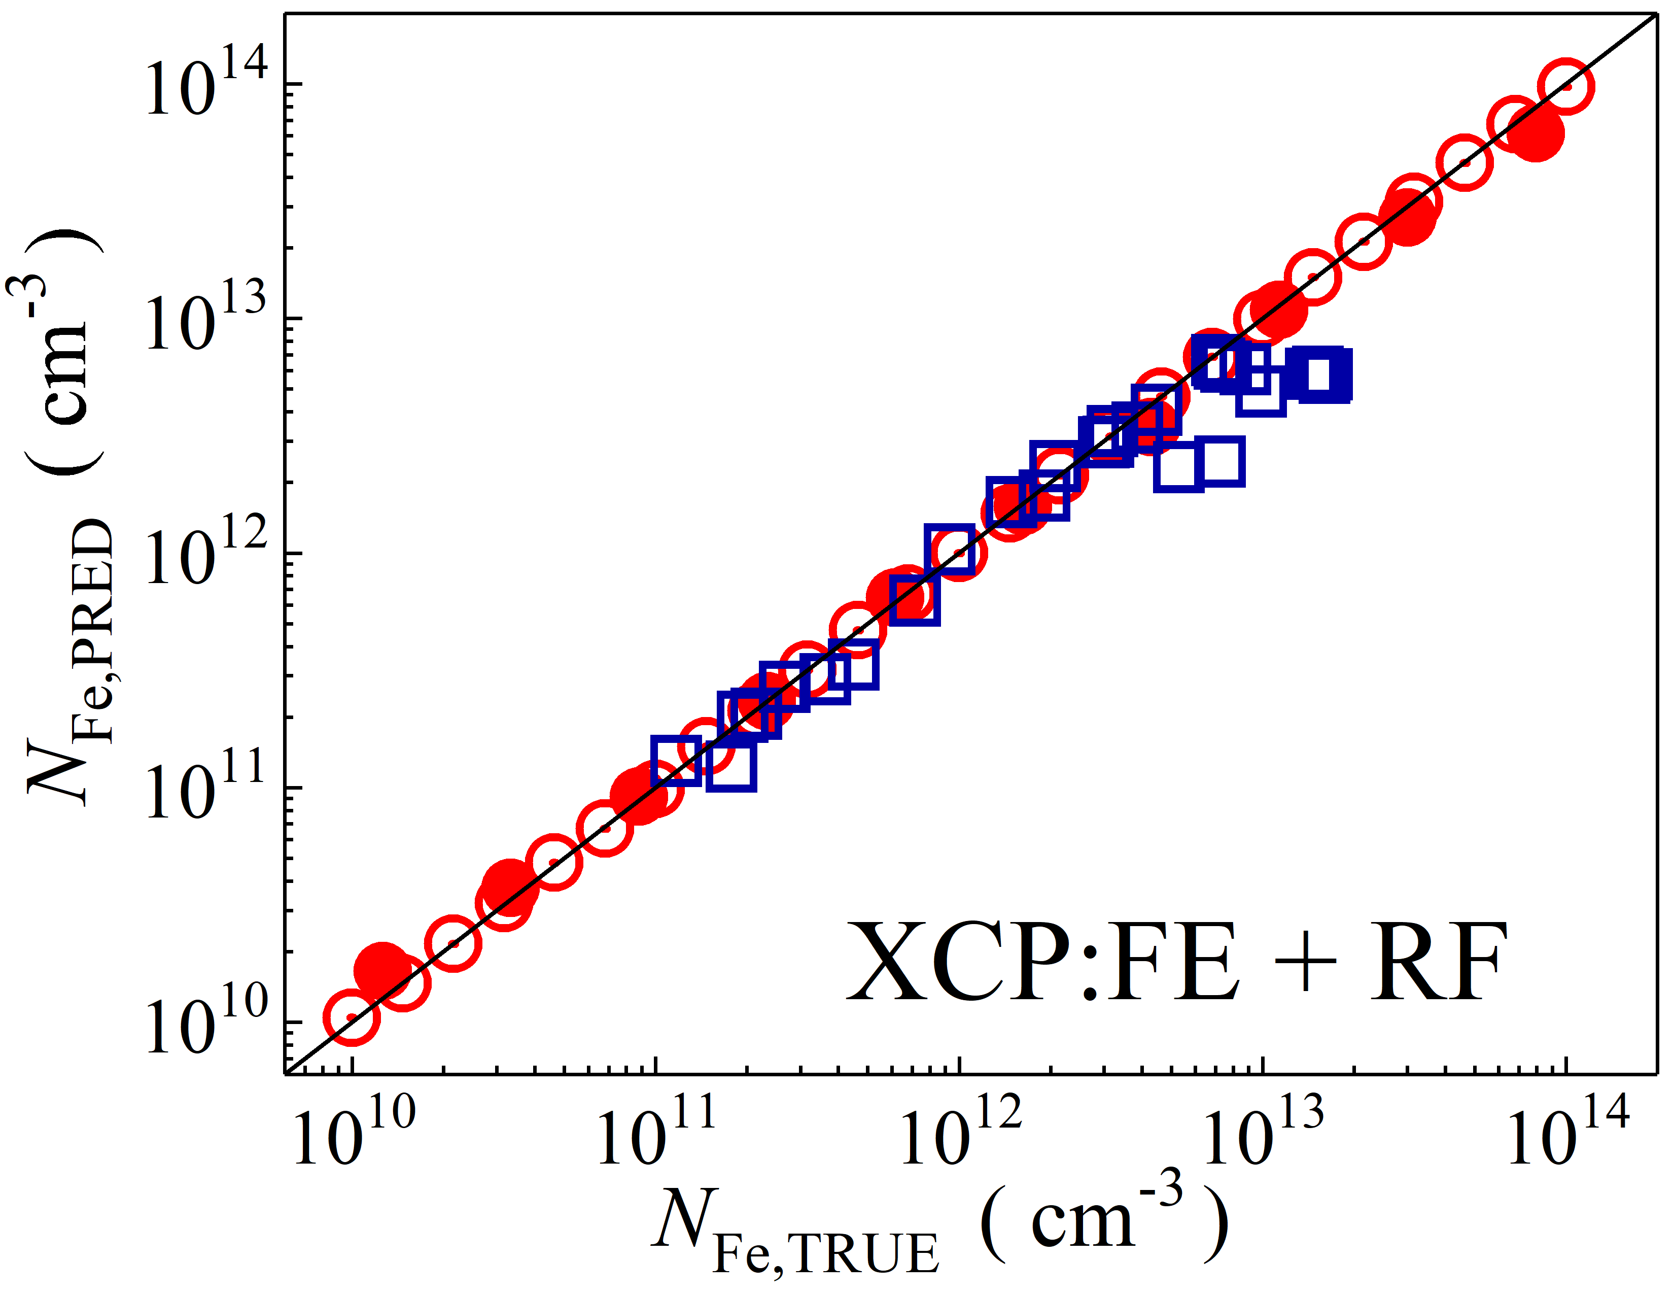

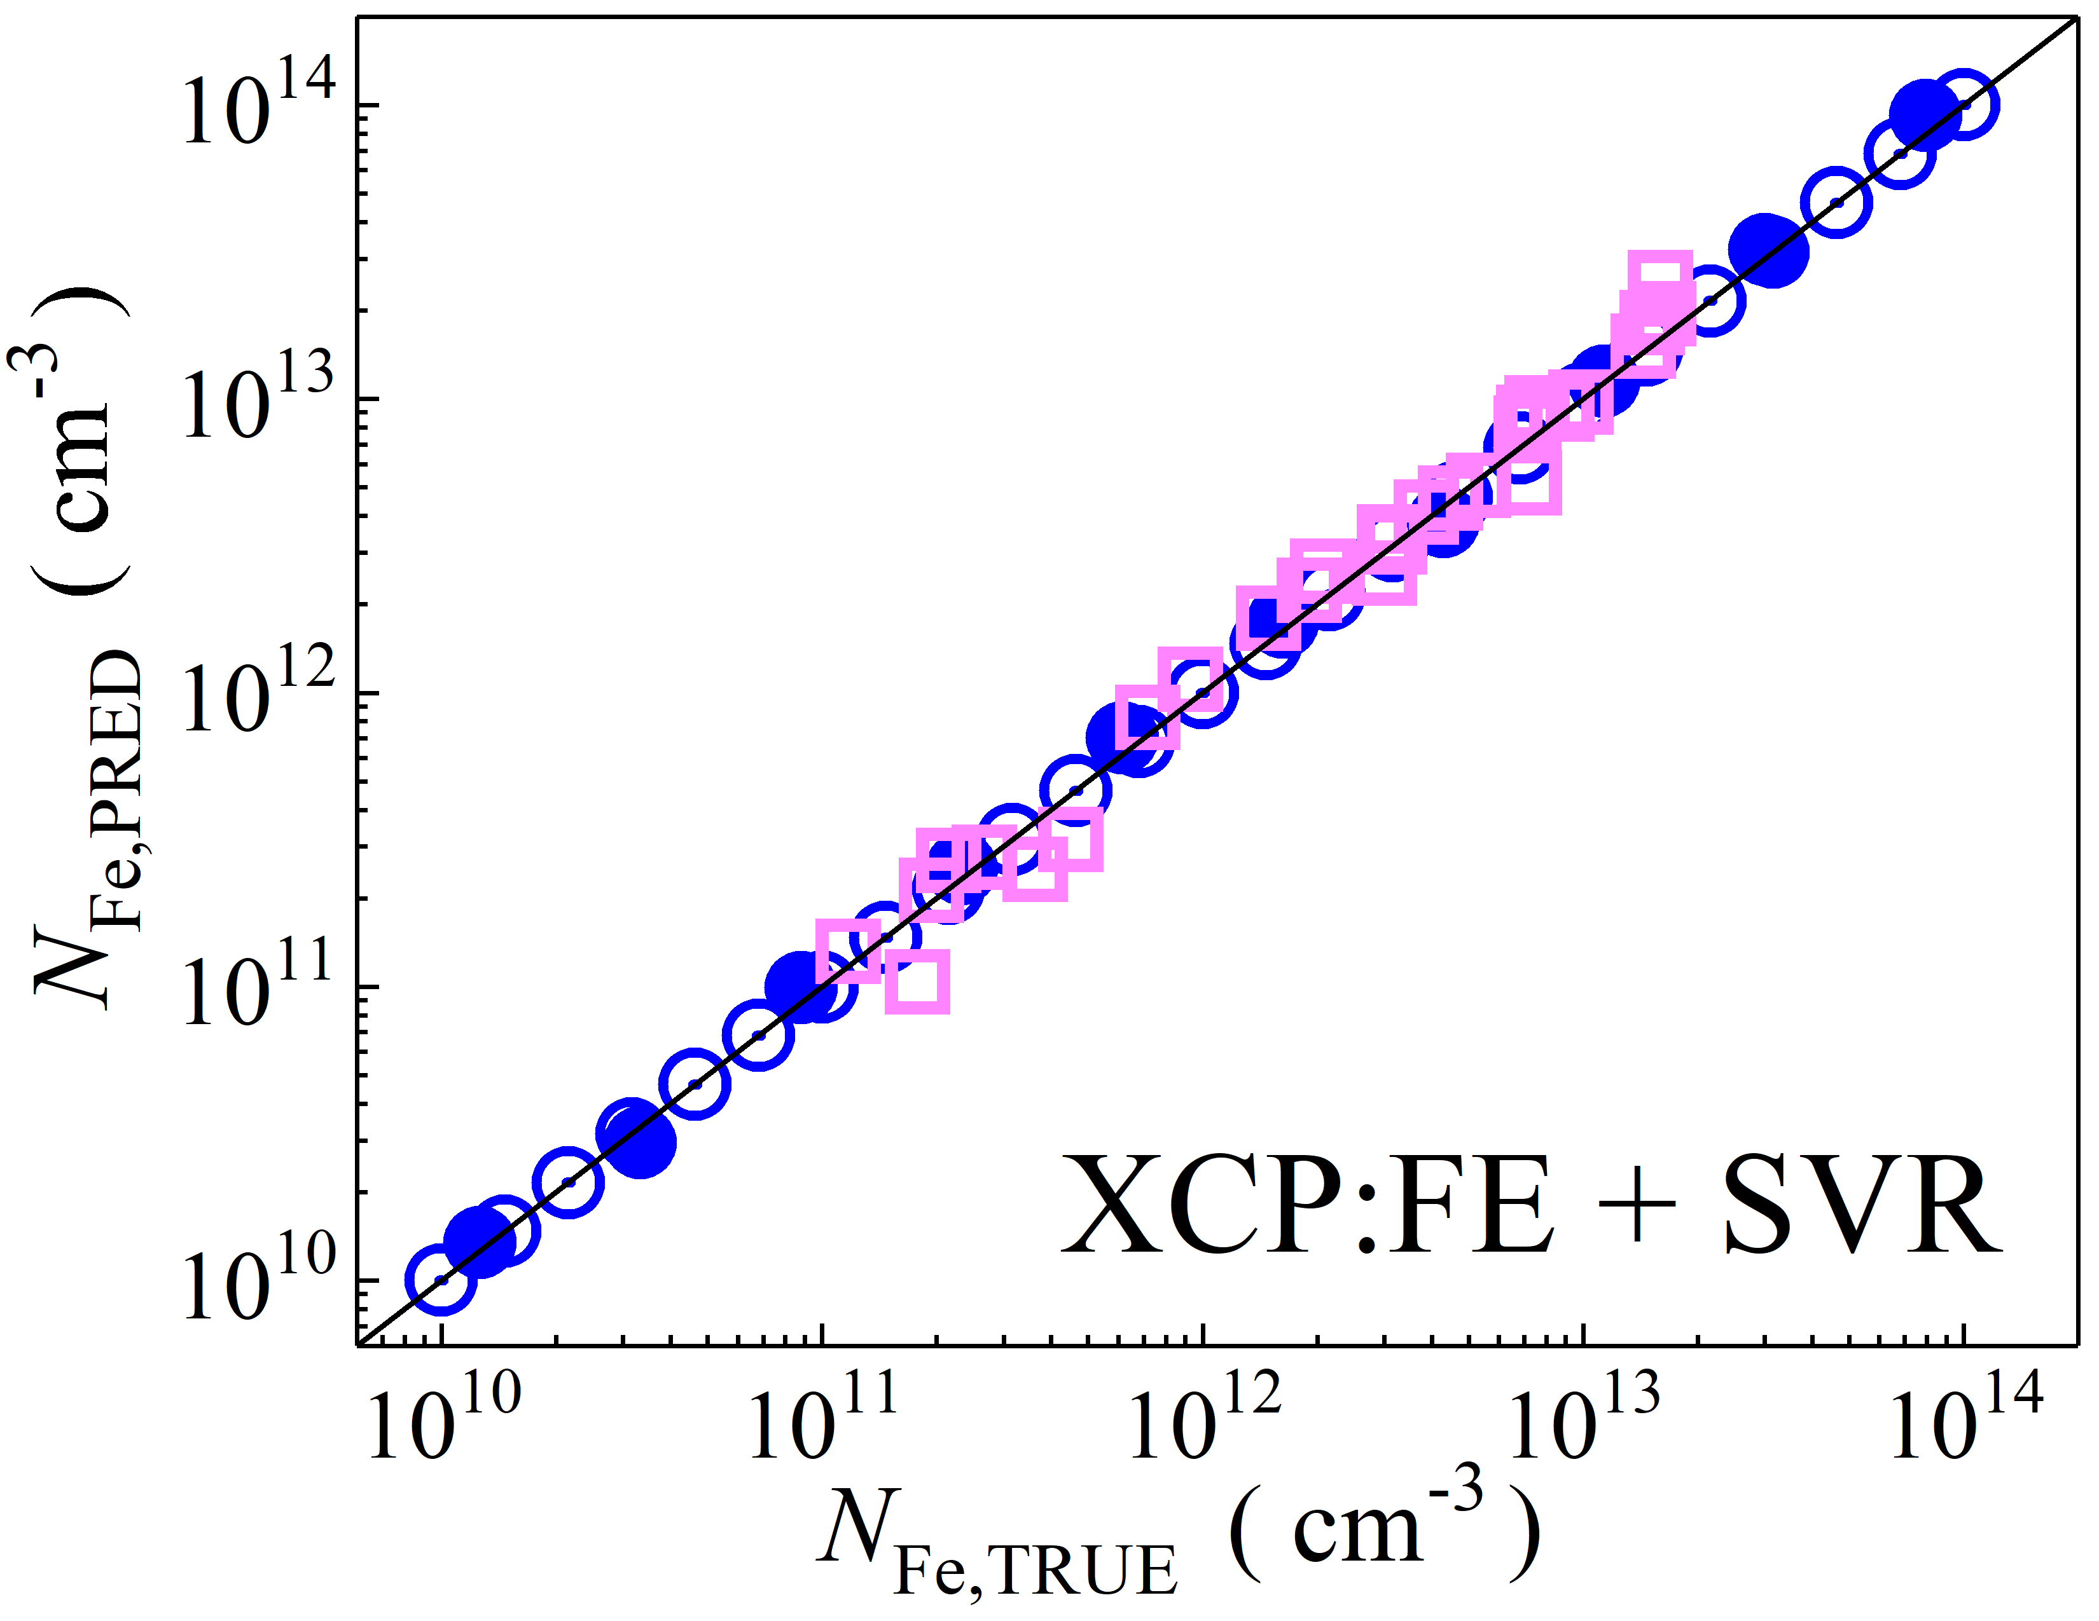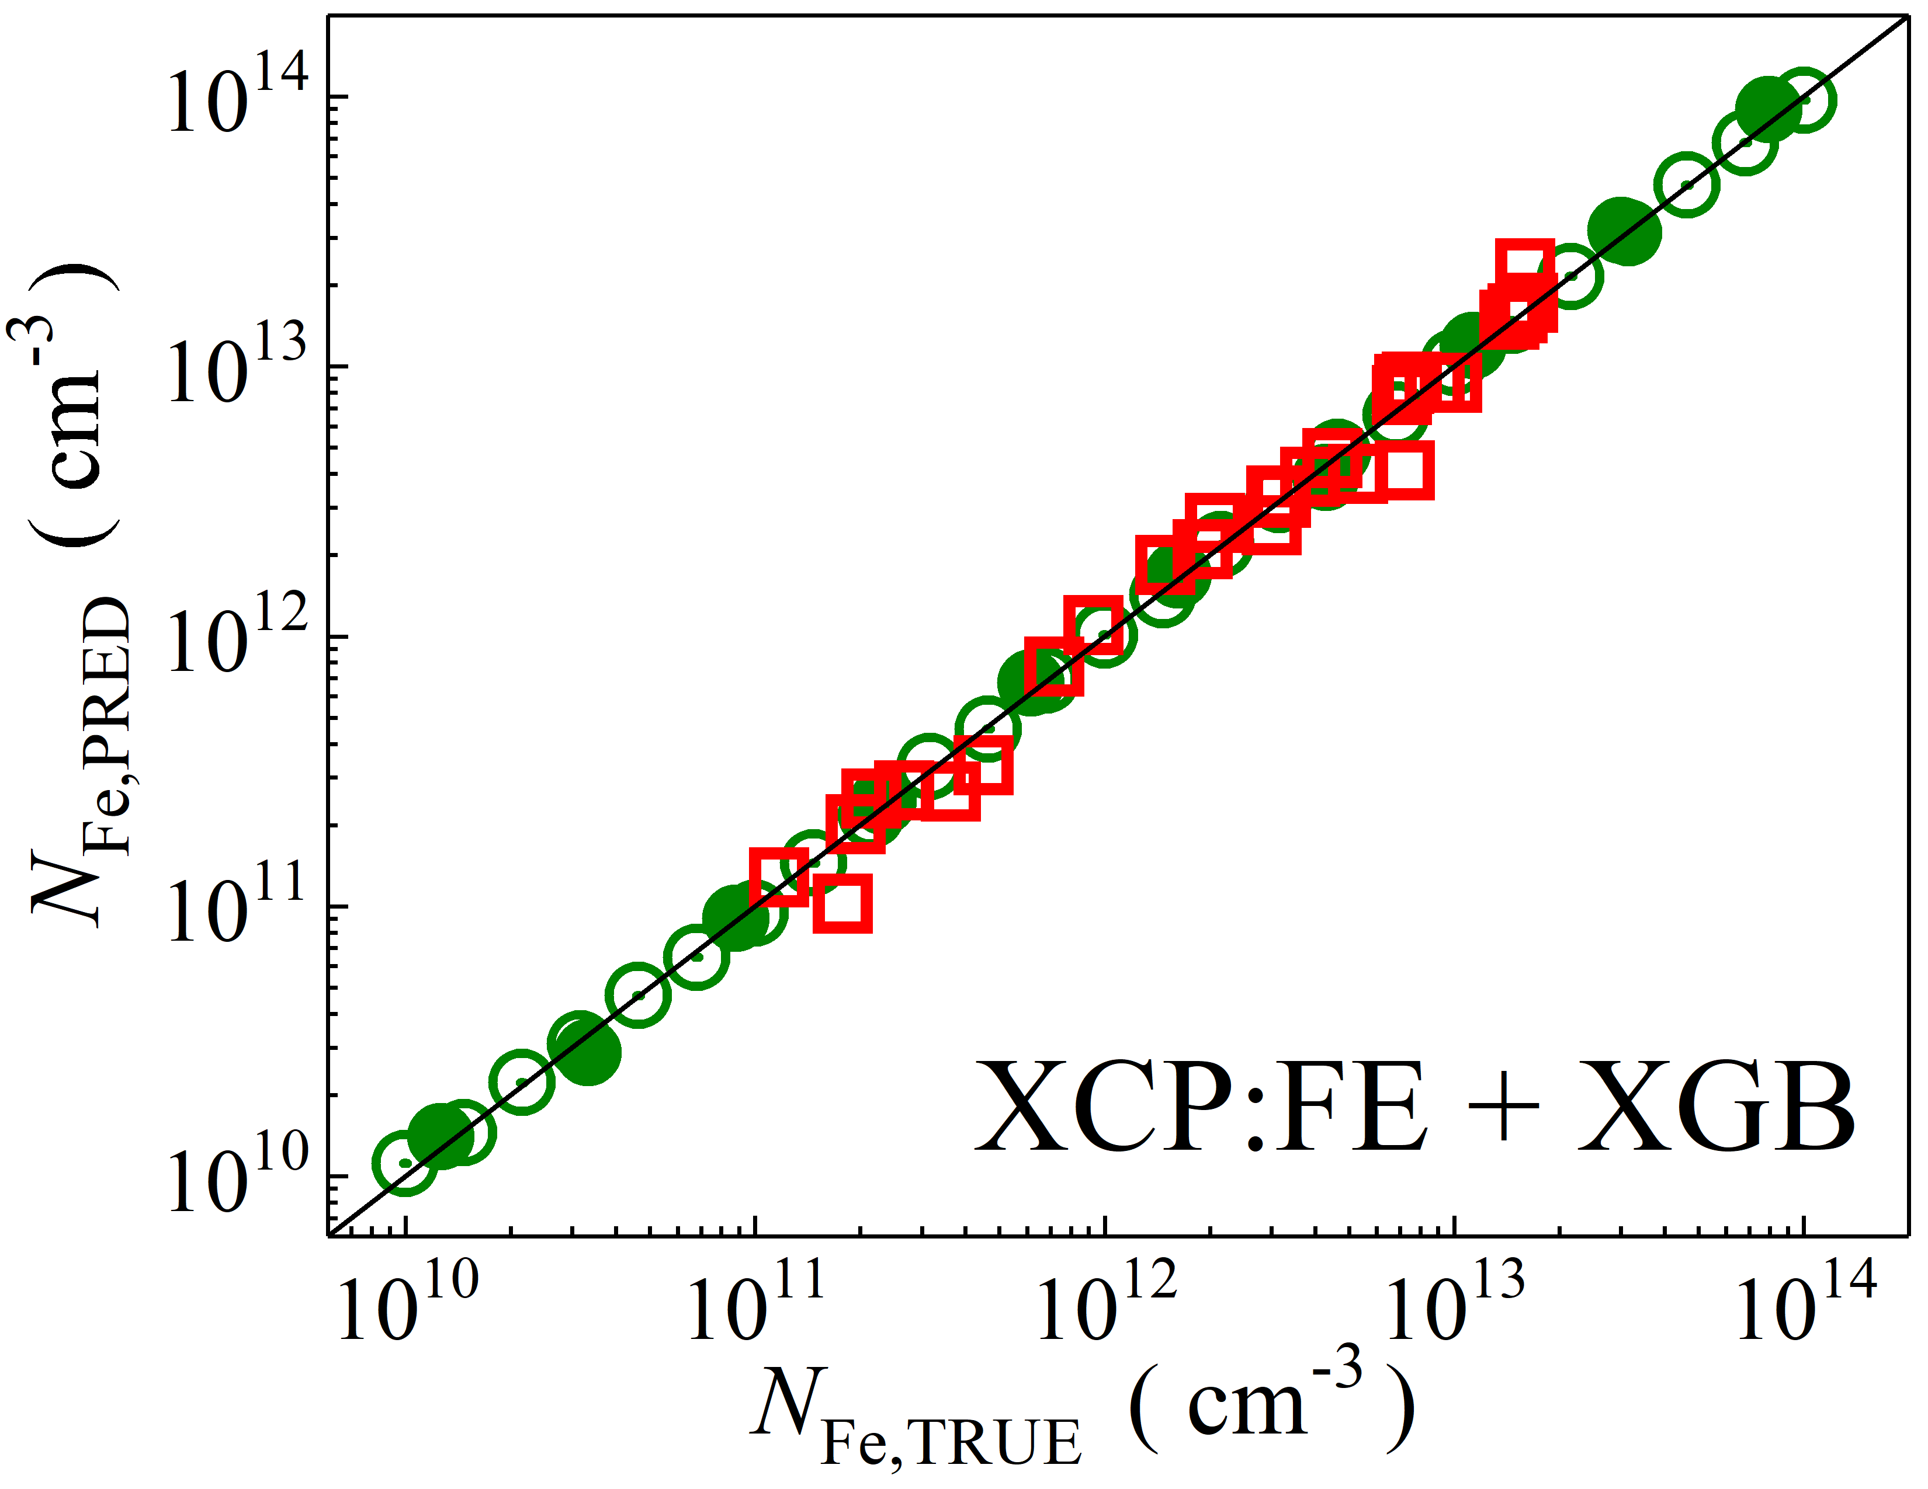

Fig. S13. Scatter plots compare reference iron concentrations $N_{Fe,TRUE}$ with ML-predicted values $N_{Fe,PRED}$ using feature vectors extracted from the feature extractor layer of Xception visual model. The ML algorithms include DNN (green and purple), GB (dark yellow and yellow), RF (red and blue), SVR (blue and pink), and XGB (green and red). Symbols represent different datasets: open circles — training data (simulated), filled circles — test data (simulated), and open squares — test data from experimental measurements. The black lines are the identified lines serving as the references.

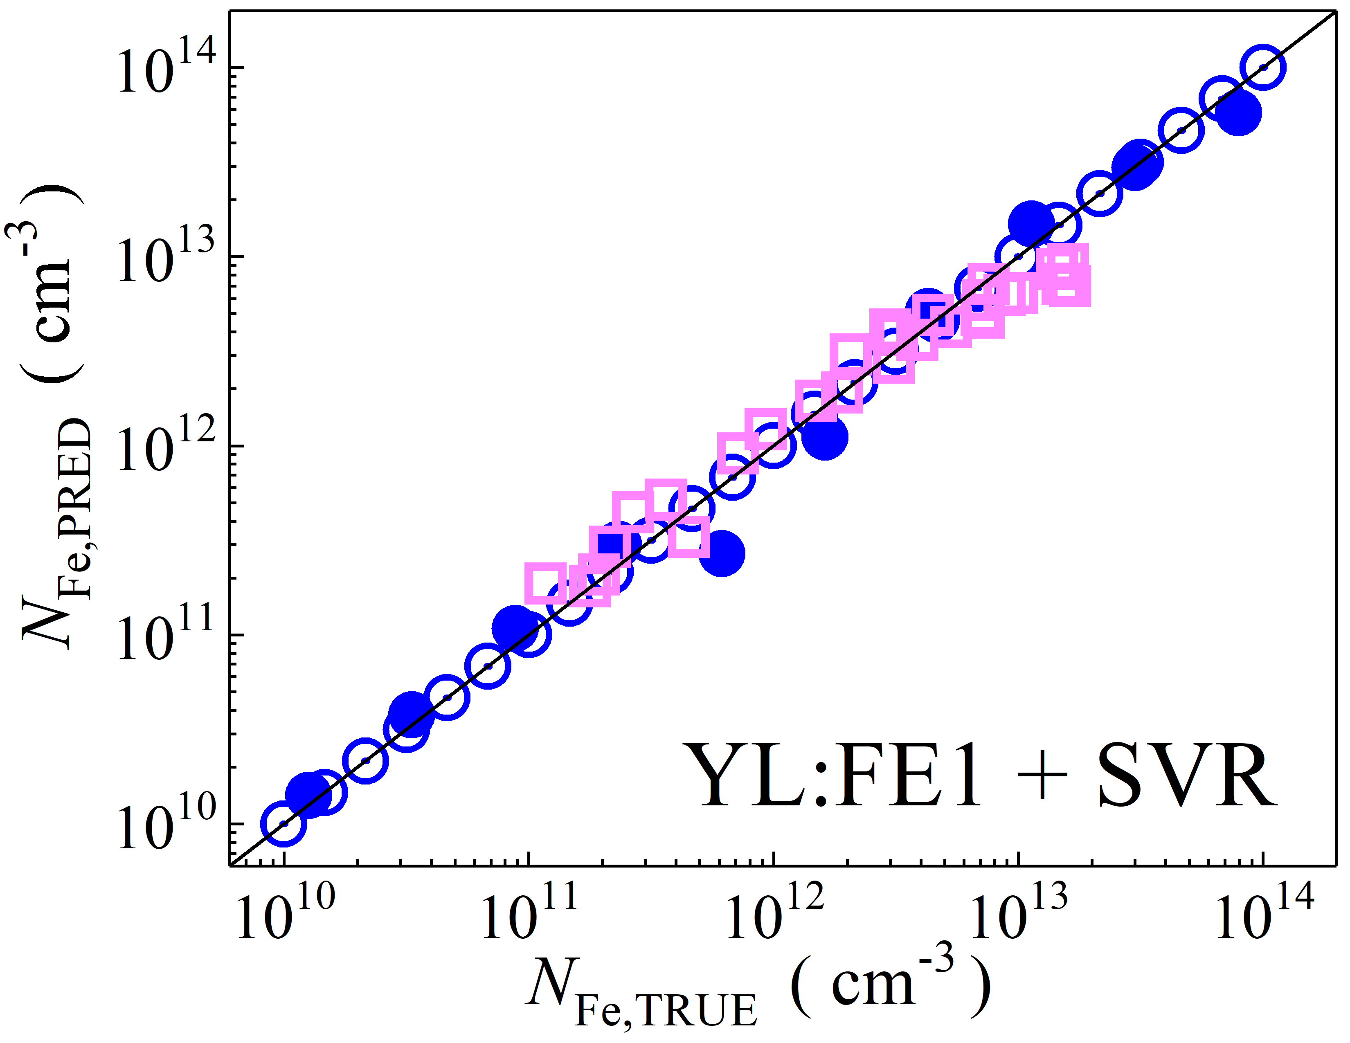

Fig. S14. Scatter plots compare reference iron concentrations $N_{Fe,TRUE}$ with ML-predicted values $N_{Fe,PRED}$ using raw feature extractor layer of YOLOv4 (CSPDarknet53) visual model. The ML algorithms include SVR (blue and pink). Symbols represent different datasets: open circles — training data (simulated), filled circles — test data (simulated), and open squares — test data from experimental measurements. The black lines are the identified lines serving as the references.

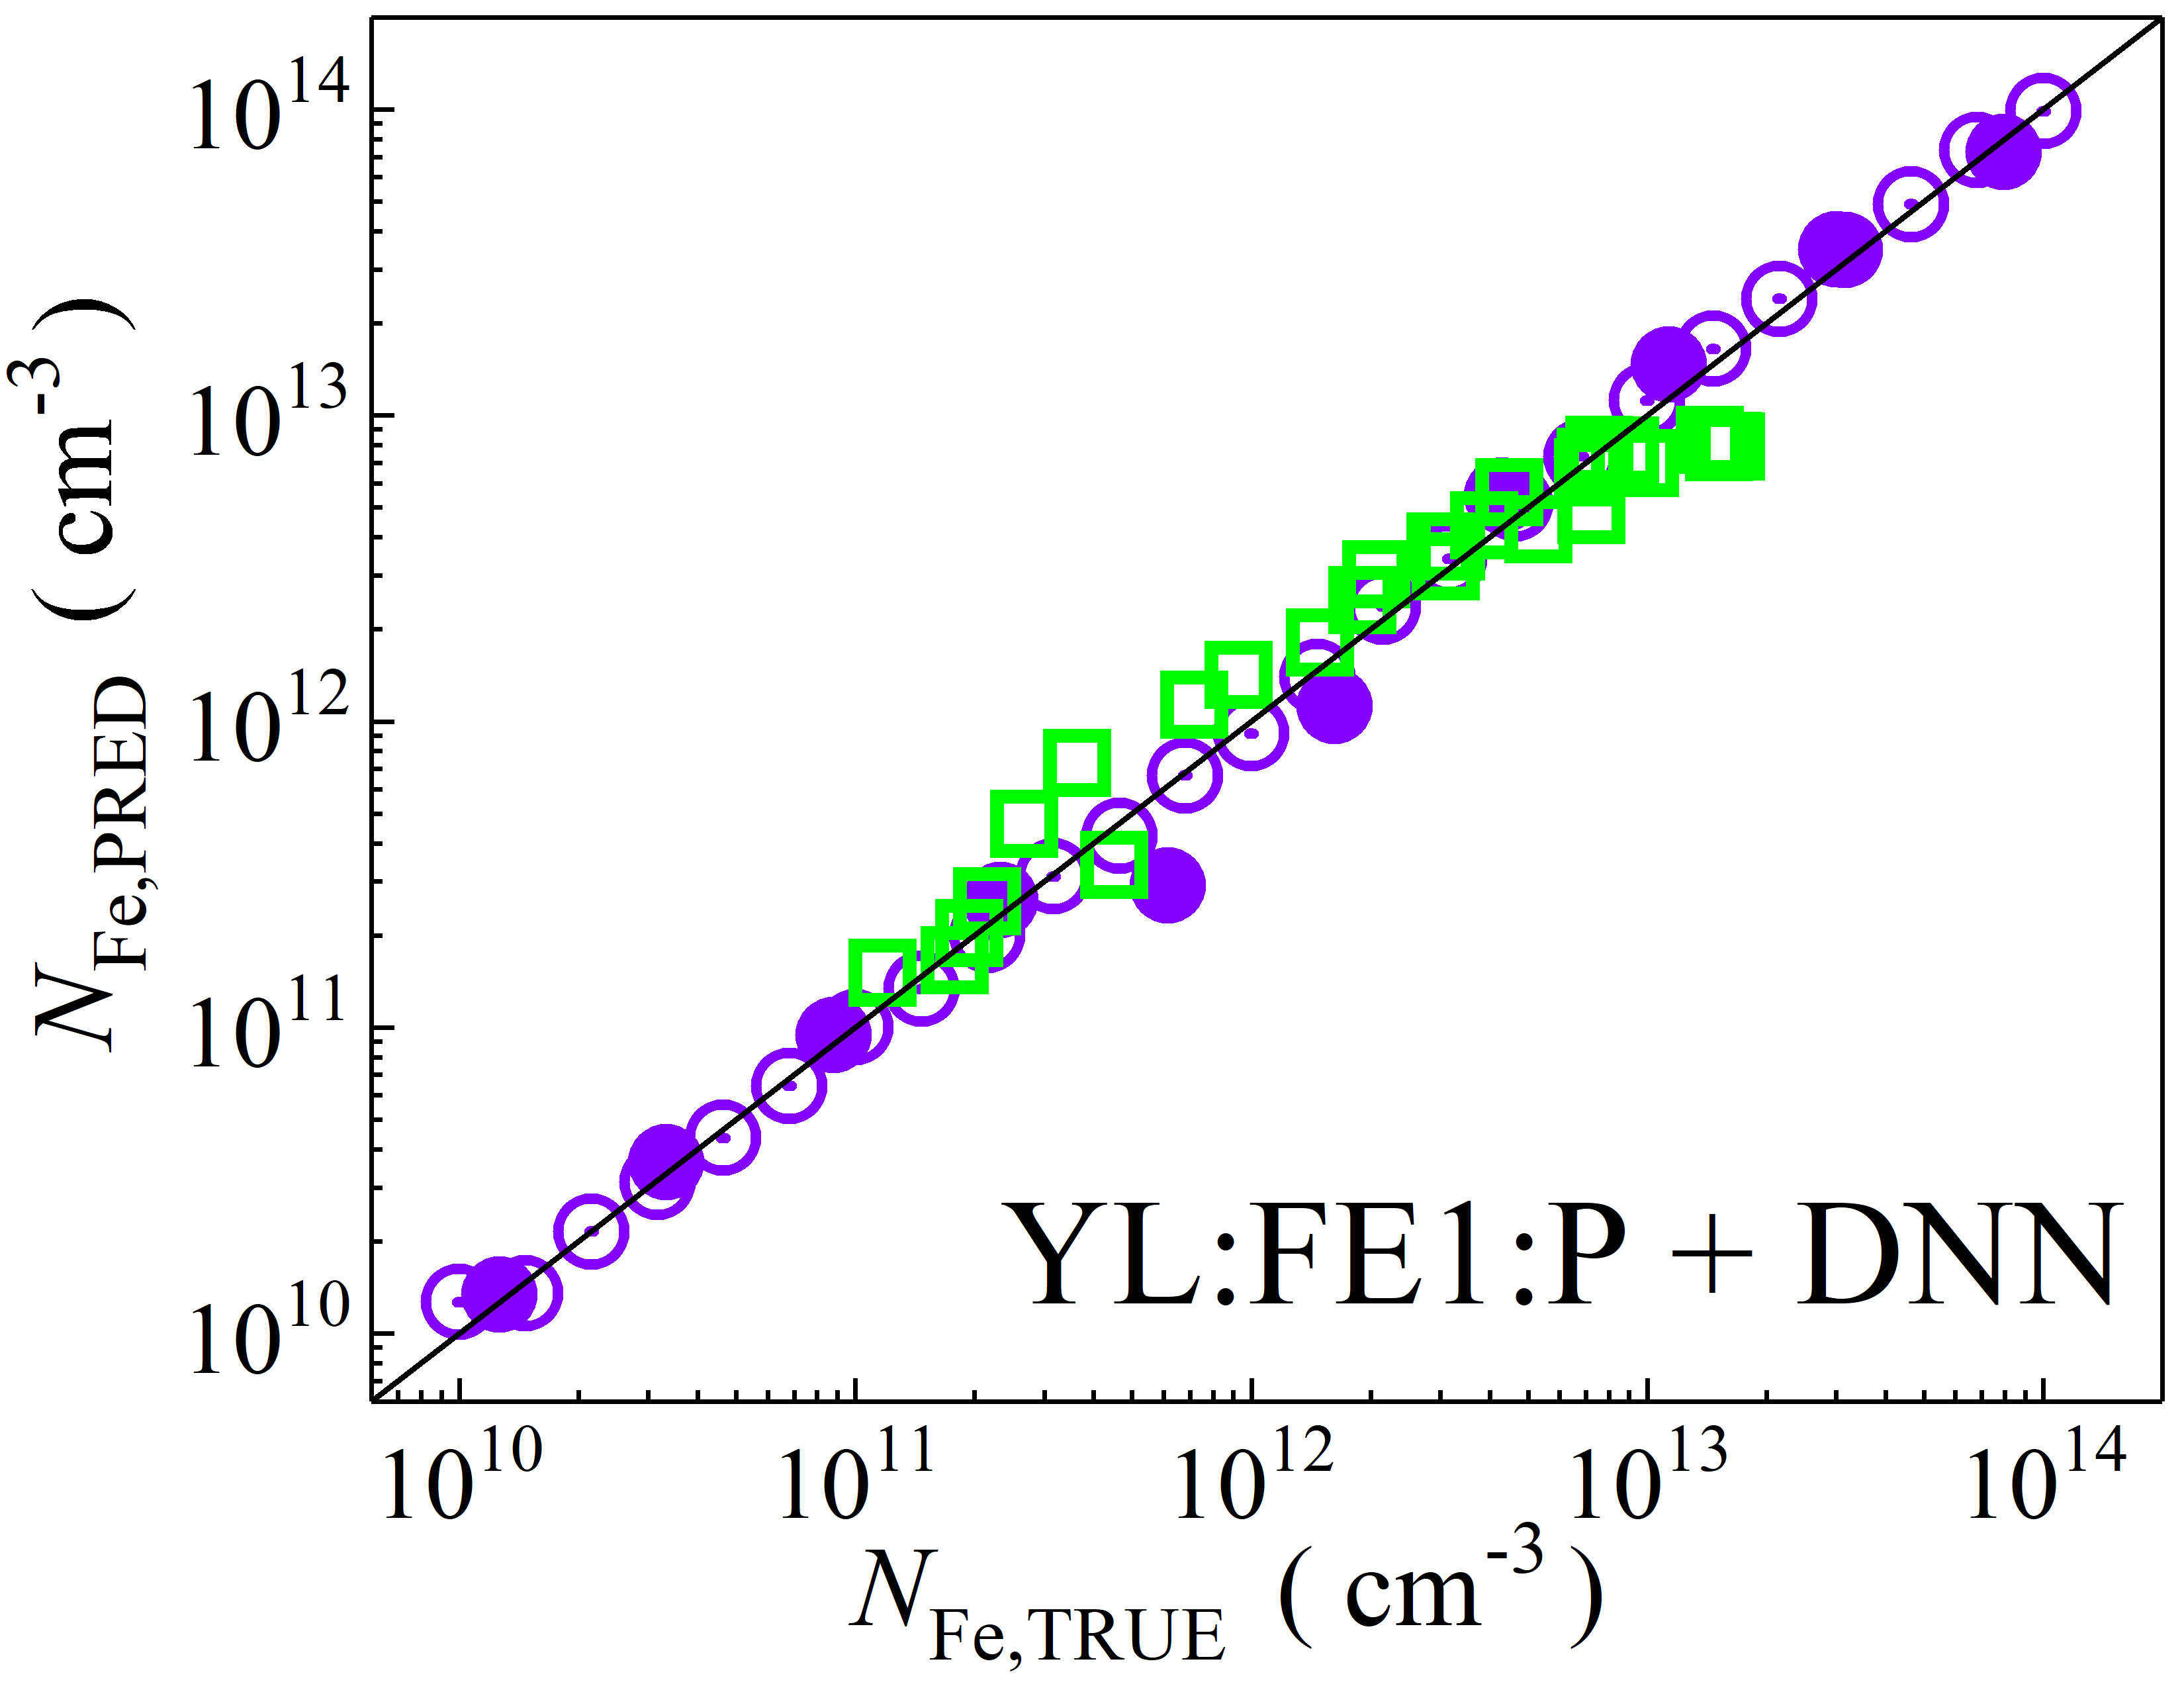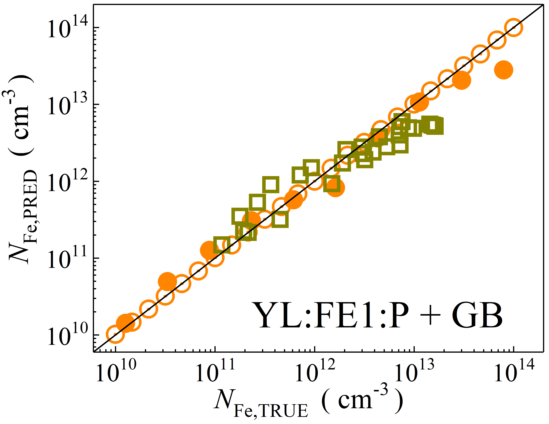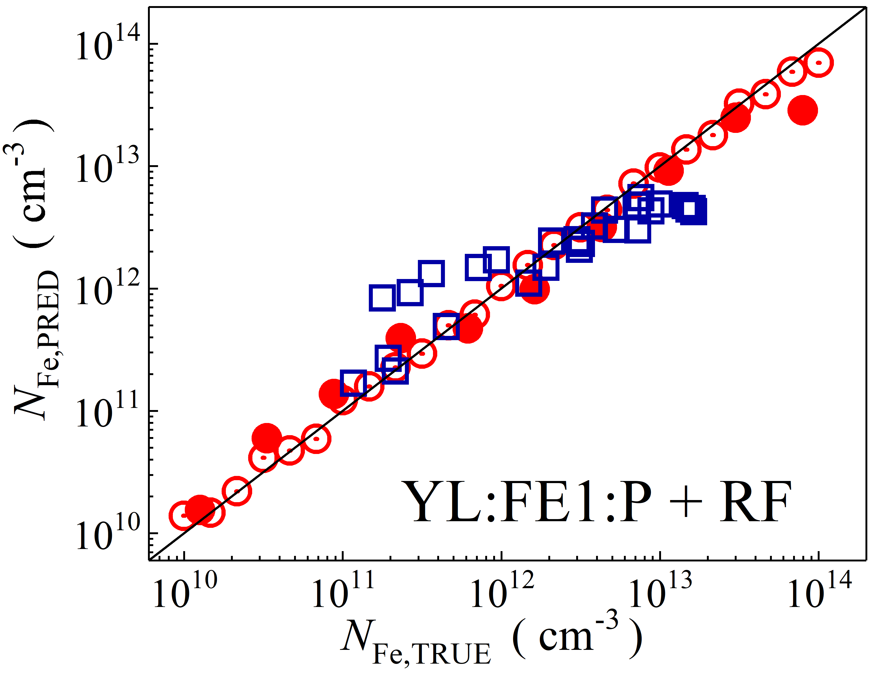

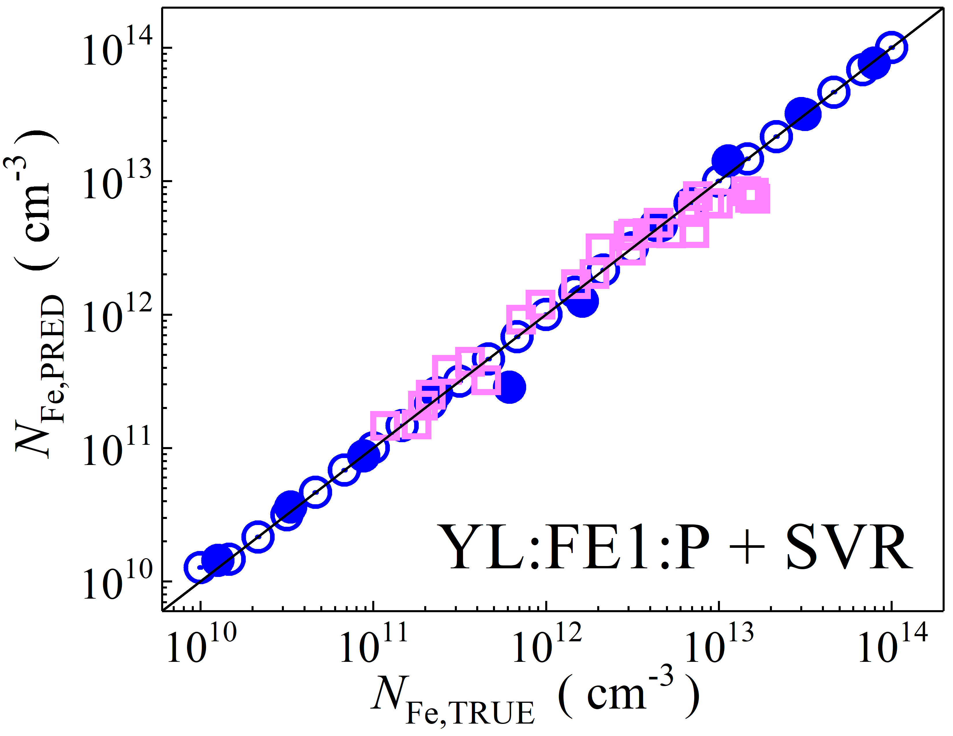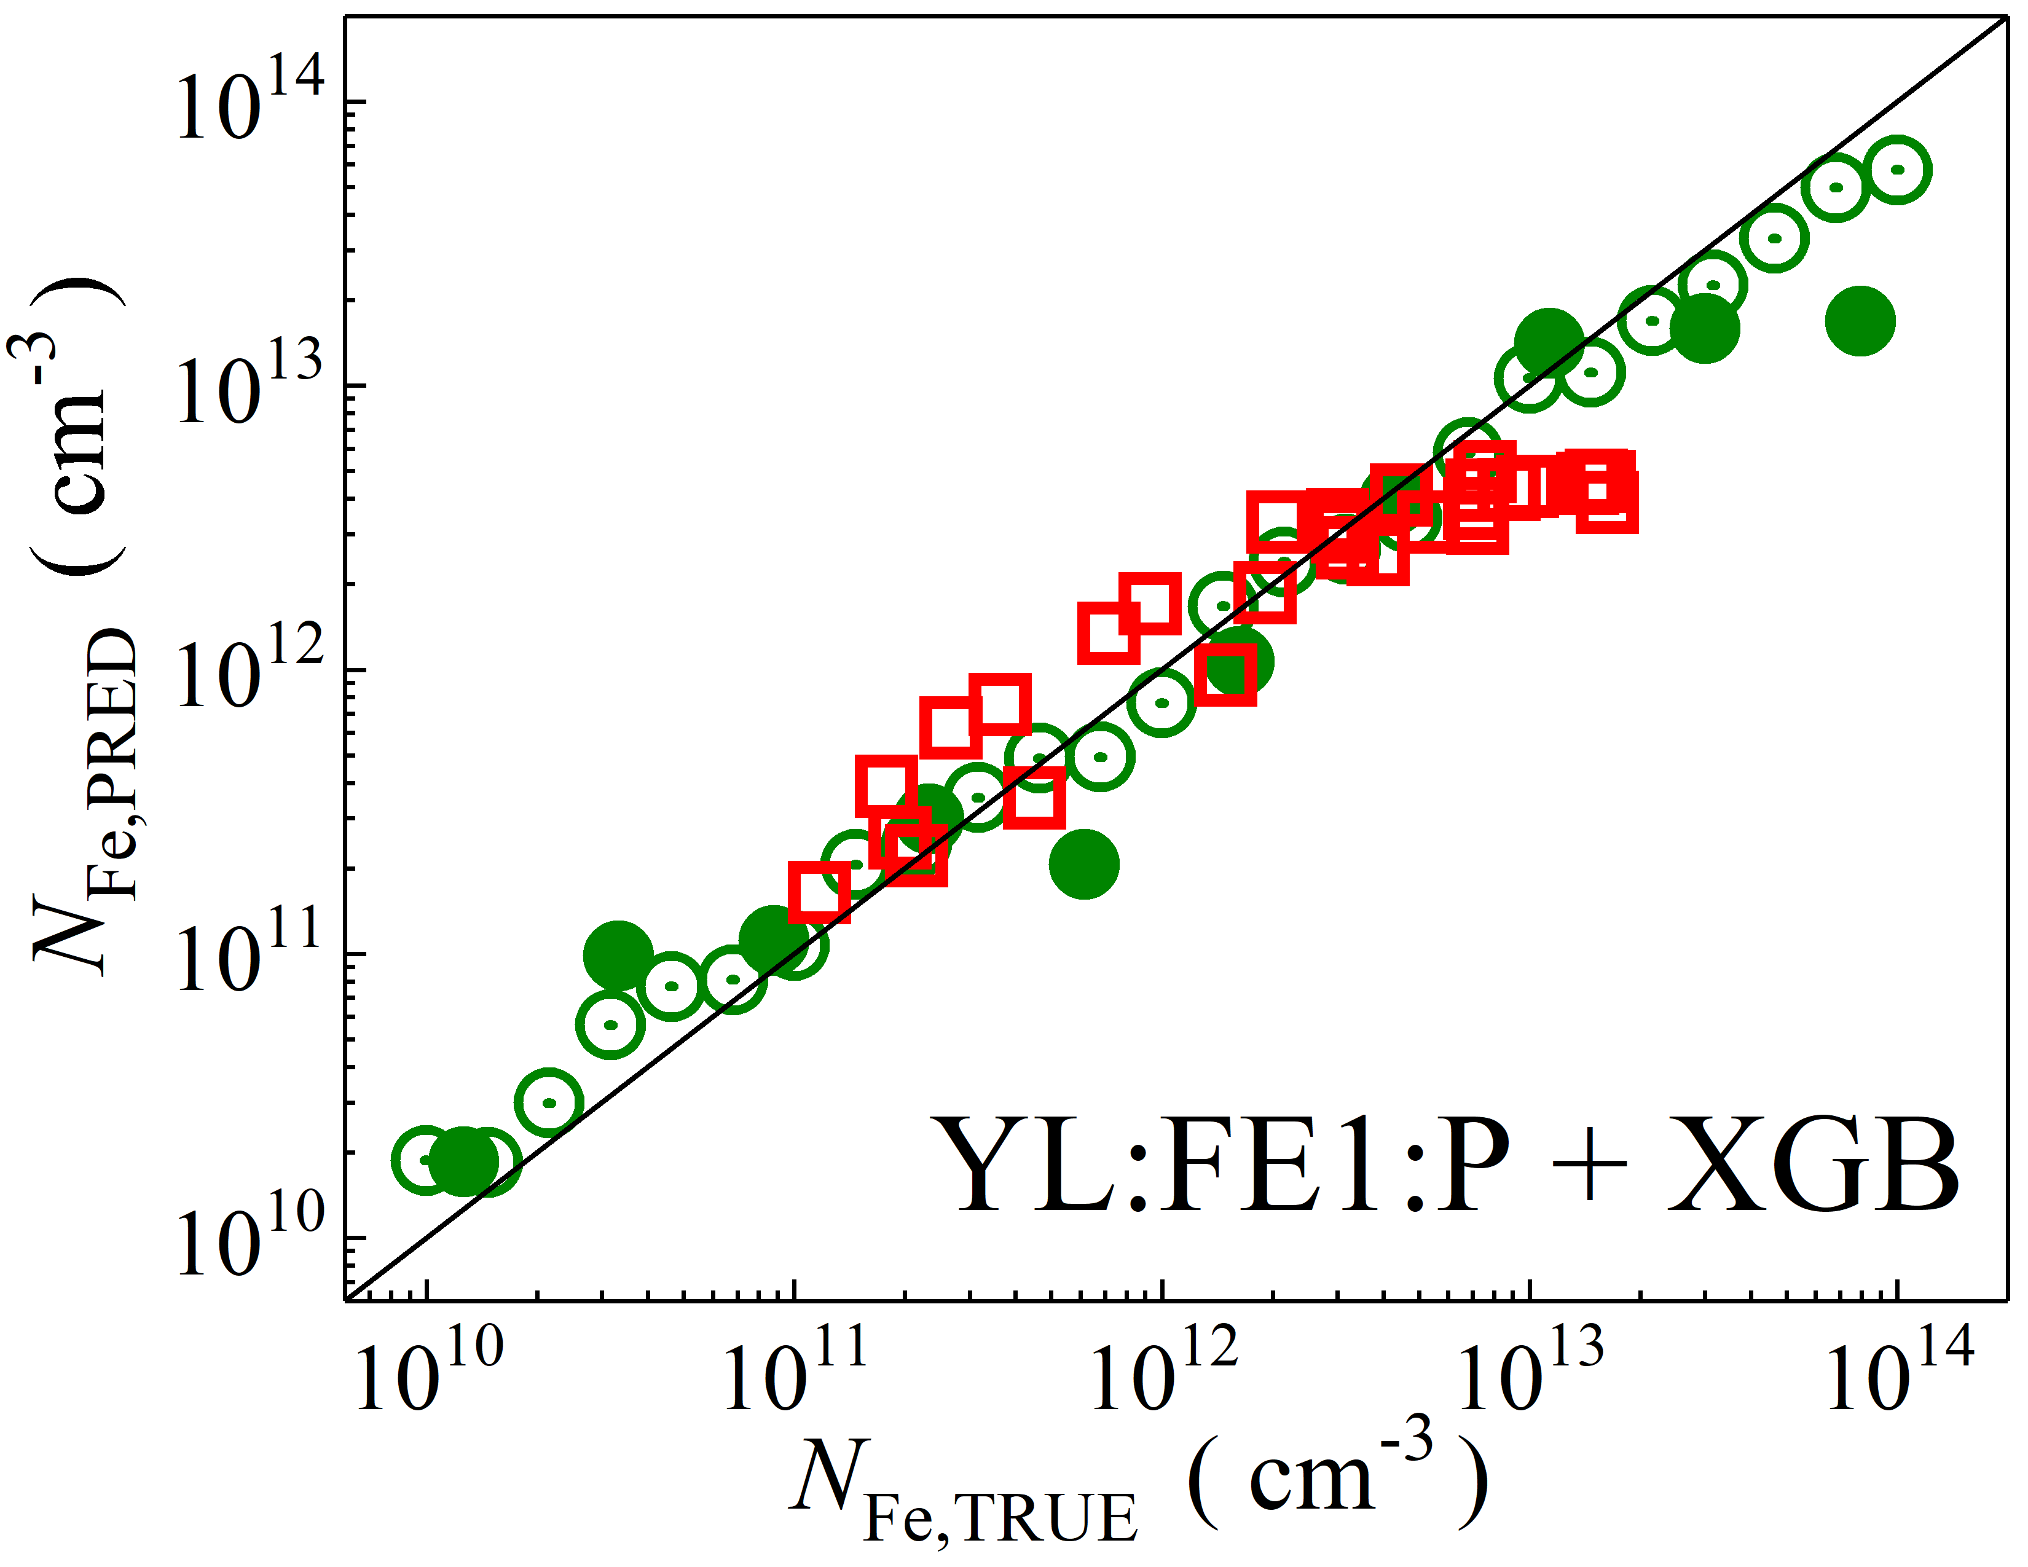

Fig. S15. Scatter plots compare reference iron concentrations $N_{Fe,TRUE}$ with ML-predicted values $N_{Fe,PRED}$ using raw feature extractor layer with PCA reduction of YOLOv4 (CSPDarknet53) visual model. The ML algorithms include DNN (green and purple), GB (dark yellow and yellow), RF (red and blue), SVR (blue and pink), and XGB (green and red). Symbols represent different datasets: open circles — training data (simulated), filled circles — test data (simulated), and open squares — test data from experimental measurements. The black lines are the identified lines serving as the references.

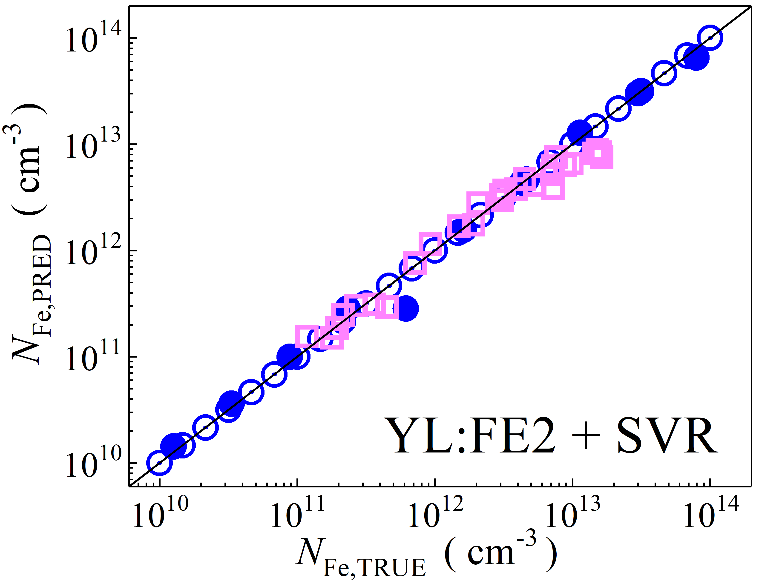

Fig. S16. Scatter plots compare reference iron concentrations $N_{Fe,TRUE}$ with ML-predicted values $N_{Fe,PRED}$ using raw feature extractor layer of CSPDarknet53 backbone visual model (top, penultimate layers). The ML algorithms include SVR (blue and pink). Symbols represent different datasets: open circles — training data (simulated), filled circles — test data (simulated), and open squares — test data from experimental measurements. The black lines are the identified lines serving as the references.

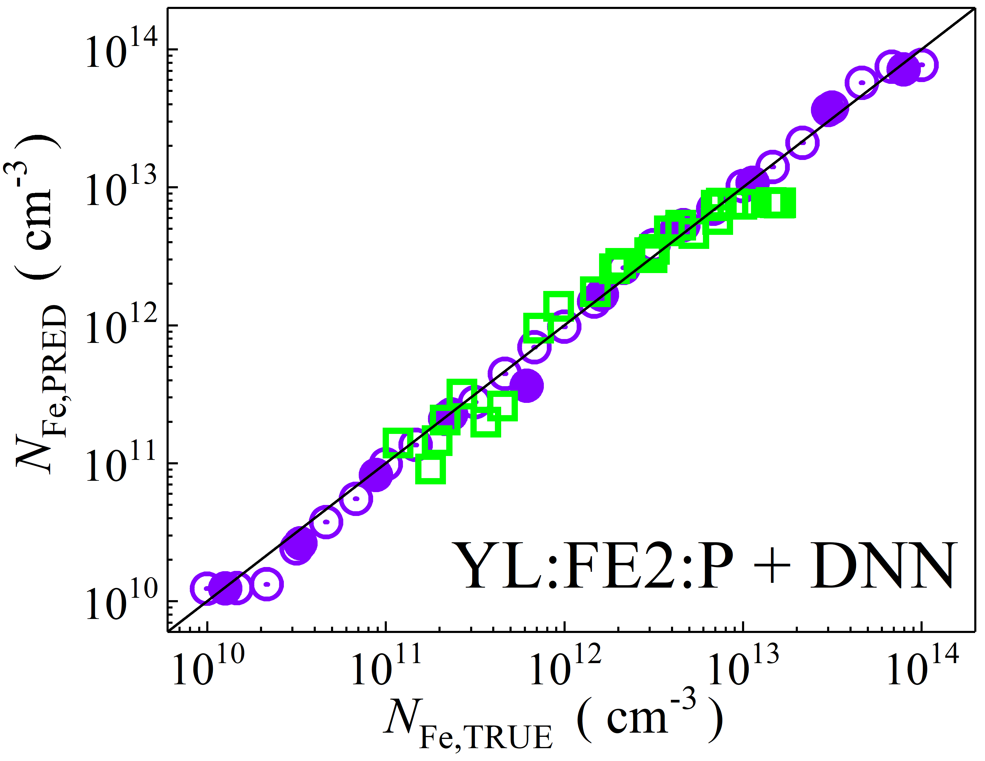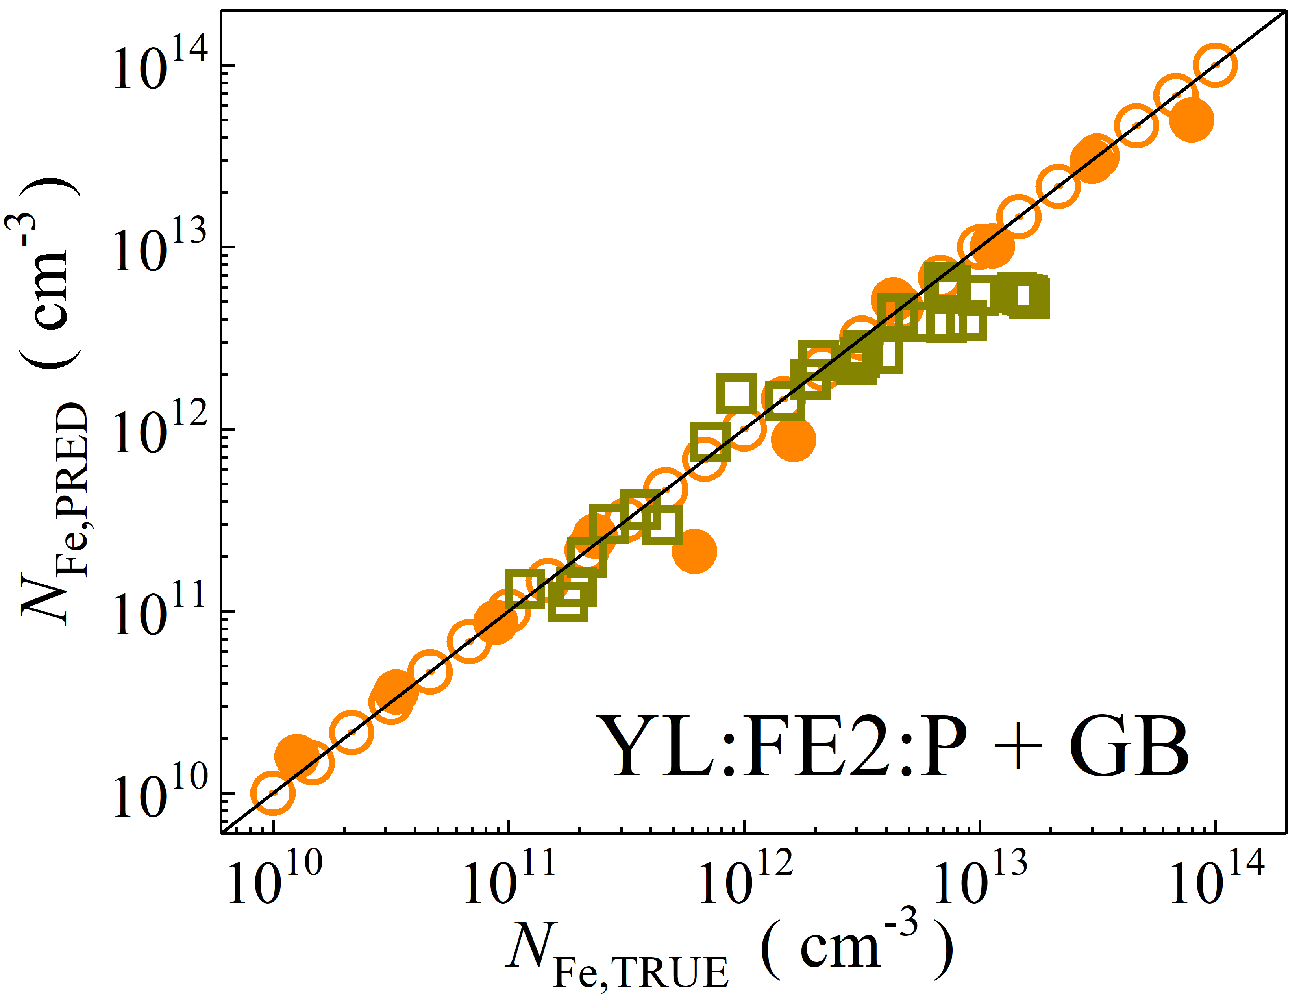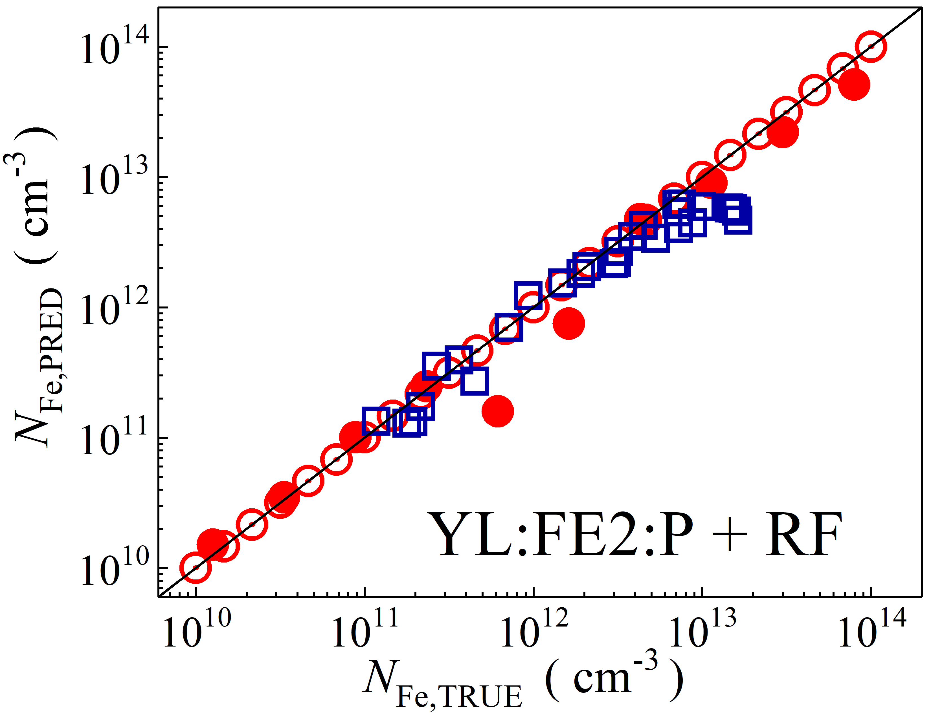

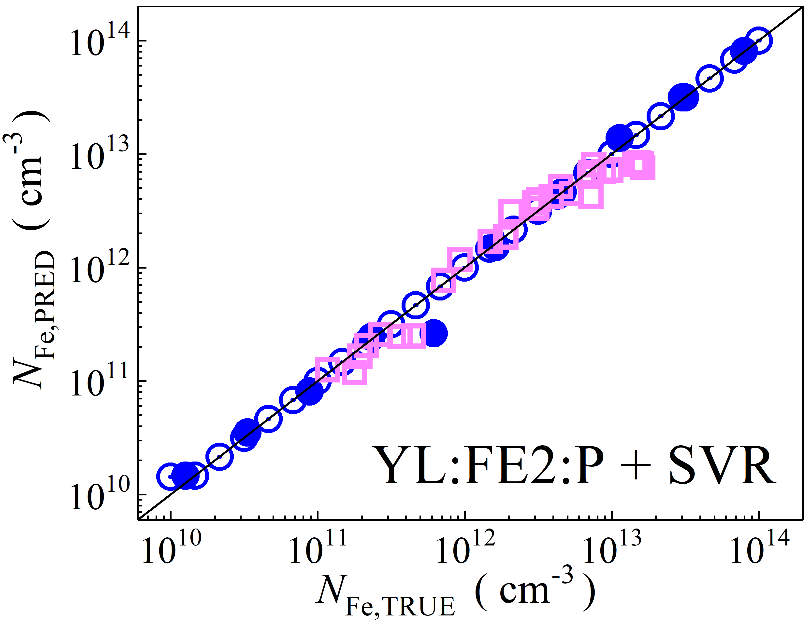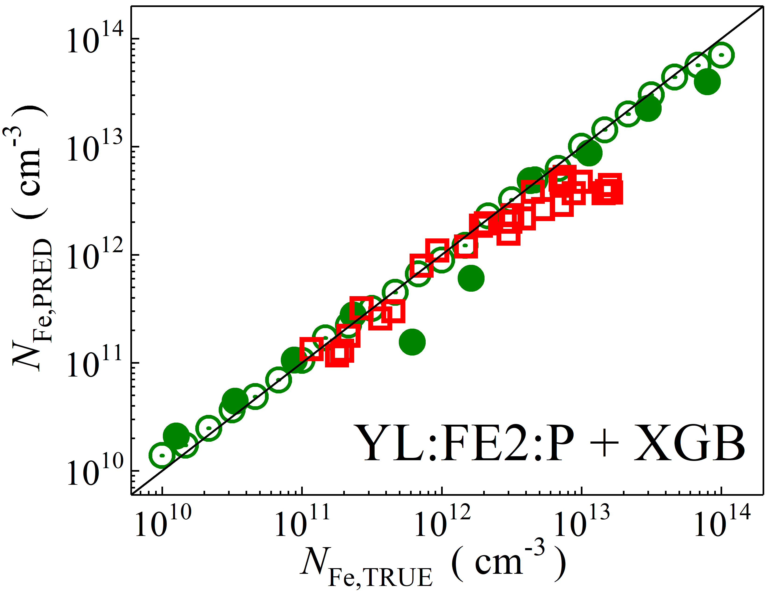

Fig. S17. Scatter plots compare reference iron concentrations $N_{Fe,TRUE}$ with ML-predicted values $N_{Fe,PRED}$ using raw feature extractor layer with PCA reduction of CSPDarknet53 backbone visual model (top, penultimate layers). The ML algorithms include DNN (green and purple), GB (dark yellow and yellow), RF (red and blue), SVR (blue and pink), and XGB (green and red). Symbols represent different datasets: open circles — training data (simulated), filled circles — test data (simulated), and open squares — test data from experimental measurements. The black lines are the identified lines serving as the references.

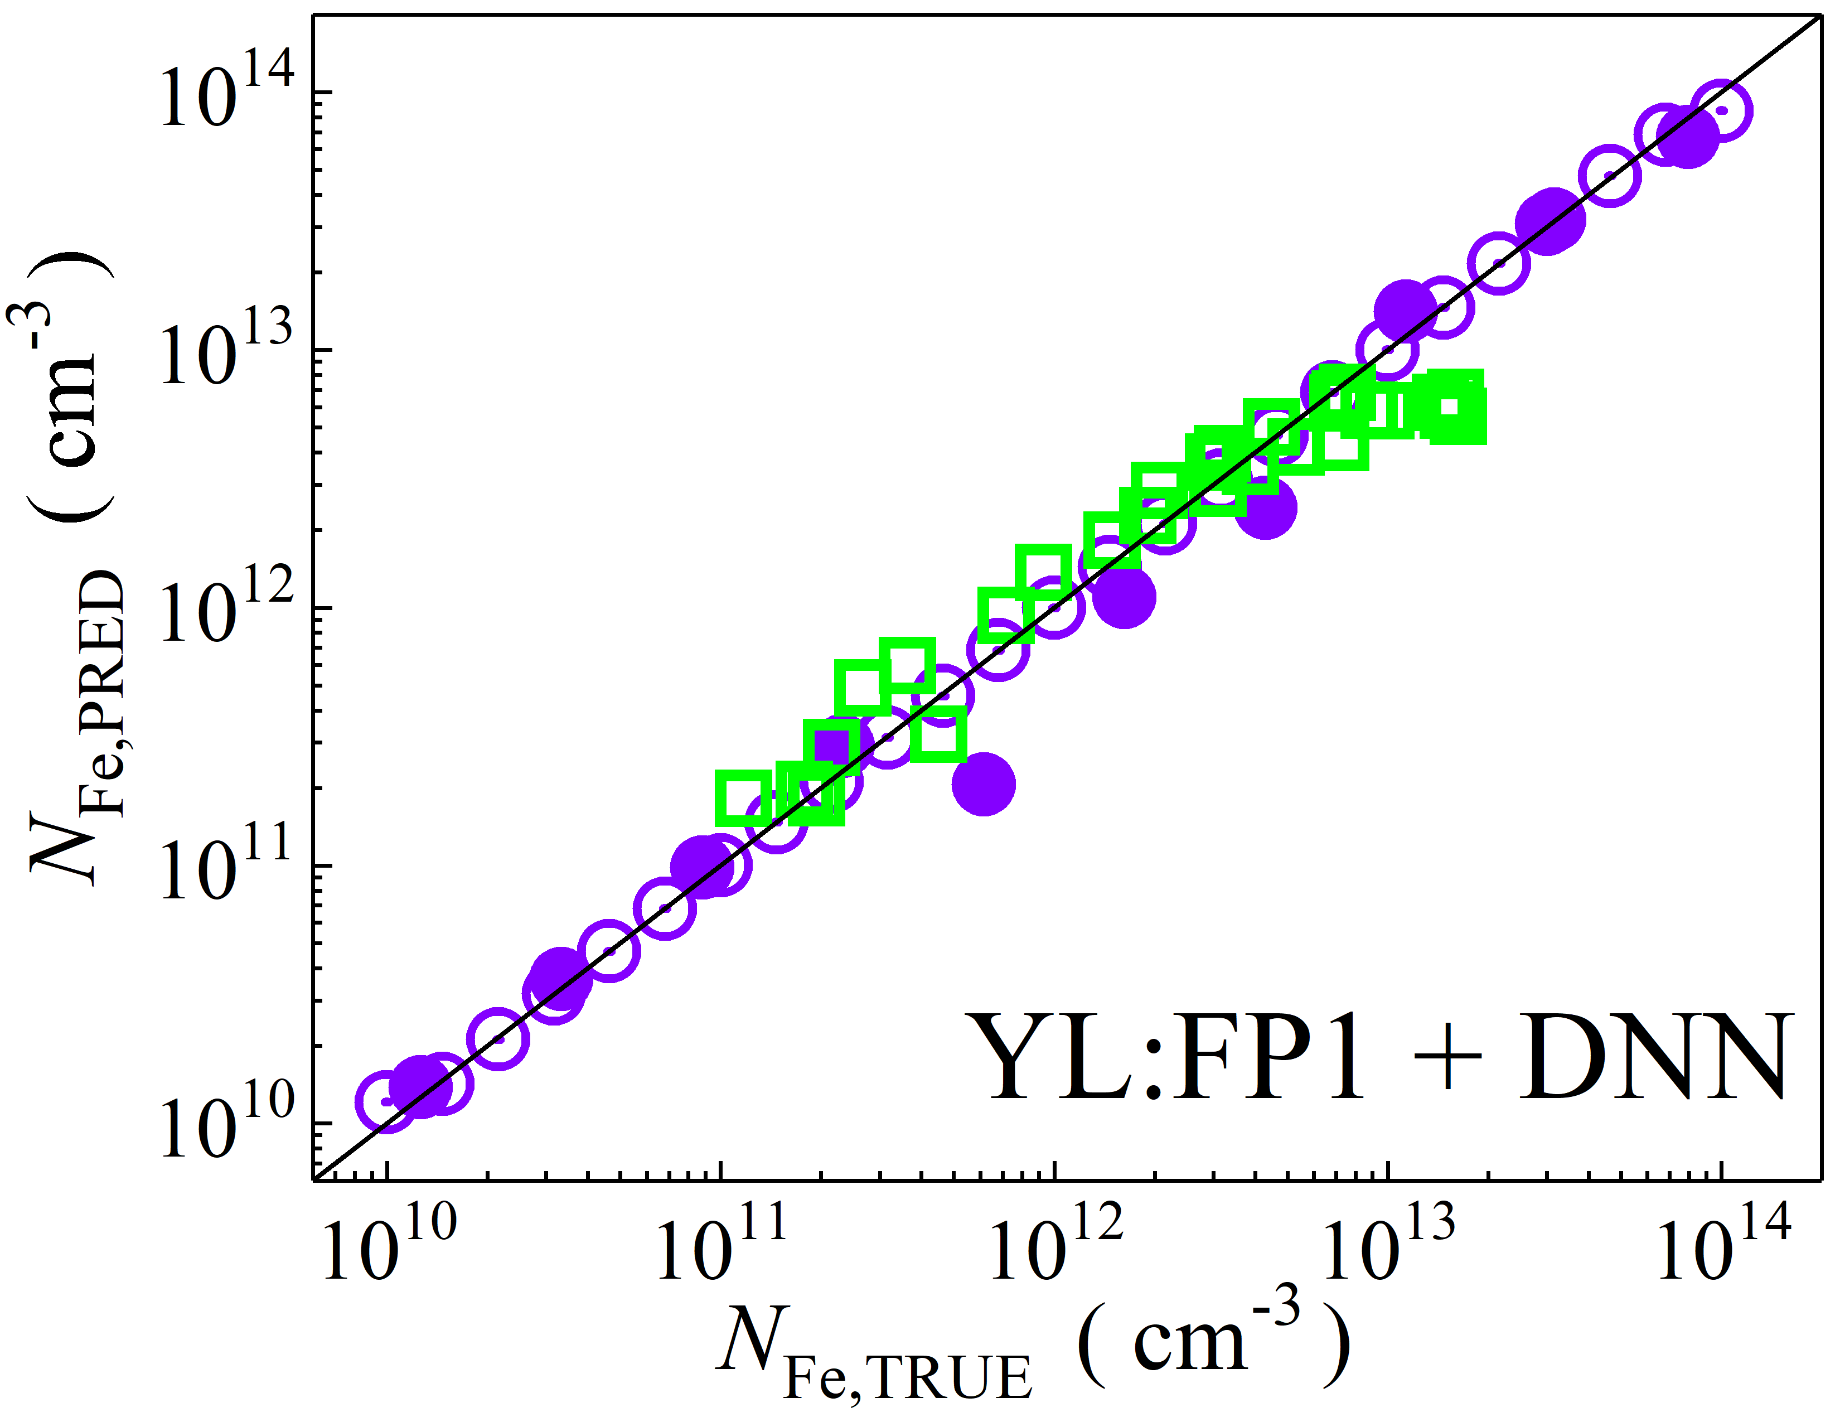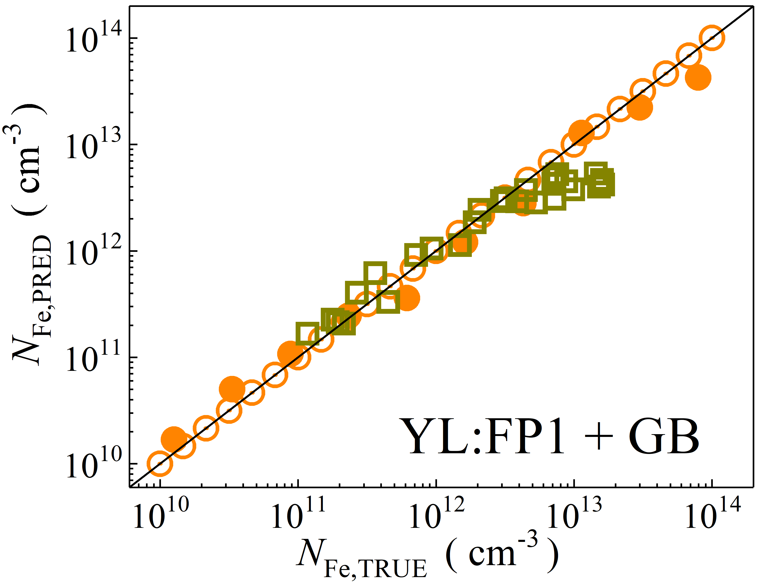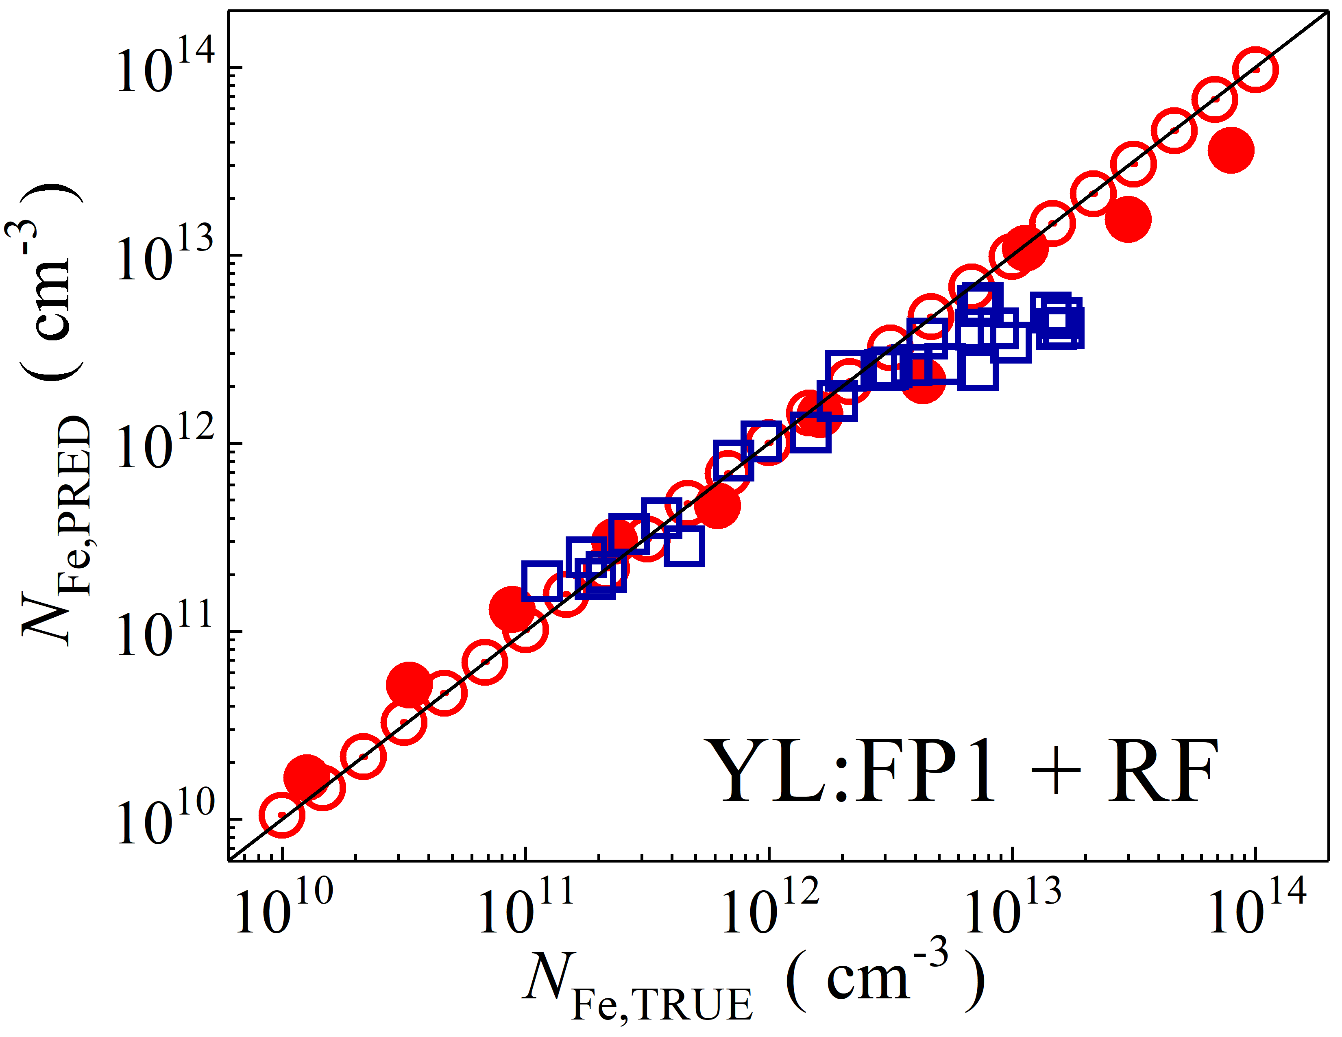

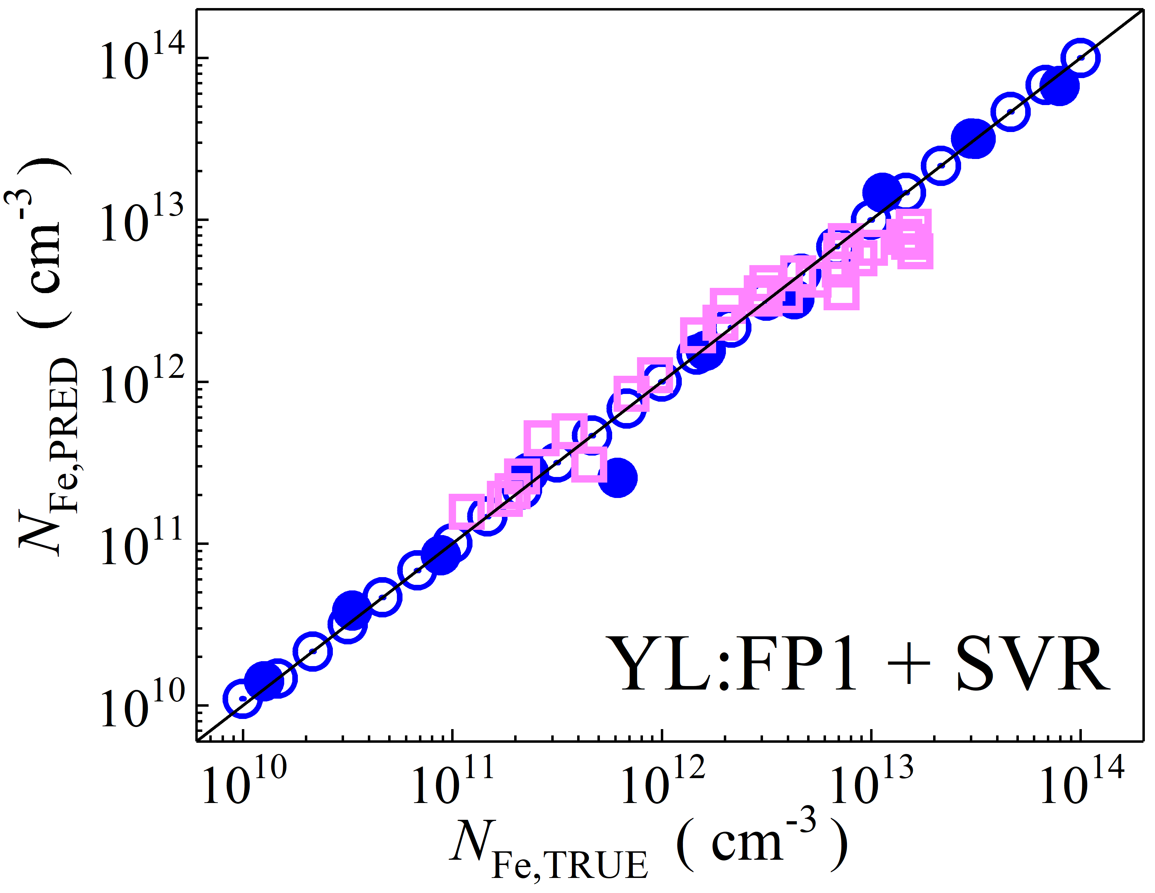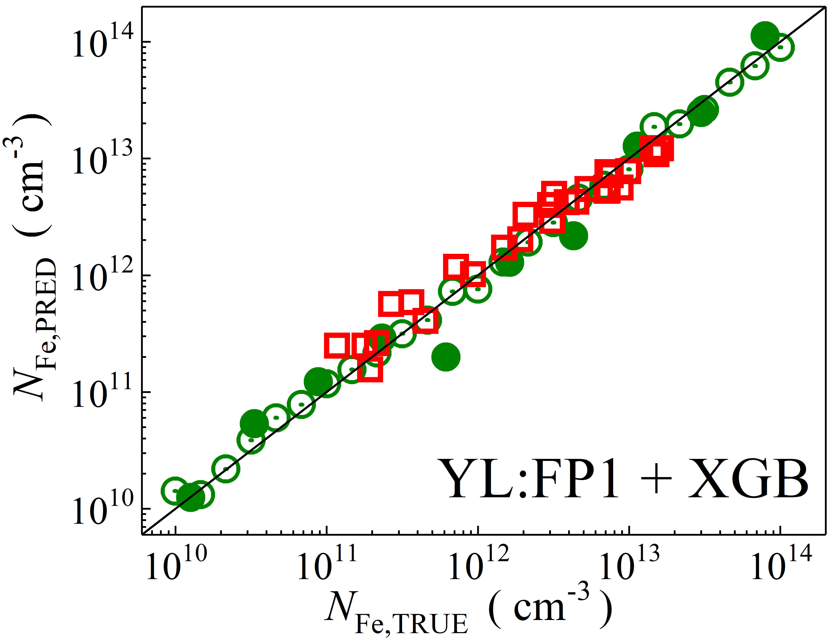

Fig. S18. Scatter plots compare reference iron concentrations $N_{Fe,TRUE}$ with ML-predicted values $N_{Fe,PRED}$ using global average pooled features from the top layer of YOLOv4 visual model. The ML algorithms include DNN (green and purple), GB (dark yellow and yellow), RF (red and blue), SVR (blue and pink), and XGB (green and red). Symbols represent different datasets: open circles — training data (simulated), filled circles — test data (simulated), and open squares — test data from experimental measurements. The black lines are the identified lines serving as the references.

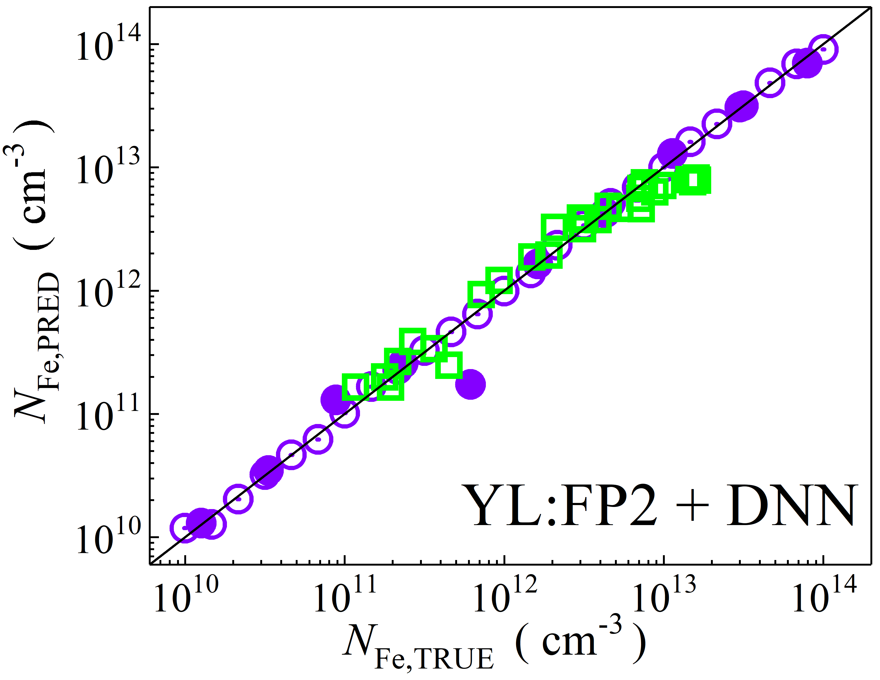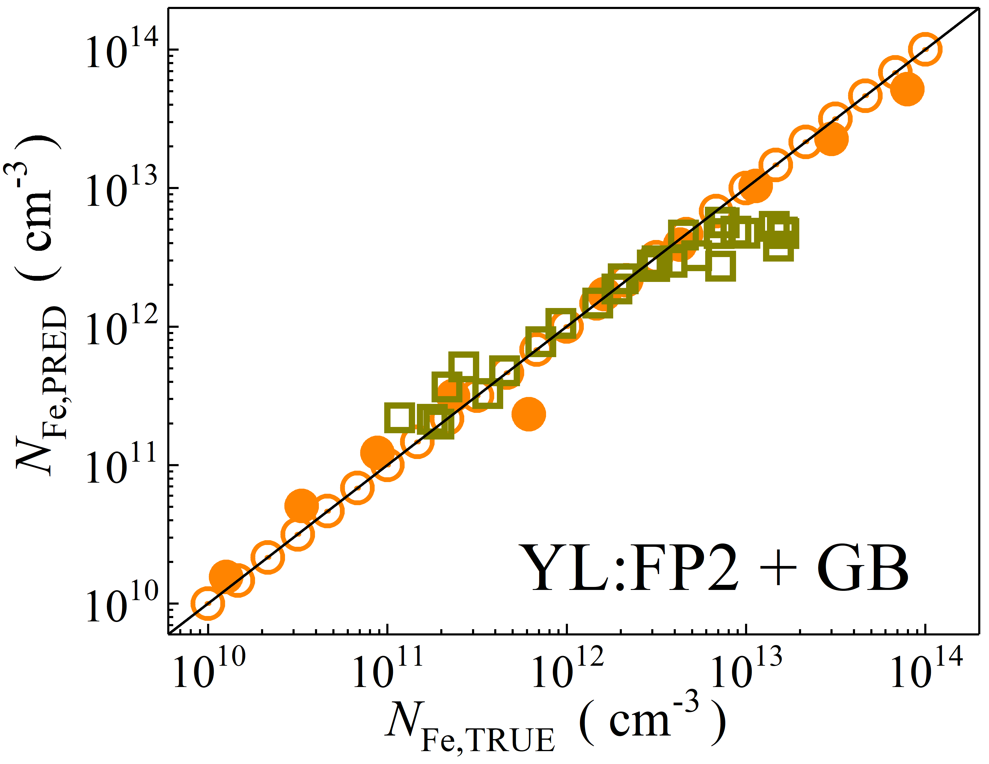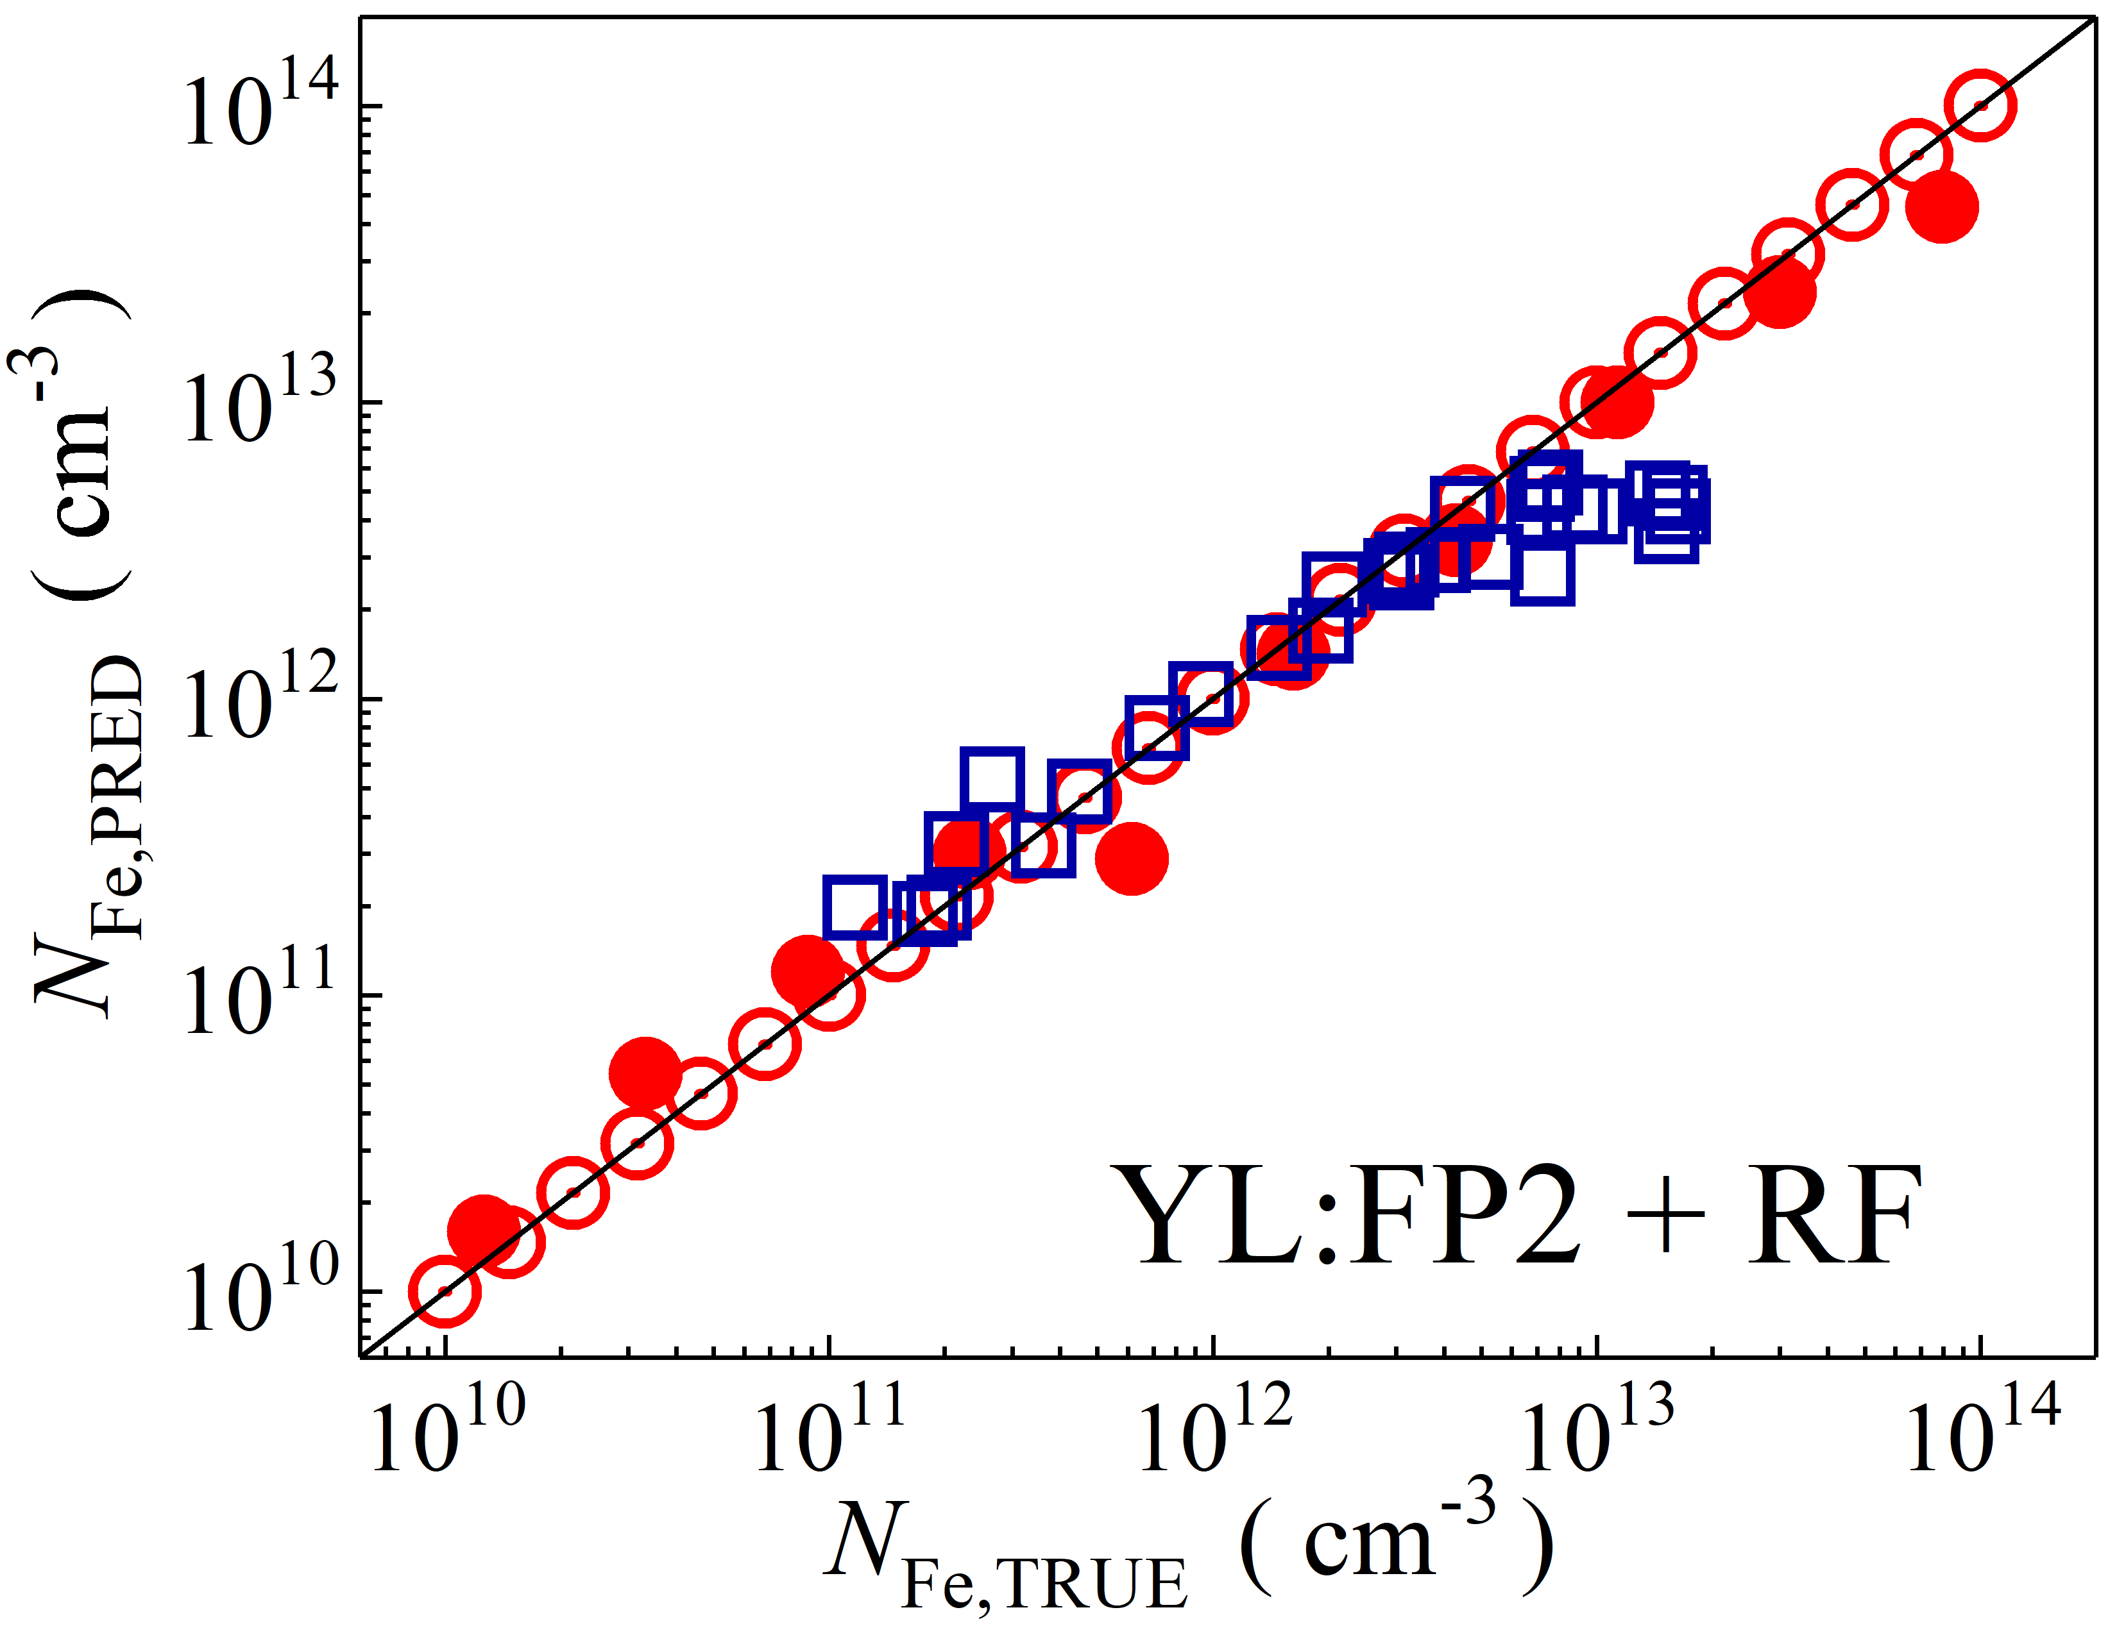

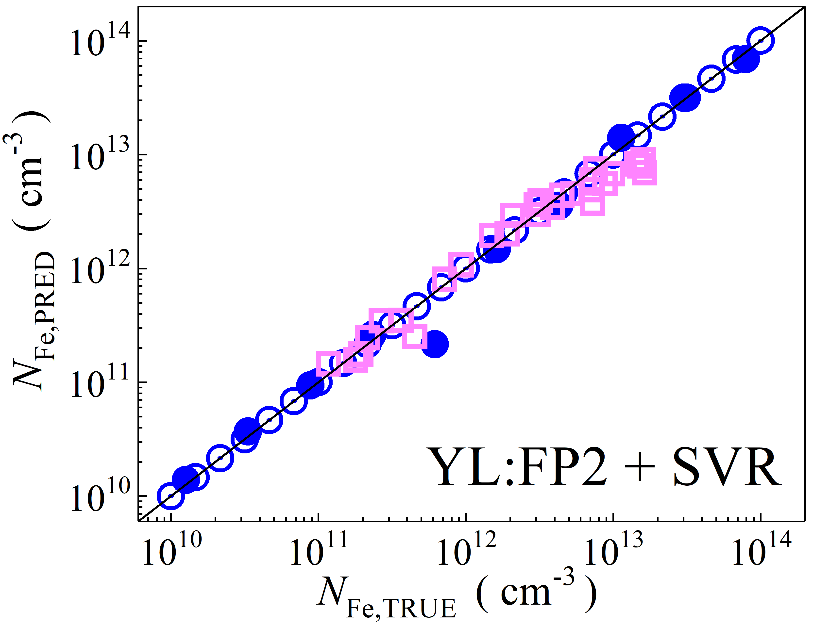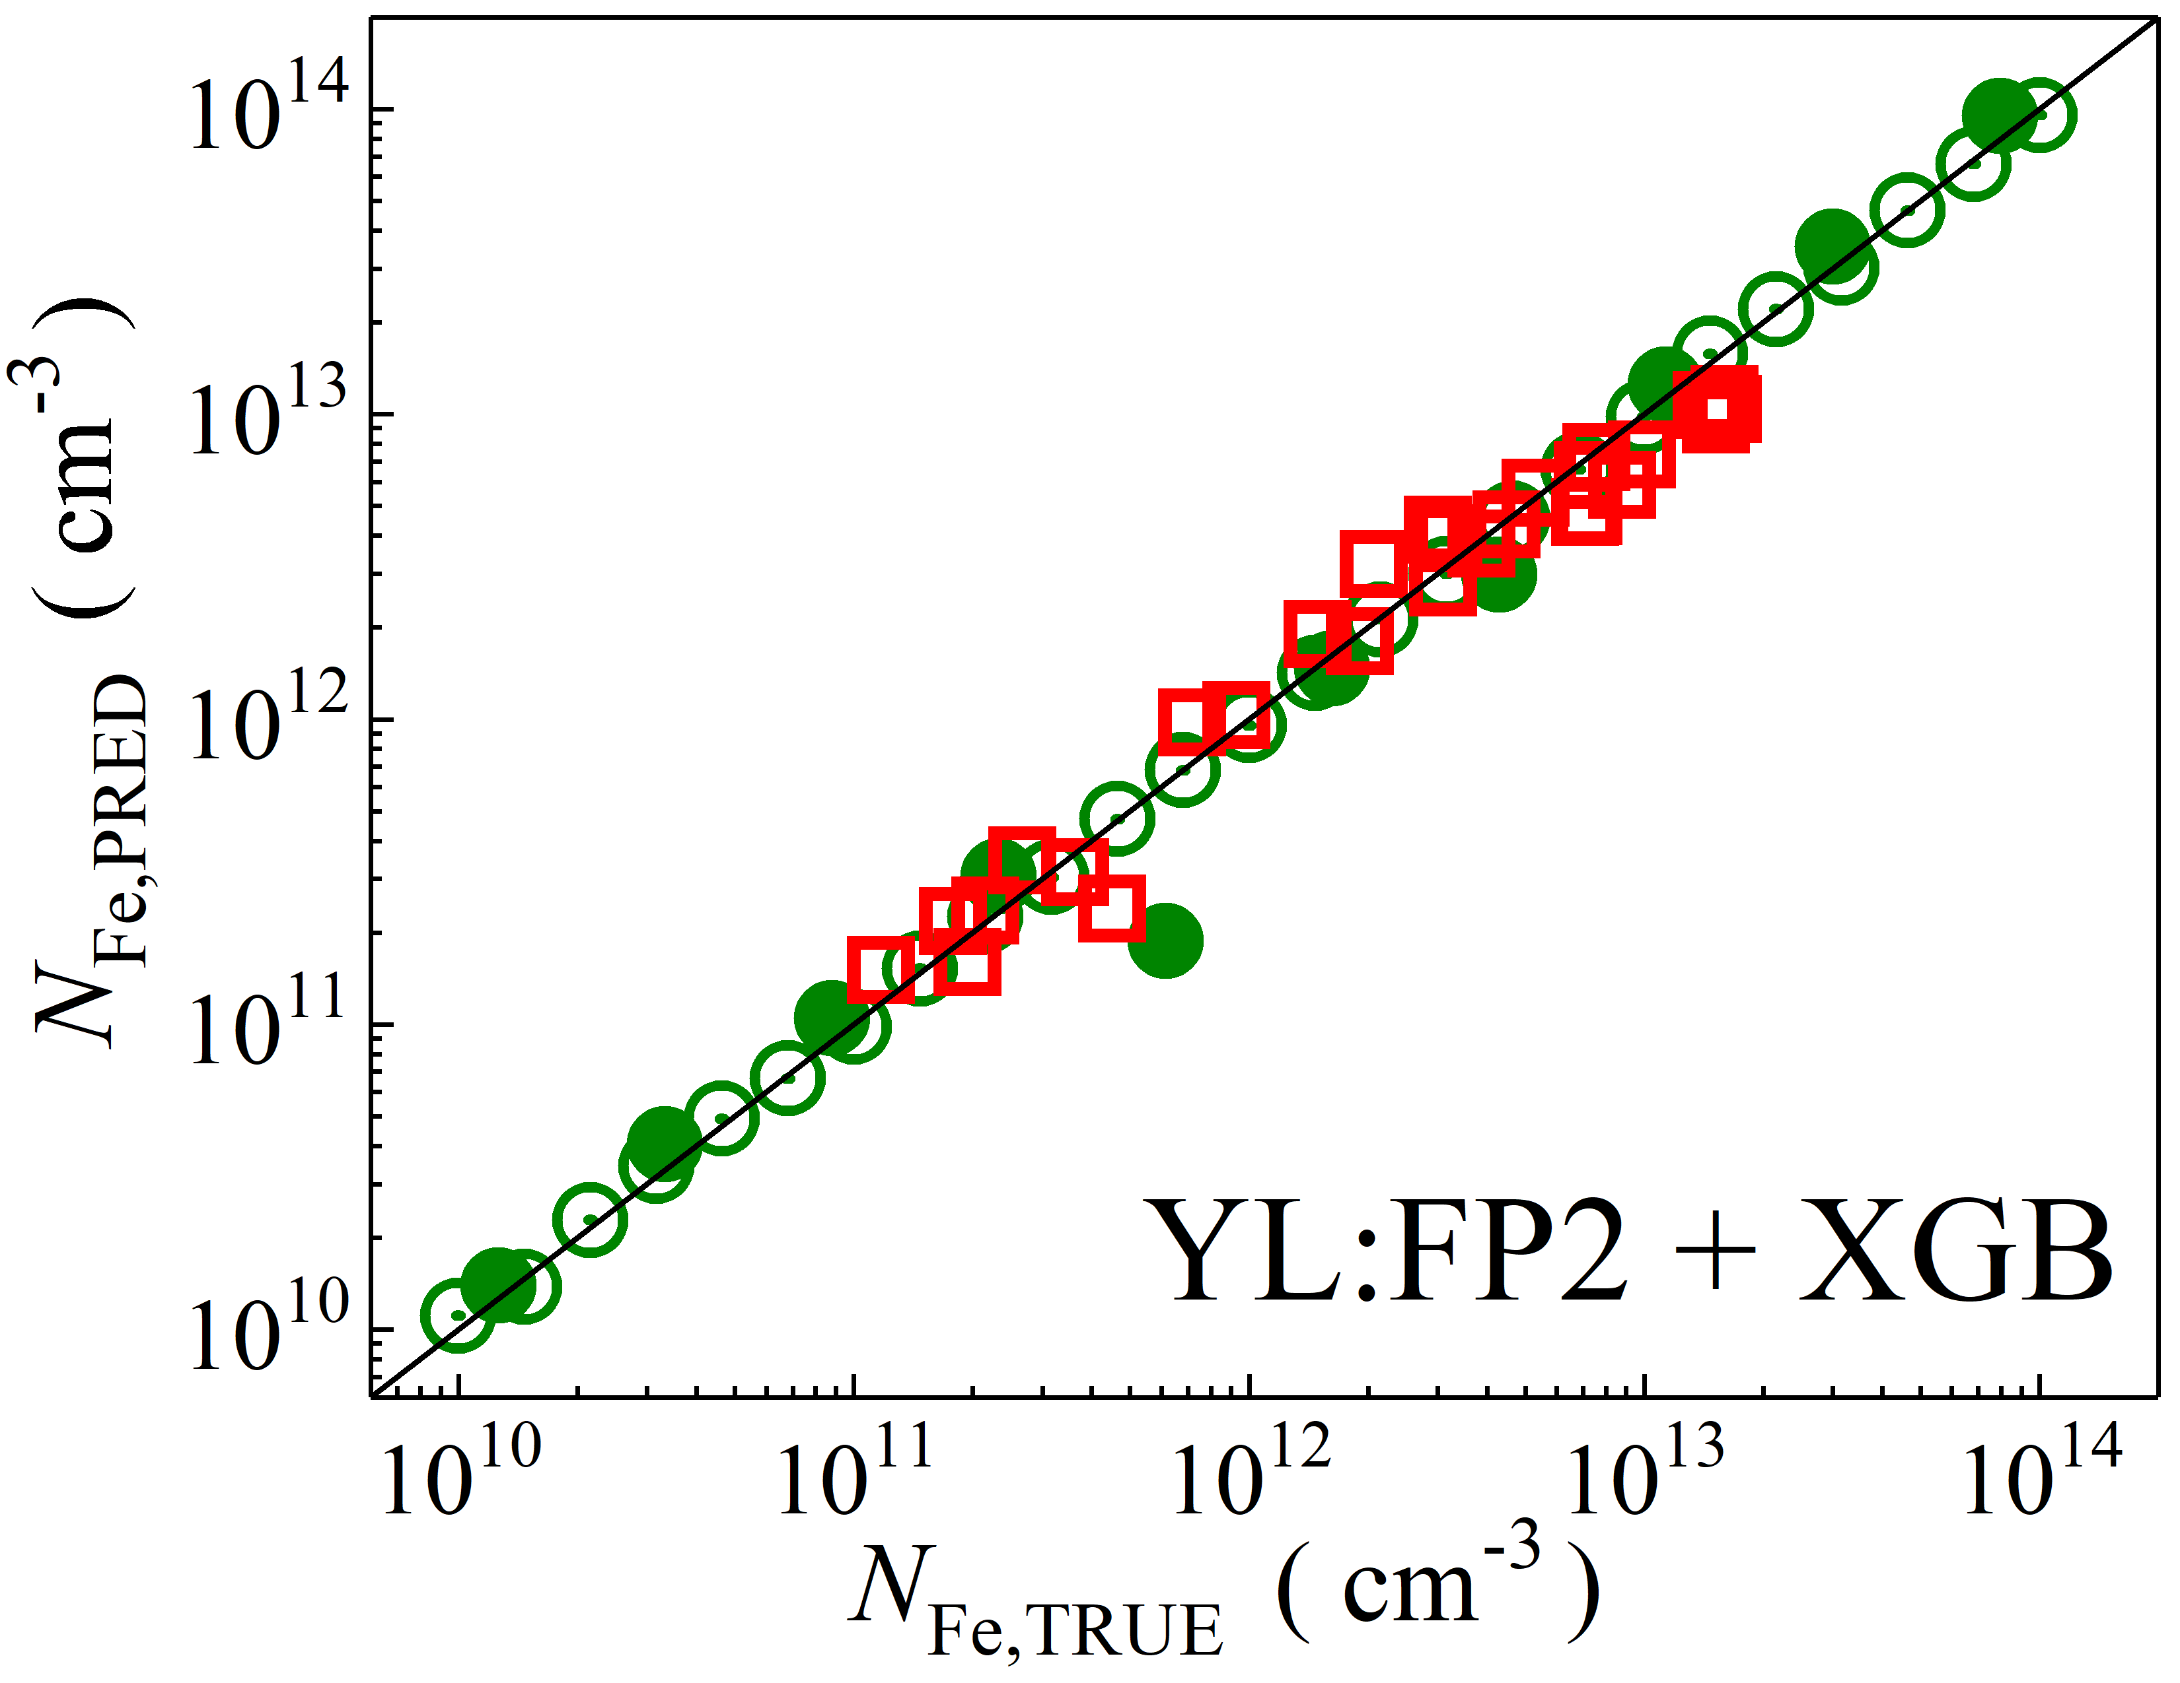

Fig. S19. Scatter plots compare reference iron concentrations $N_{Fe,TRUE}$ with ML-predicted values $N_{Fe,PRED}$ using concatenated pooled features from the top and penultimate layers of YOLOv4 visual model. The ML algorithms include DNN (green and purple), GB (dark yellow and yellow), RF (red and blue), SVR (blue and pink), and XGB (green and red). Symbols represent different datasets: open circles — training data (simulated), filled circles — test data (simulated), and open squares — test data from experimental measurements. The black lines are the identified lines serving as the references.

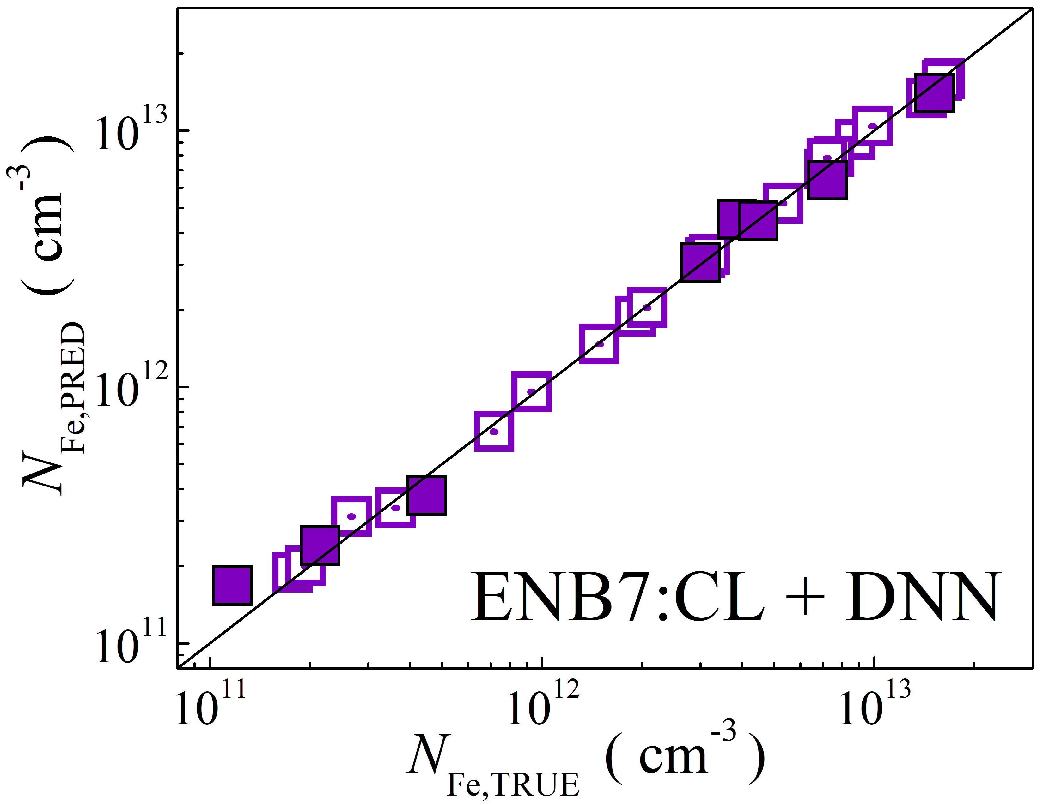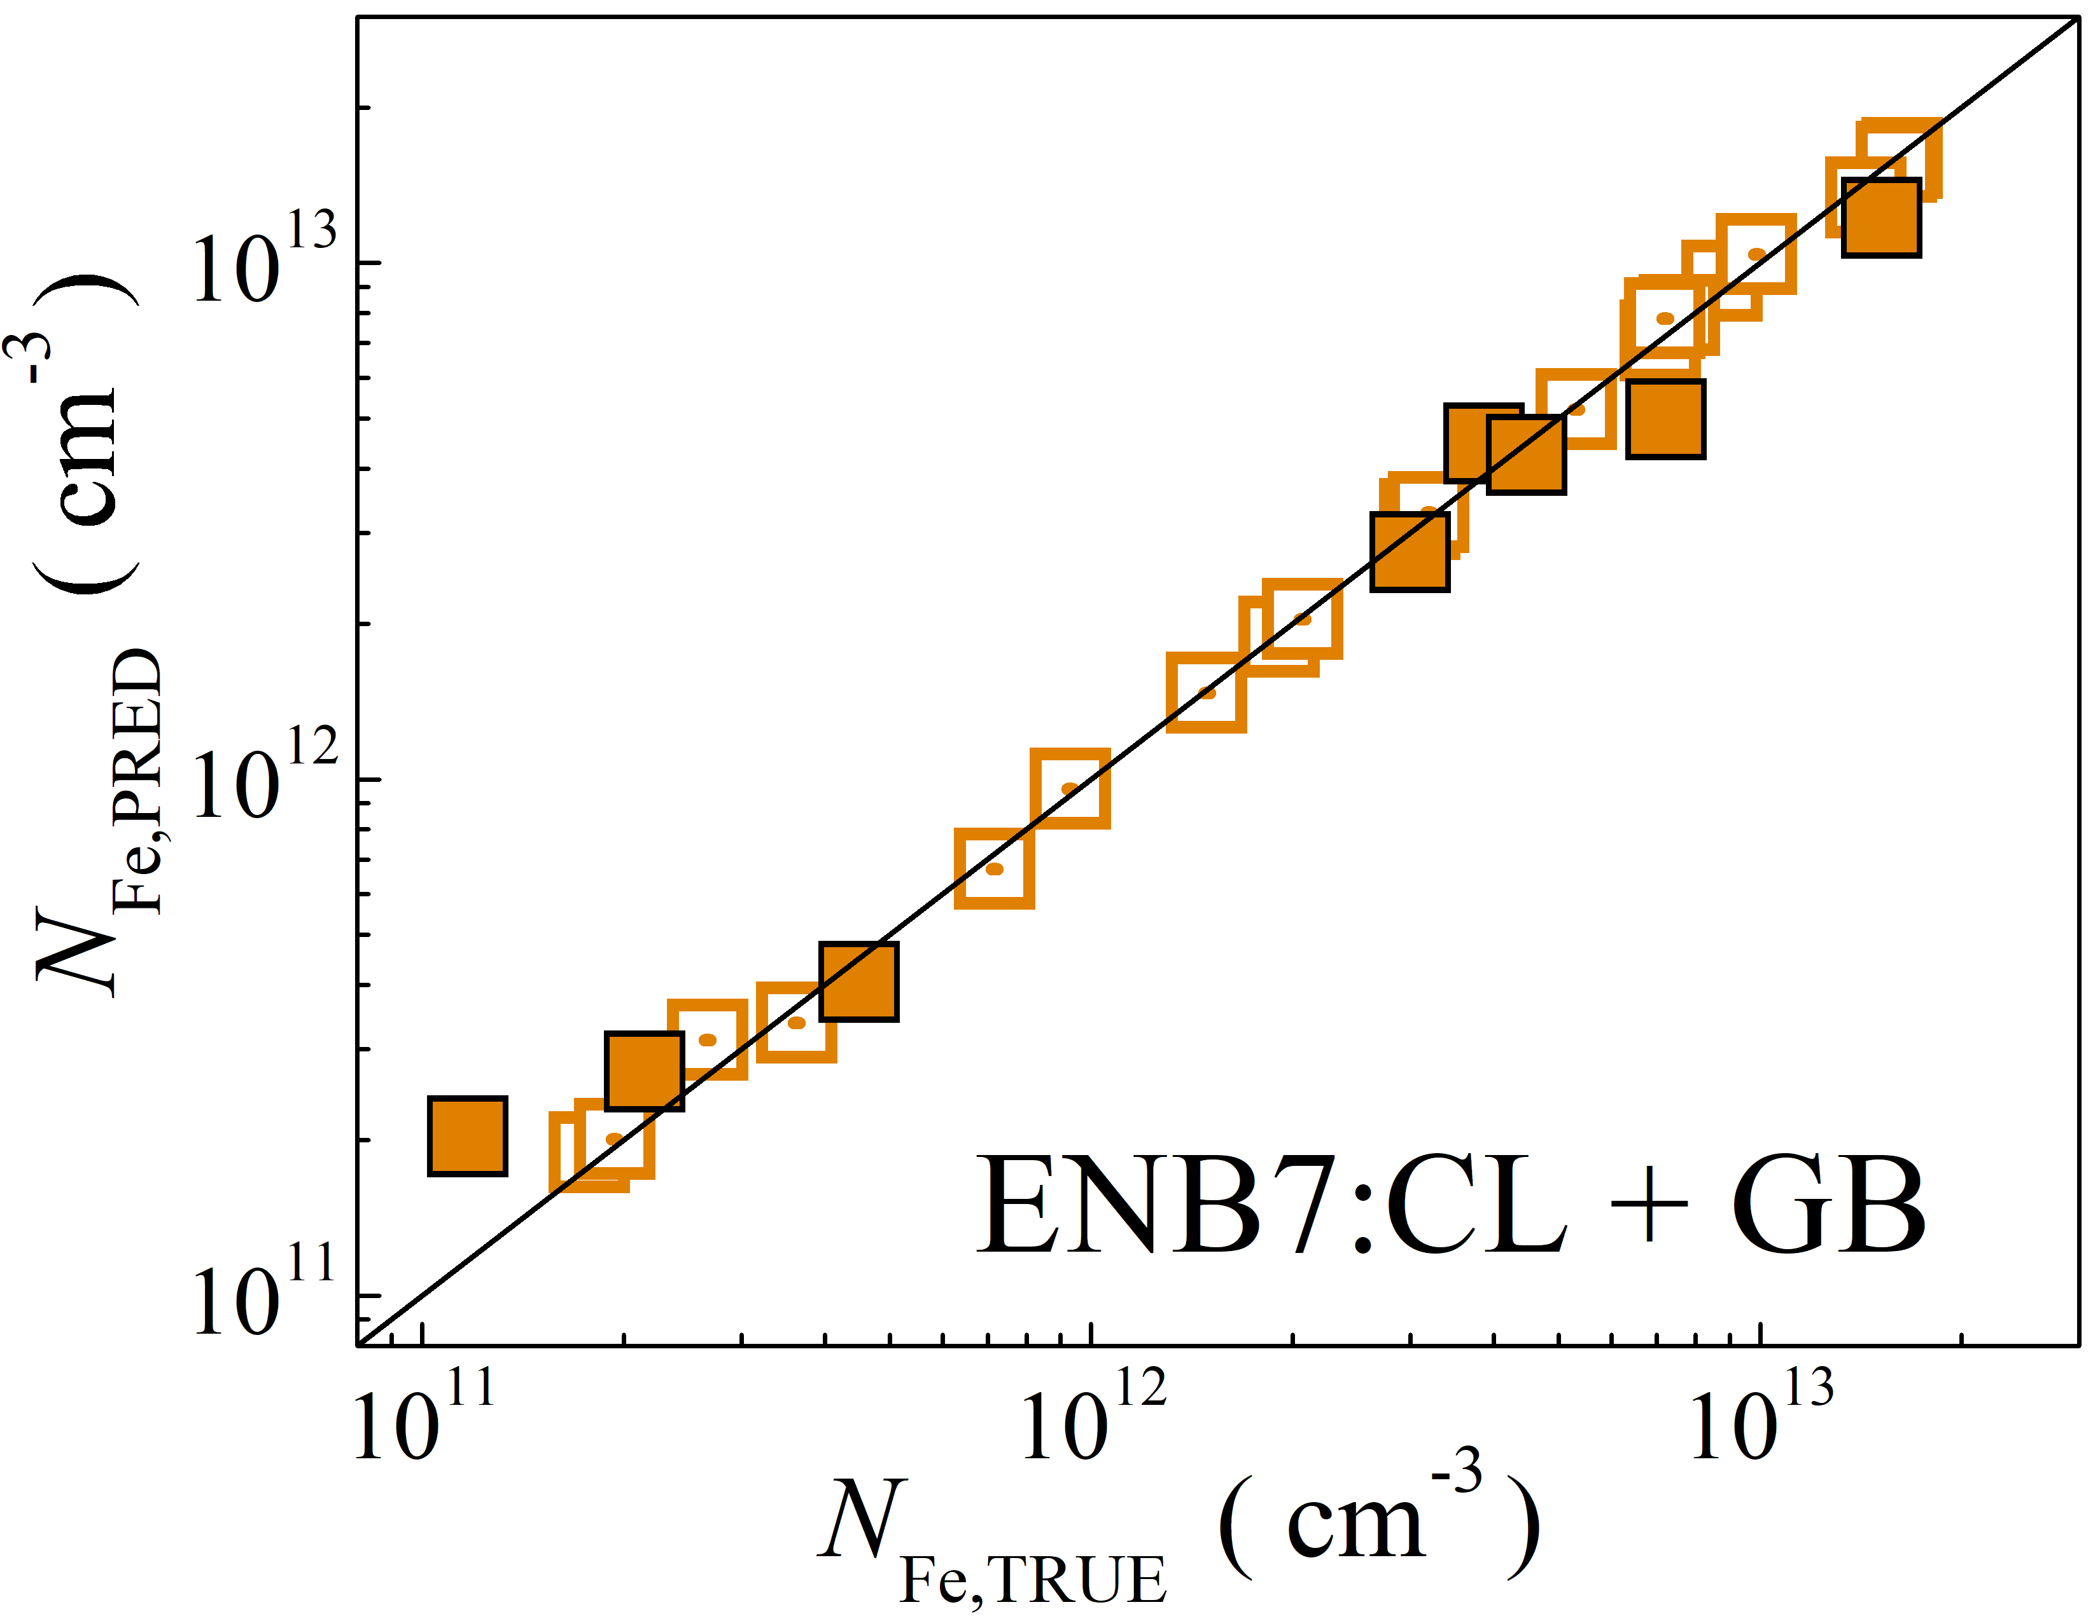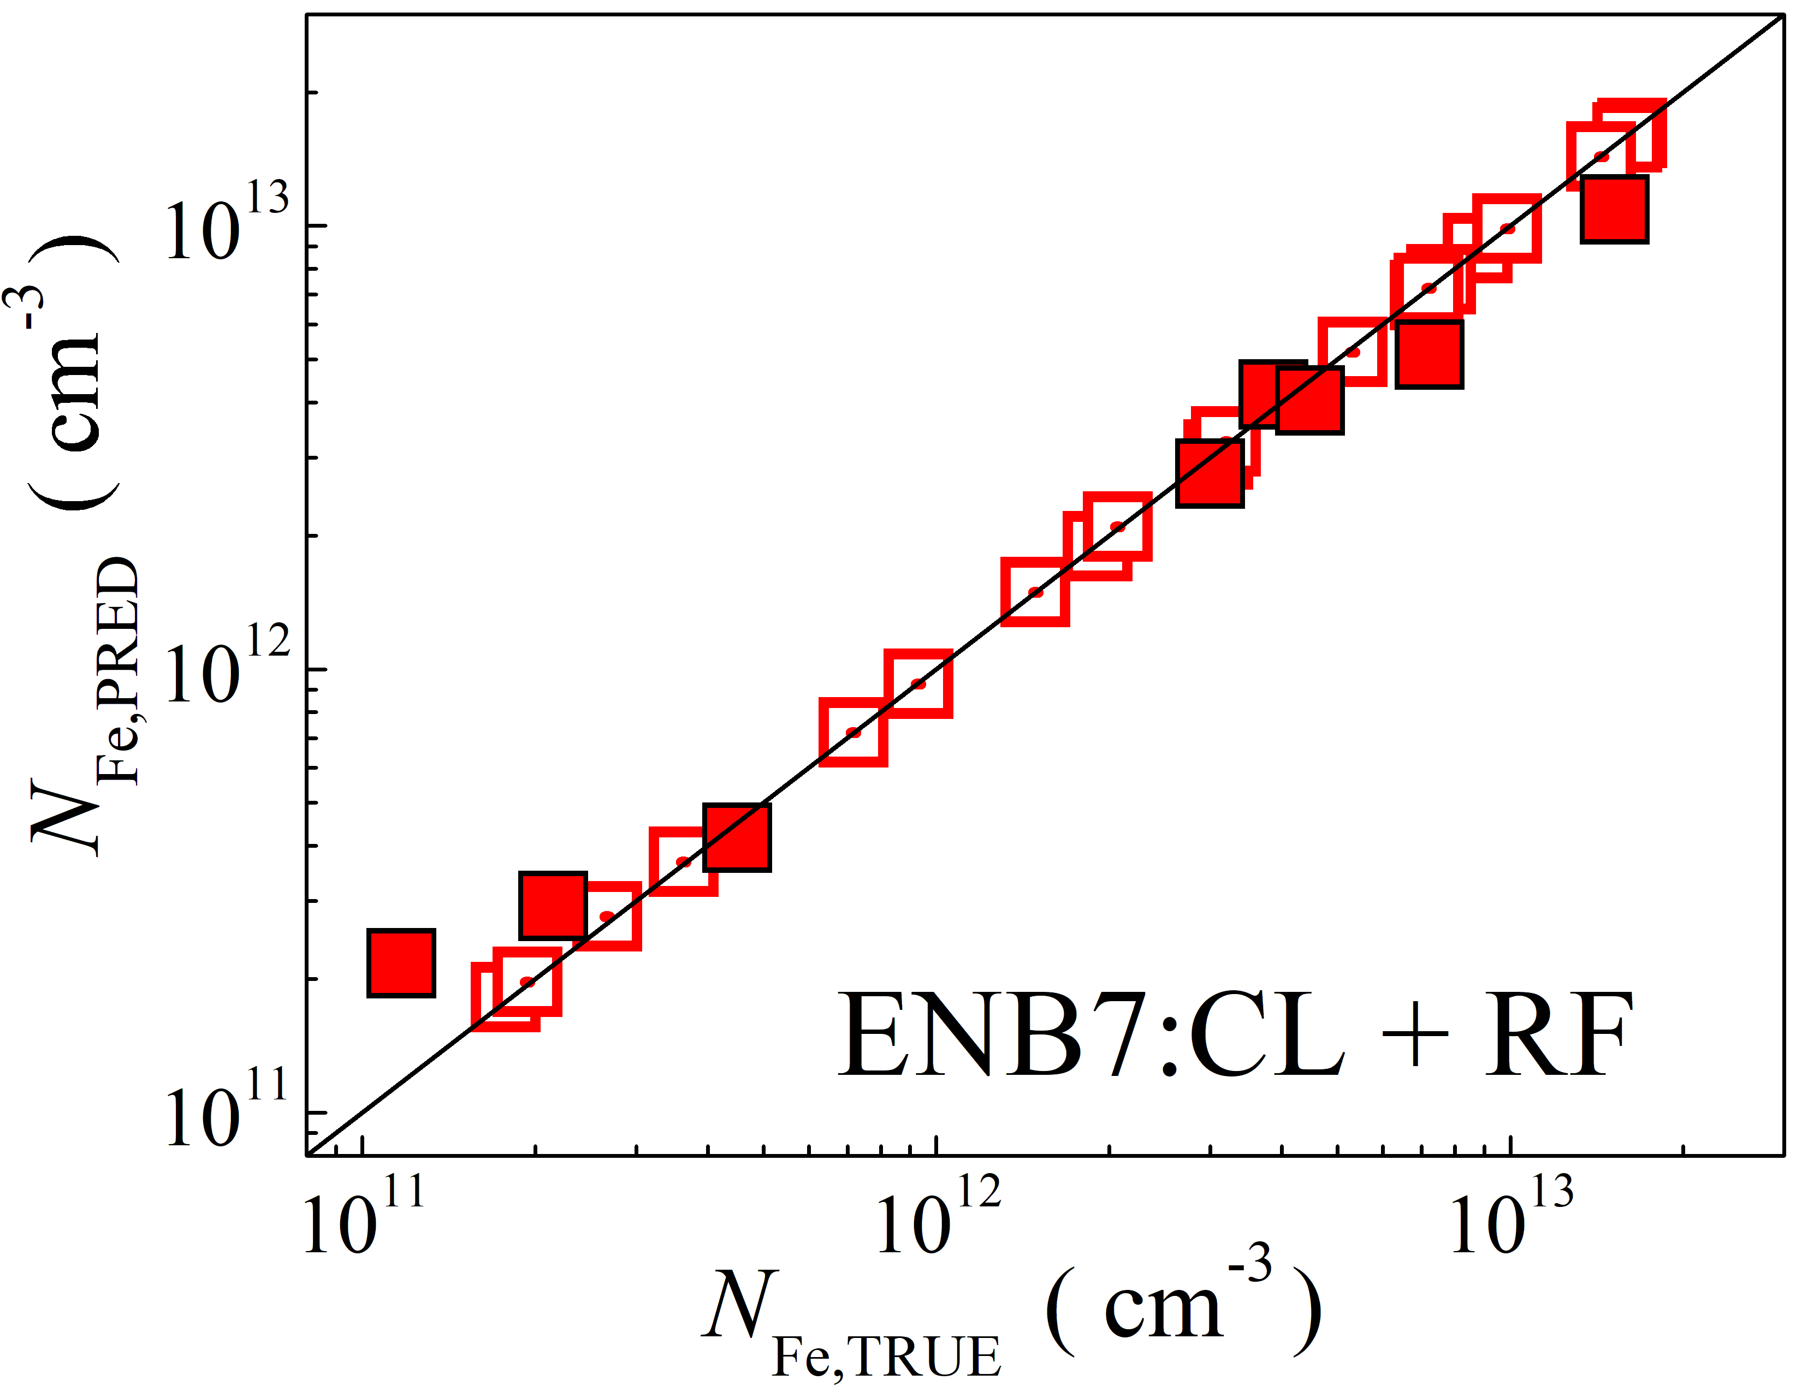

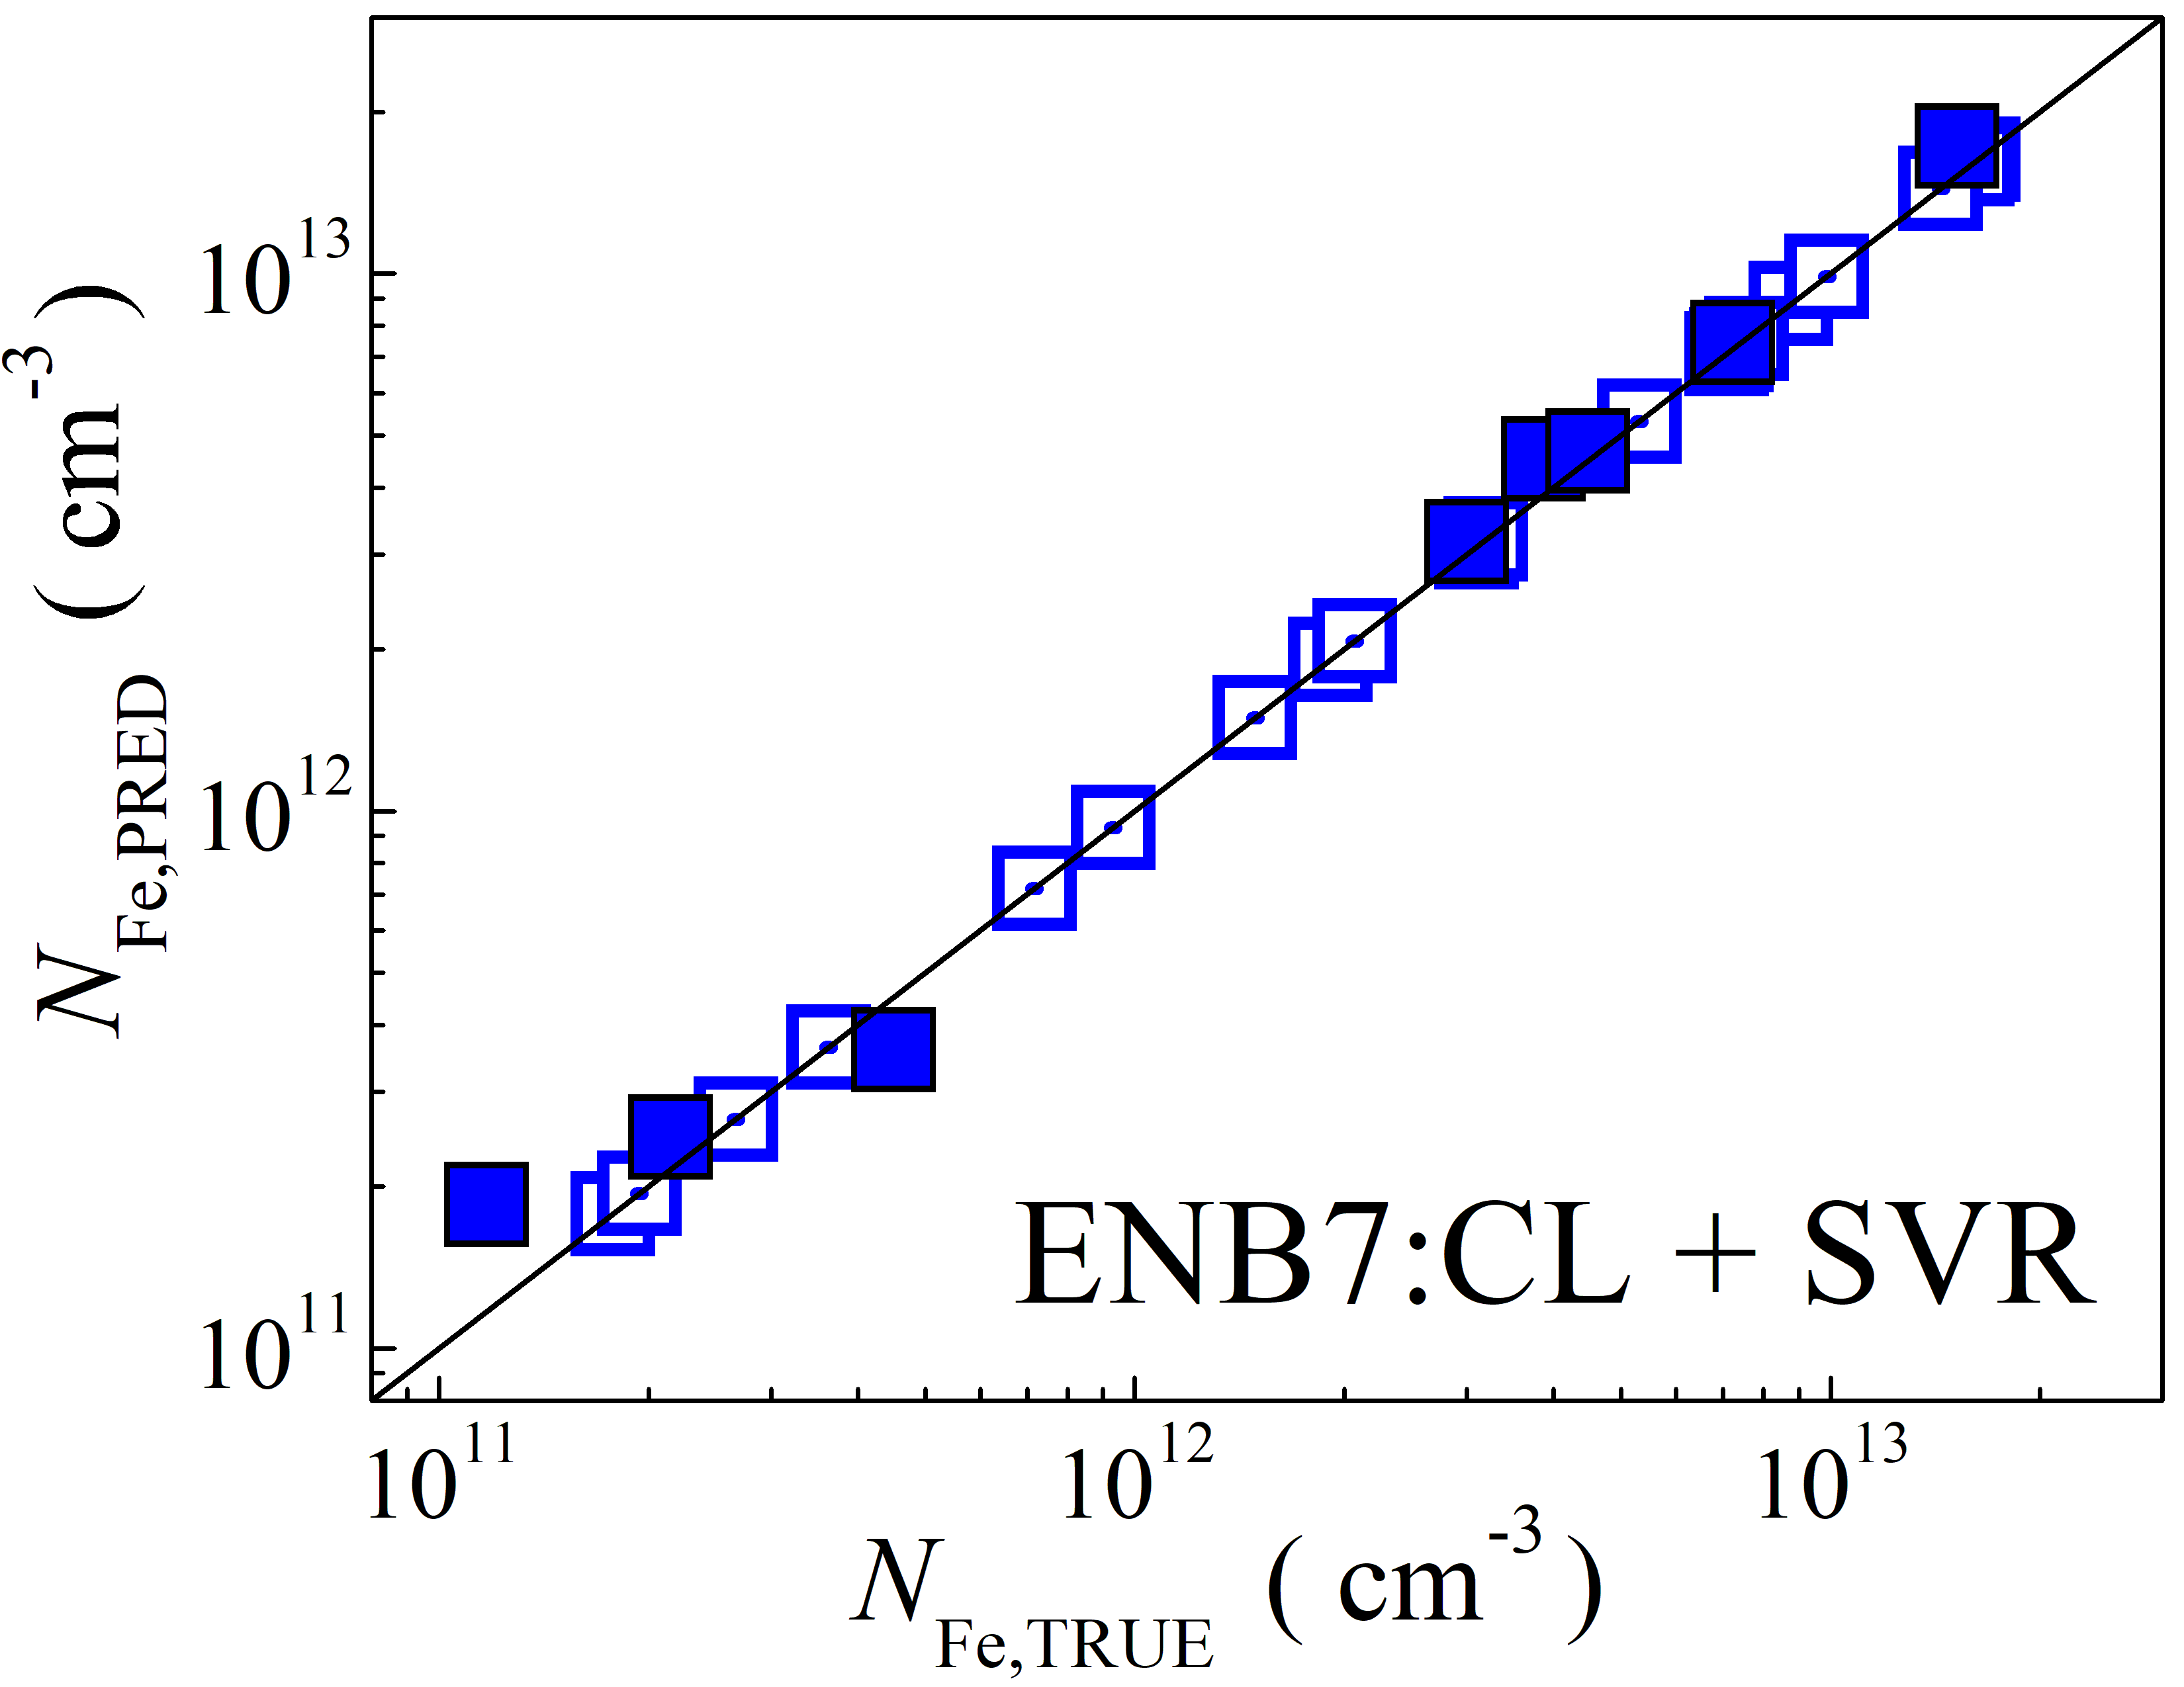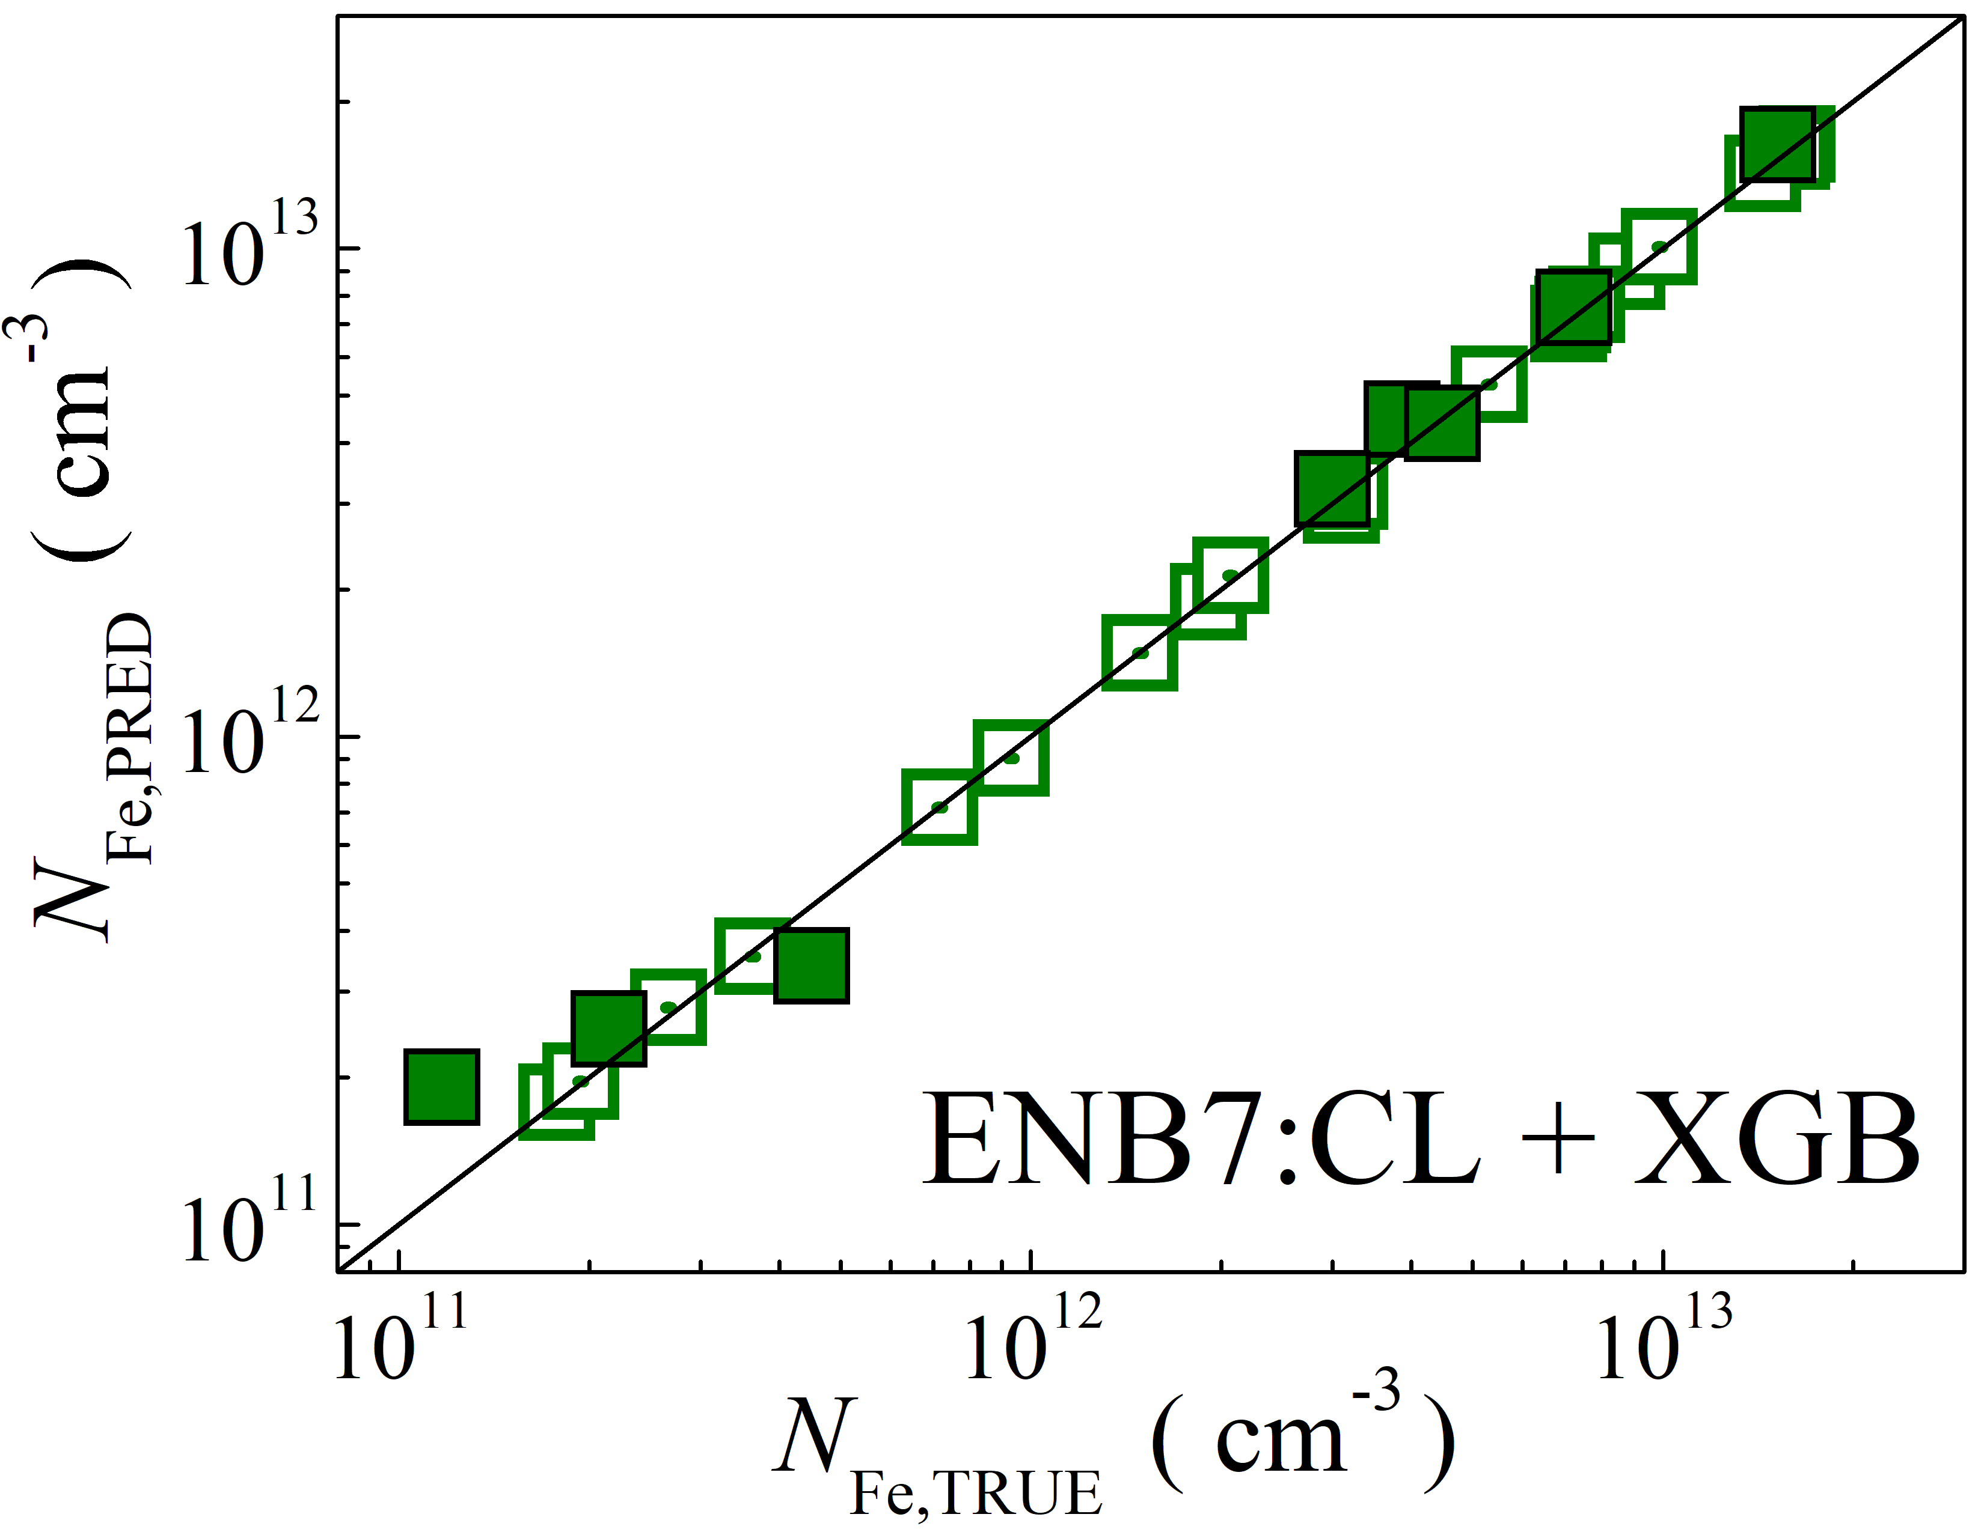

Fig. S20. Scatter plots compare reference iron concentrations $N_{Fe,TRUE}$ with ML-predicted values $N_{Fe,PRED}$ using feature vectors extracted from the classifier layer of EfficientNetB7 visual model. The ML algorithms include DNN (green and purple), GB (dark yellow and yellow), RF (red and blue), SVR (blue and pink), and XGB (green and red). Symbols represent different datasets: filled squares — test data from experimental measurements, and open squares — train data from experimental measurements. The black lines are the identified lines serving as the references.

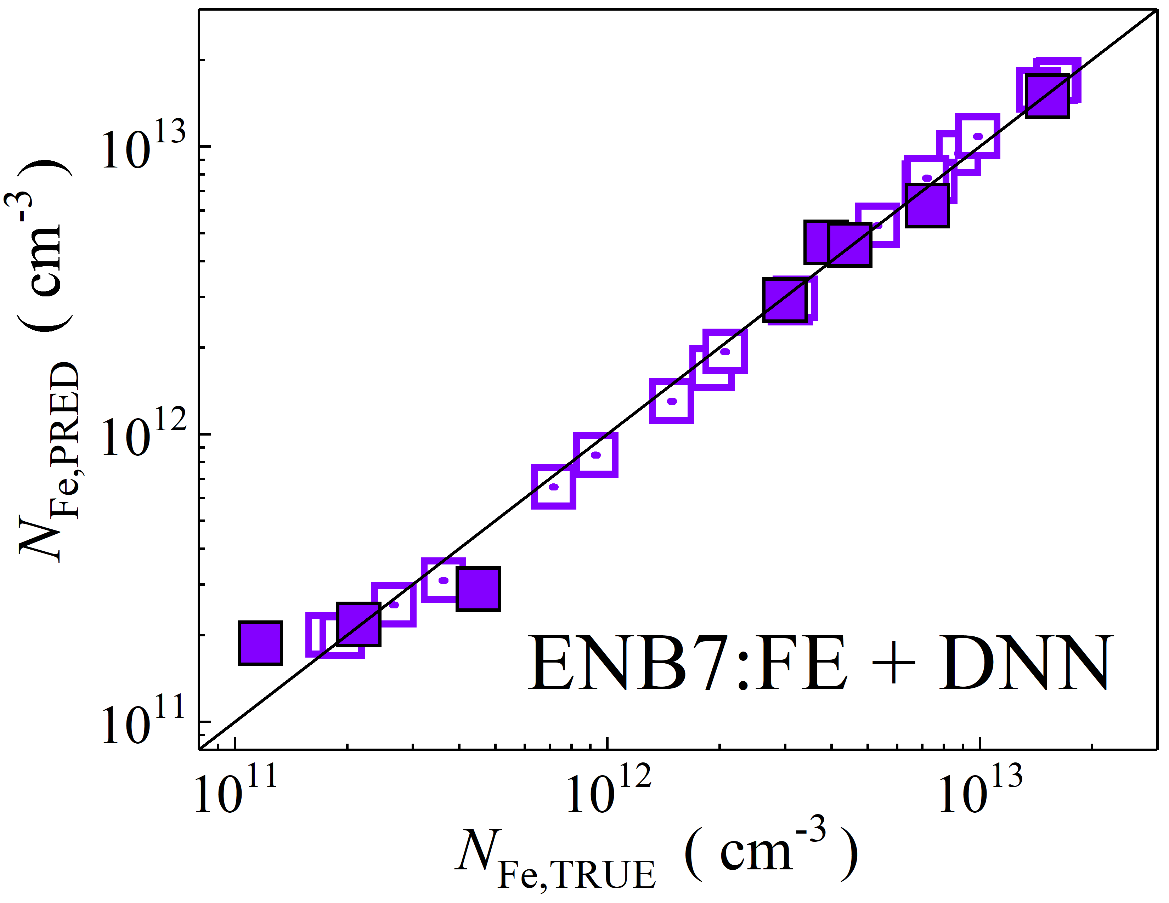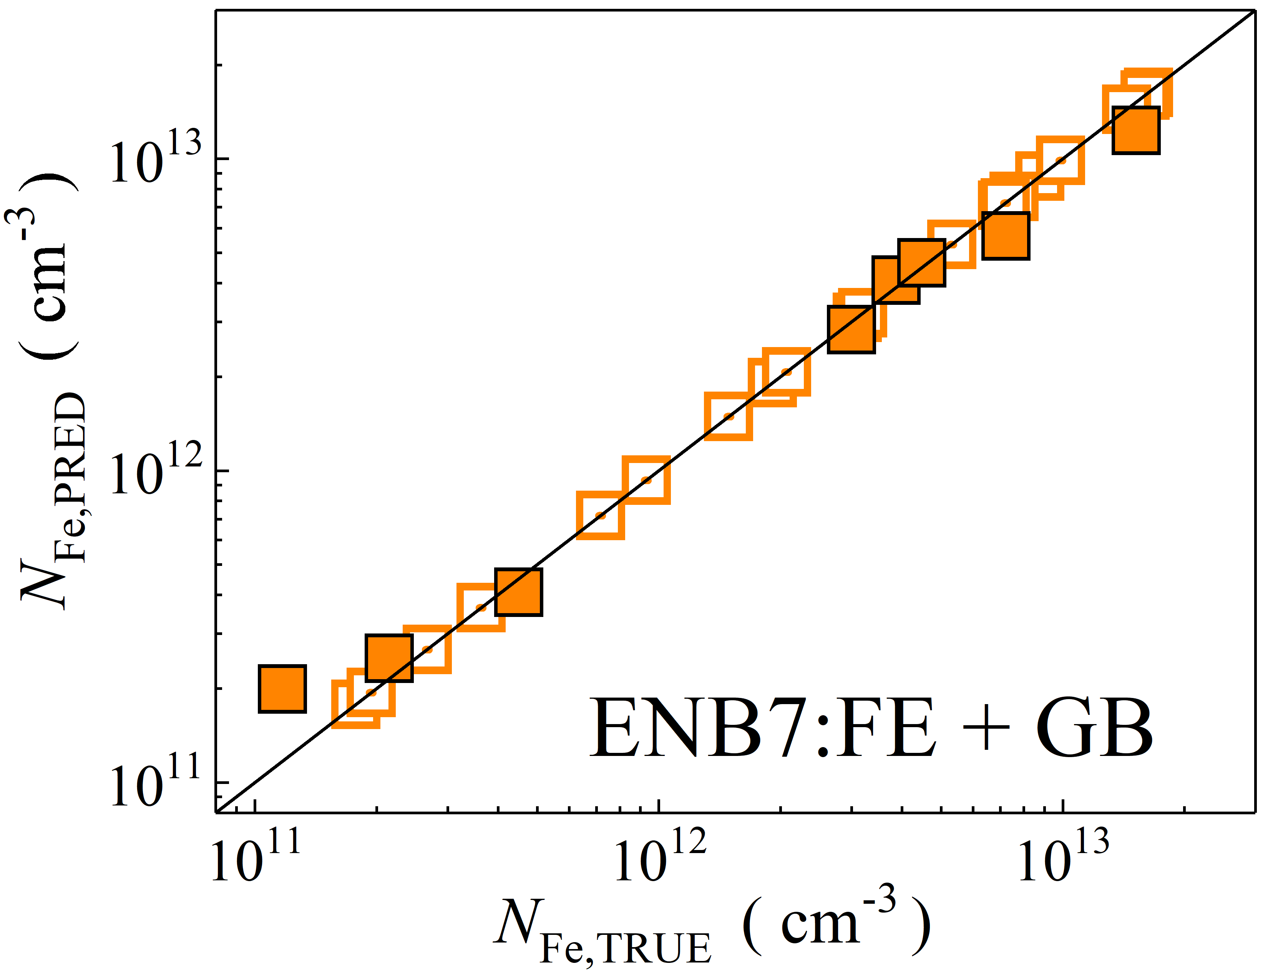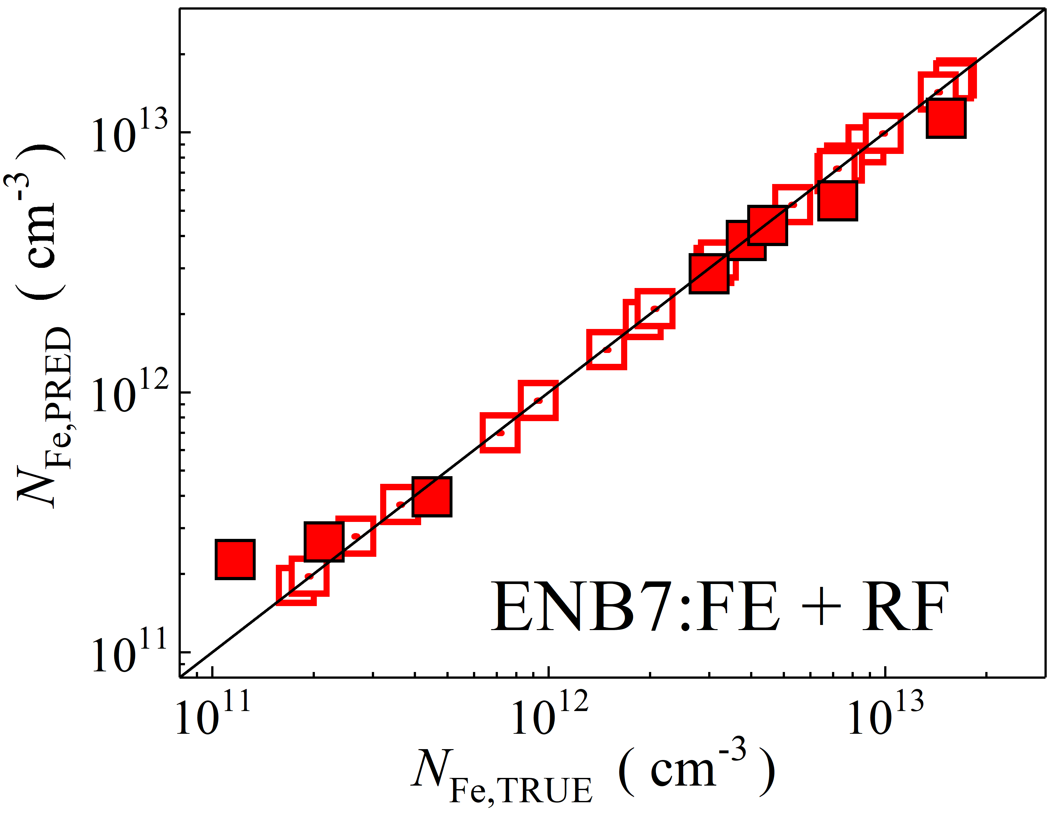

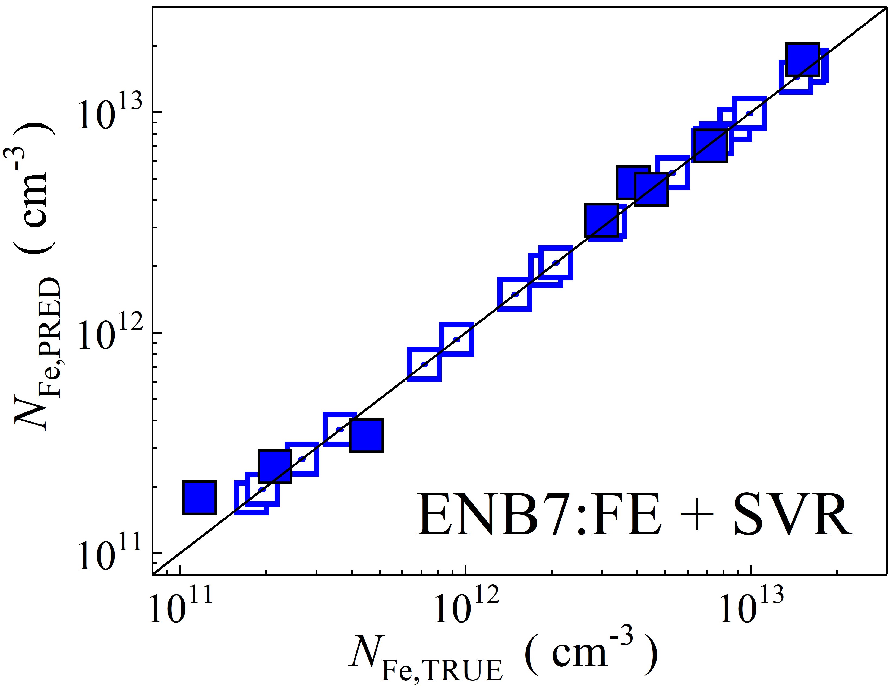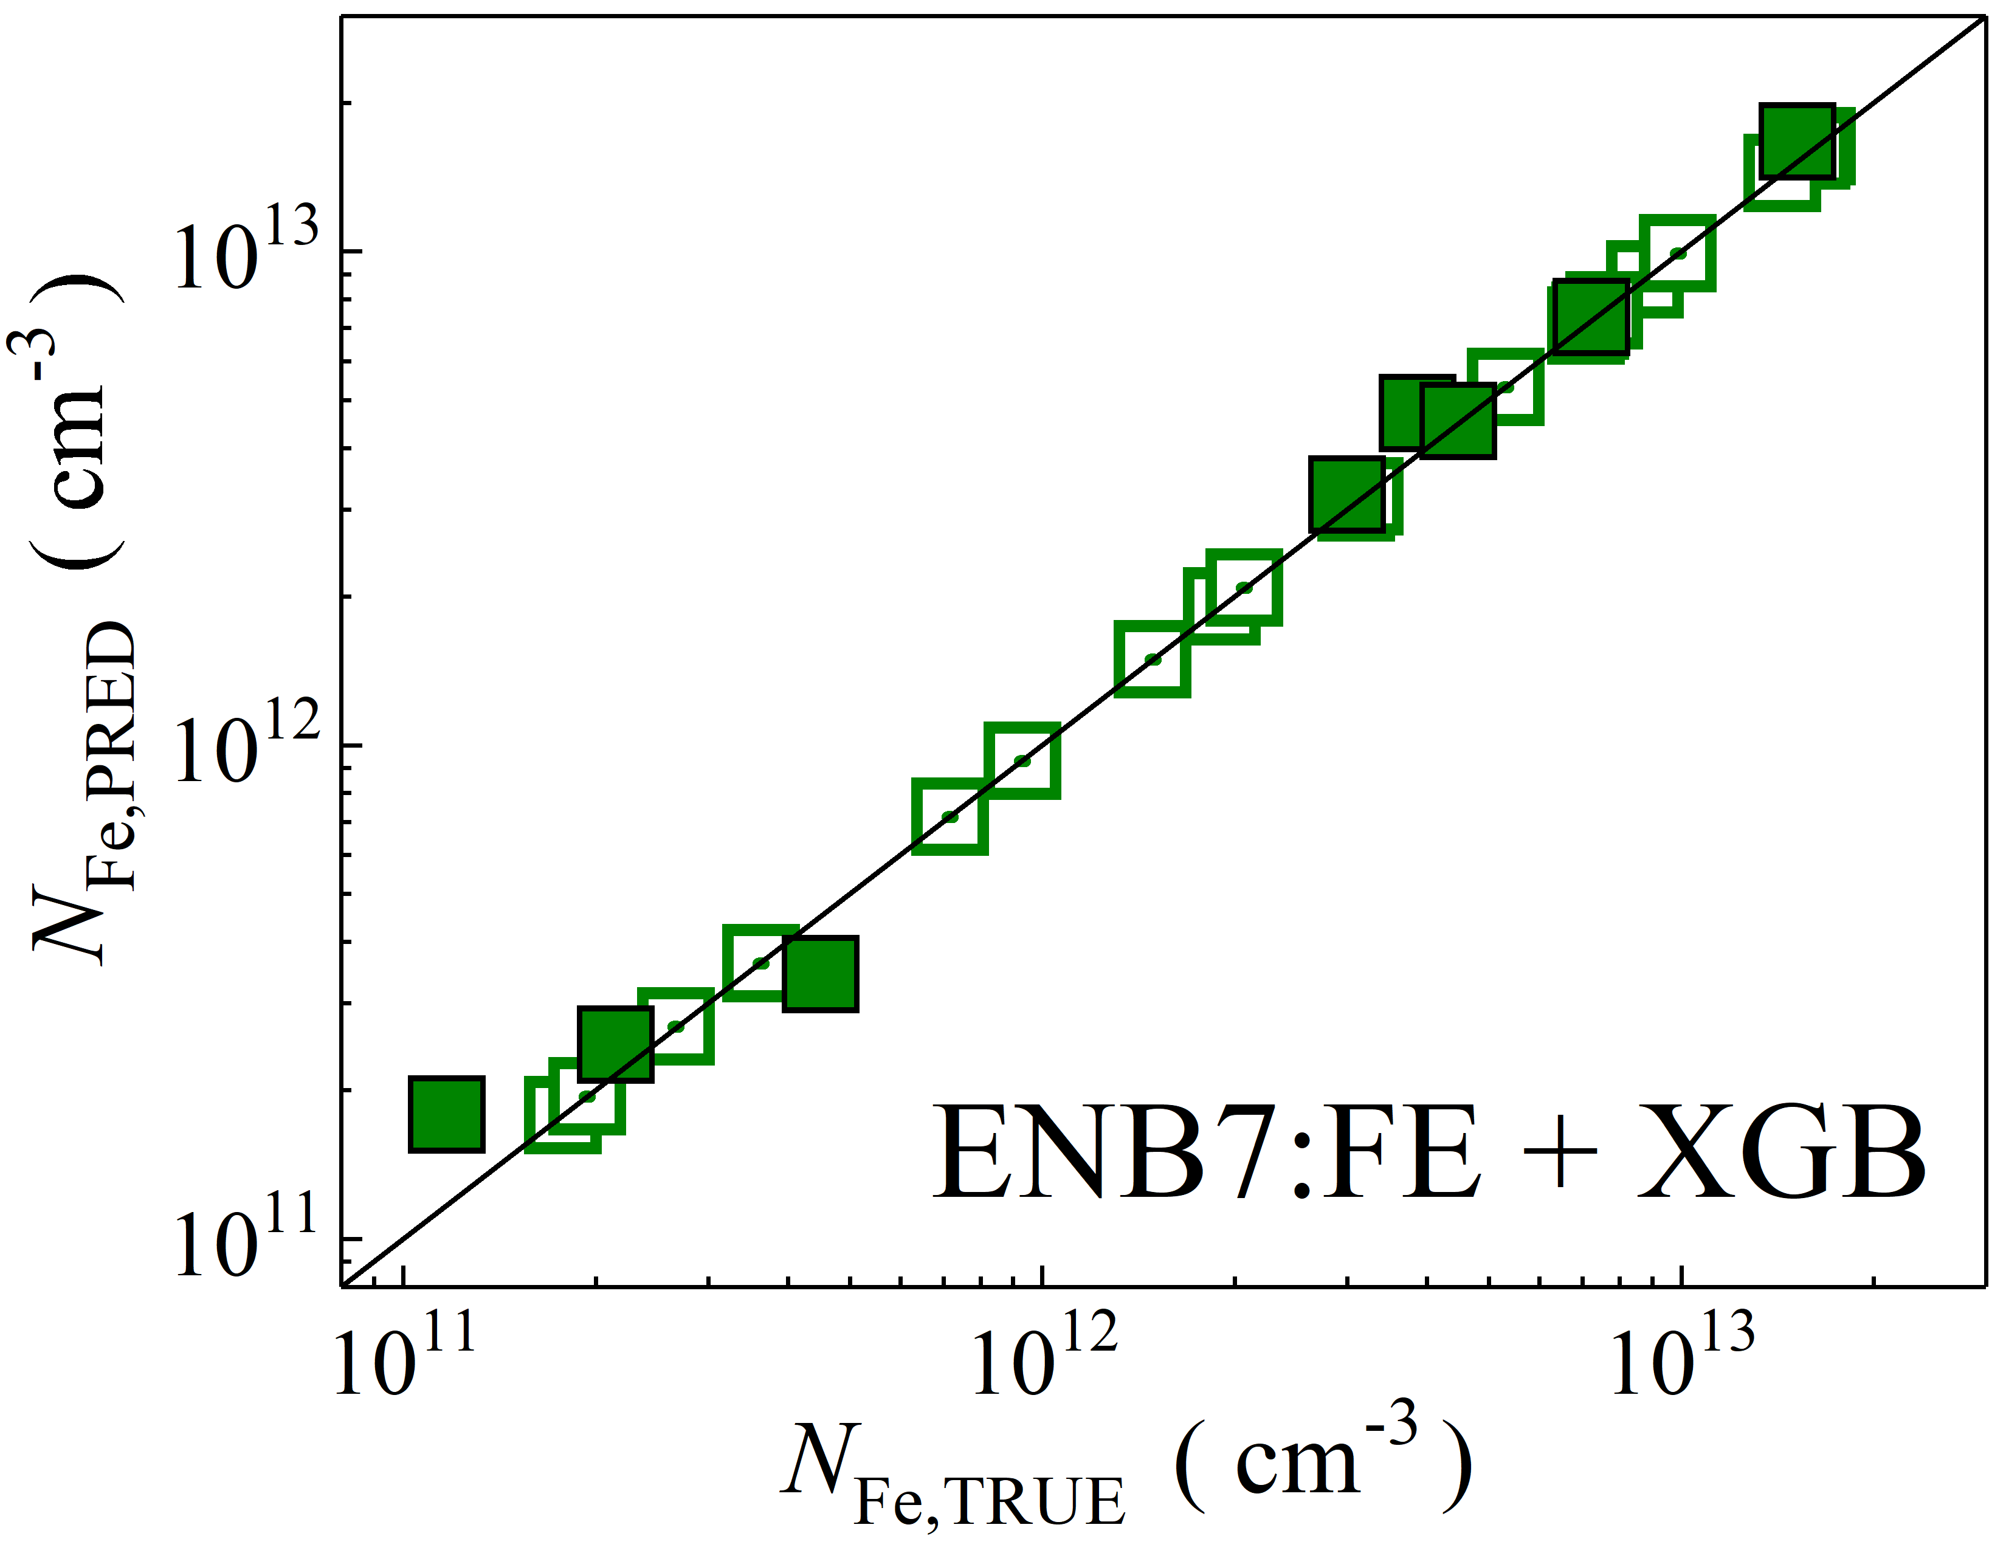

Fig. S21. Scatter plots compare reference iron concentrations $N_{Fe,TRUE}$ with ML-predicted values $N_{Fe,PRED}$ using feature vectors extracted from the feature extractor layer of EfficientNetB7 visual model. The ML algorithms include DNN (green and purple), GB (dark yellow and yellow), RF (red and blue), SVR (blue and pink), and XGB (green and red). Symbols represent different datasets: filled squares — test data from experimental measurements, and open squares — train data from experimental measurements. The black lines are the identified lines serving as the references.

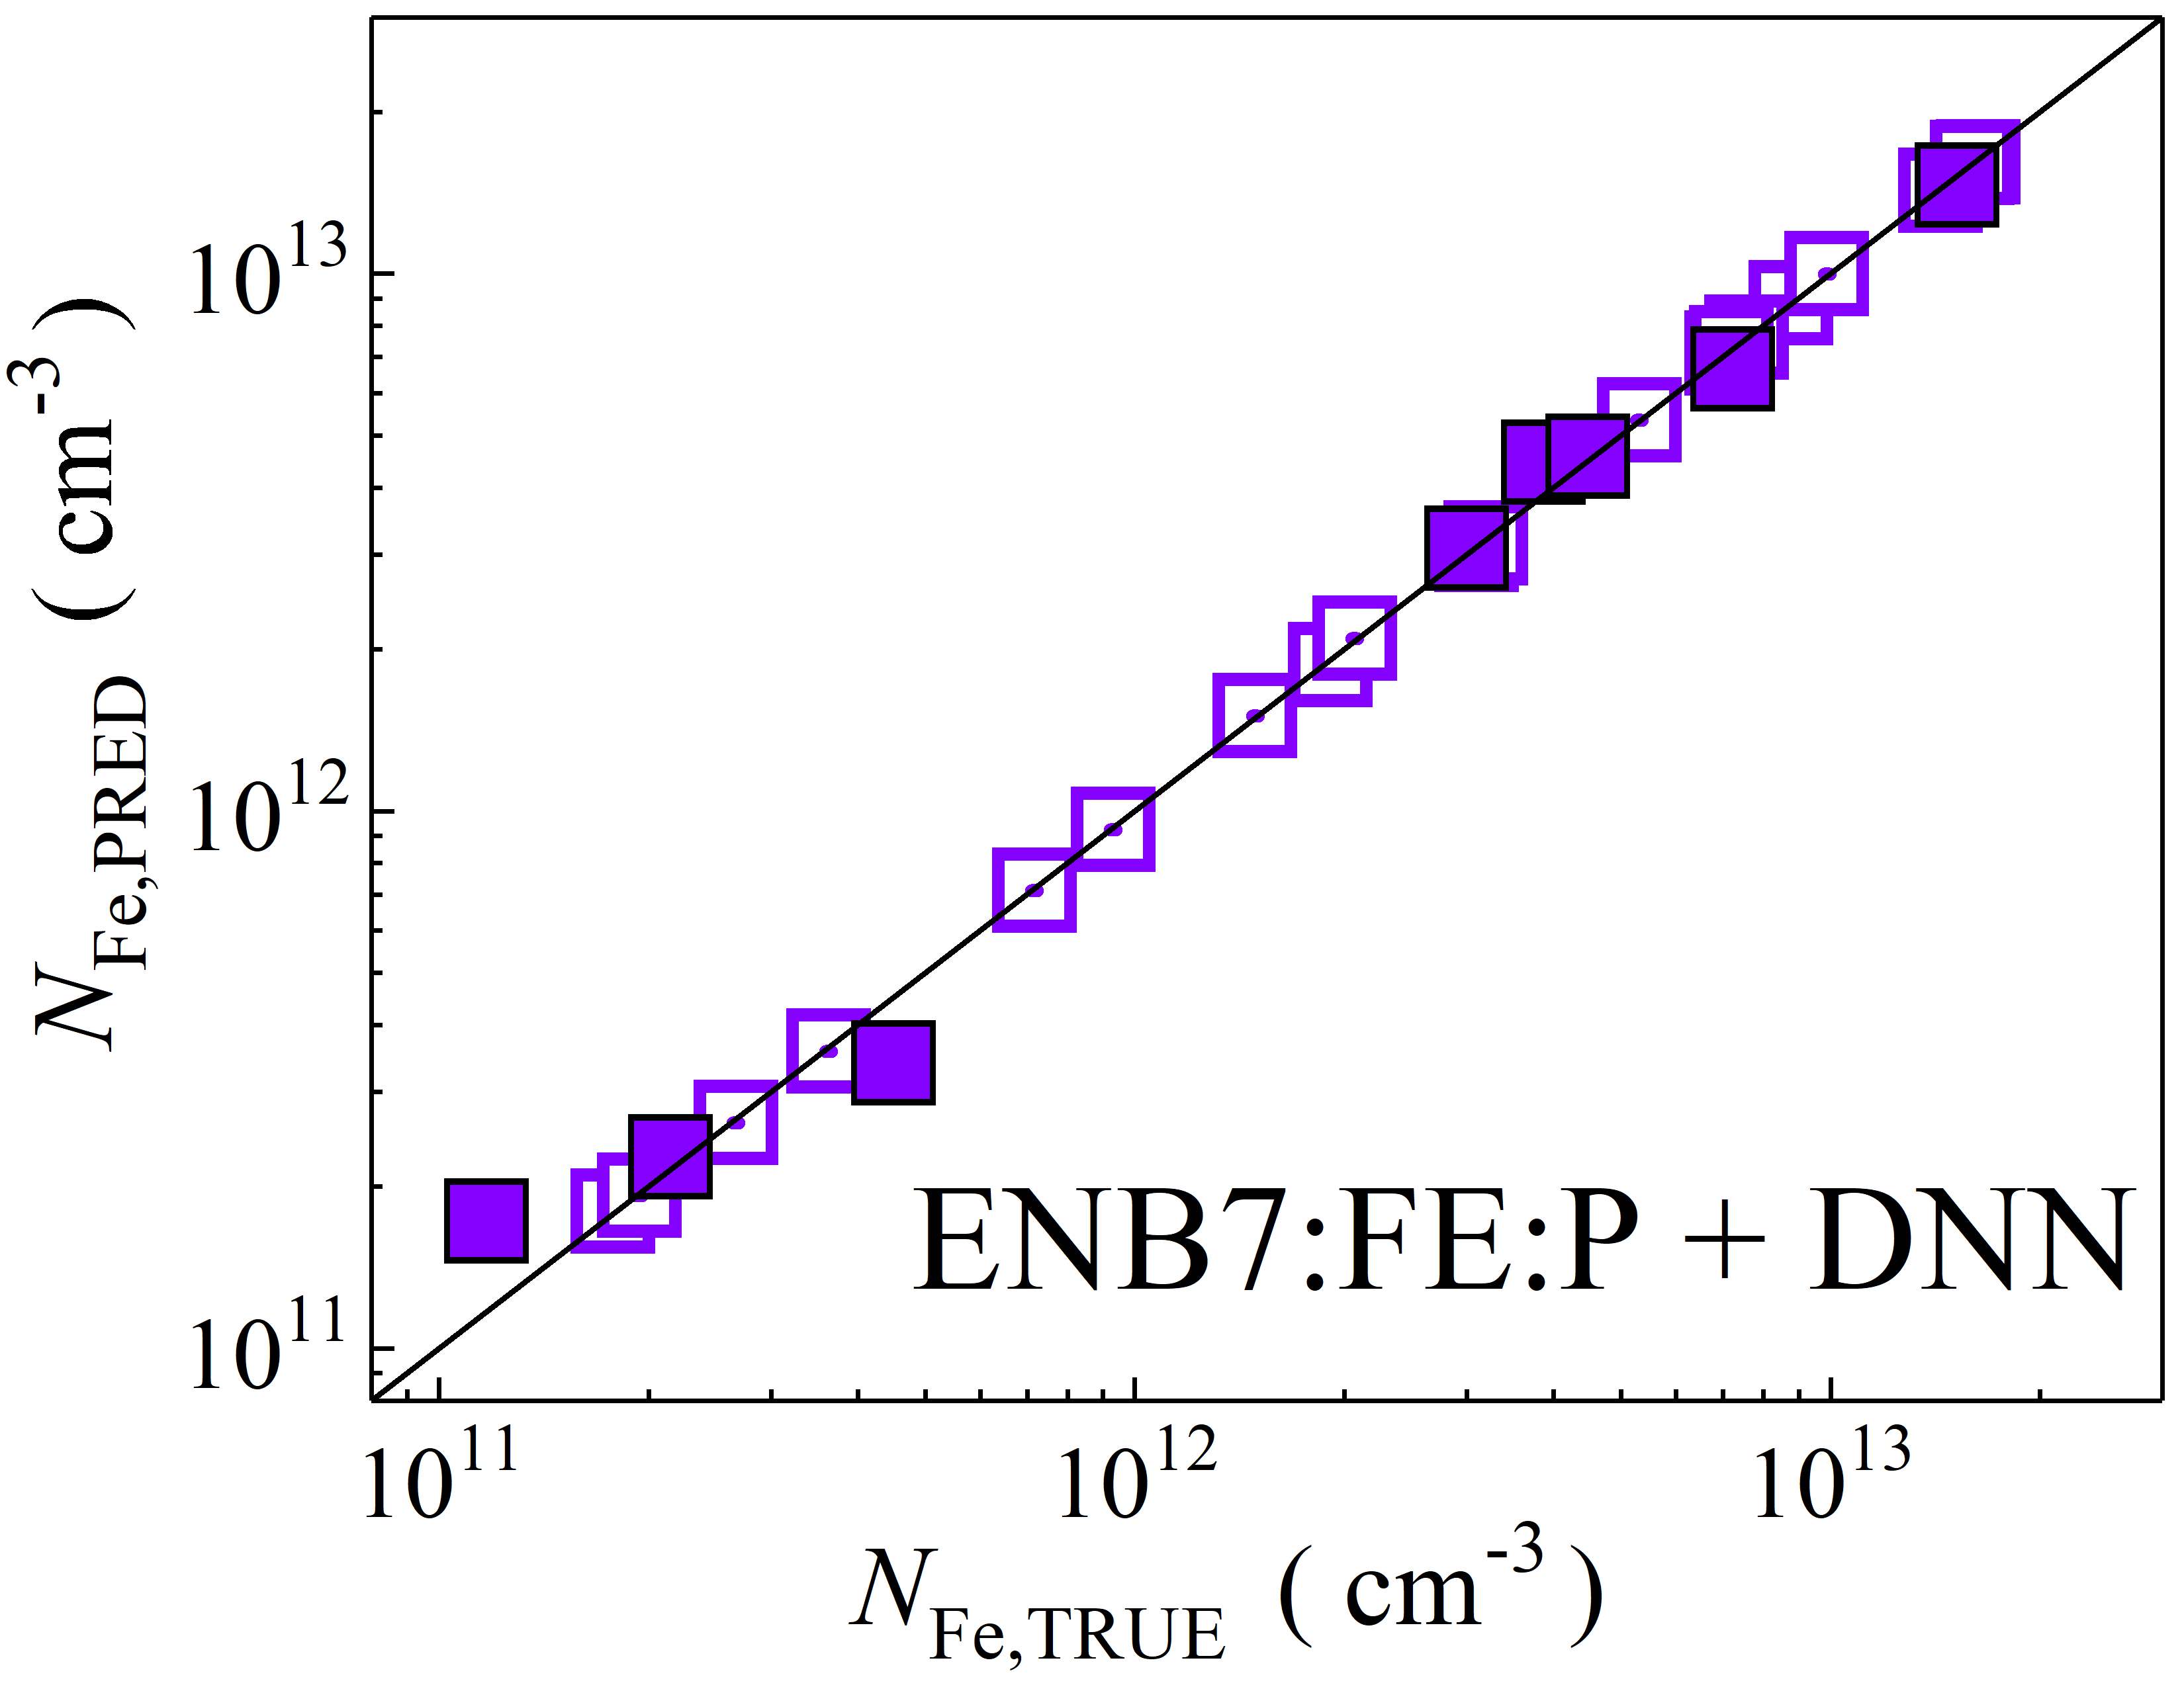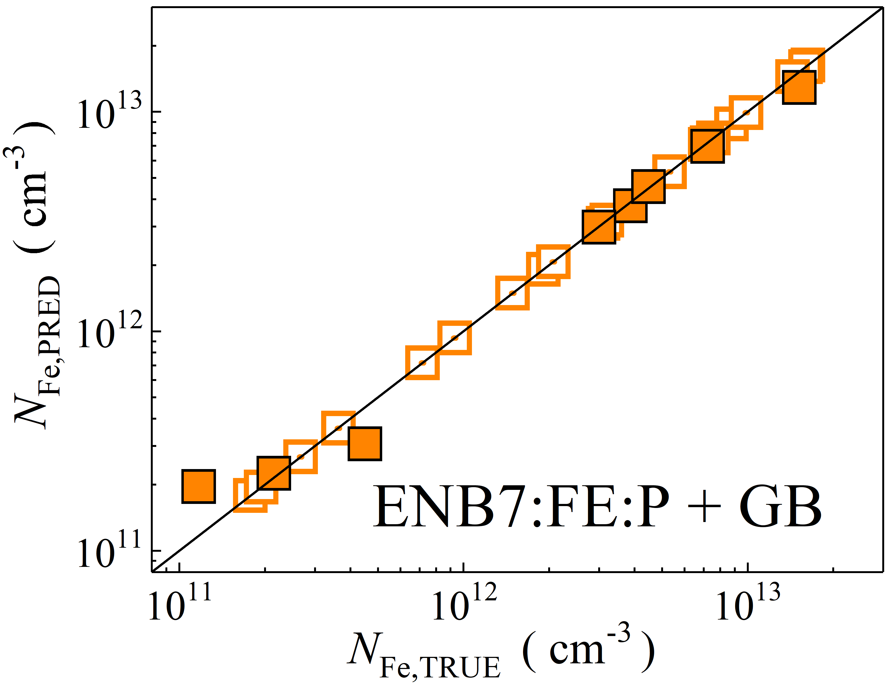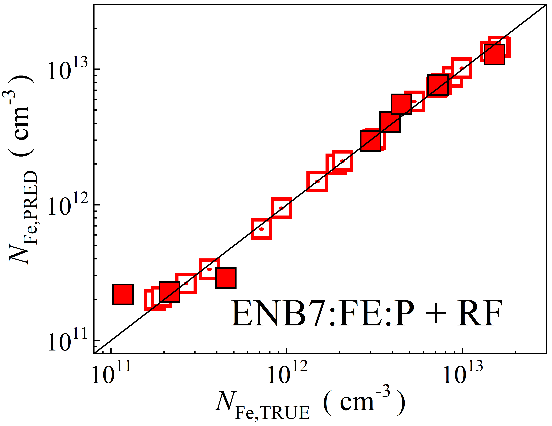

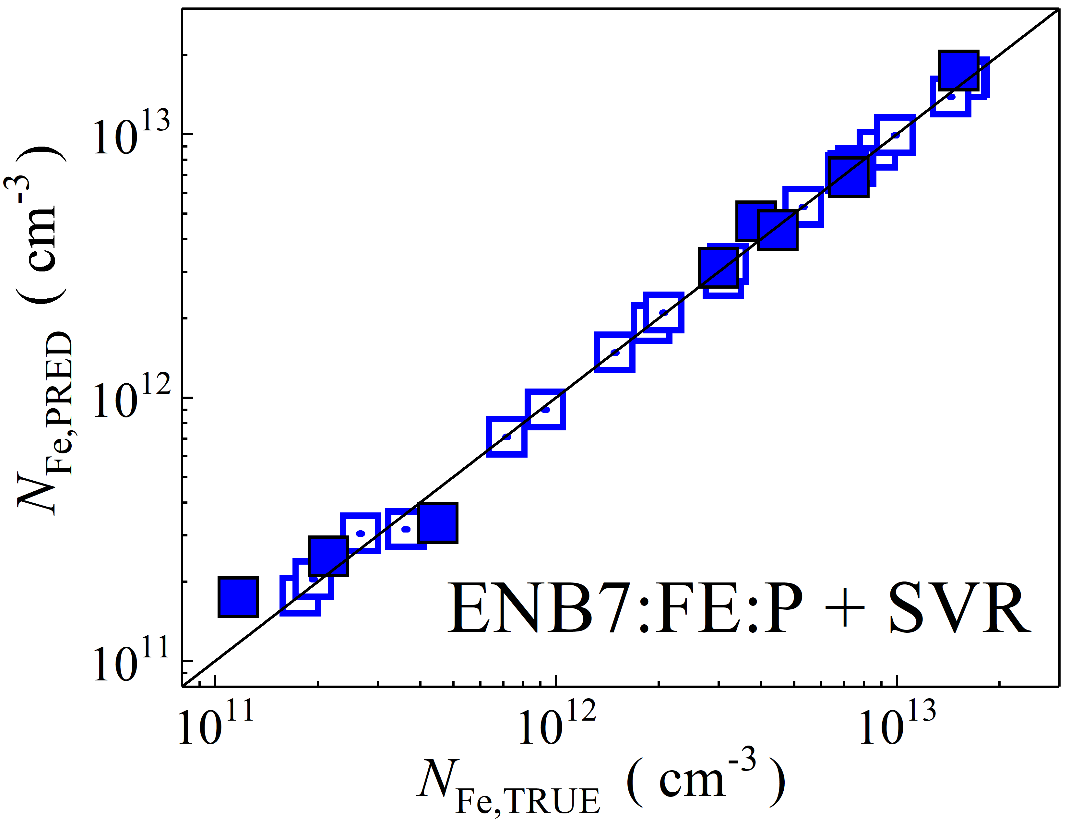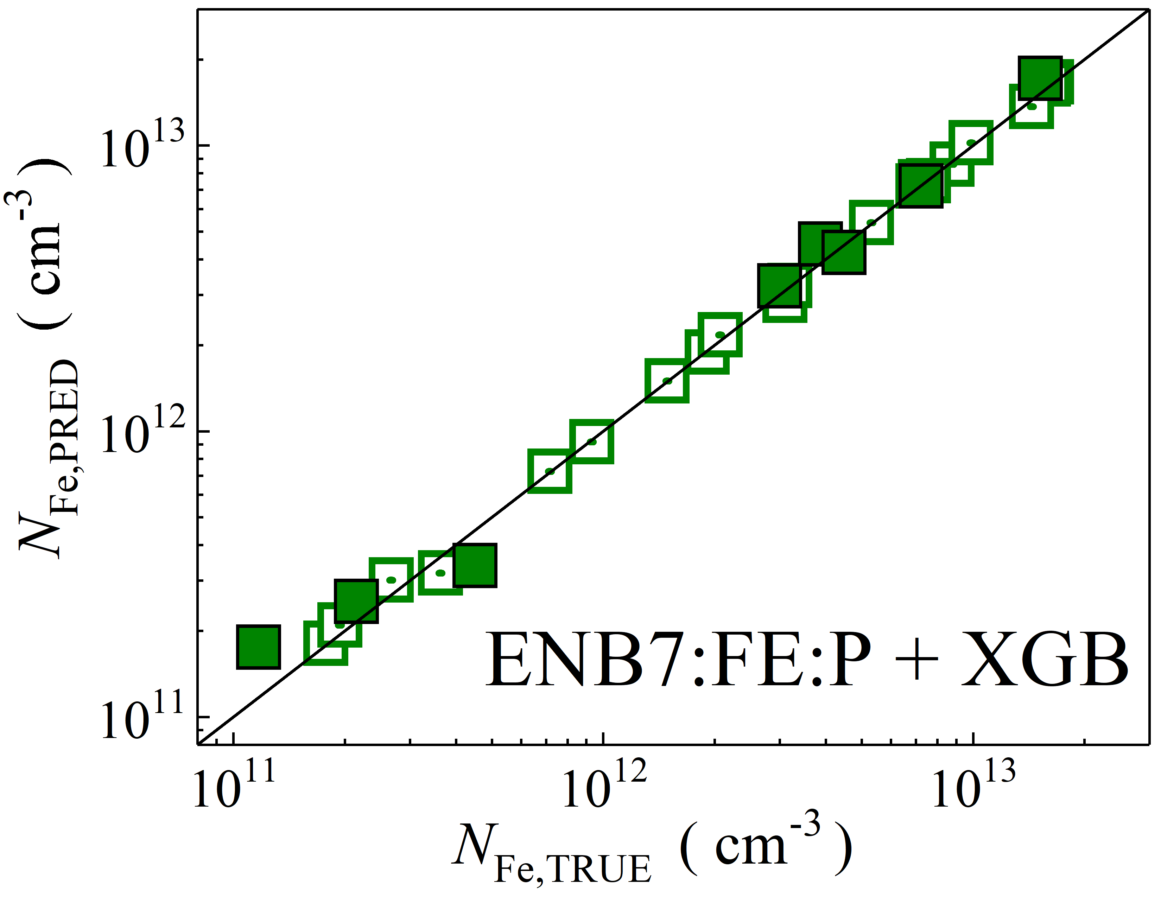

Fig. S22. Scatter plots compare reference iron concentrations $N_{Fe,TRUE}$ with ML-predicted values $N_{Fe,PRED}$ using feature vectors extracted from the feature extractor layer with PCA reduction of EfficientNetB7 visual model. The ML algorithms include DNN (green and purple), GB (dark yellow and yellow), RF (red and blue), SVR (blue and pink), and XGB (green and red). Symbols represent different datasets: filled squares — test data from experimental measurements, and open squares — train data from experimental measurements. The black lines are the identified lines serving as the references.

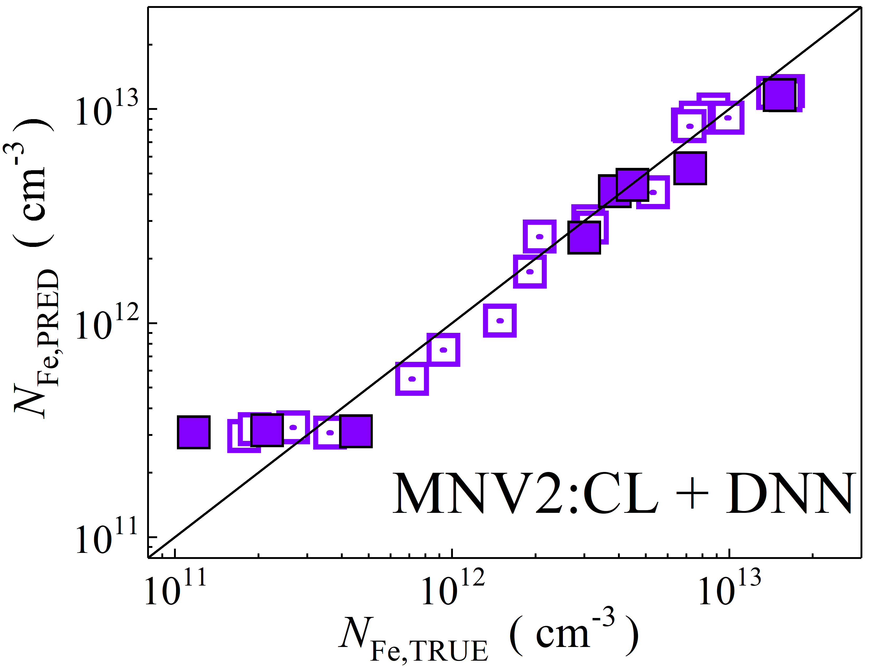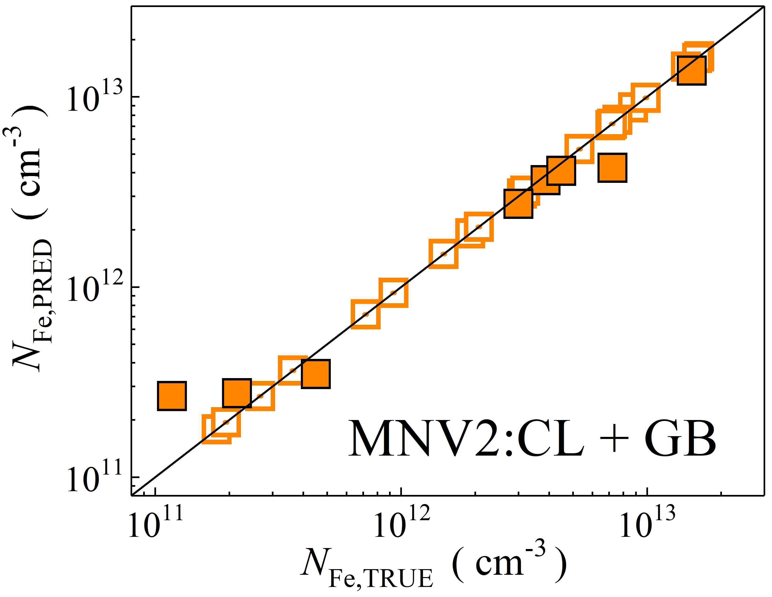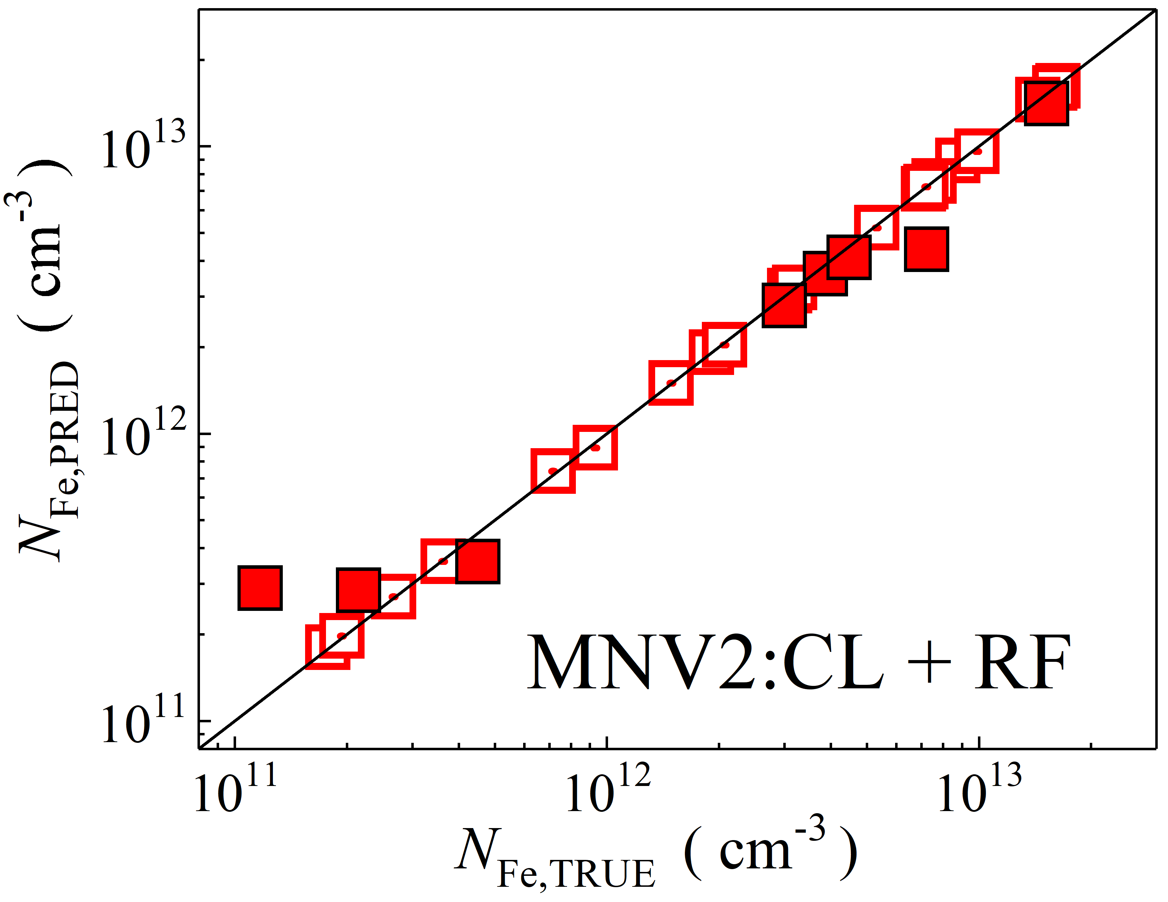

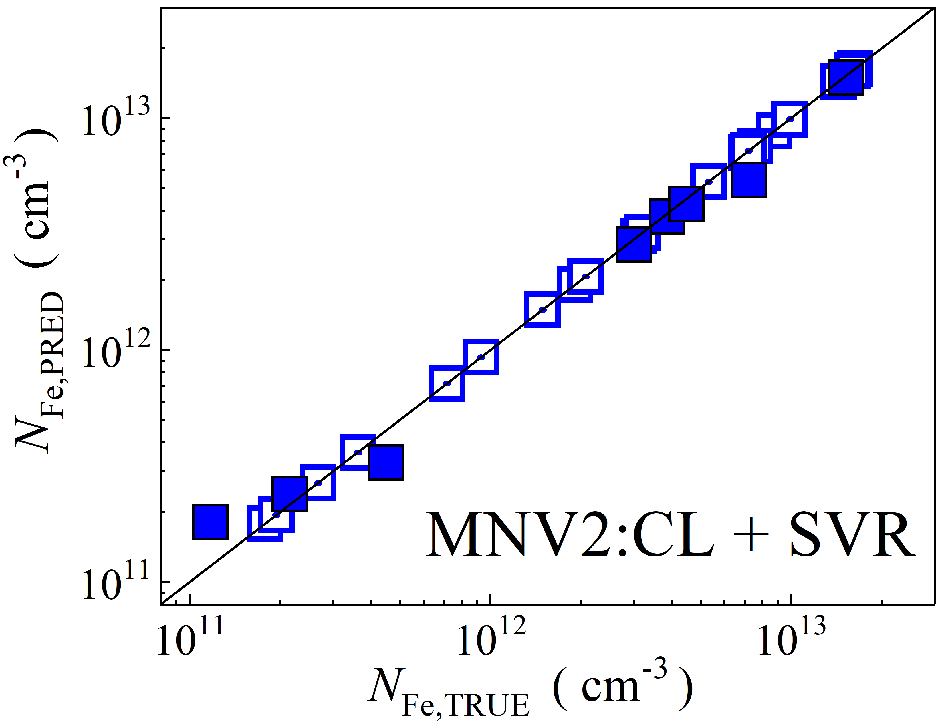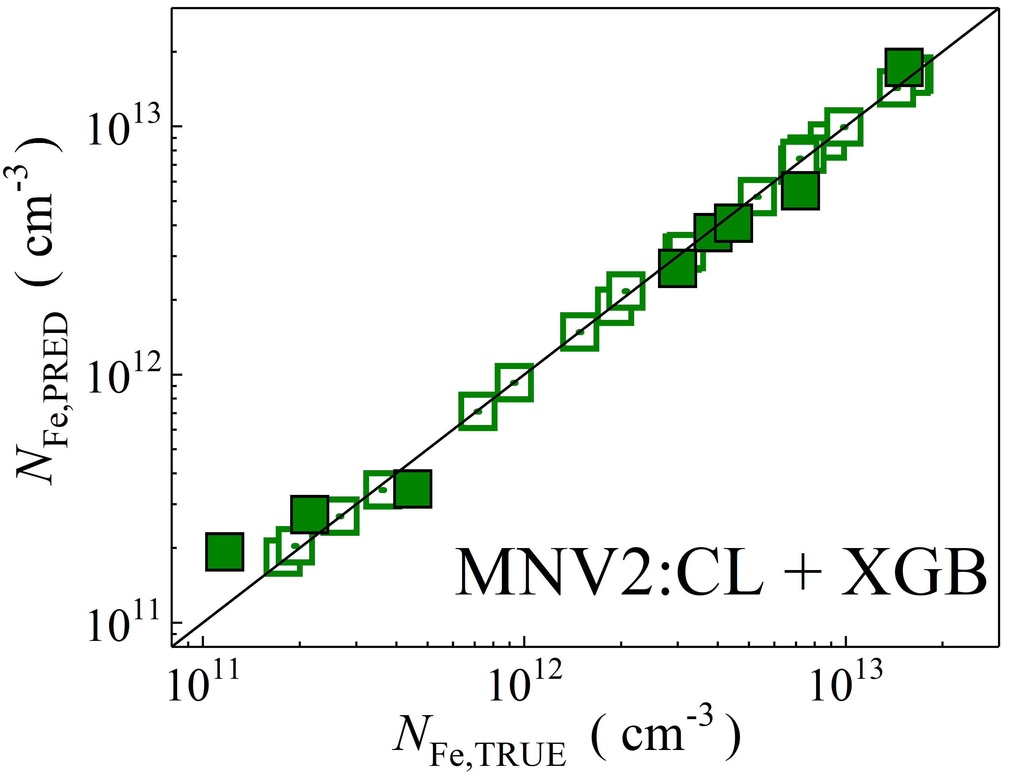

Fig. S23. Scatter plots compare reference iron concentrations $N_{Fe,TRUE}$ with ML-predicted values $N_{Fe,PRED}$ using feature vectors extracted from the classifier layer of MobileNetV2 visual model. The ML algorithms include DNN (green and purple), GB (dark yellow and yellow), RF (red and blue), SVR (blue and pink), and XGB (green and red). Symbols represent different datasets: filled squares — test data from experimental measurements, and open squares — train data from experimental measurements. The black lines are the identified lines serving as the references.

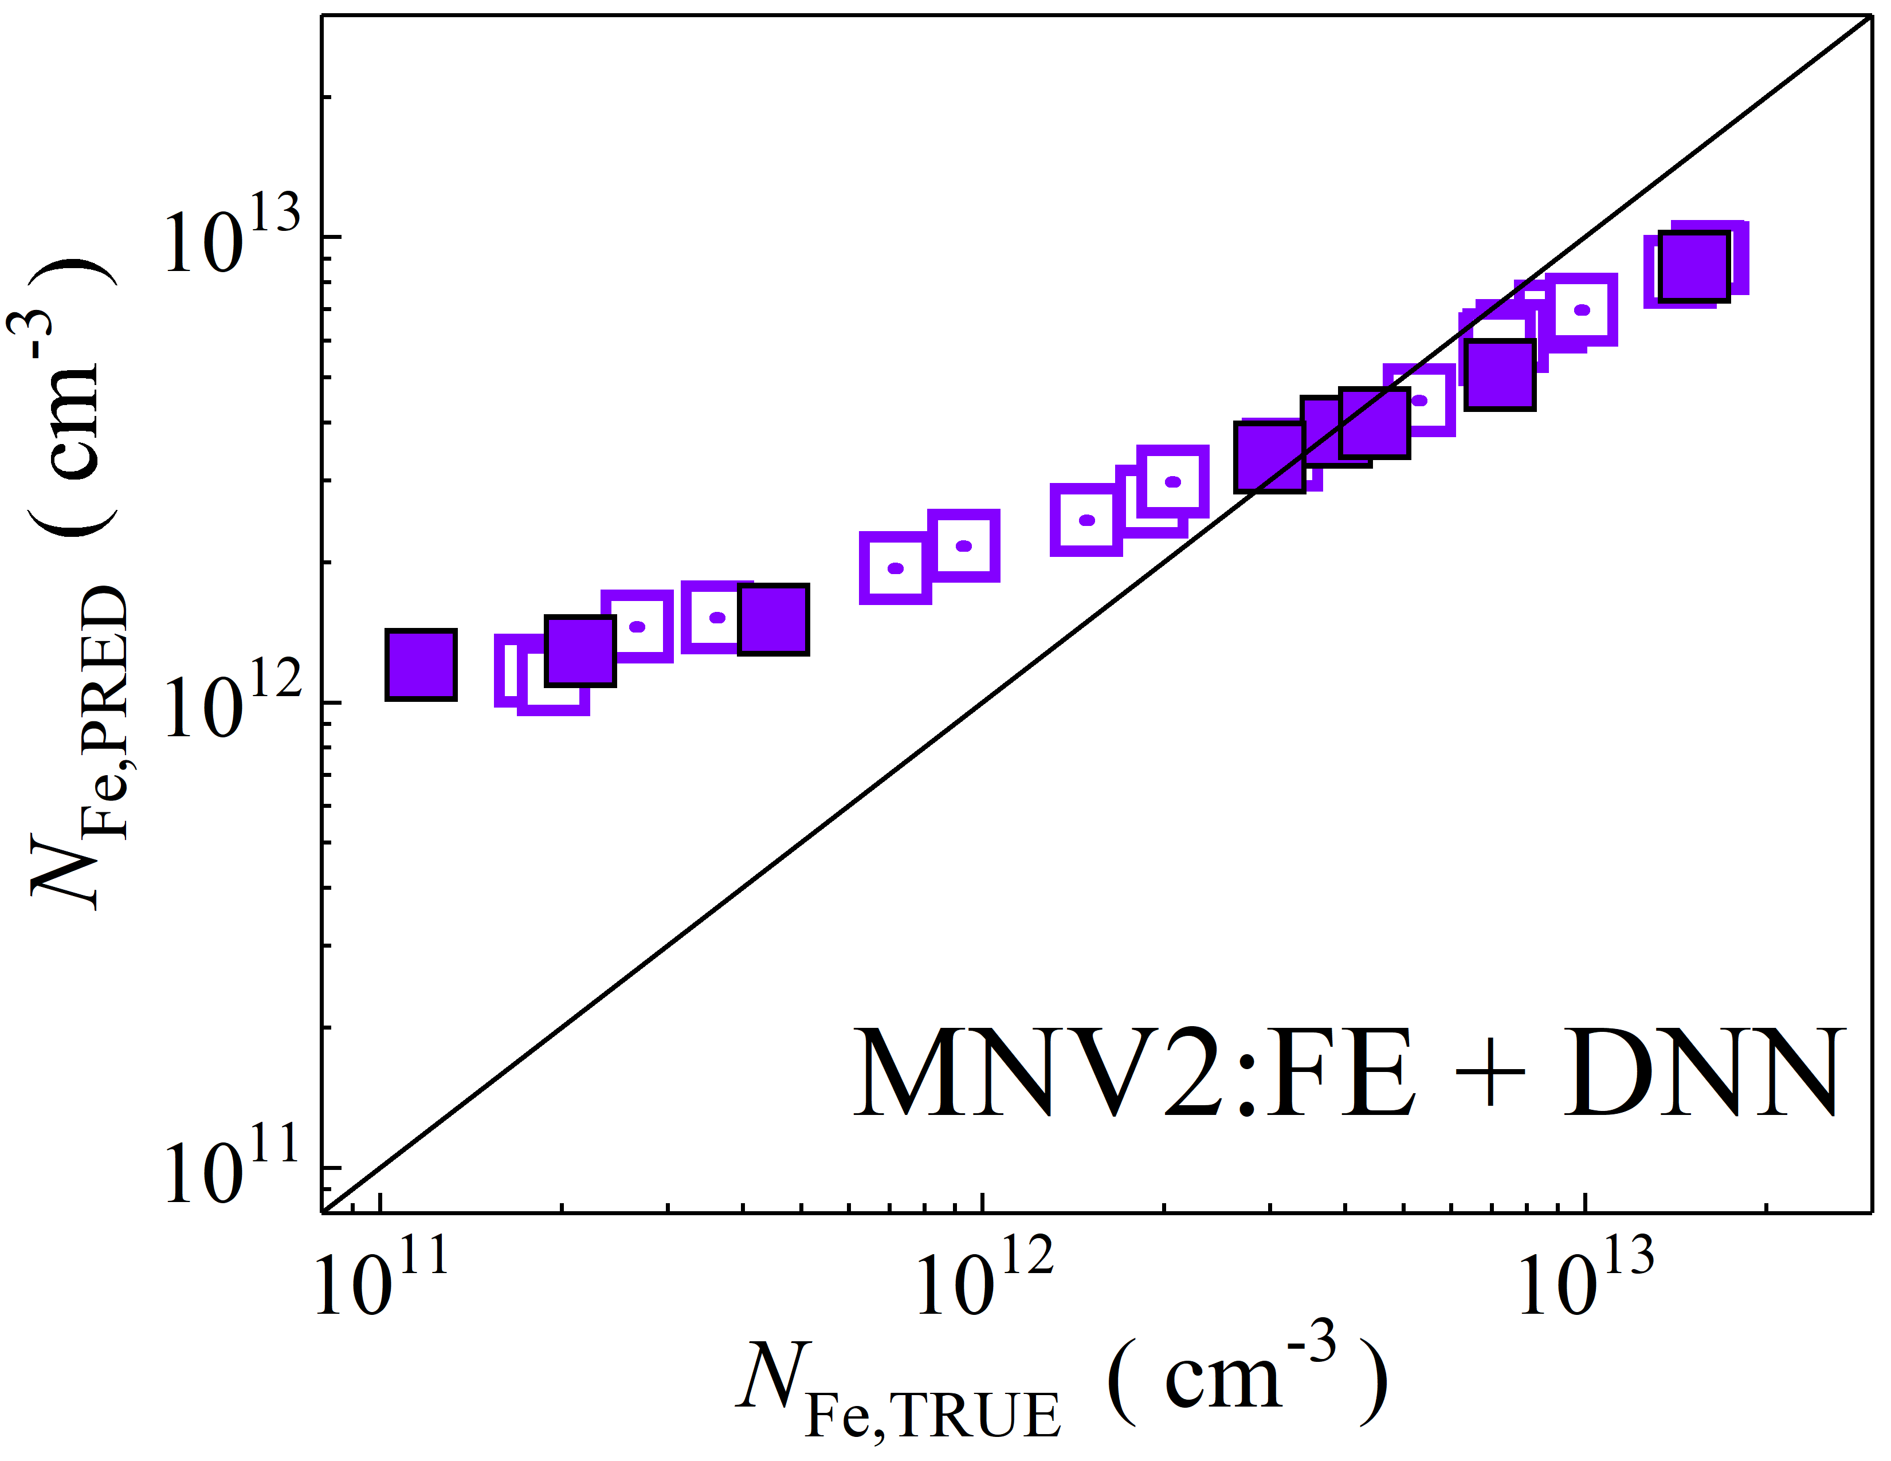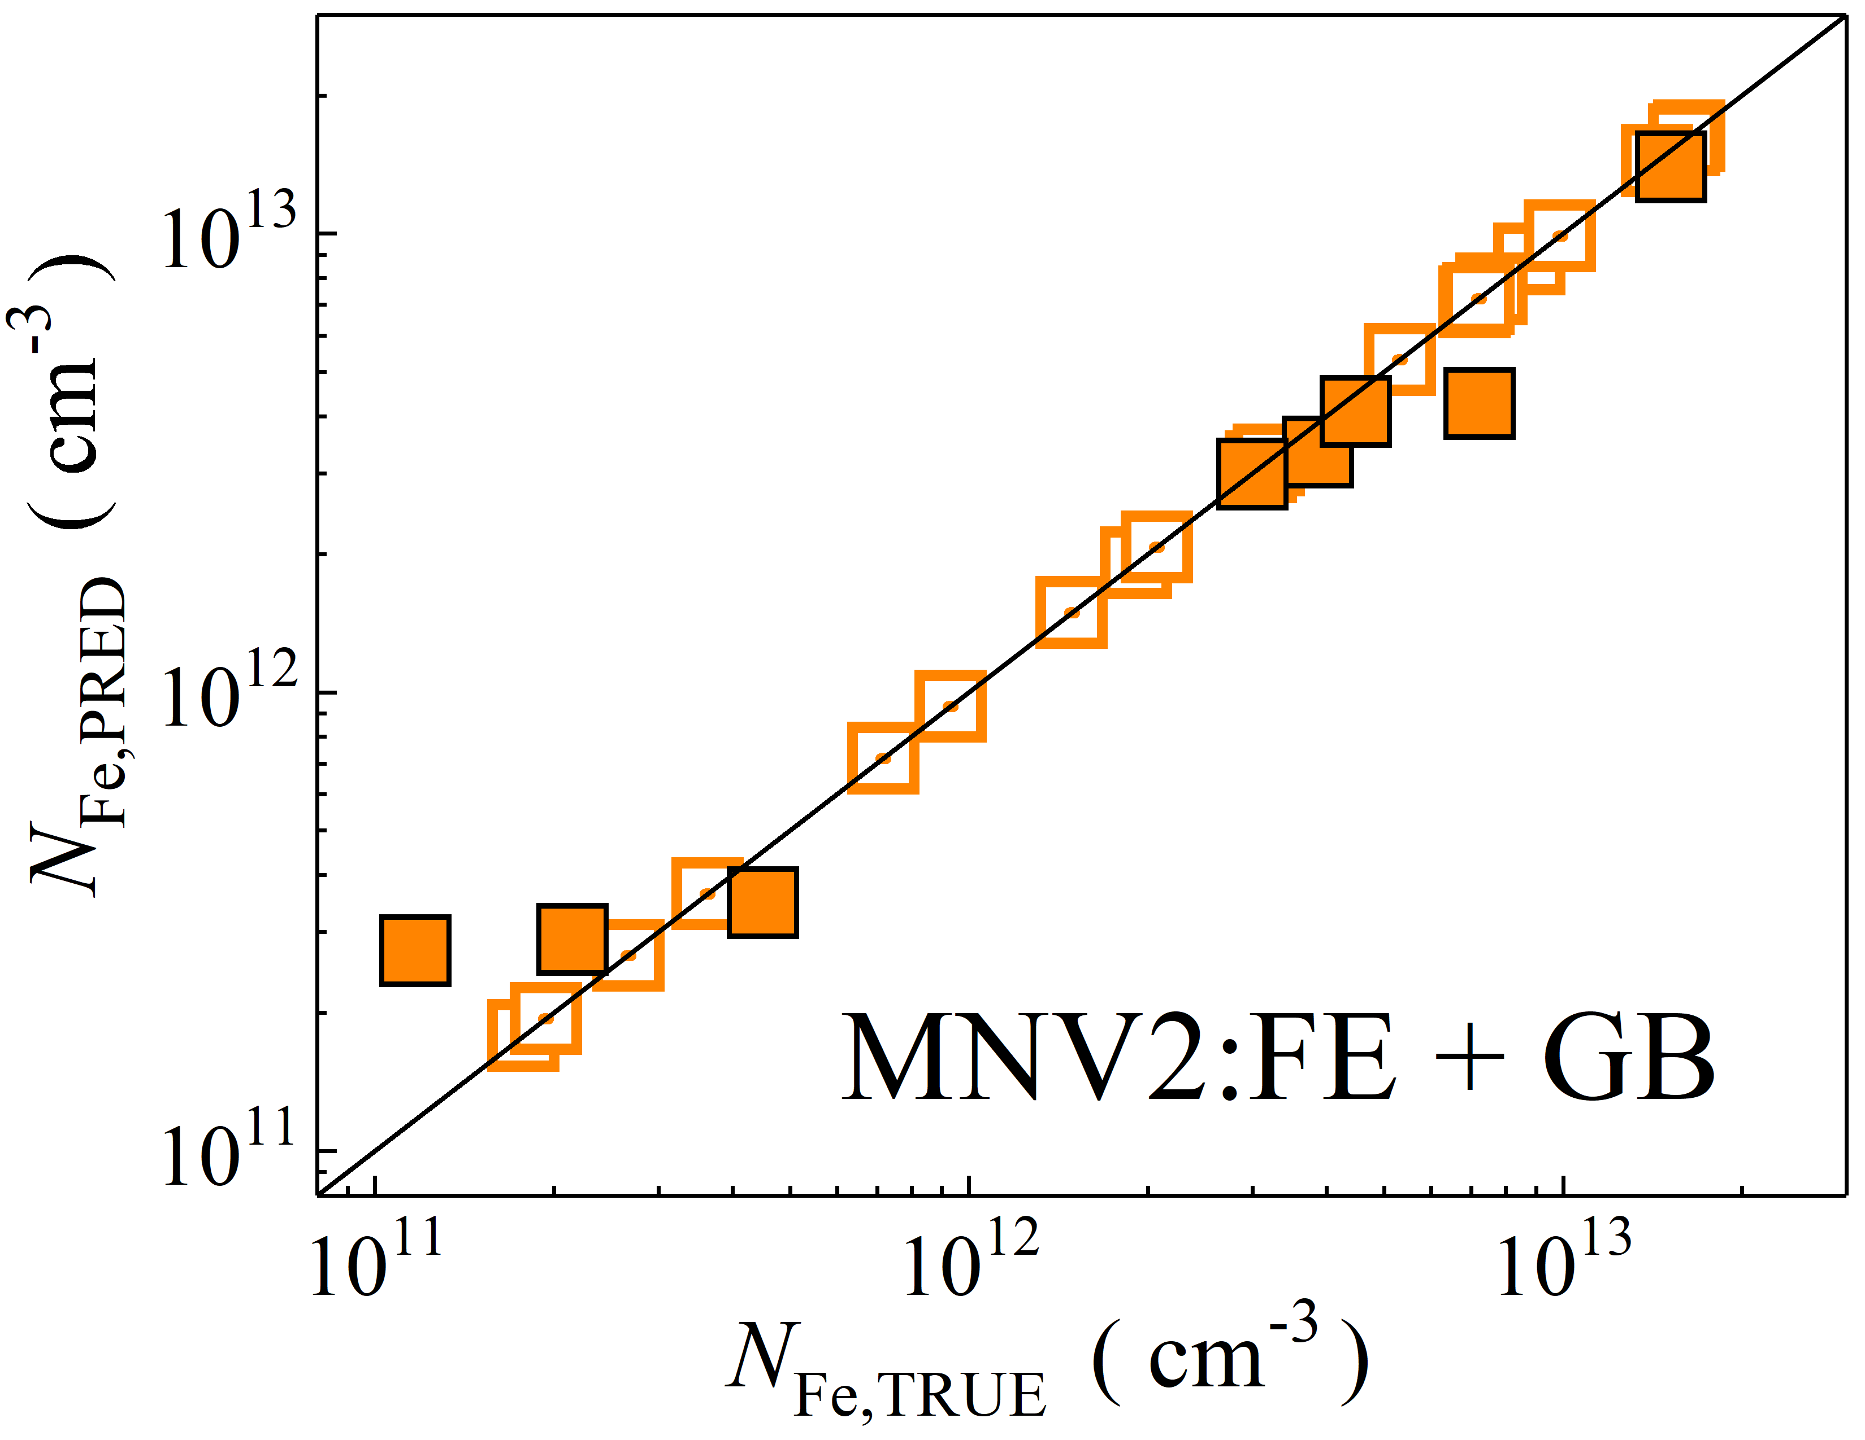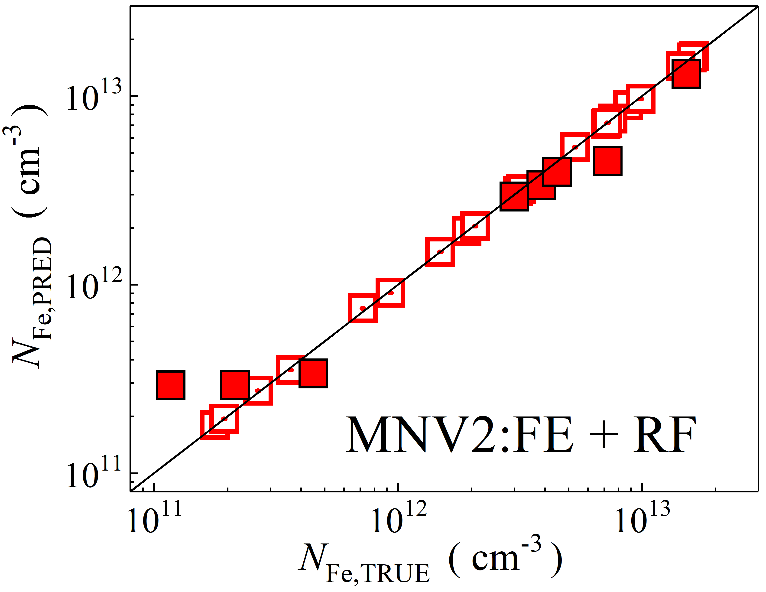

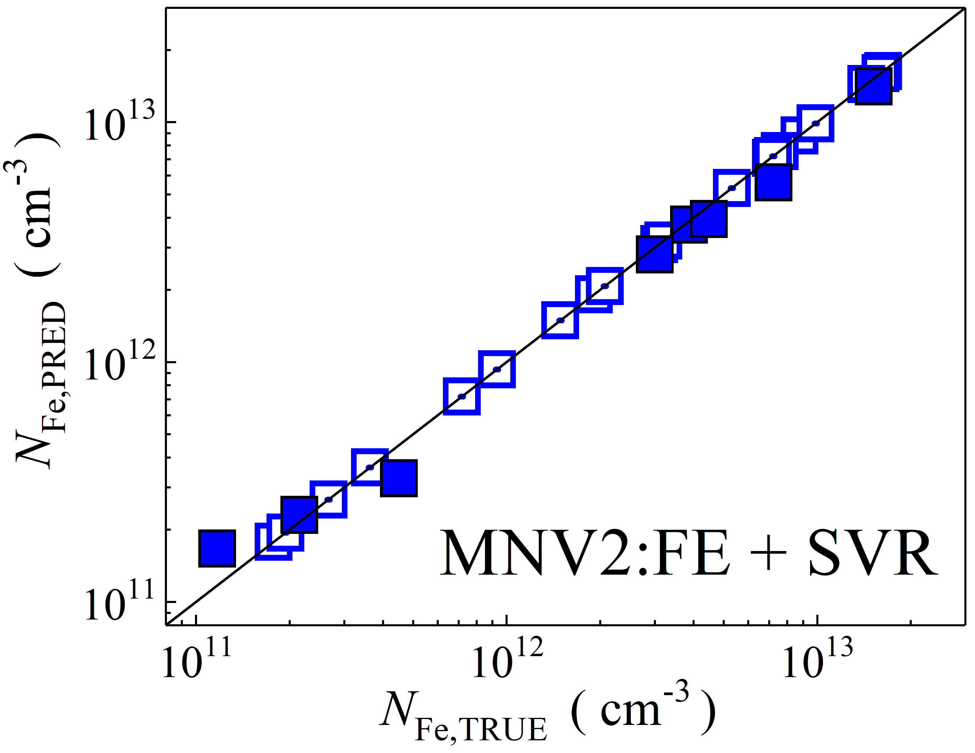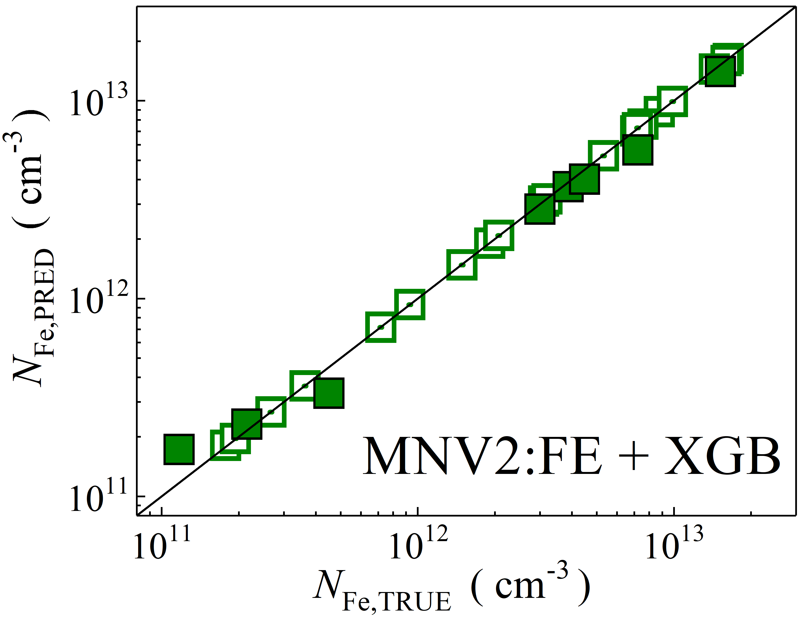

Fig. S24. Scatter plots compare reference iron concentrations $N_{Fe,TRUE}$ with ML-predicted values $N_{Fe,PRED}$ using feature vectors extracted from the feature extractor layer of MobileNetV2 visual model. The ML algorithms include DNN (green and purple), GB (dark yellow and yellow), RF (red and blue), SVR (blue and pink), and XGB (green and red). Symbols represent different datasets: filled squares — test data from experimental measurements, and open squares — train data from experimental measurements. The black lines are the identified lines serving as the references.

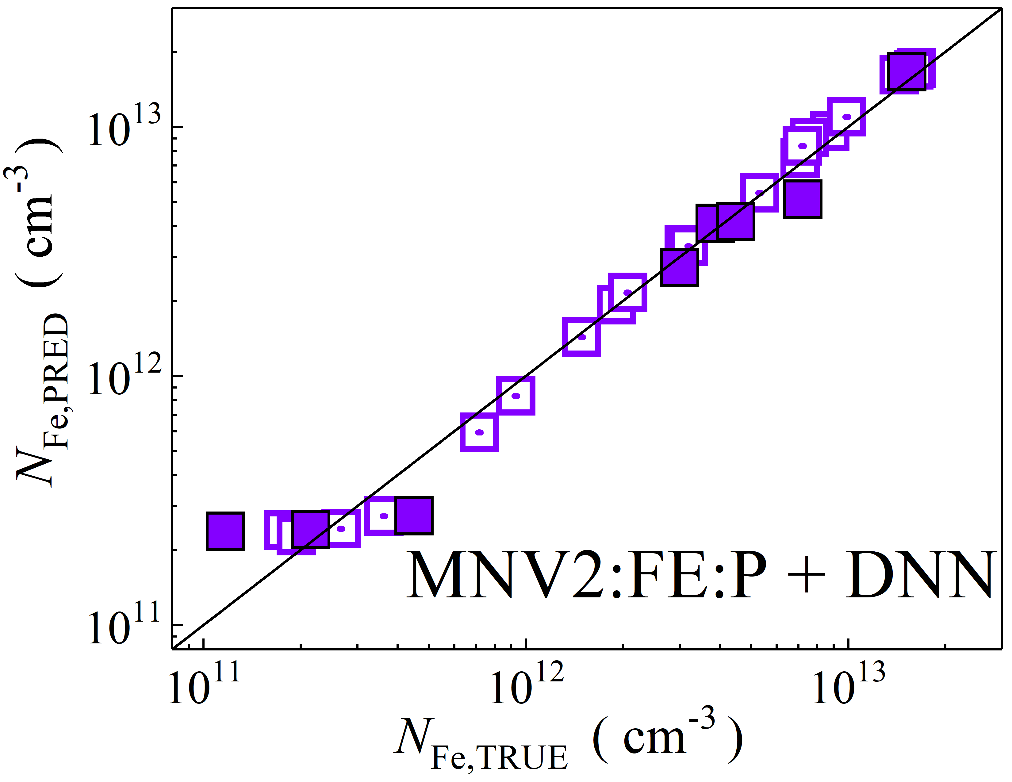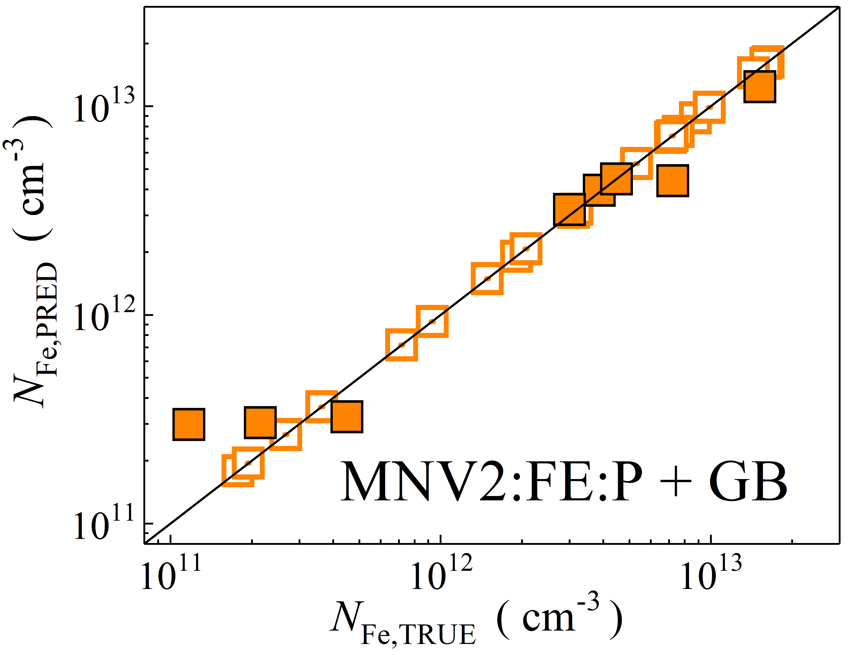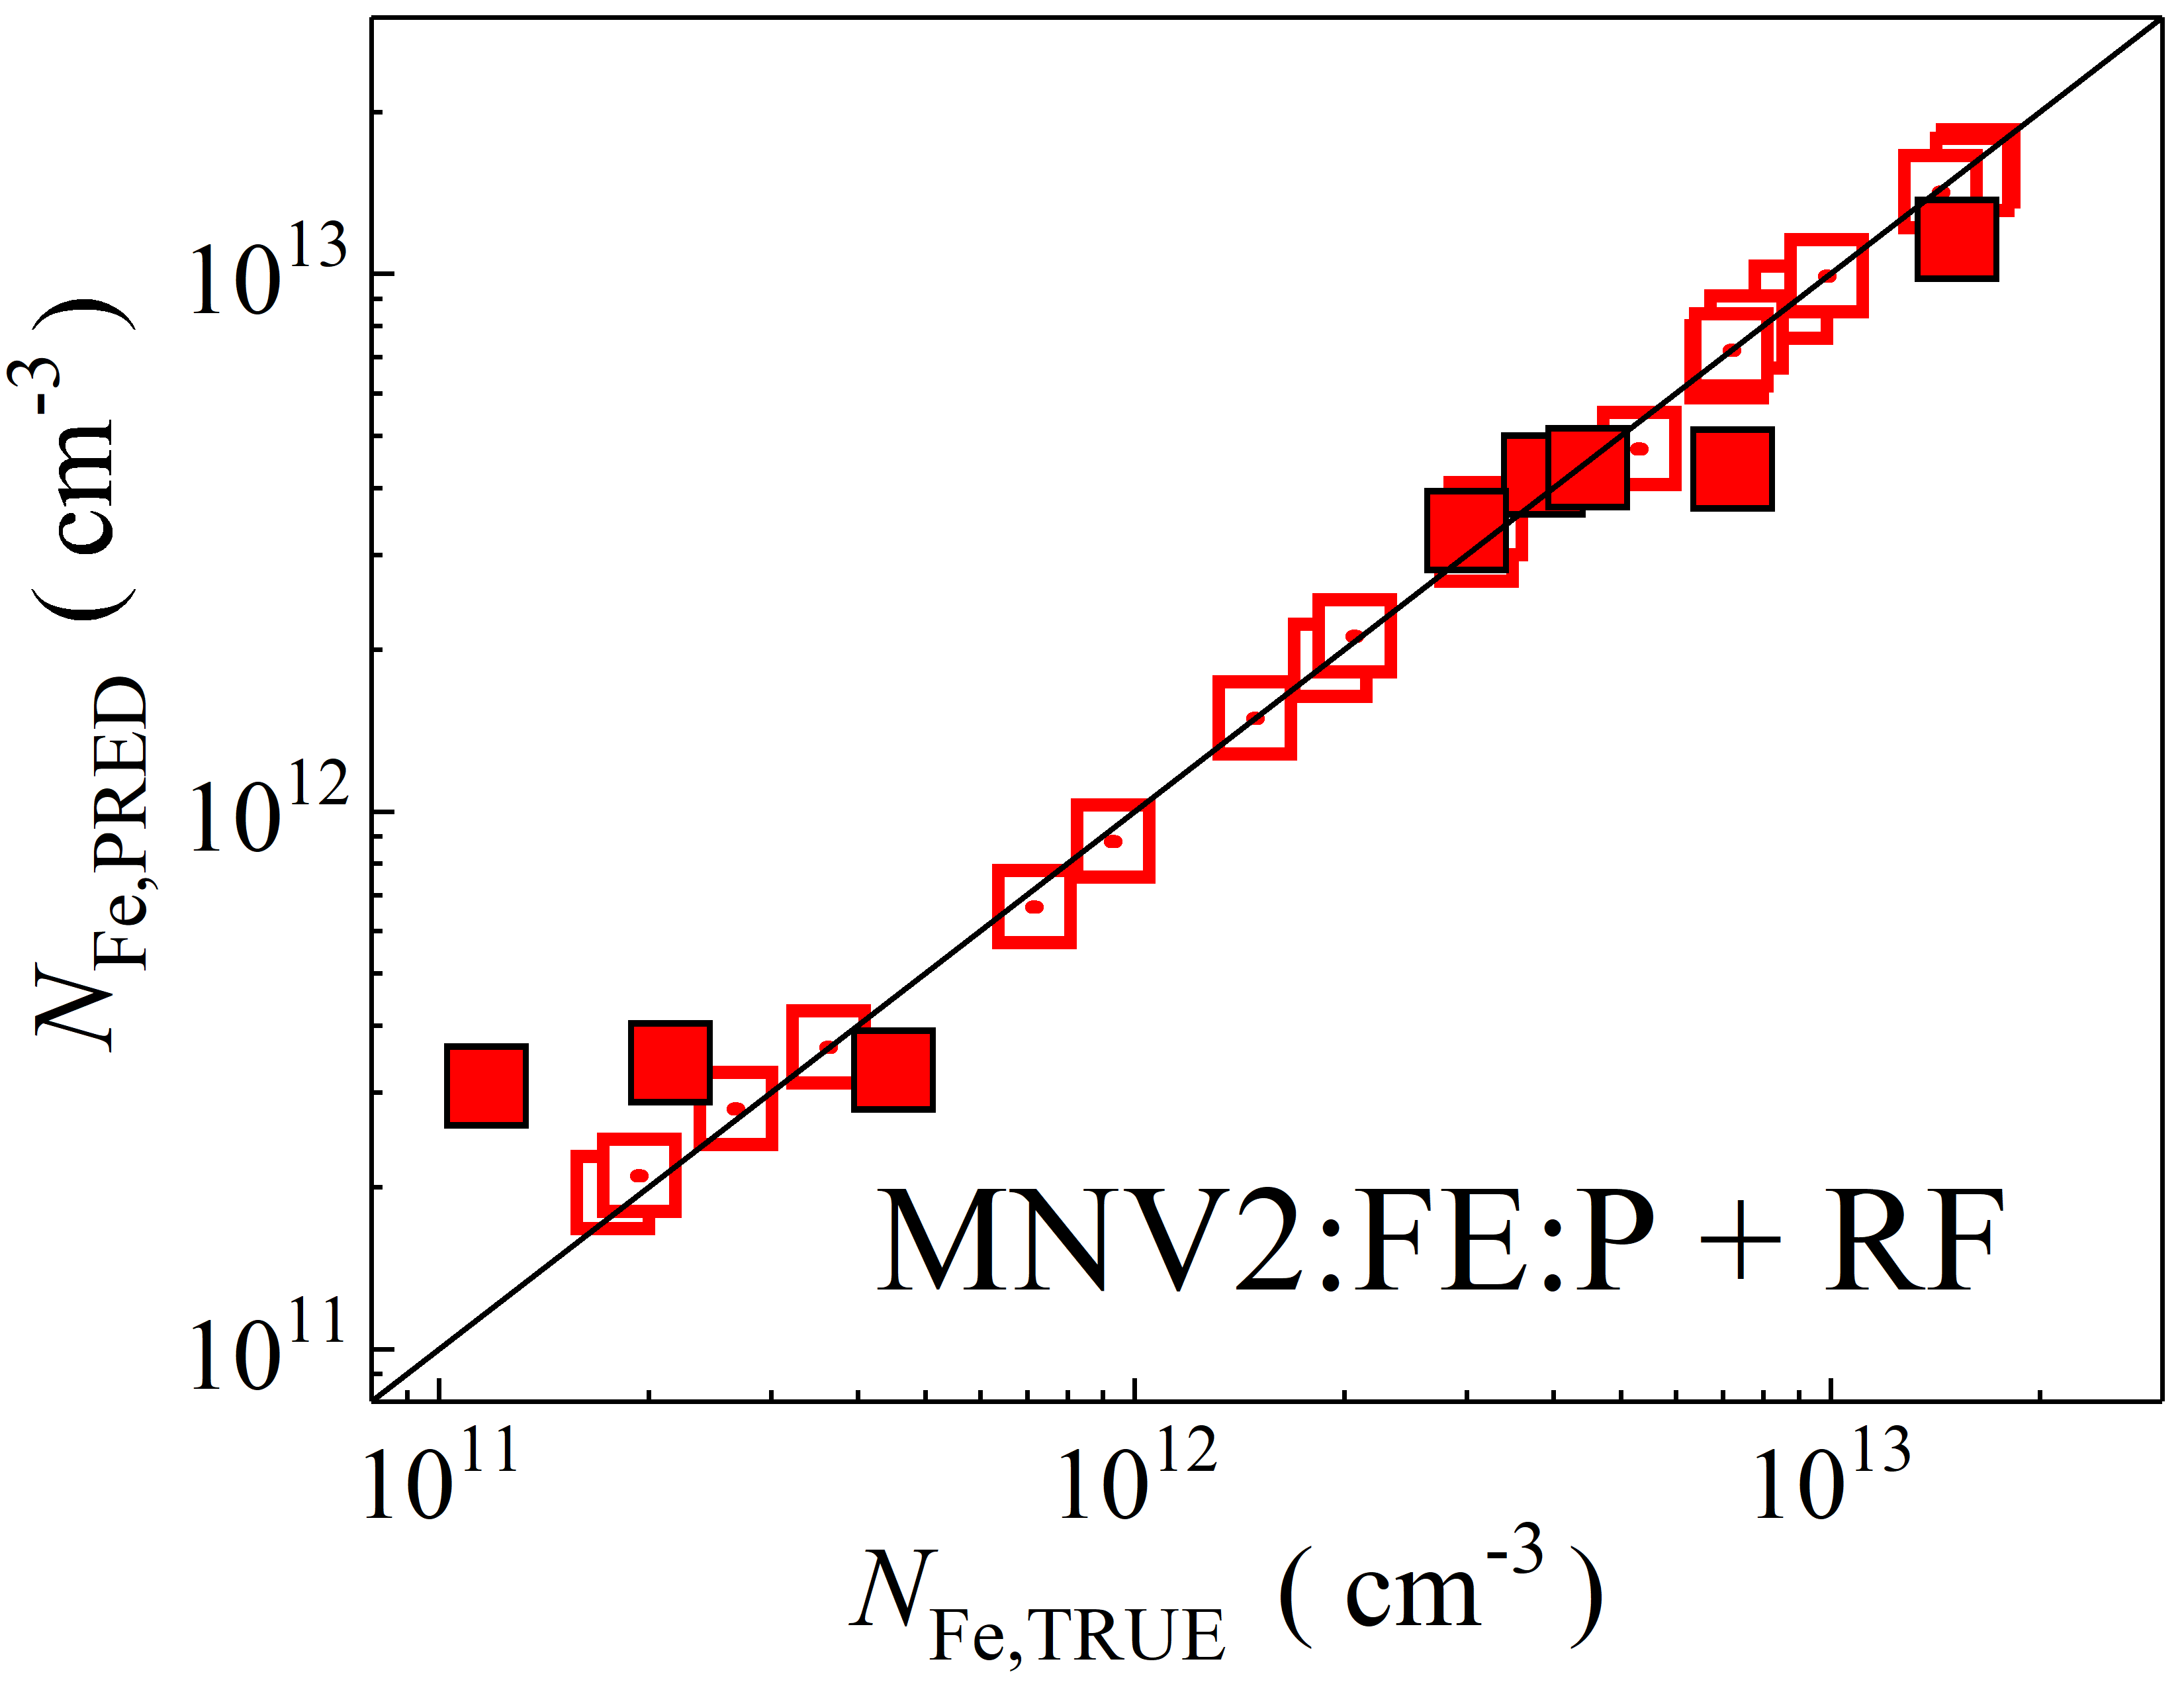

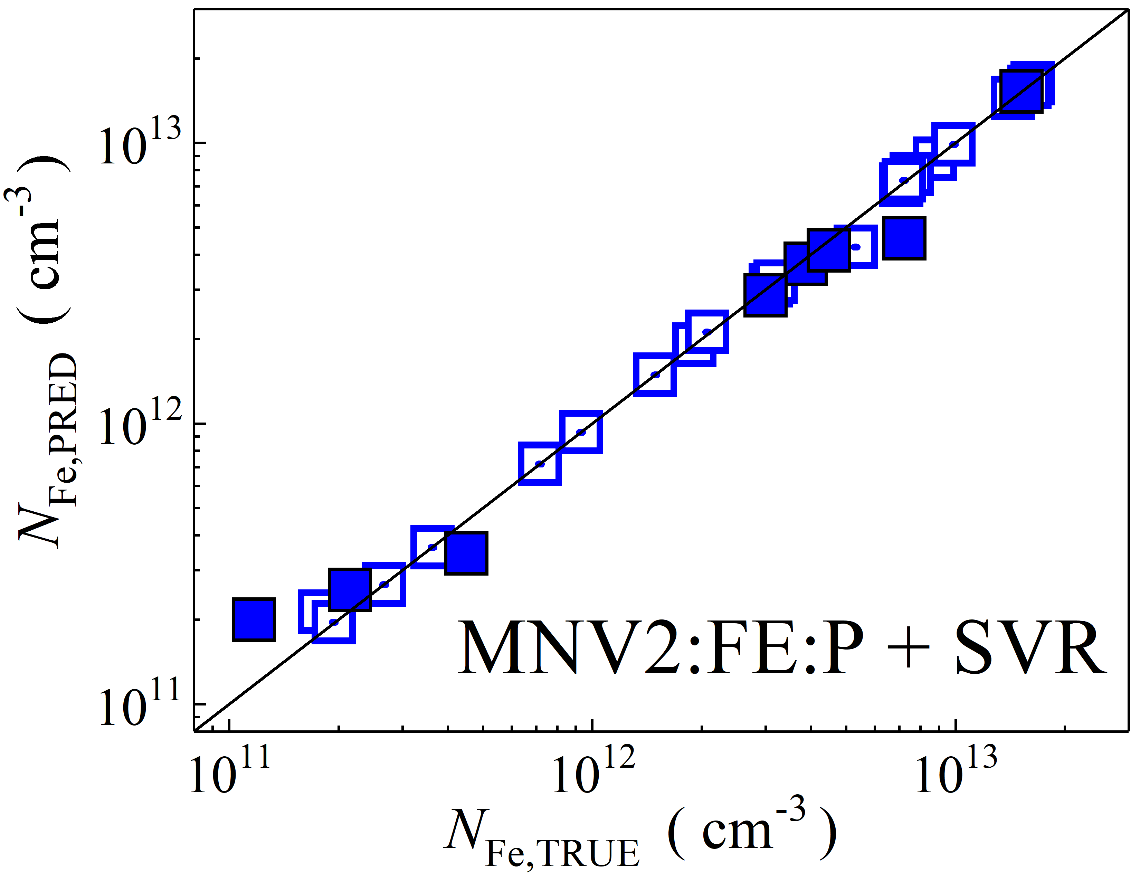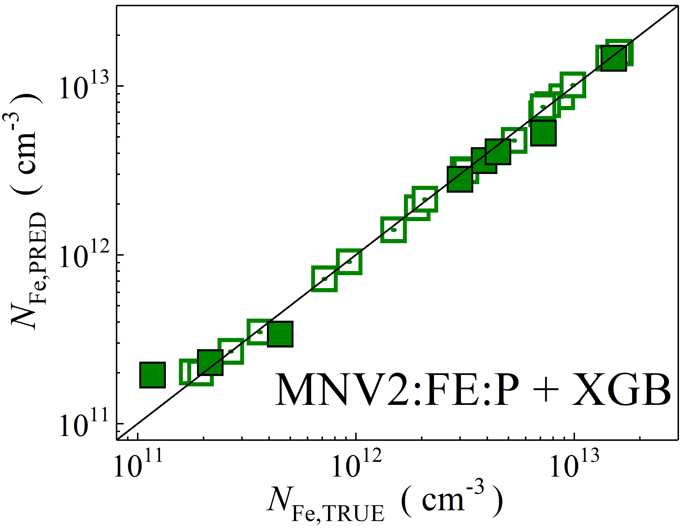

Fig. S25. Scatter plots compare reference iron concentrations $N_{Fe,TRUE}$ with ML-predicted values $N_{Fe,PRED}$ using feature vectors extracted from the feature extractor layer with PCA reduction of MobileNetV2 visual model. The ML algorithms include DNN (green and purple), GB (dark yellow and yellow), RF (red and blue), SVR (blue and pink), and XGB (green and red). Symbols represent different datasets: filled squares — test data from experimental measurements, and open squares — train data from experimental measurements. The black lines are the identified lines serving as the references.

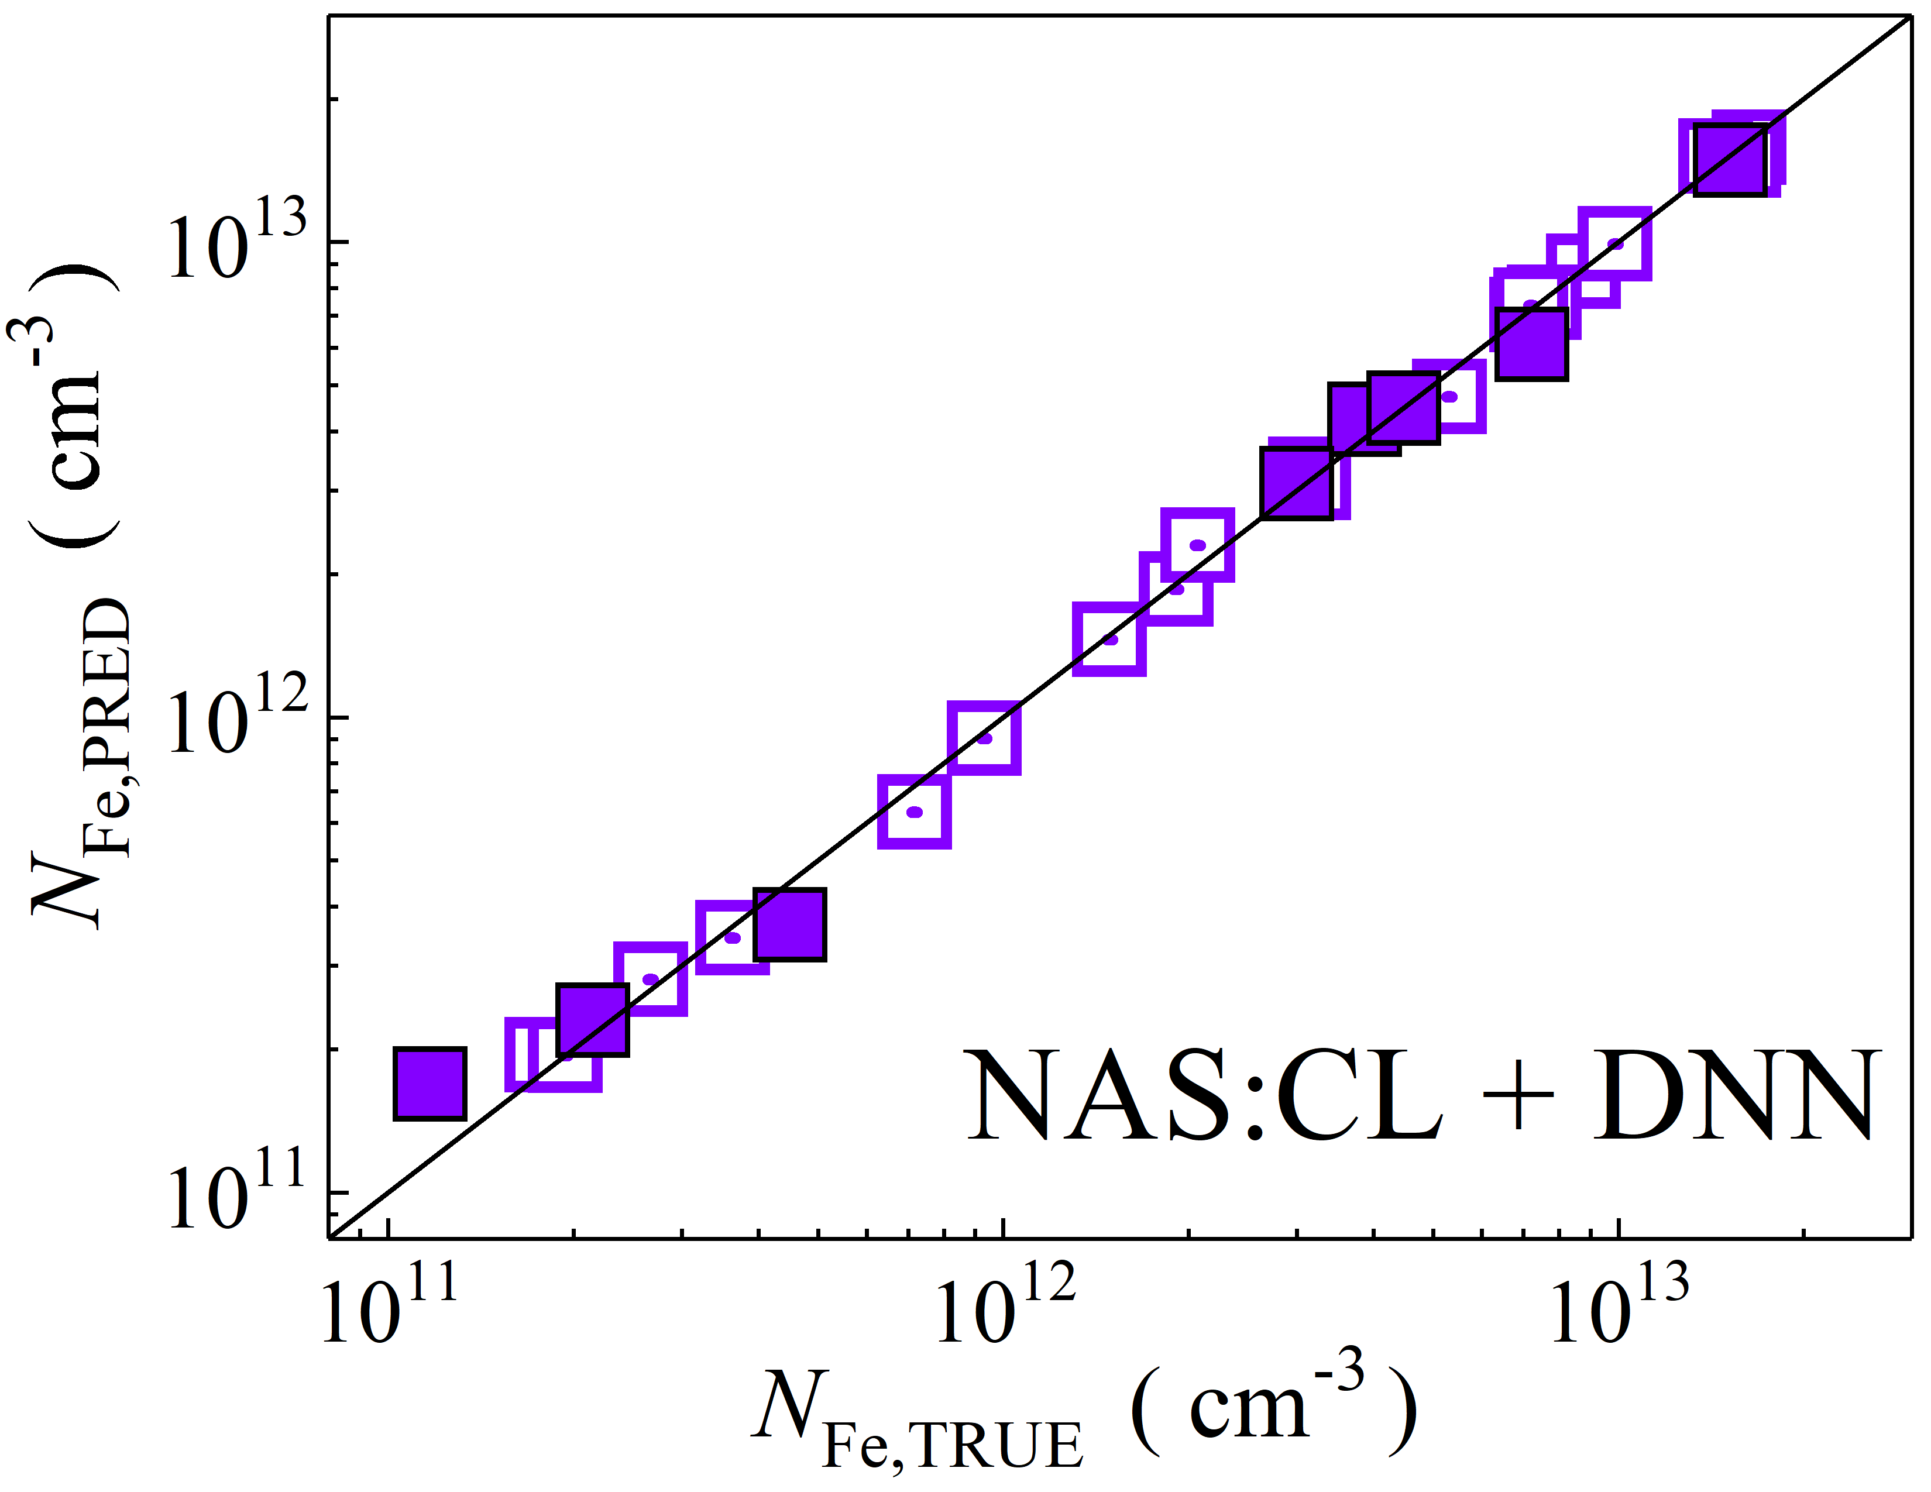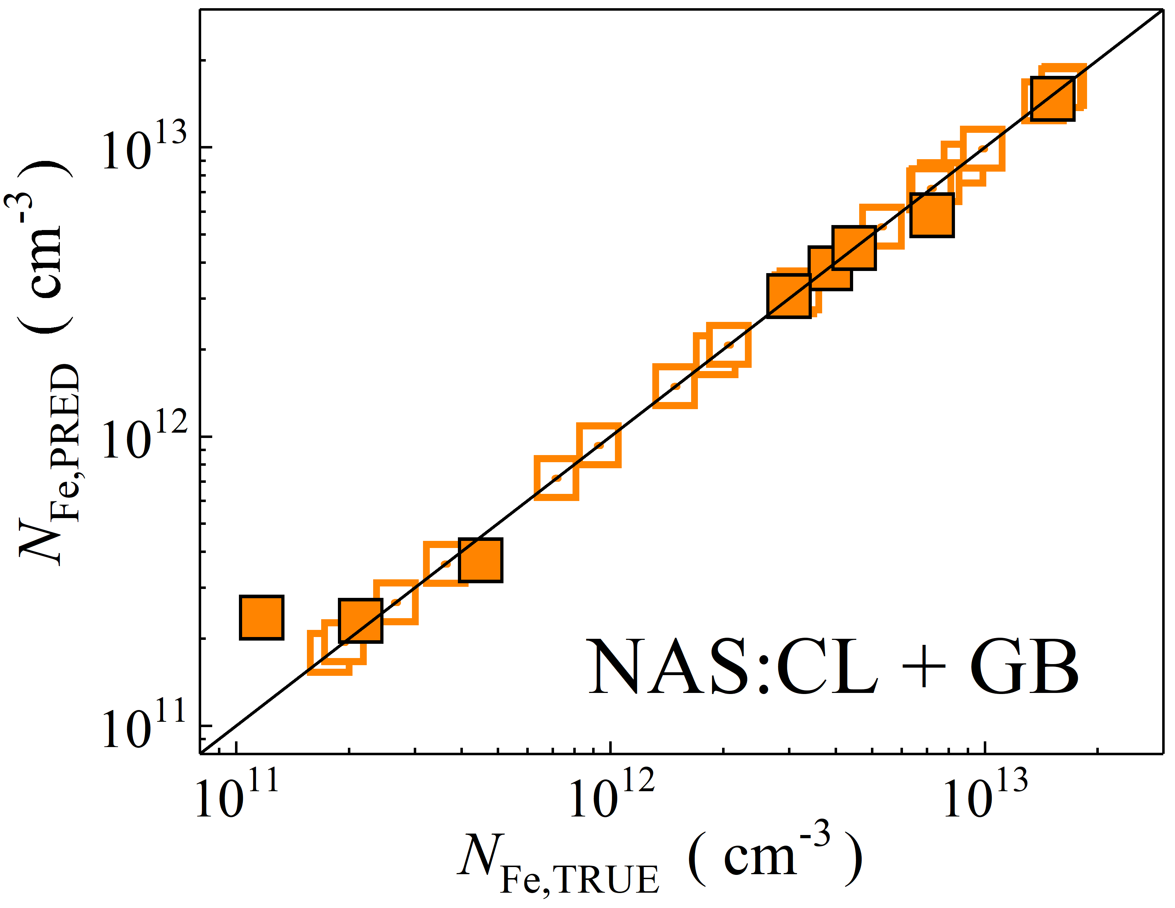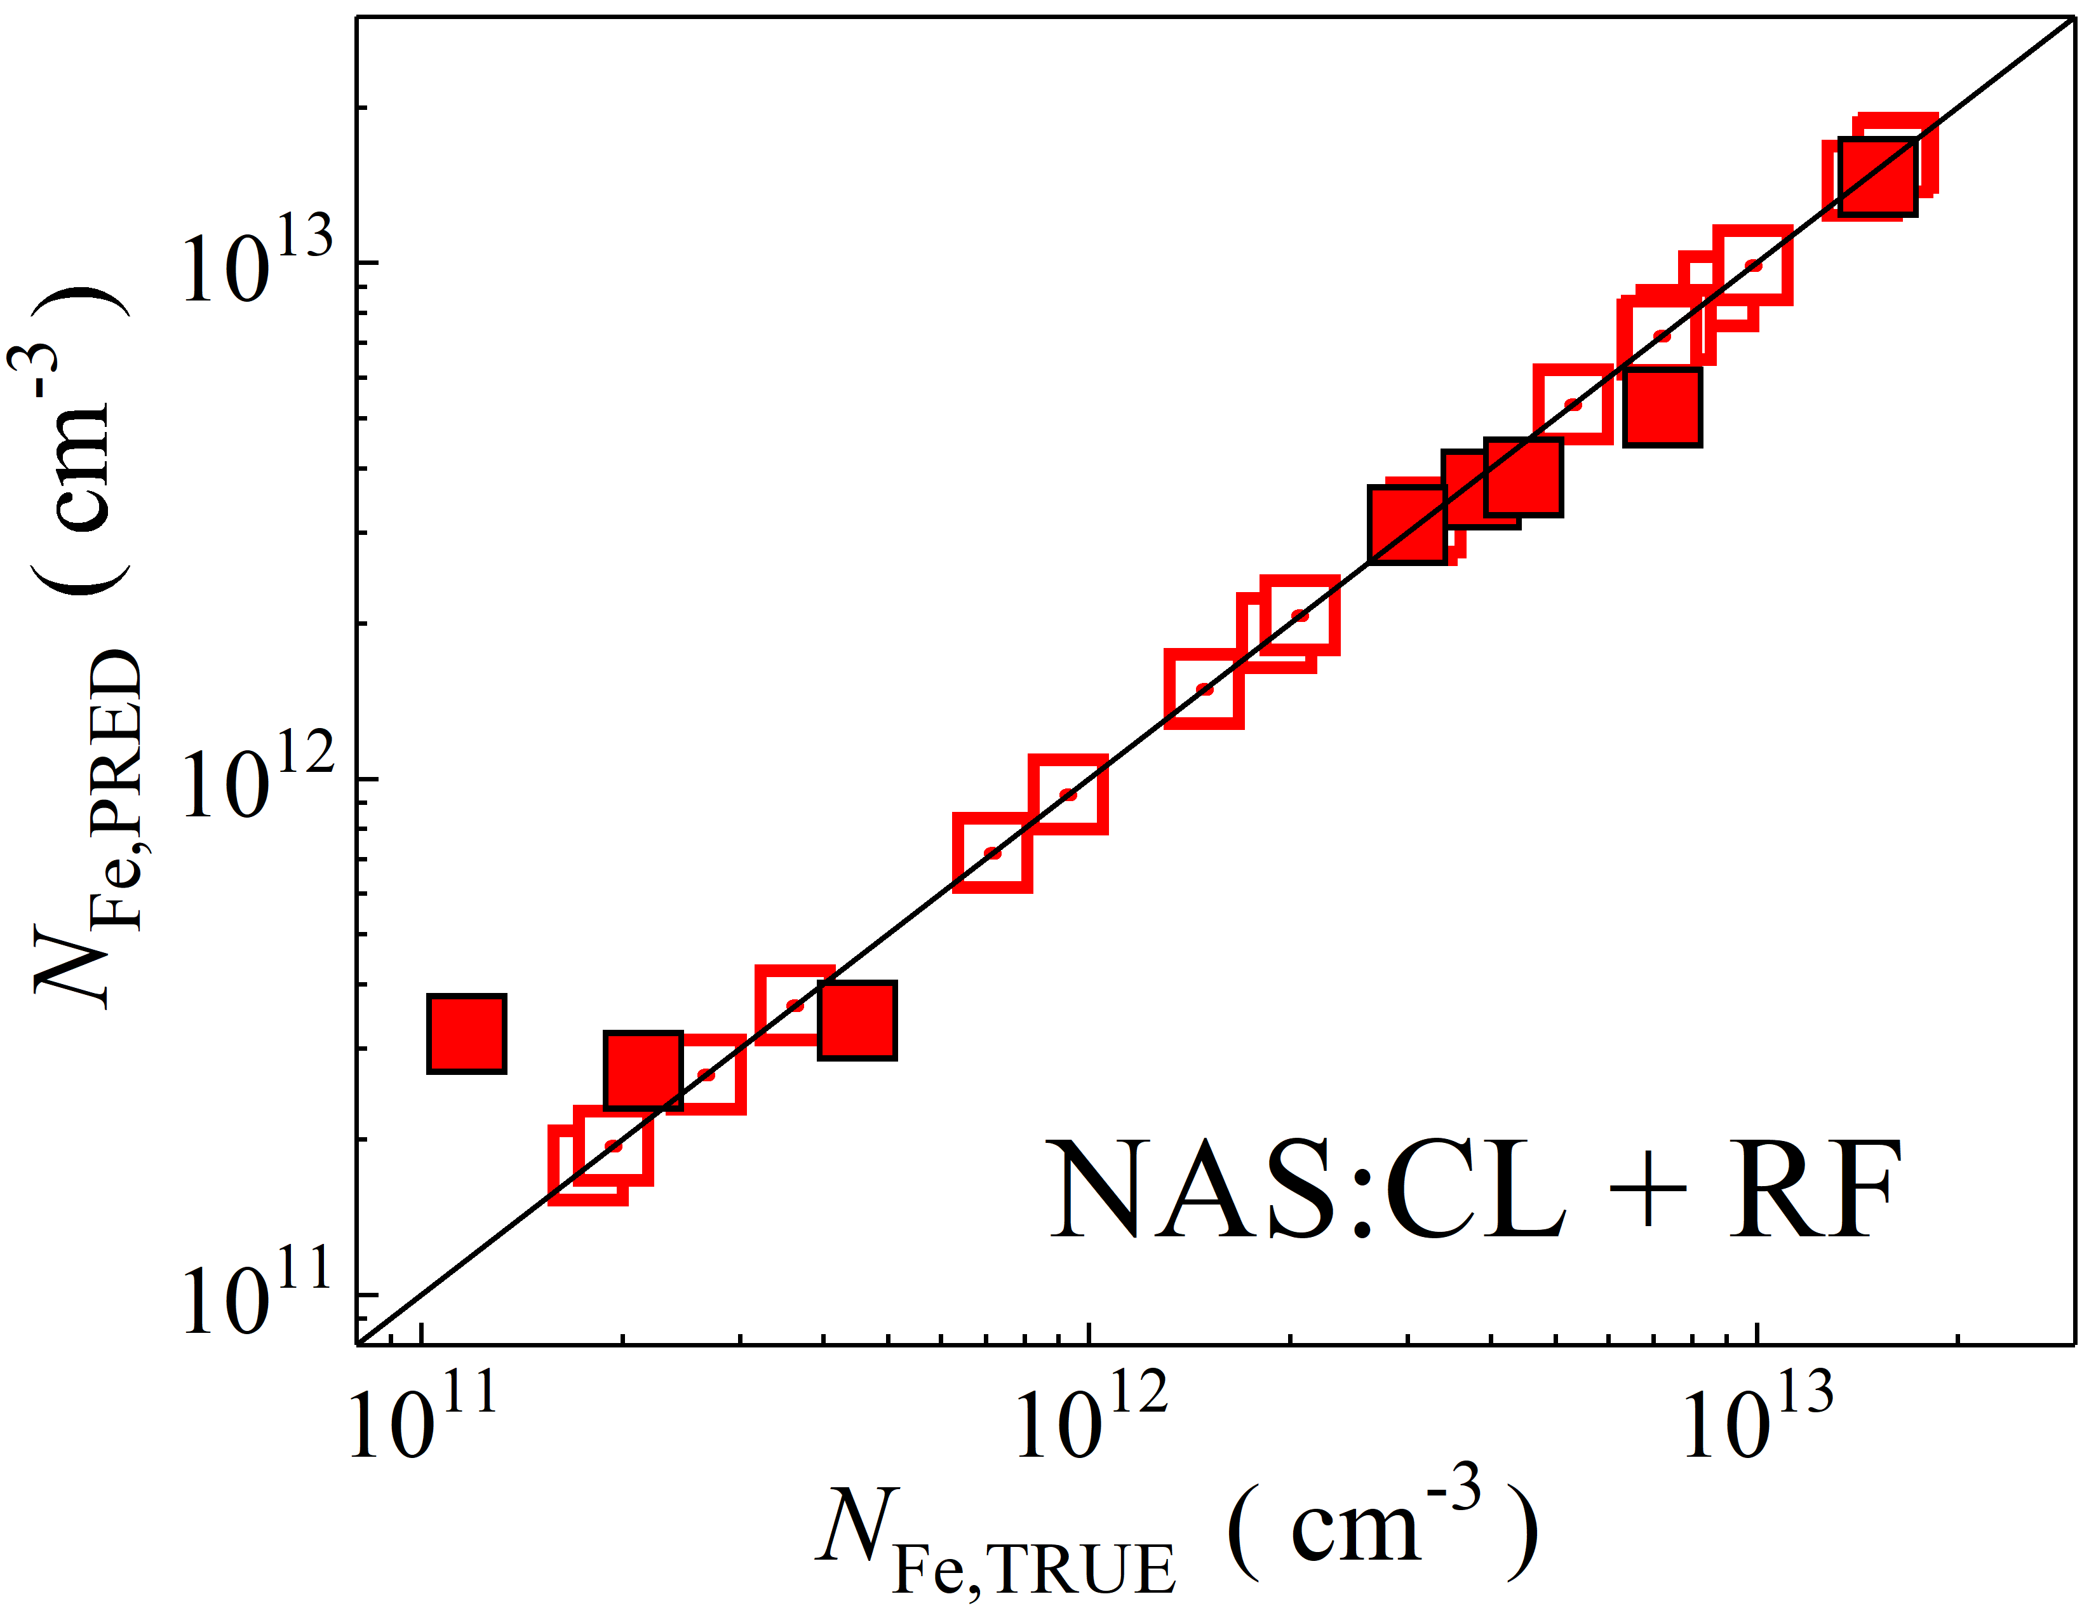

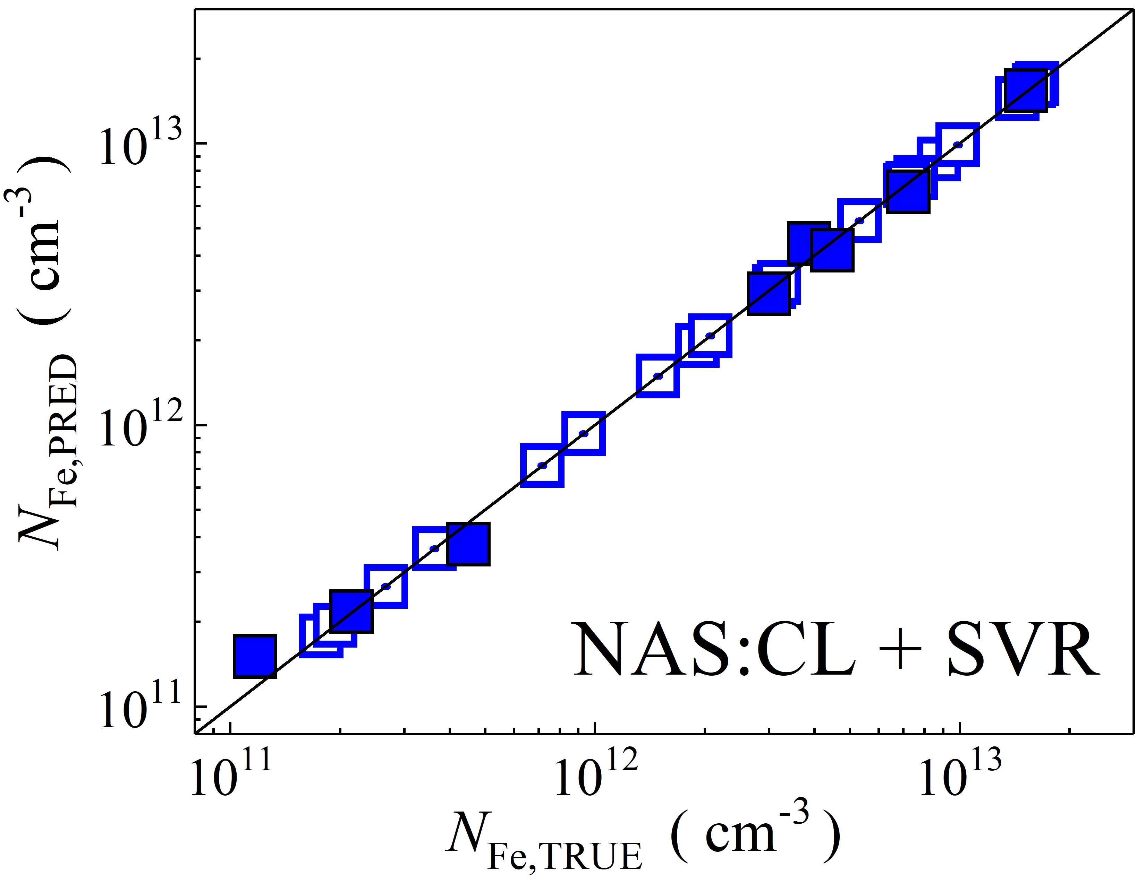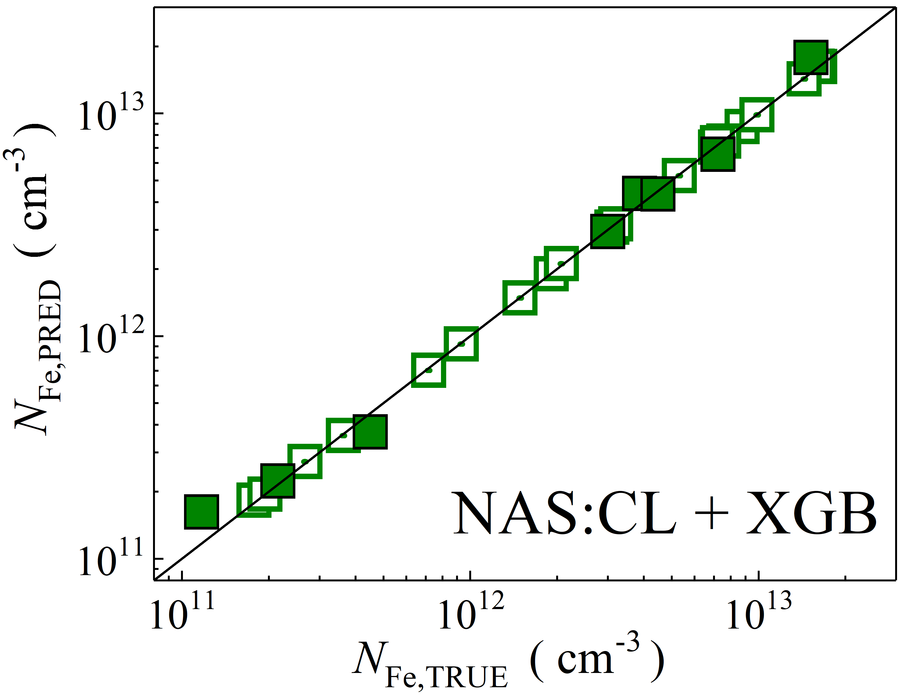

Fig. S26. Scatter plots compare reference iron concentrations $N_{Fe,TRUE}$ with ML-predicted values $N_{Fe,PRED}$ using feature vectors extracted from the classifier layer of NASNetLarge visual model. The ML algorithms include DNN (green and purple), GB (dark yellow and yellow), RF (red and blue), SVR (blue and pink), and XGB (green and red). Symbols represent different datasets: filled squares — test data from experimental measurements, and open squares — train data from experimental measurements. The black lines are the identified lines serving as the references.

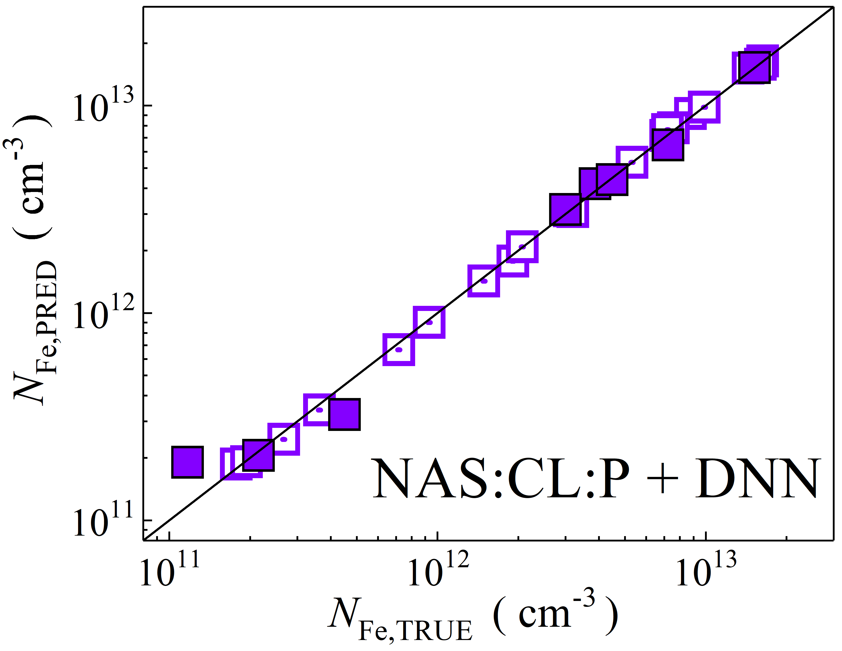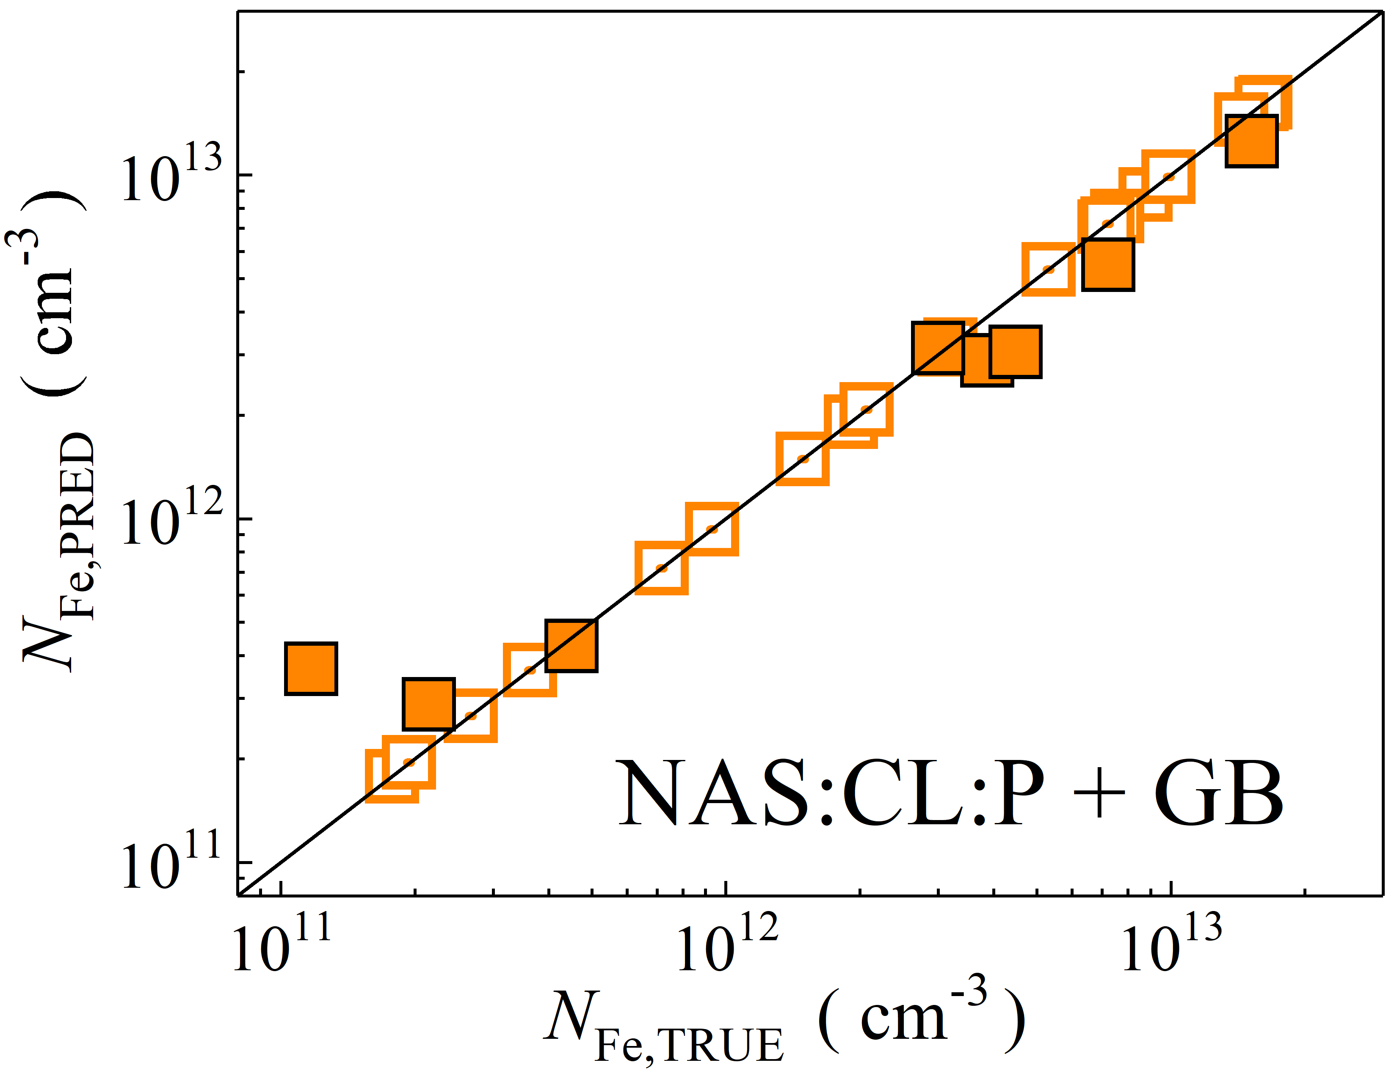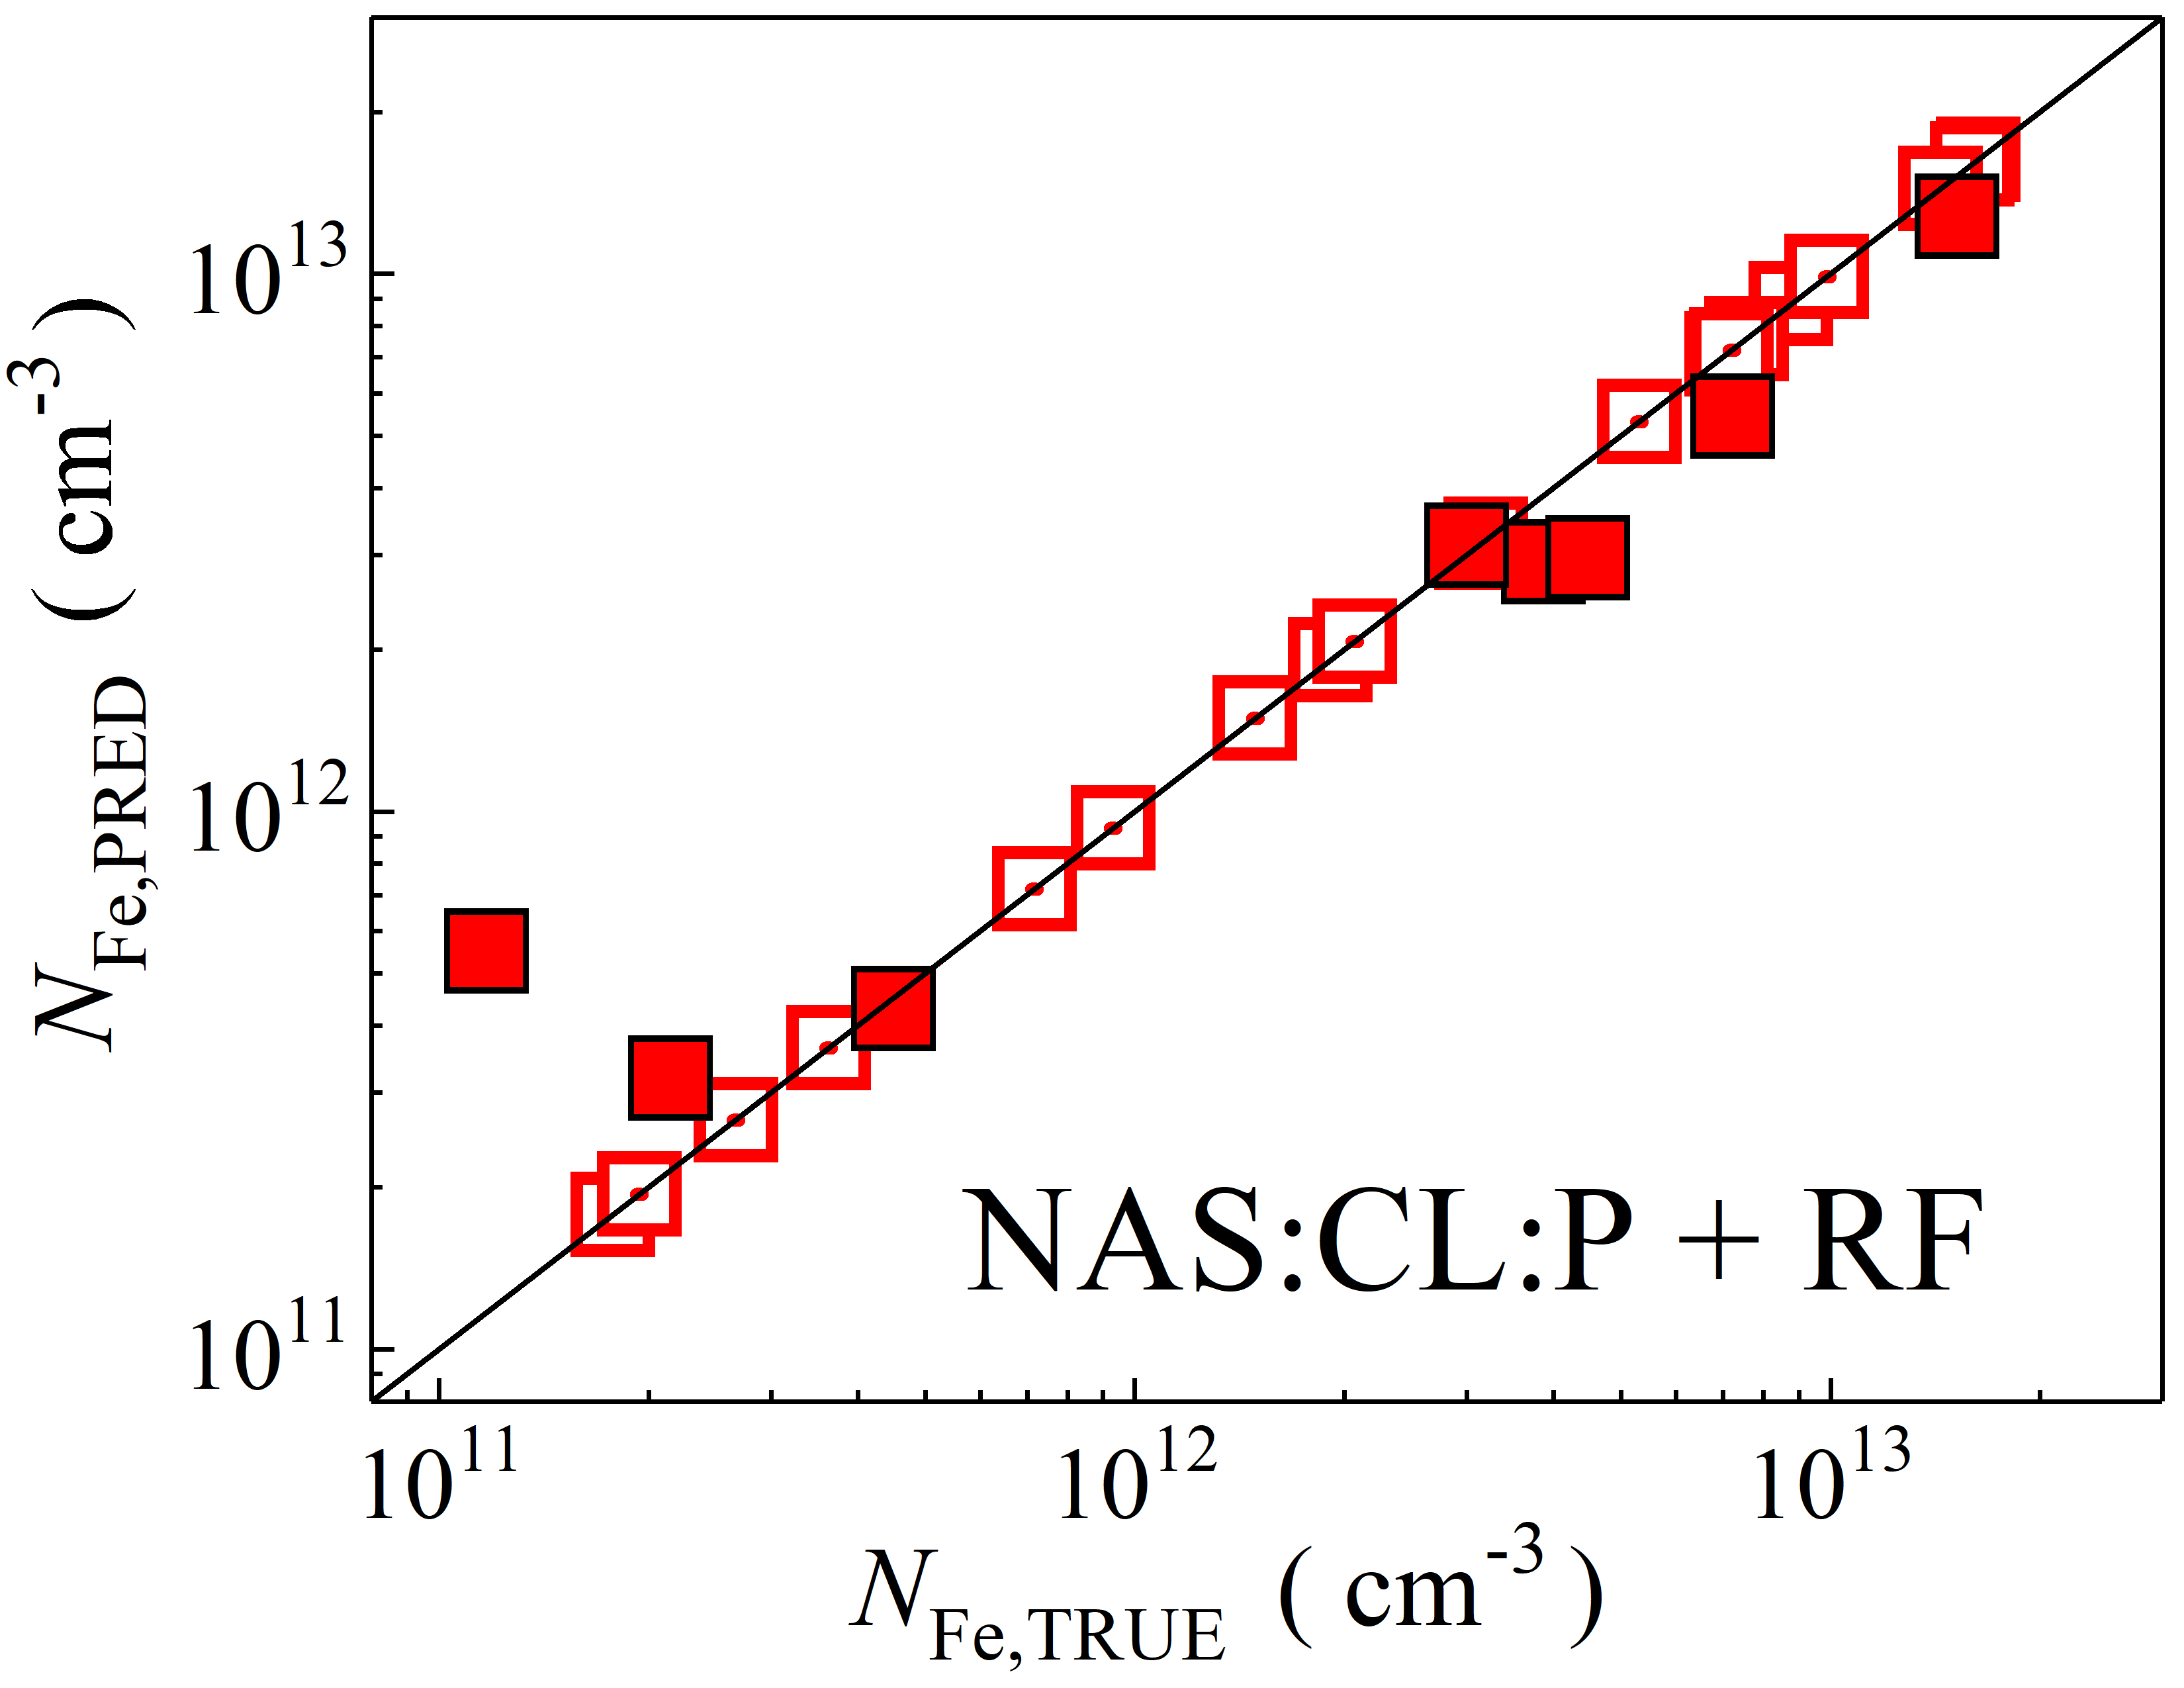

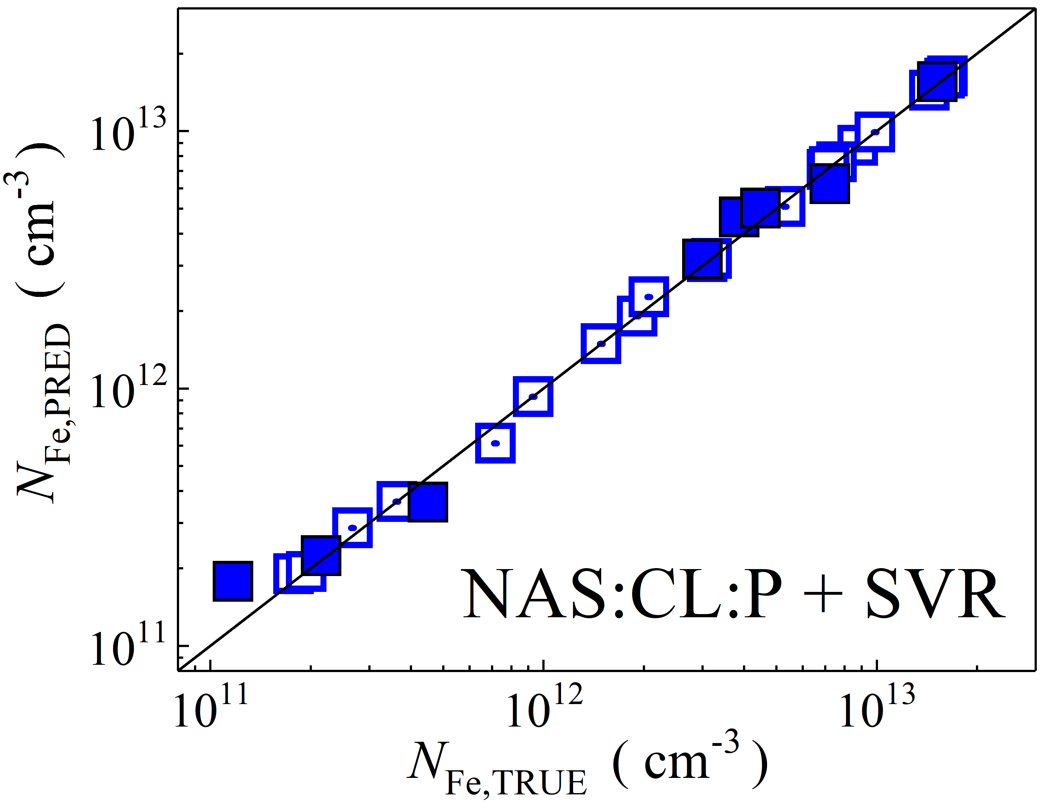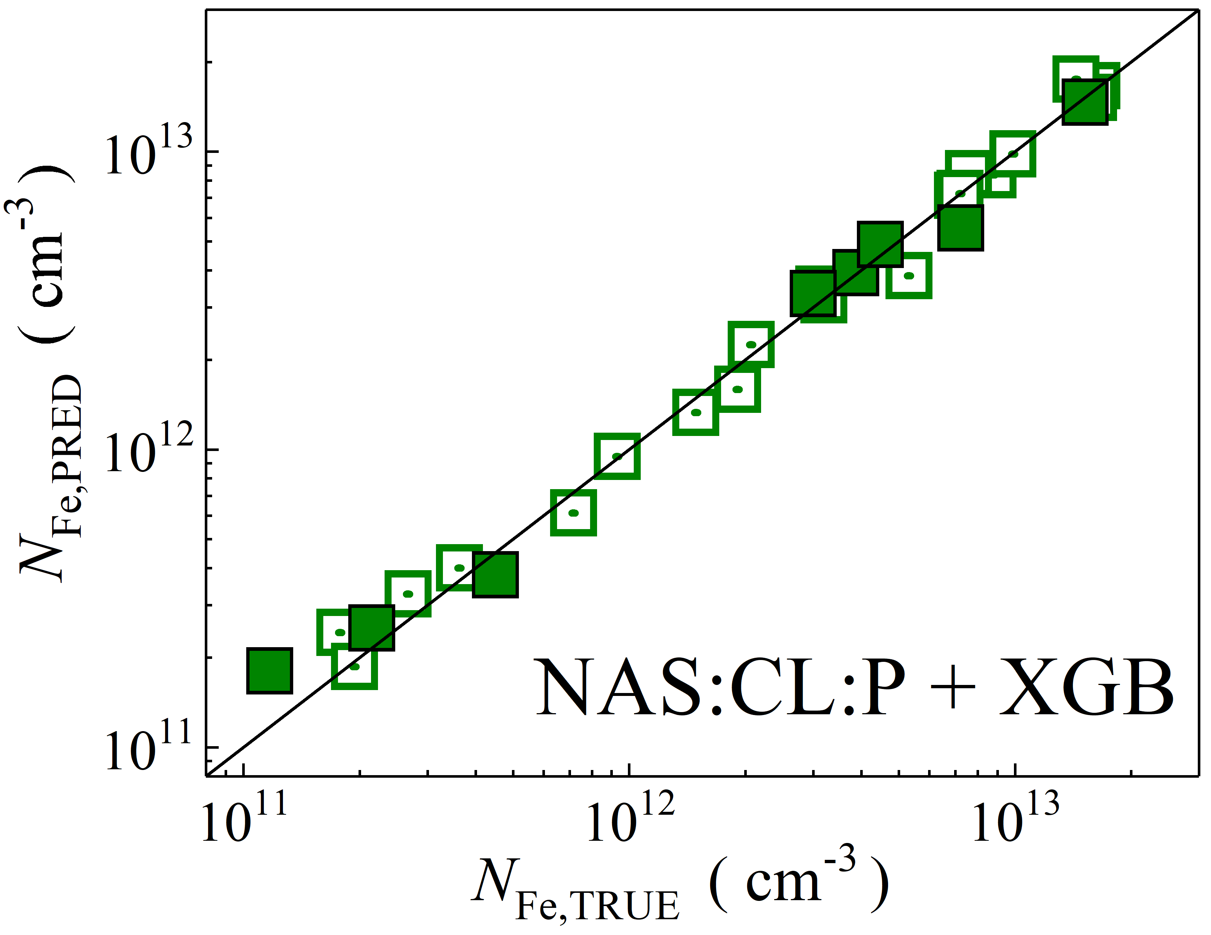

Fig. S27. Scatter plots compare reference iron concentrations $N_{Fe,TRUE}$ with ML-predicted values $N_{Fe,PRED}$ using feature vectors extracted from the classifier layer with PCA reduction of NASNetLarge visual model. The ML algorithms include DNN (green and purple), GB (dark yellow and yellow), RF (red and blue), SVR (blue and pink), and XGB (green and red). Symbols represent different datasets: filled squares — test data from experimental measurements, and open squares — train data from experimental measurements. The black lines are the identified lines serving as the references.

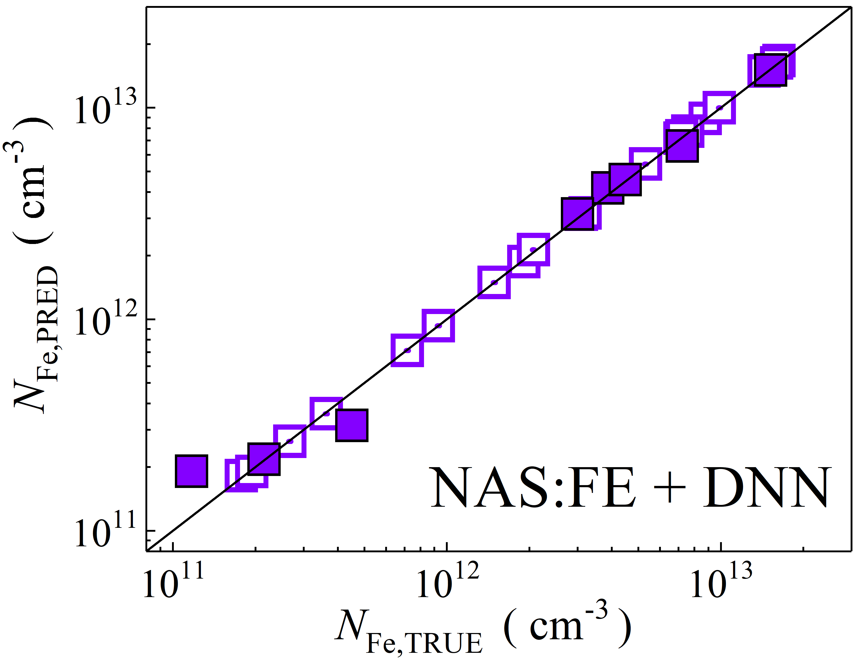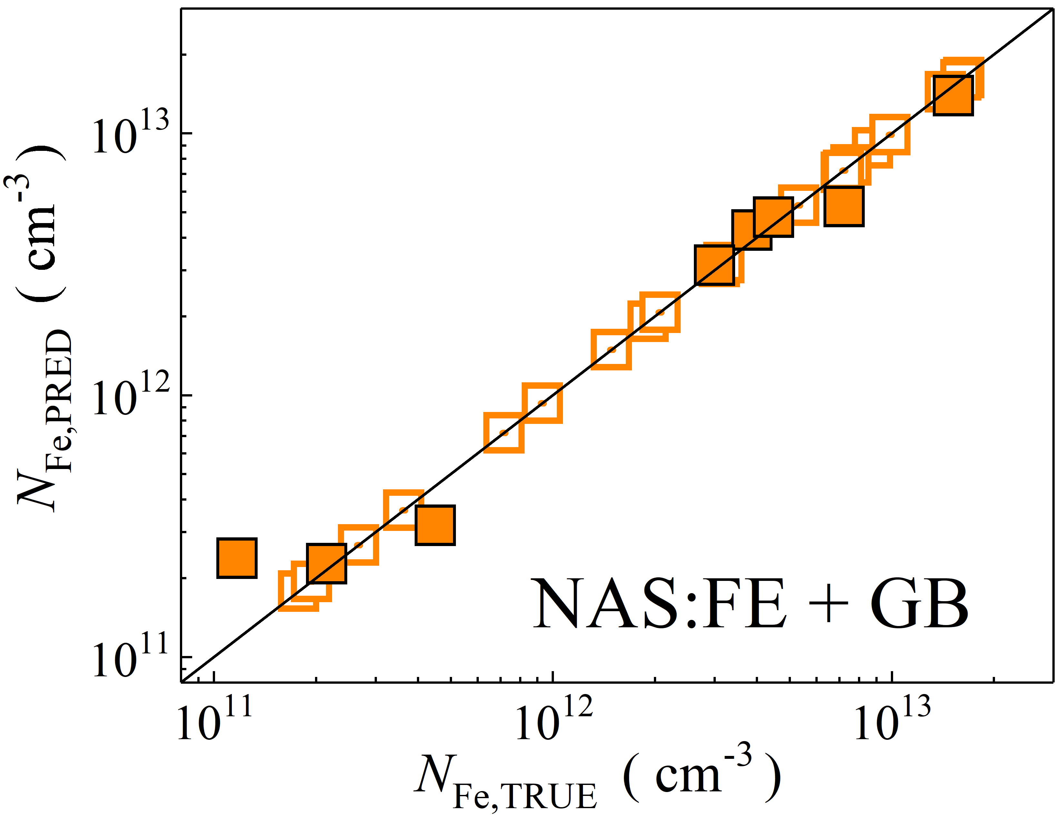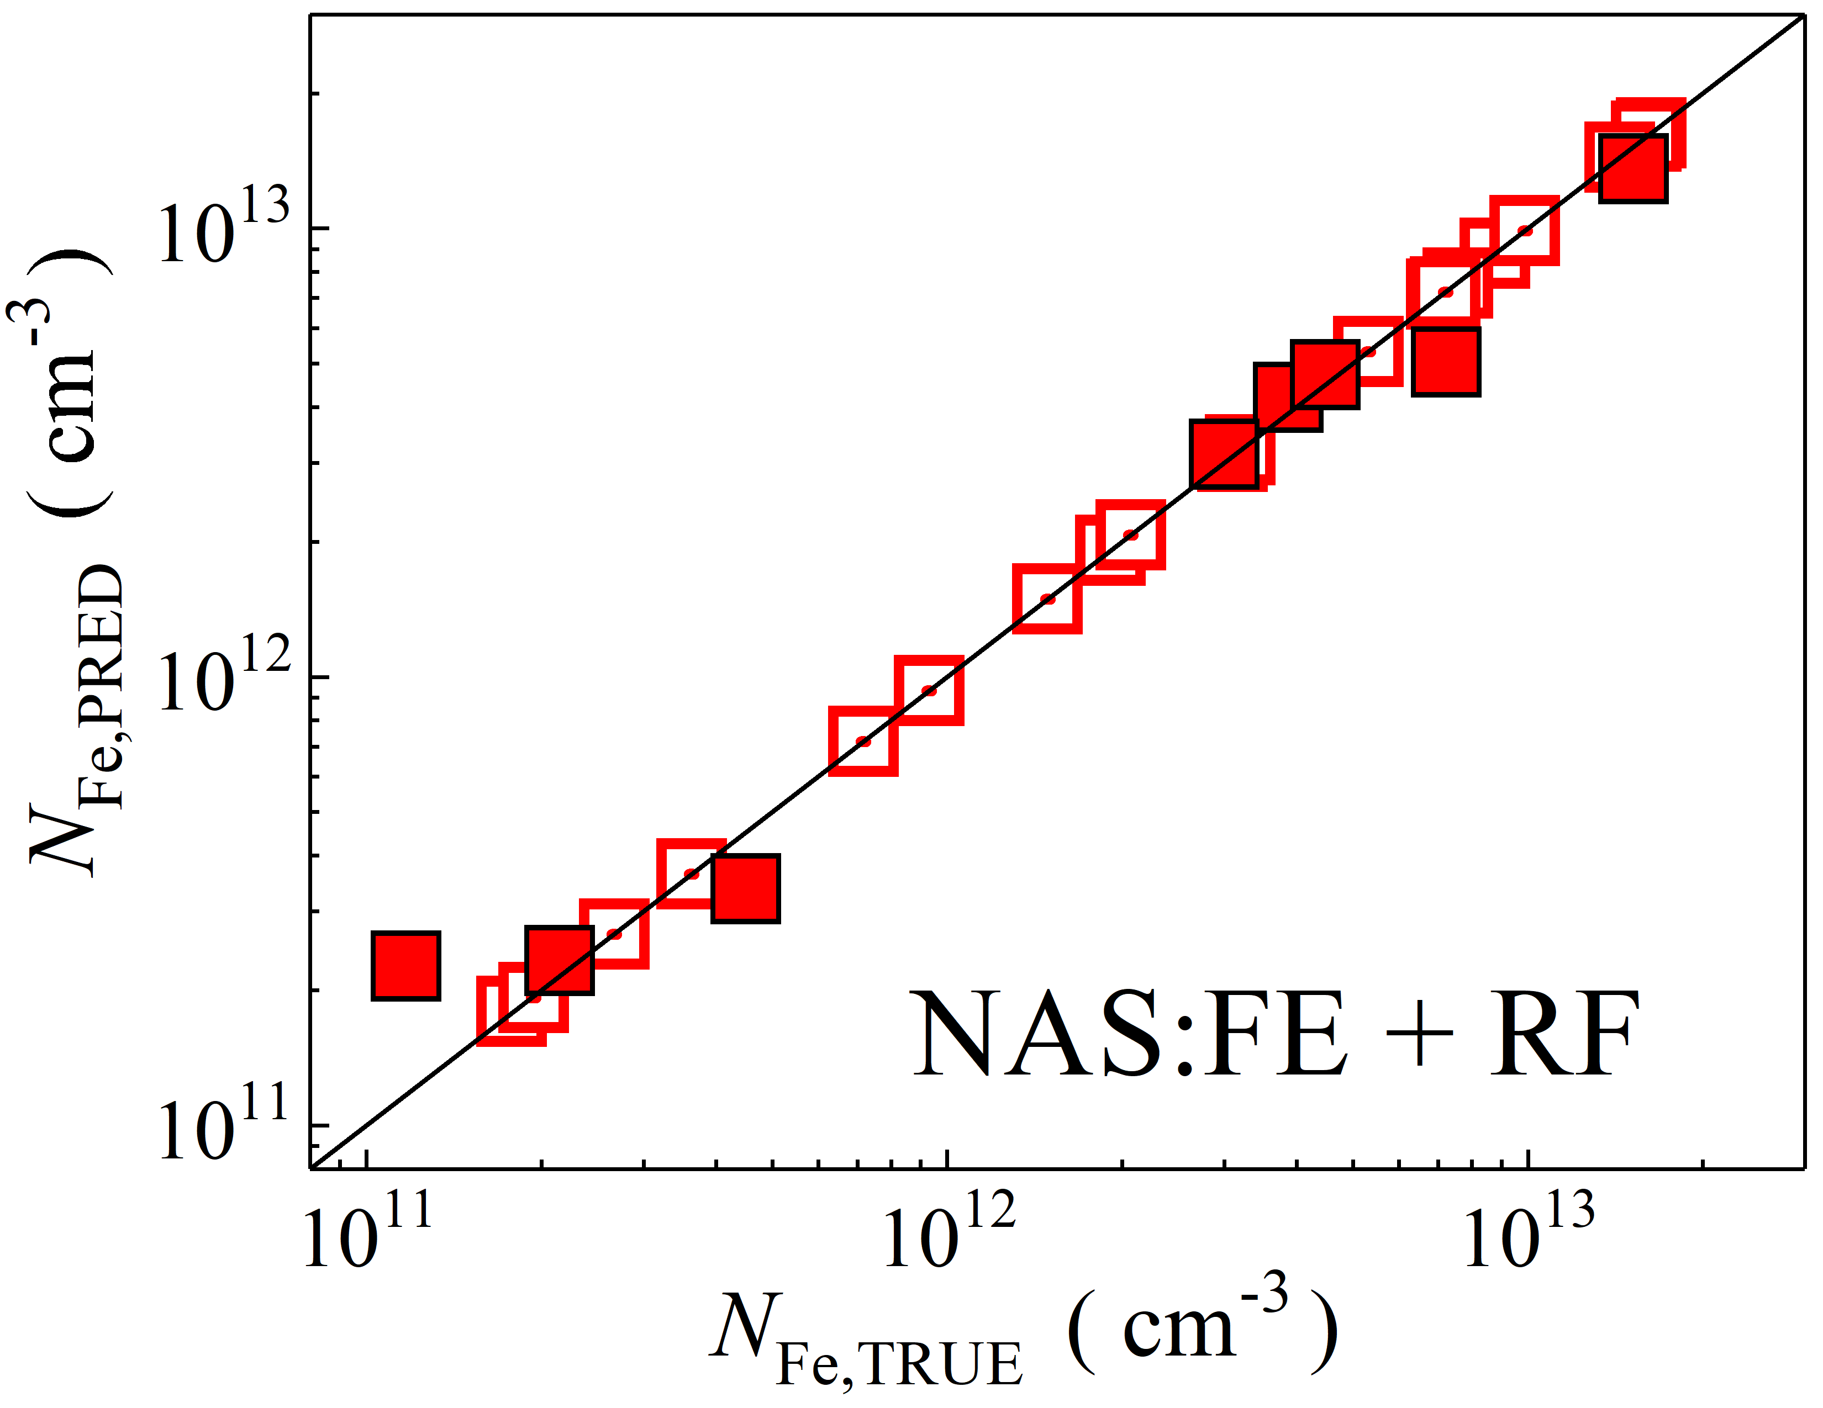

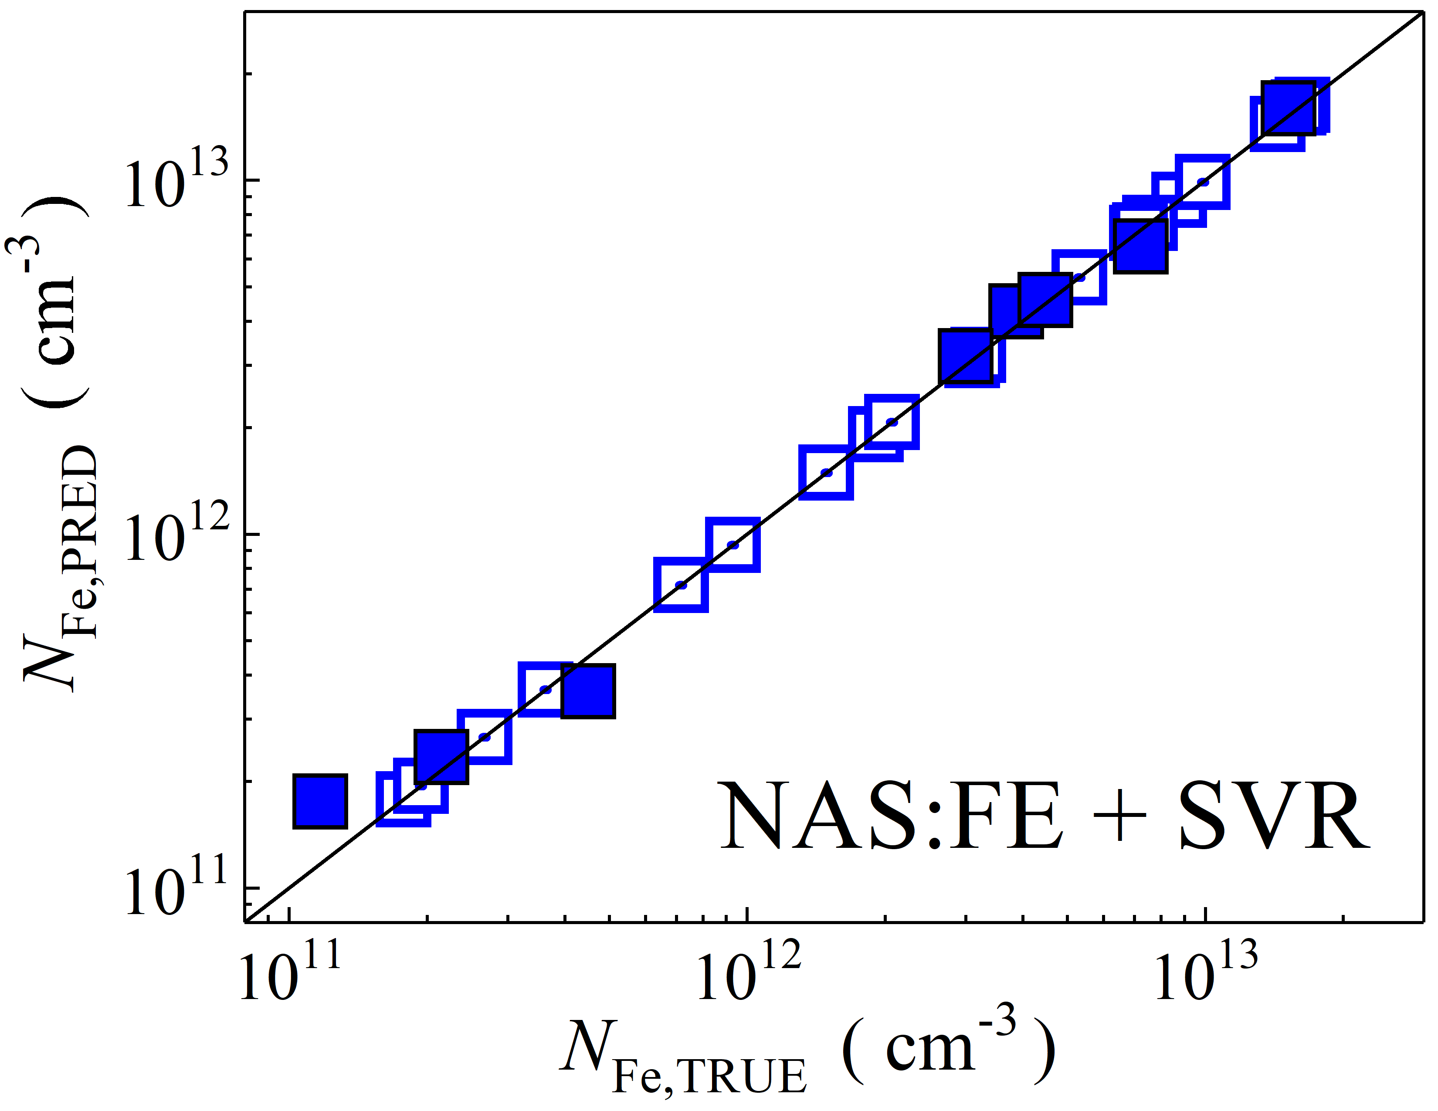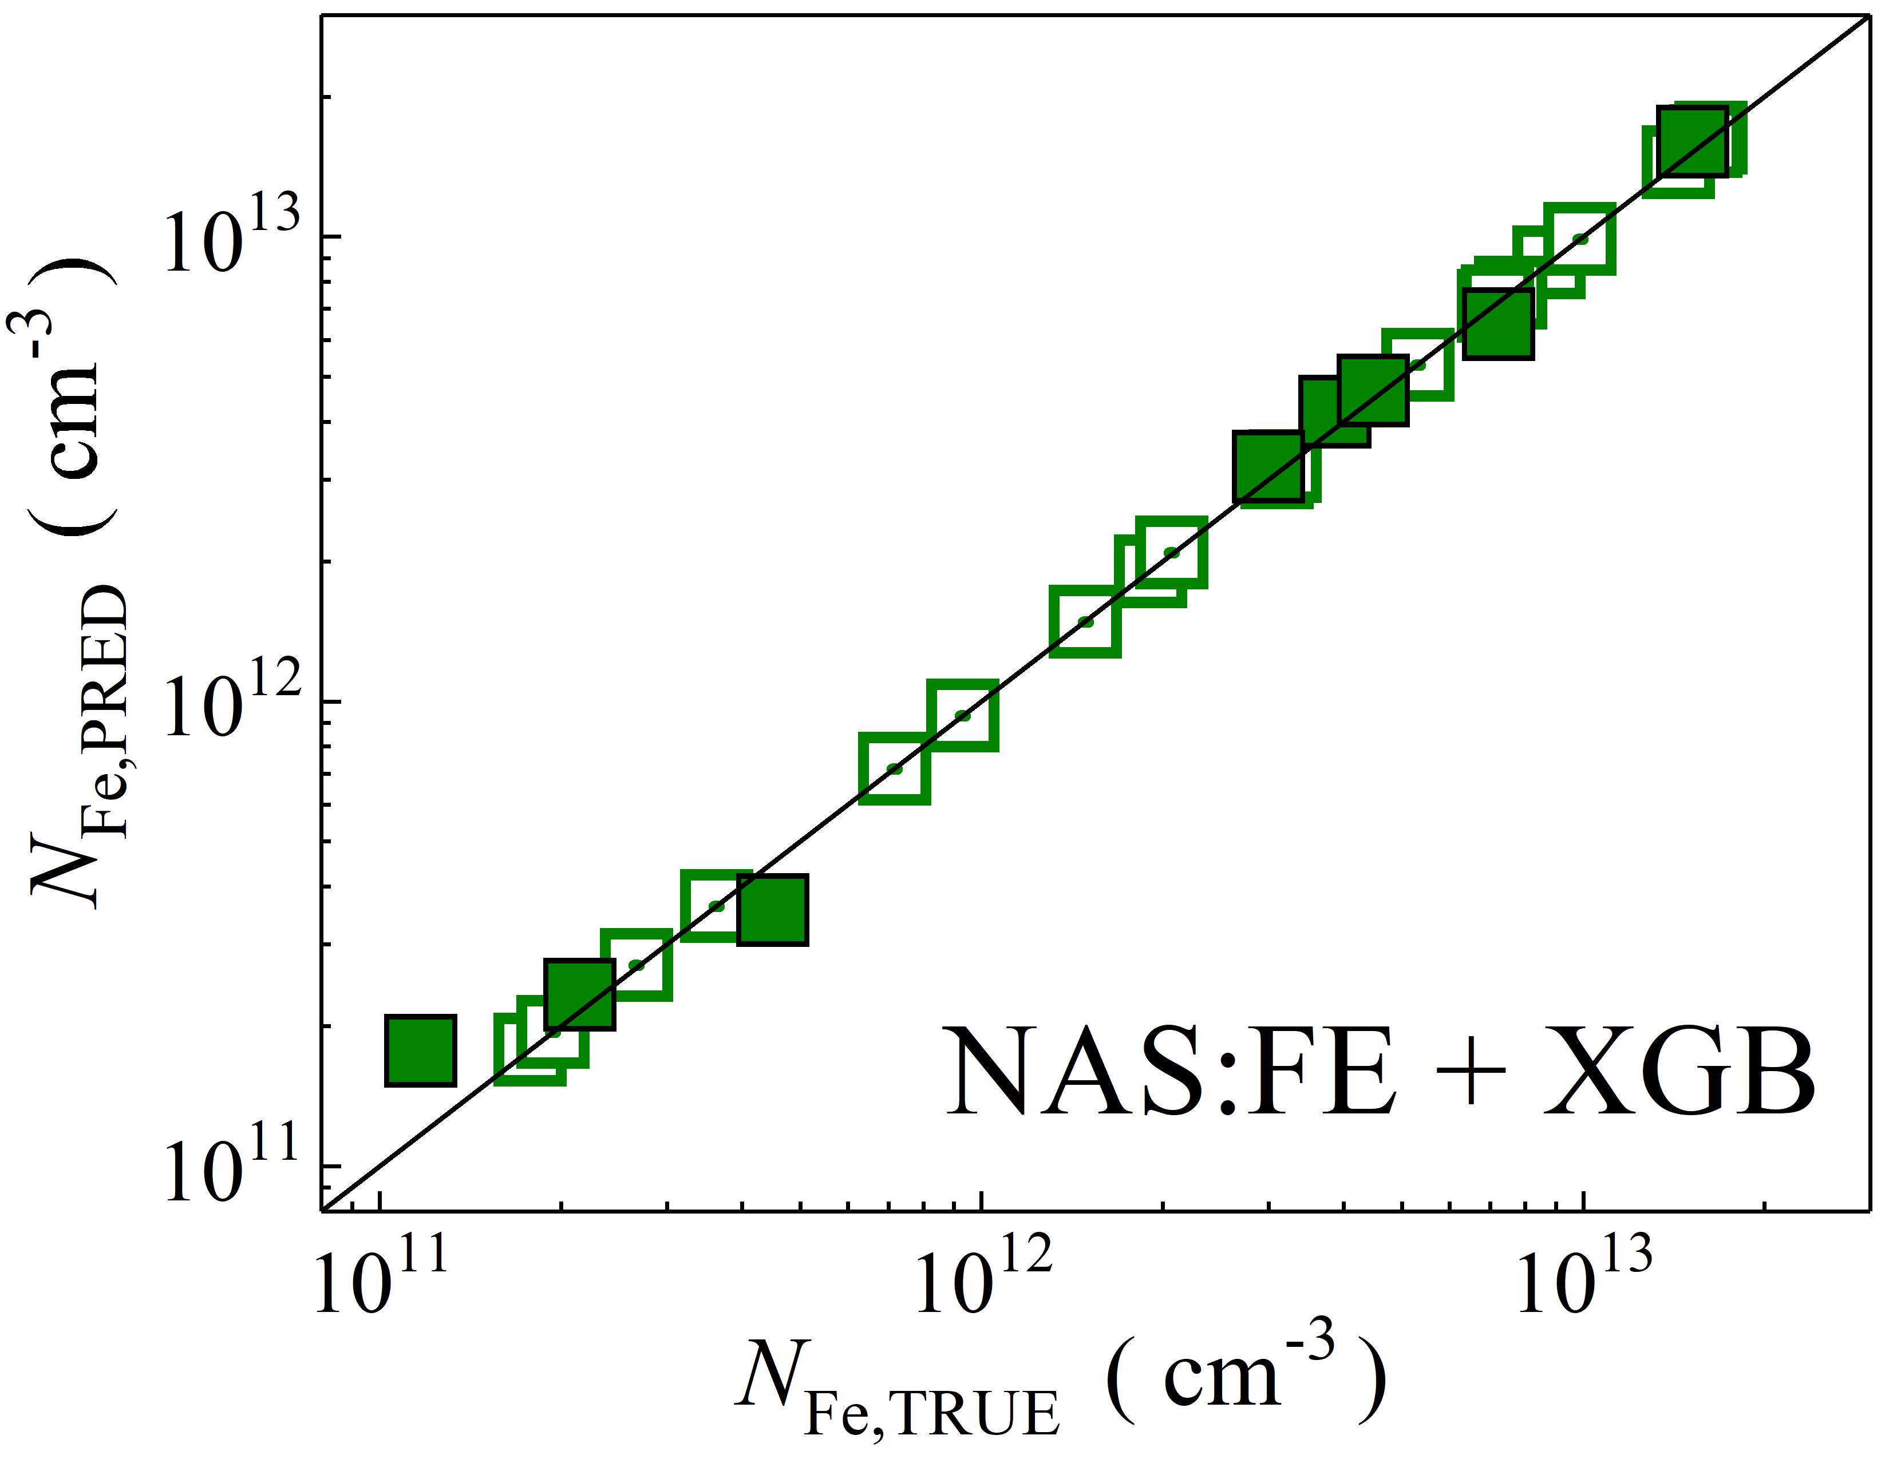

Fig. S28. Scatter plots compare reference iron concentrations $N_{Fe,TRUE}$ with ML-predicted values $N_{Fe,PRED}$ using feature vectors extracted from the feature extractor layer of NASNetLarge visual model. The ML algorithms include DNN (green and purple), GB (dark yellow and yellow), RF (red and blue), SVR (blue and pink), and XGB (green and red). Symbols represent different datasets: filled squares — test data from experimental measurements, and open squares — train data from experimental measurements. The black lines are the identified lines serving as the references.

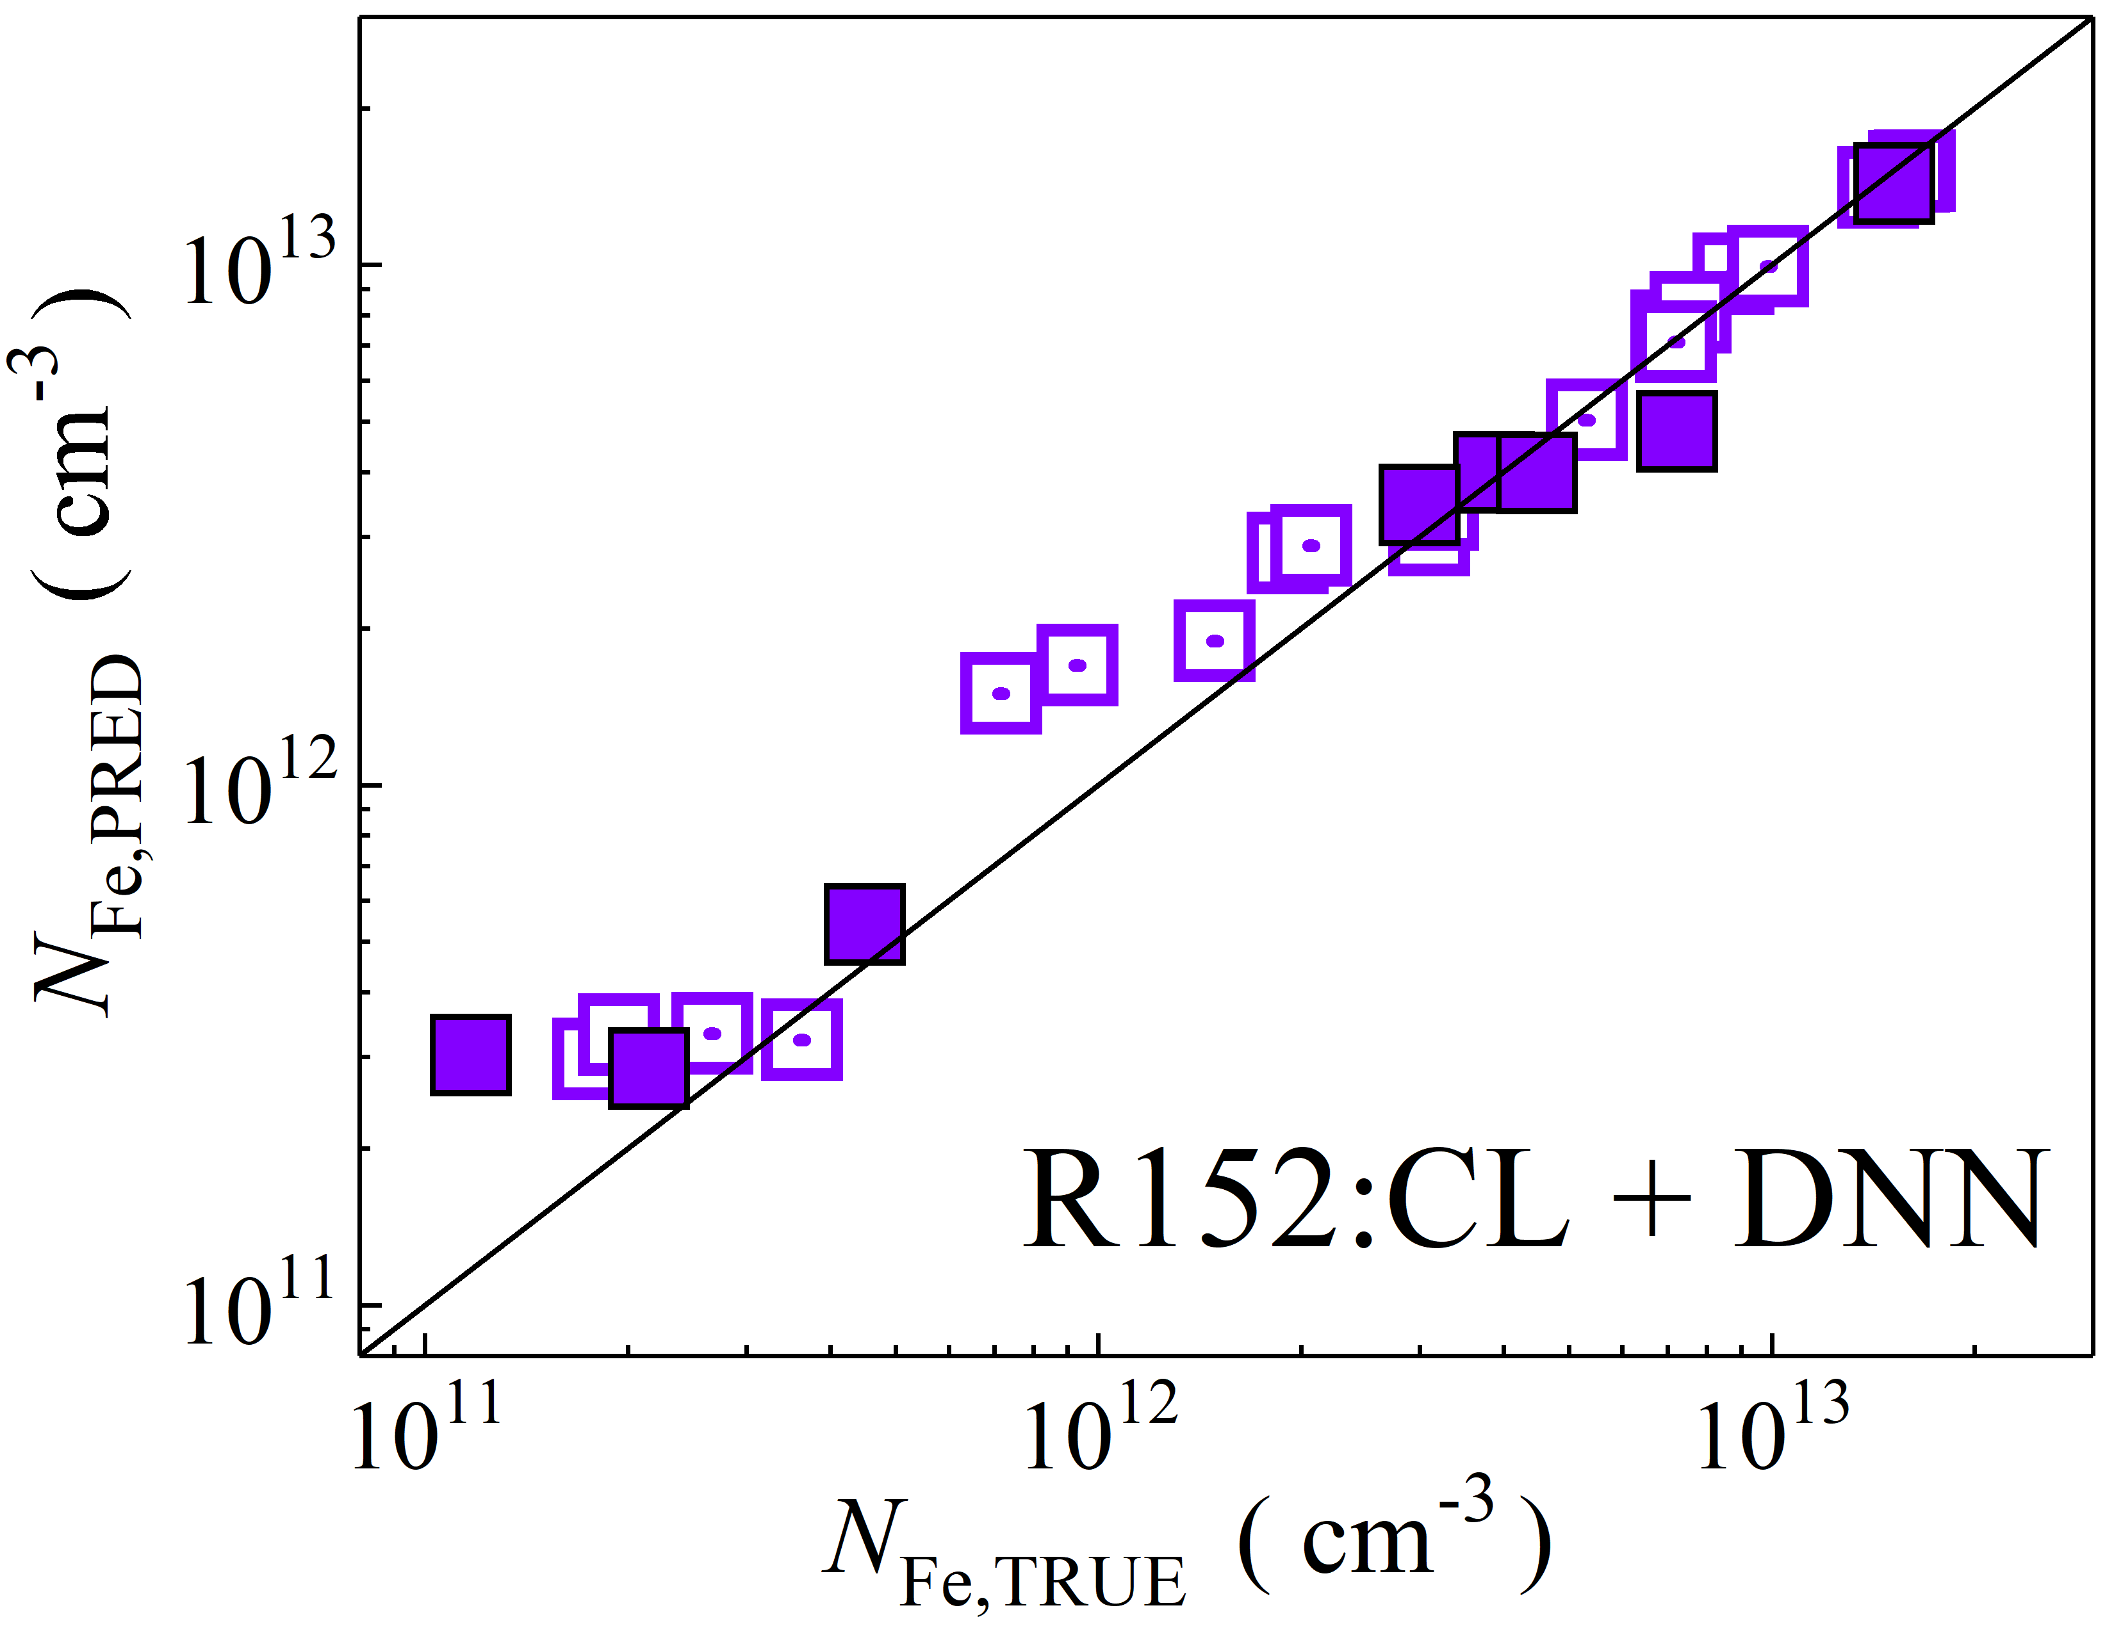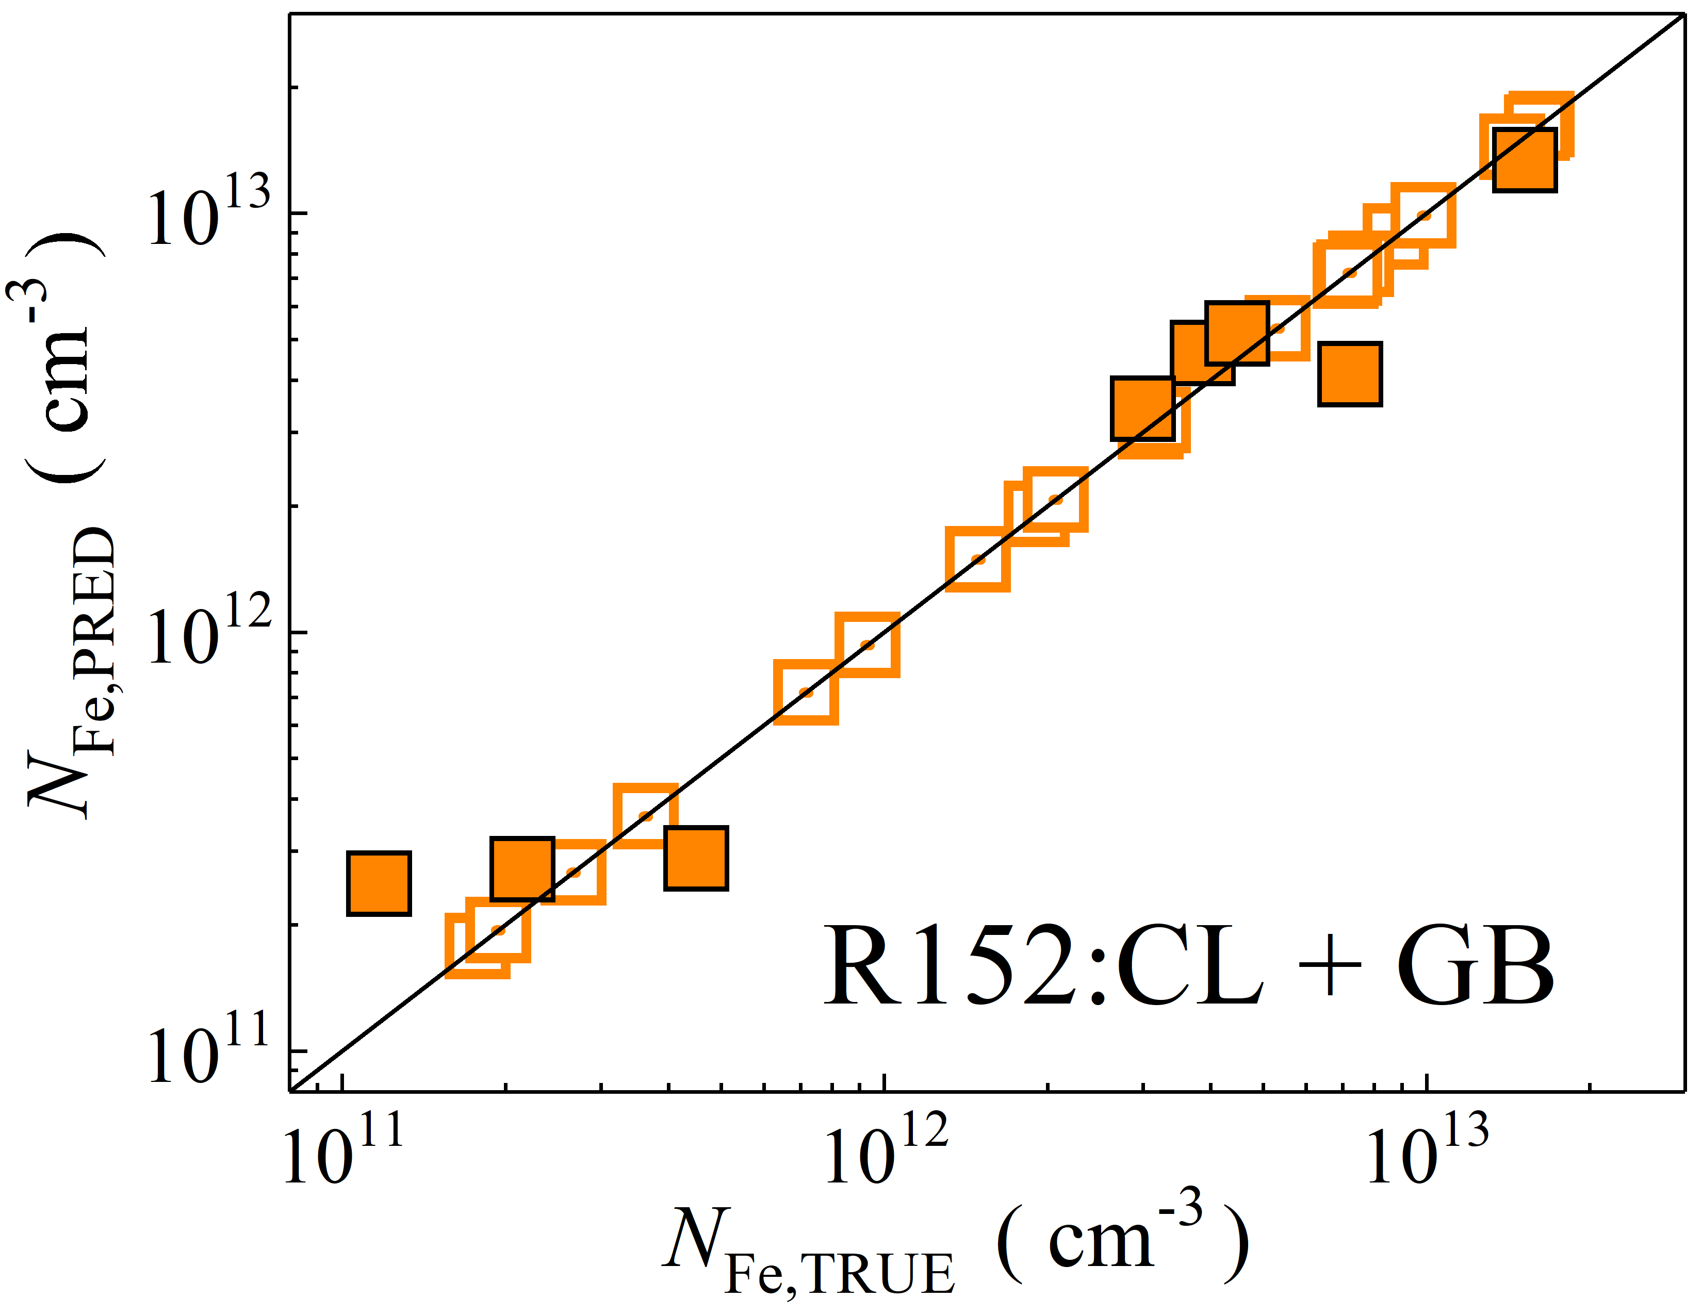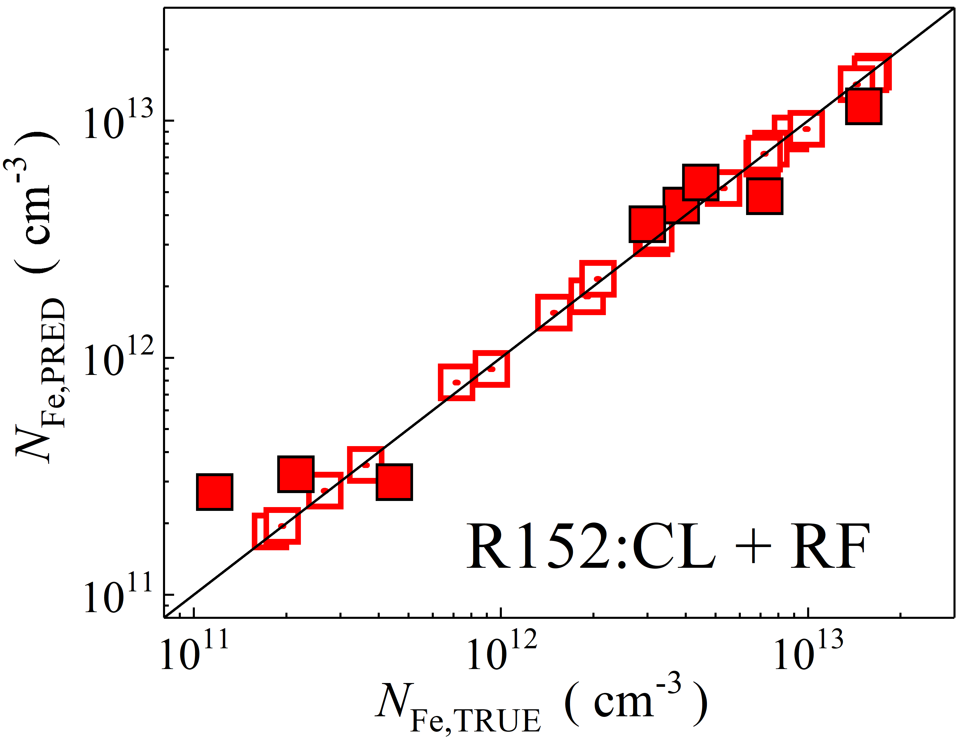

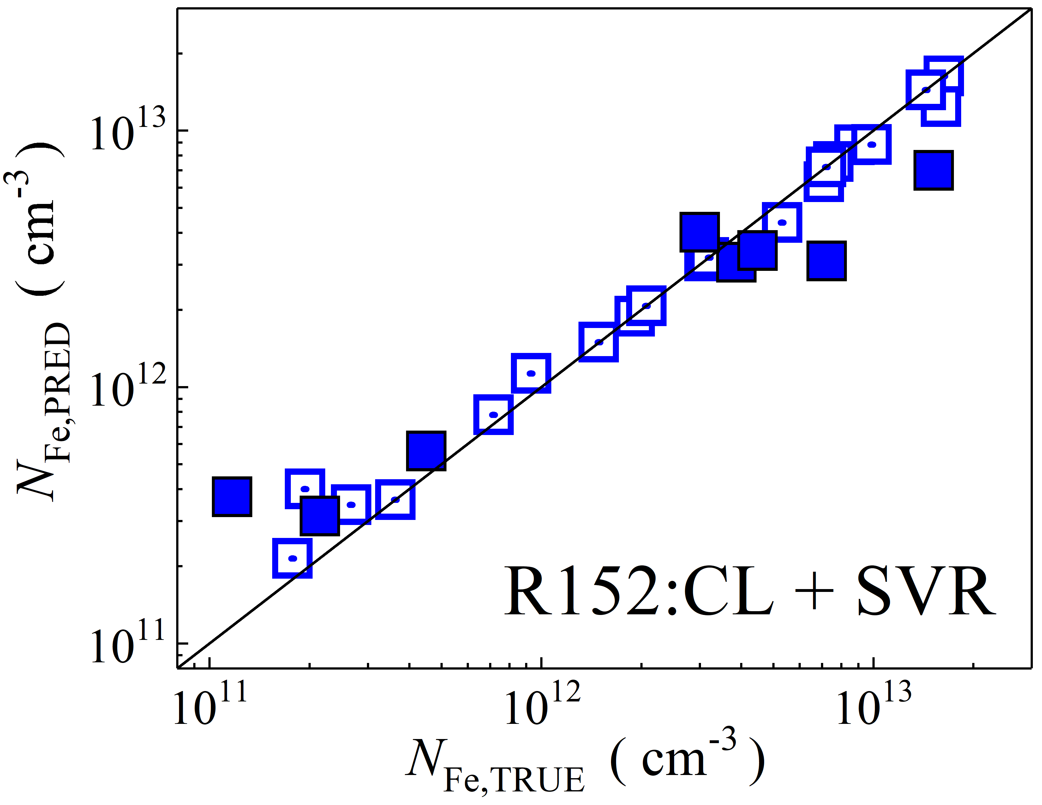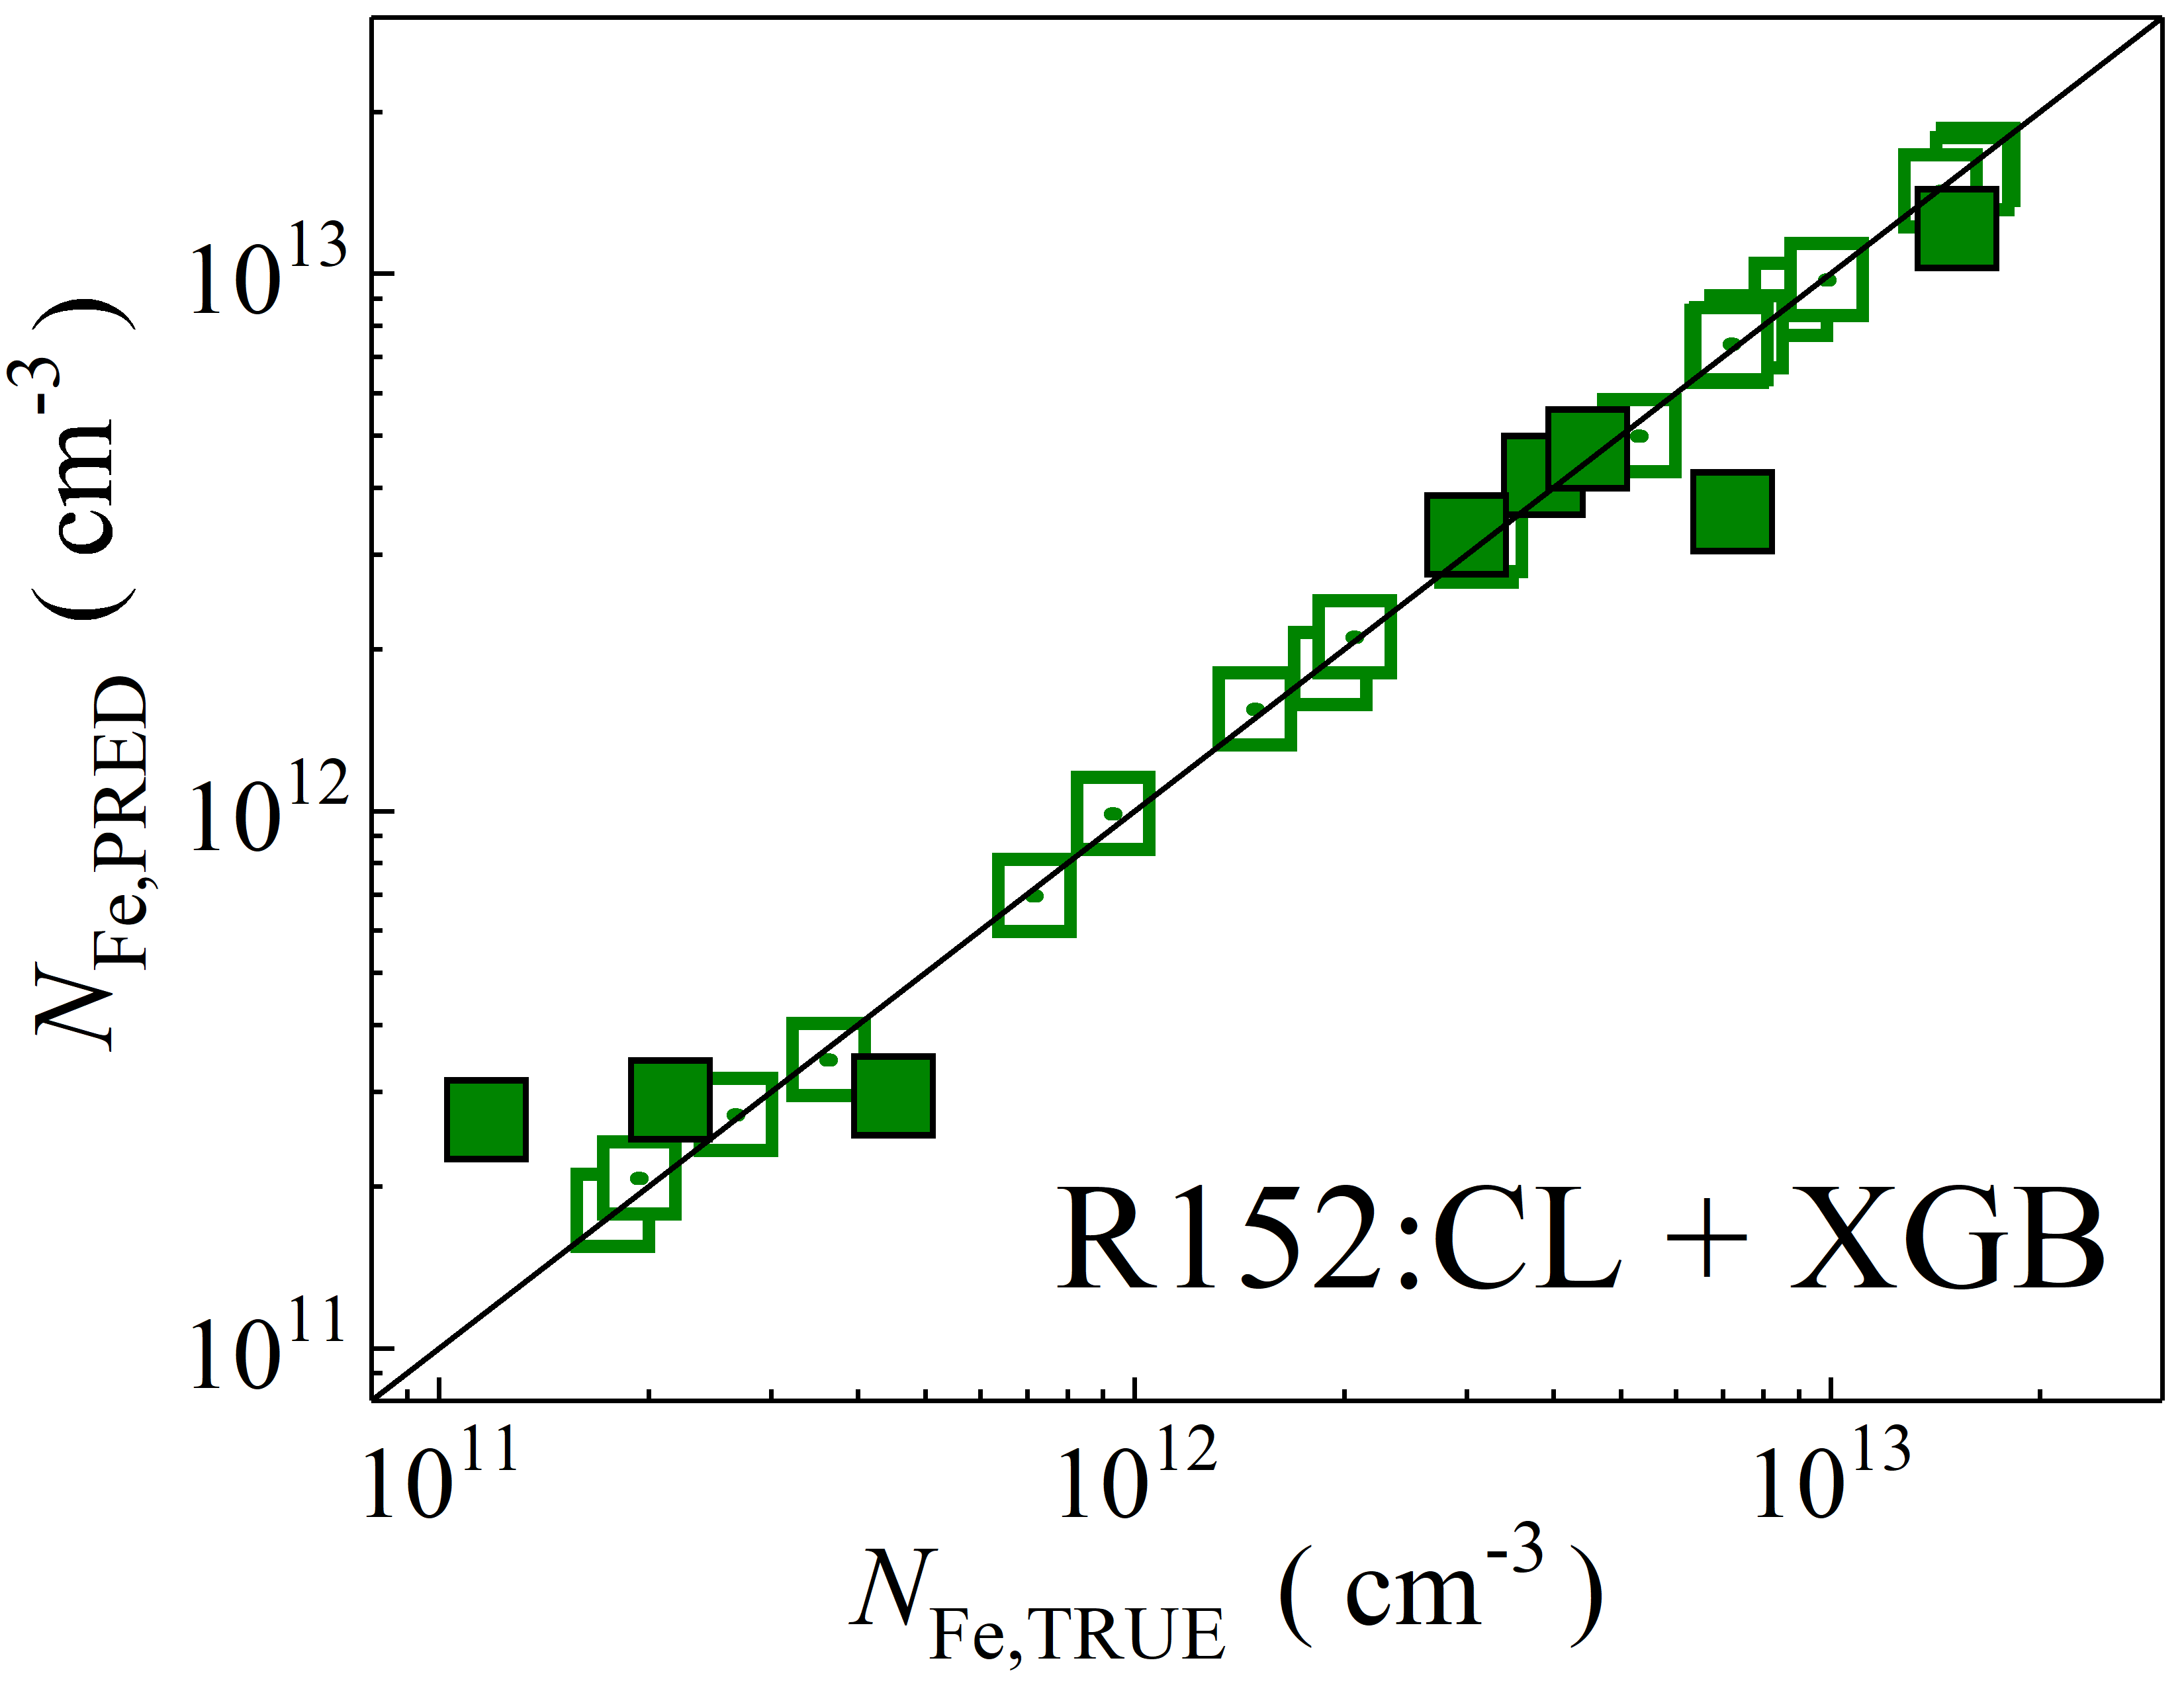

Fig. S29. Scatter plots compare reference iron concentrations $N_{Fe,TRUE}$ with ML-predicted values $N_{Fe,PRED}$ using feature vectors extracted from the classifier layer of ResNet152V2 visual model. The ML algorithms include DNN (green and purple), GB (dark yellow and yellow), RF (red and blue), SVR (blue and pink), and XGB (green and red). Symbols represent different datasets: filled squares — test data from experimental measurements, and open squares — train data from experimental measurements. The black lines are the identified lines serving as the references.

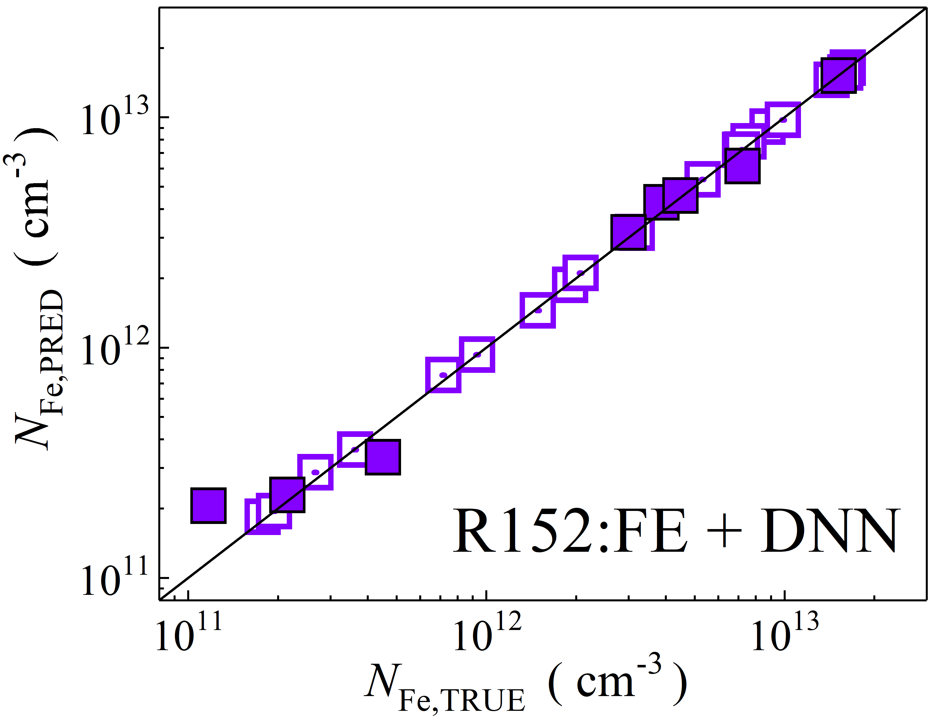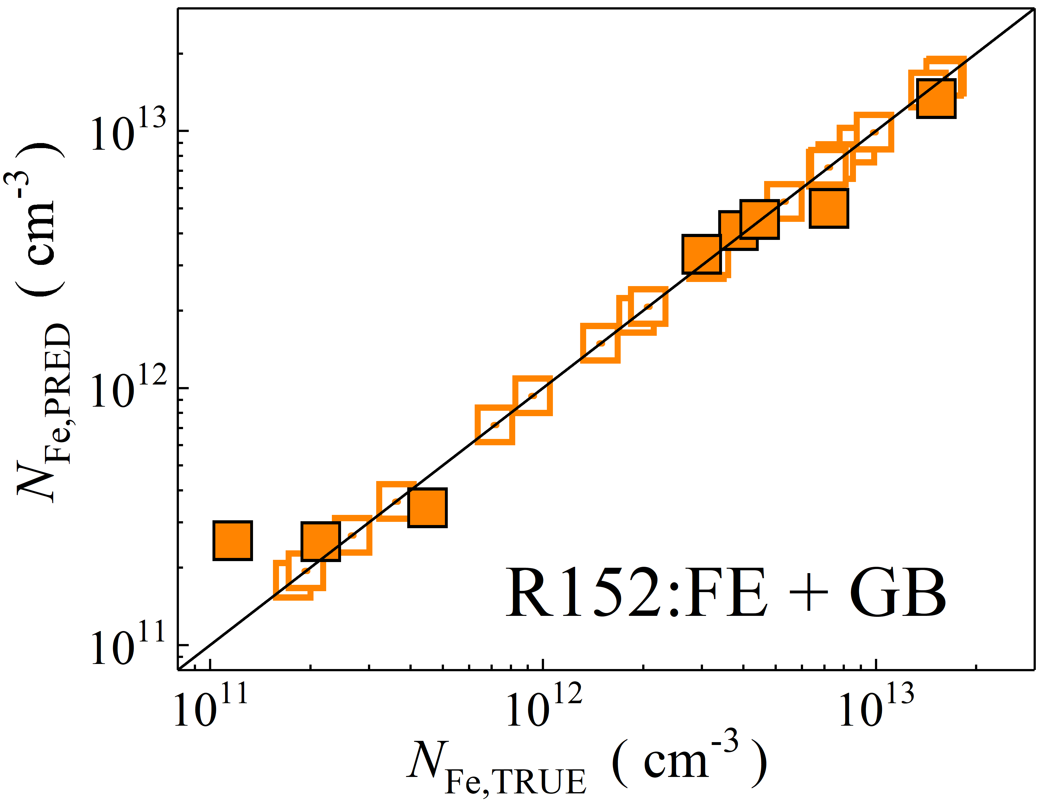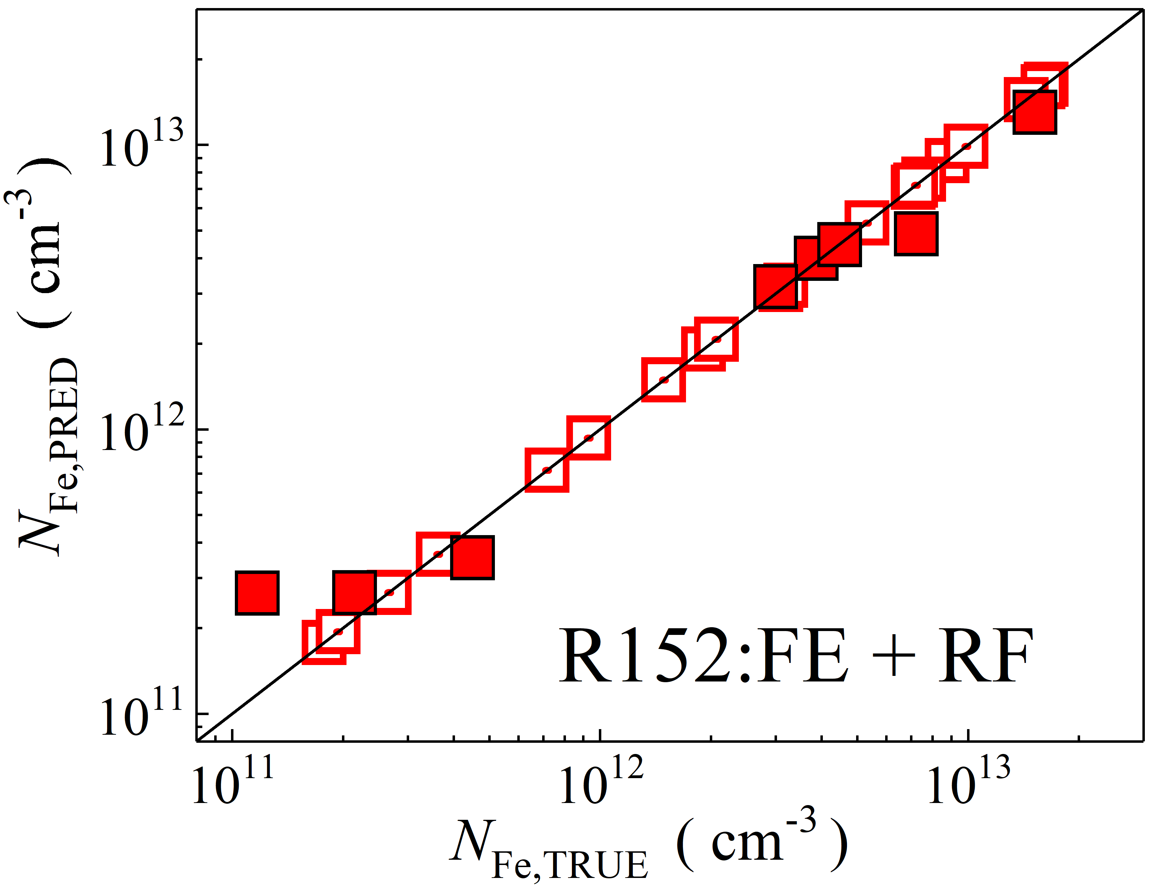

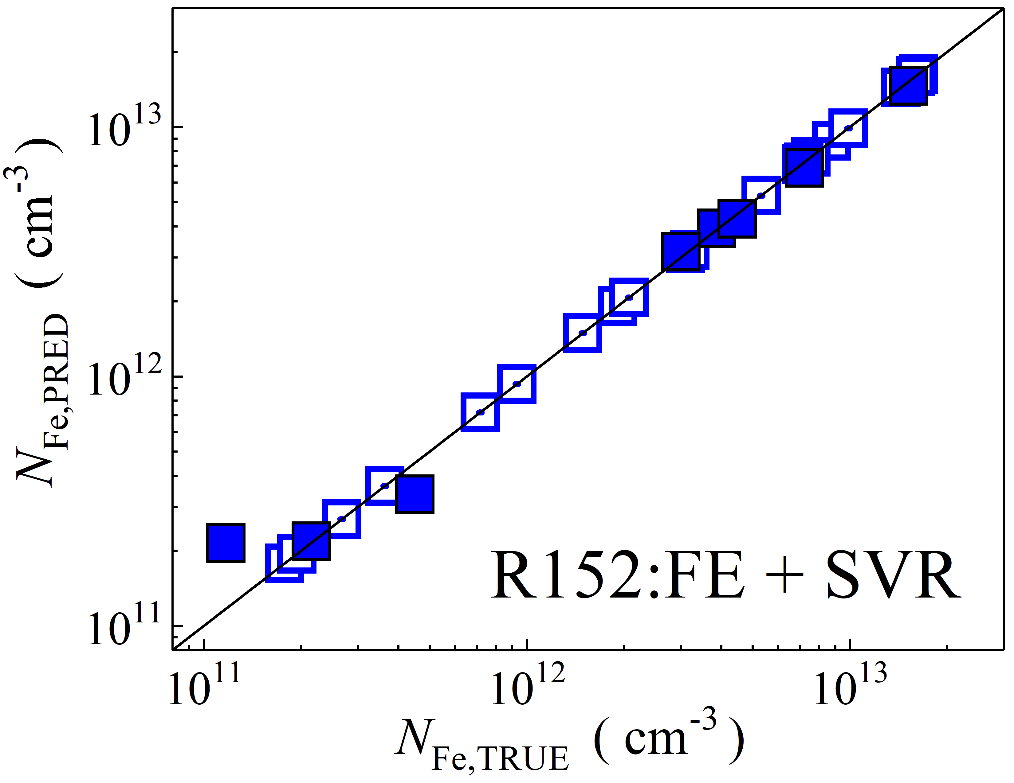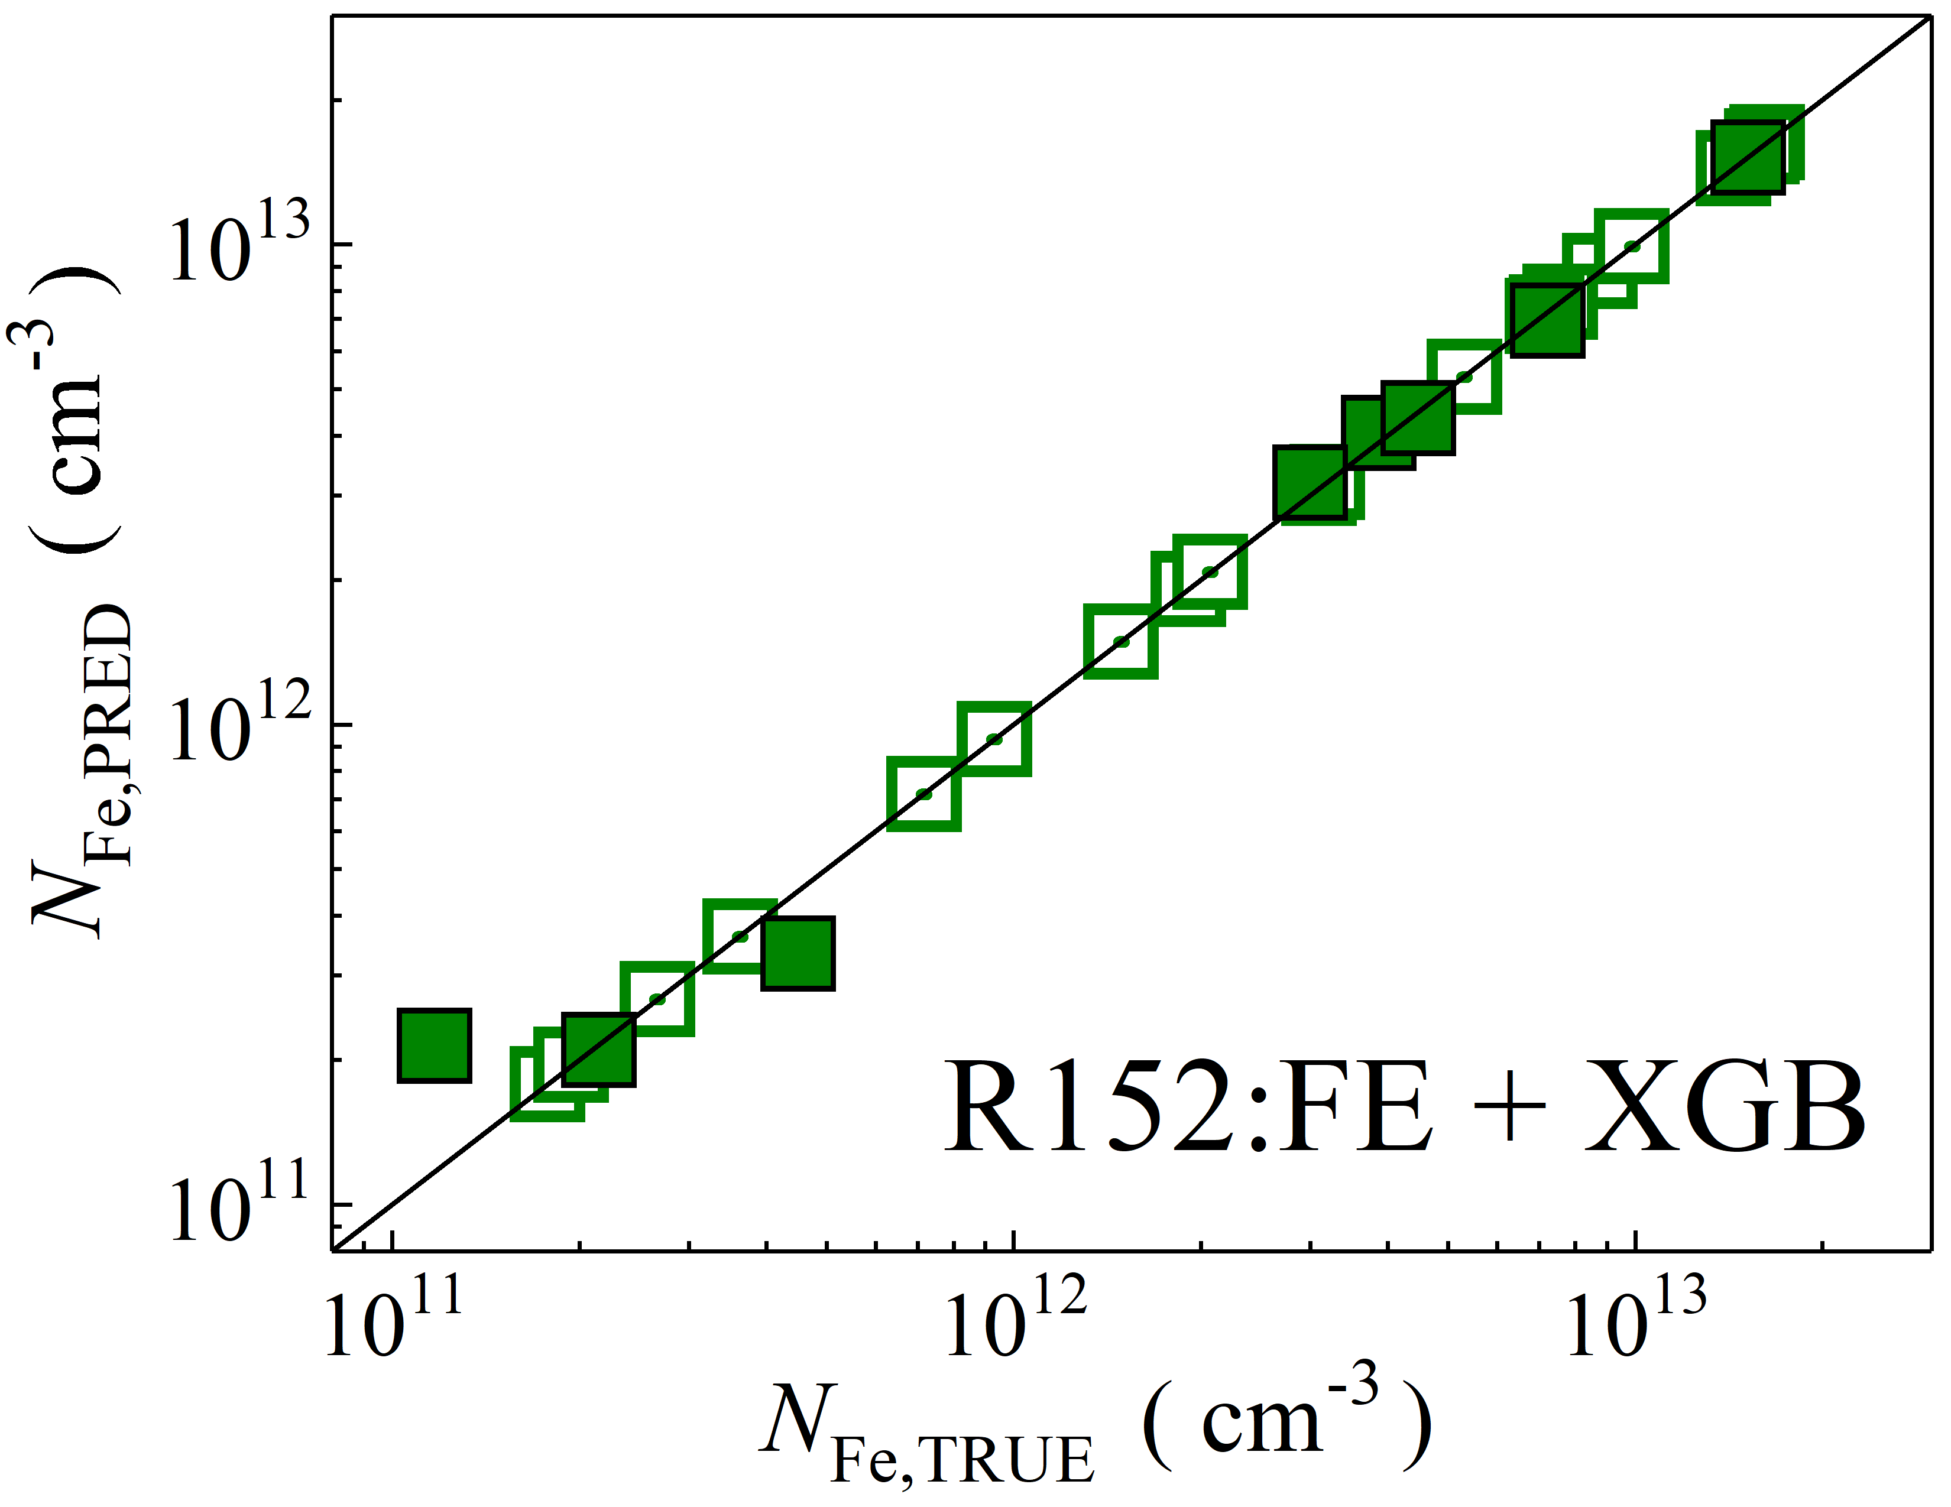

Fig. S30. Scatter plots compare reference iron concentrations $N_{Fe,TRUE}$ with ML-predicted values $N_{Fe,PRED}$ using feature vectors extracted from the feature extractor layer of ResNet152V2 visual model. The ML algorithms include DNN (green and purple), GB (dark yellow and yellow), RF (red and blue), SVR (blue and pink), and XGB (green and red). Symbols represent different datasets: filled squares — test data from experimental measurements, and open squares — train data from experimental measurements. The black lines are the identified lines serving as the references.

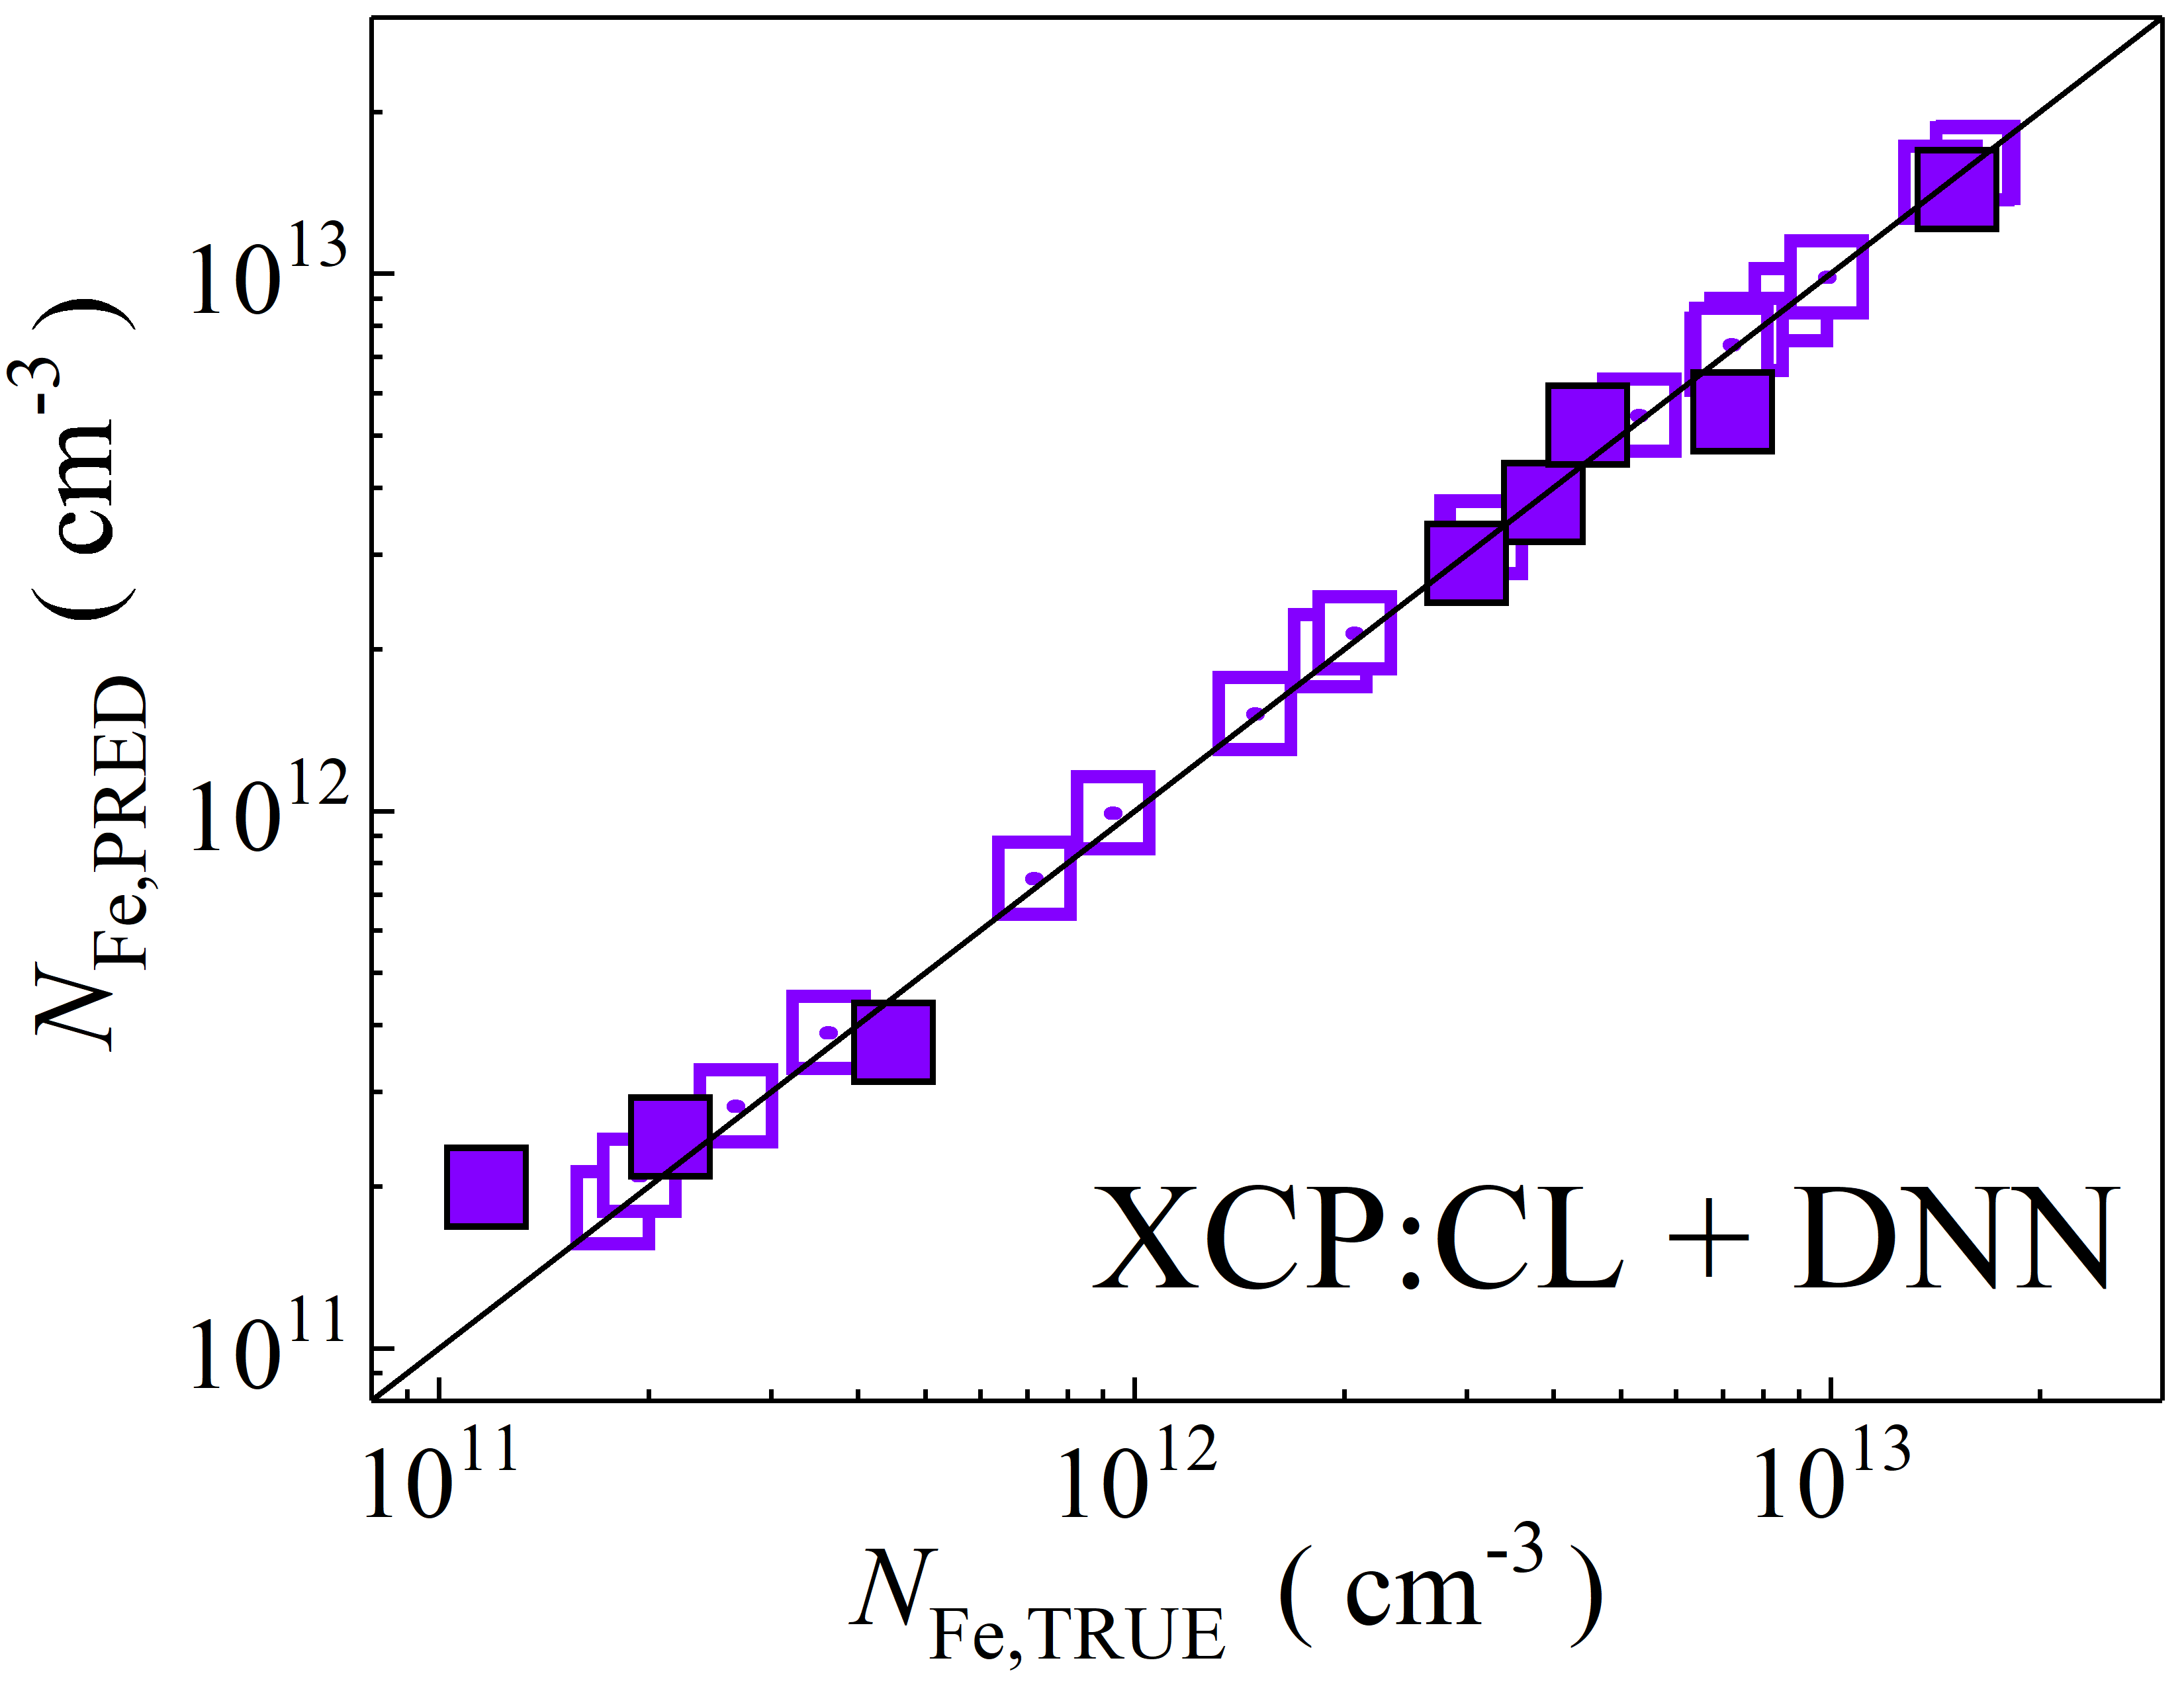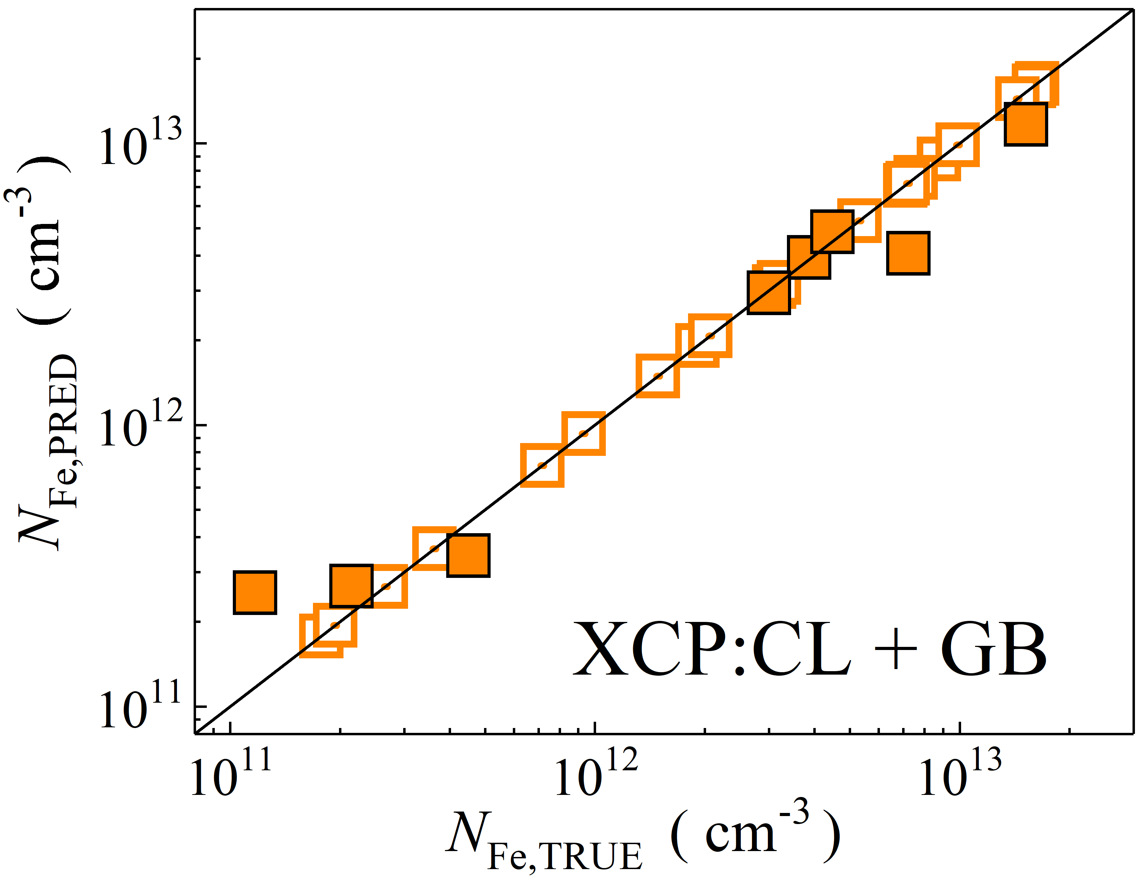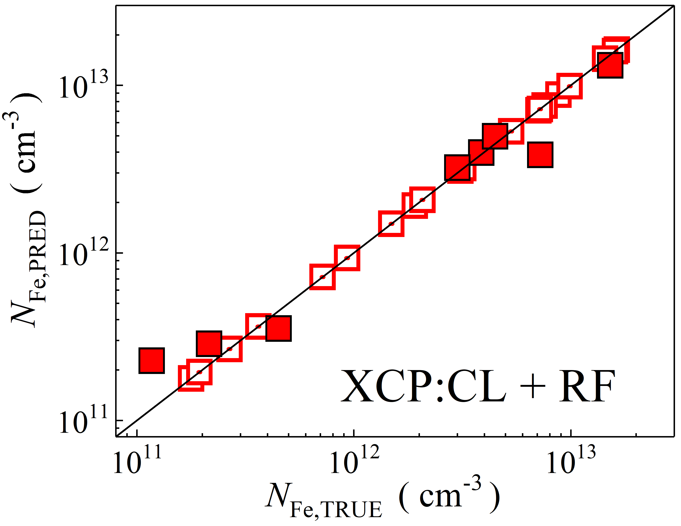

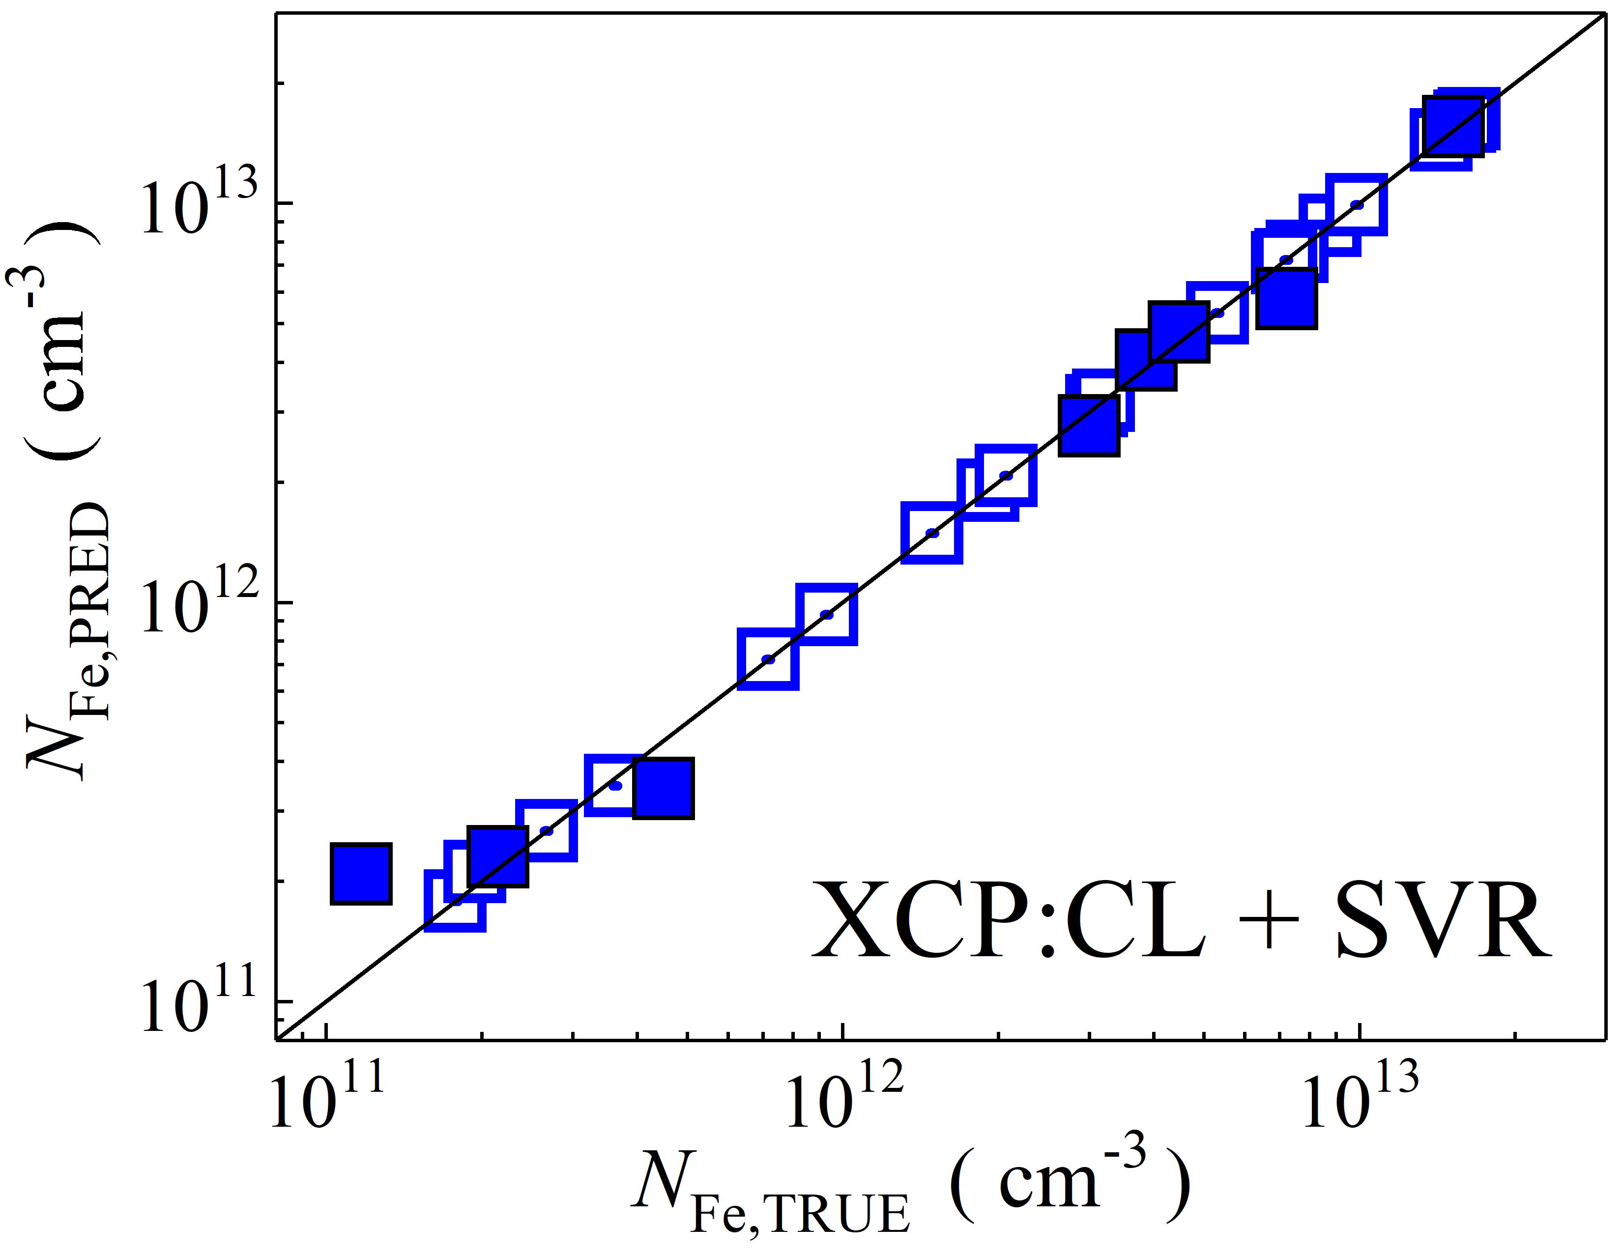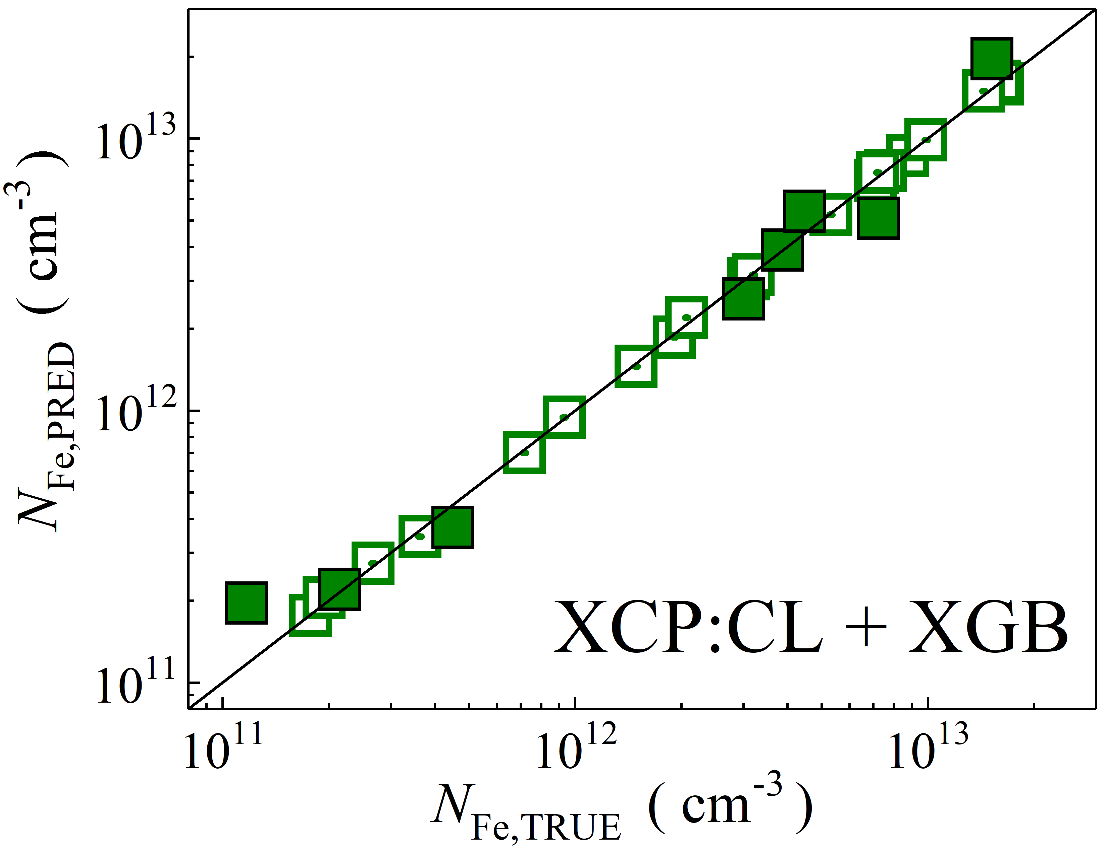

Fig. S31. Scatter plots compare reference iron concentrations $N_{Fe,TRUE}$ with ML-predicted values $N_{Fe,PRED}$ using feature vectors extracted from the classifier layer of Xception visual model. The ML algorithms include DNN (green and purple), GB (dark yellow and yellow), RF (red and blue), SVR (blue and pink), and XGB (green and red). Symbols represent different datasets: filled squares — test data from experimental measurements, and open squares — train data from experimental measurements. The black lines are the identified lines serving as the references.

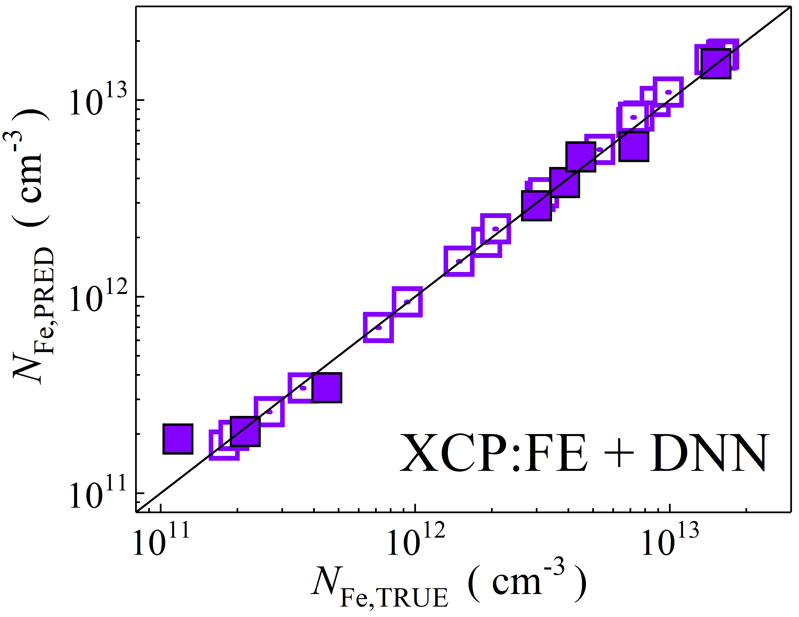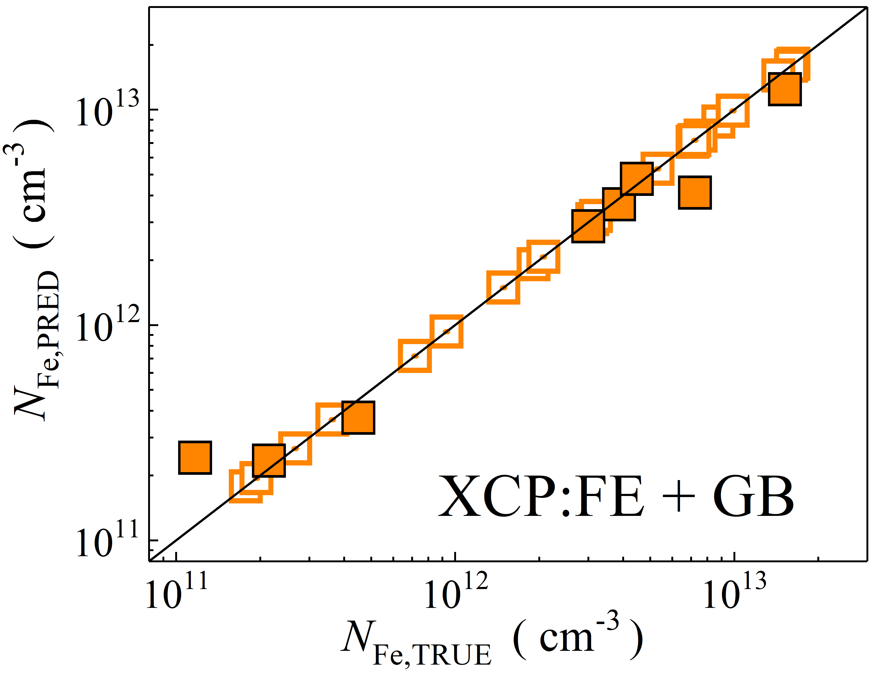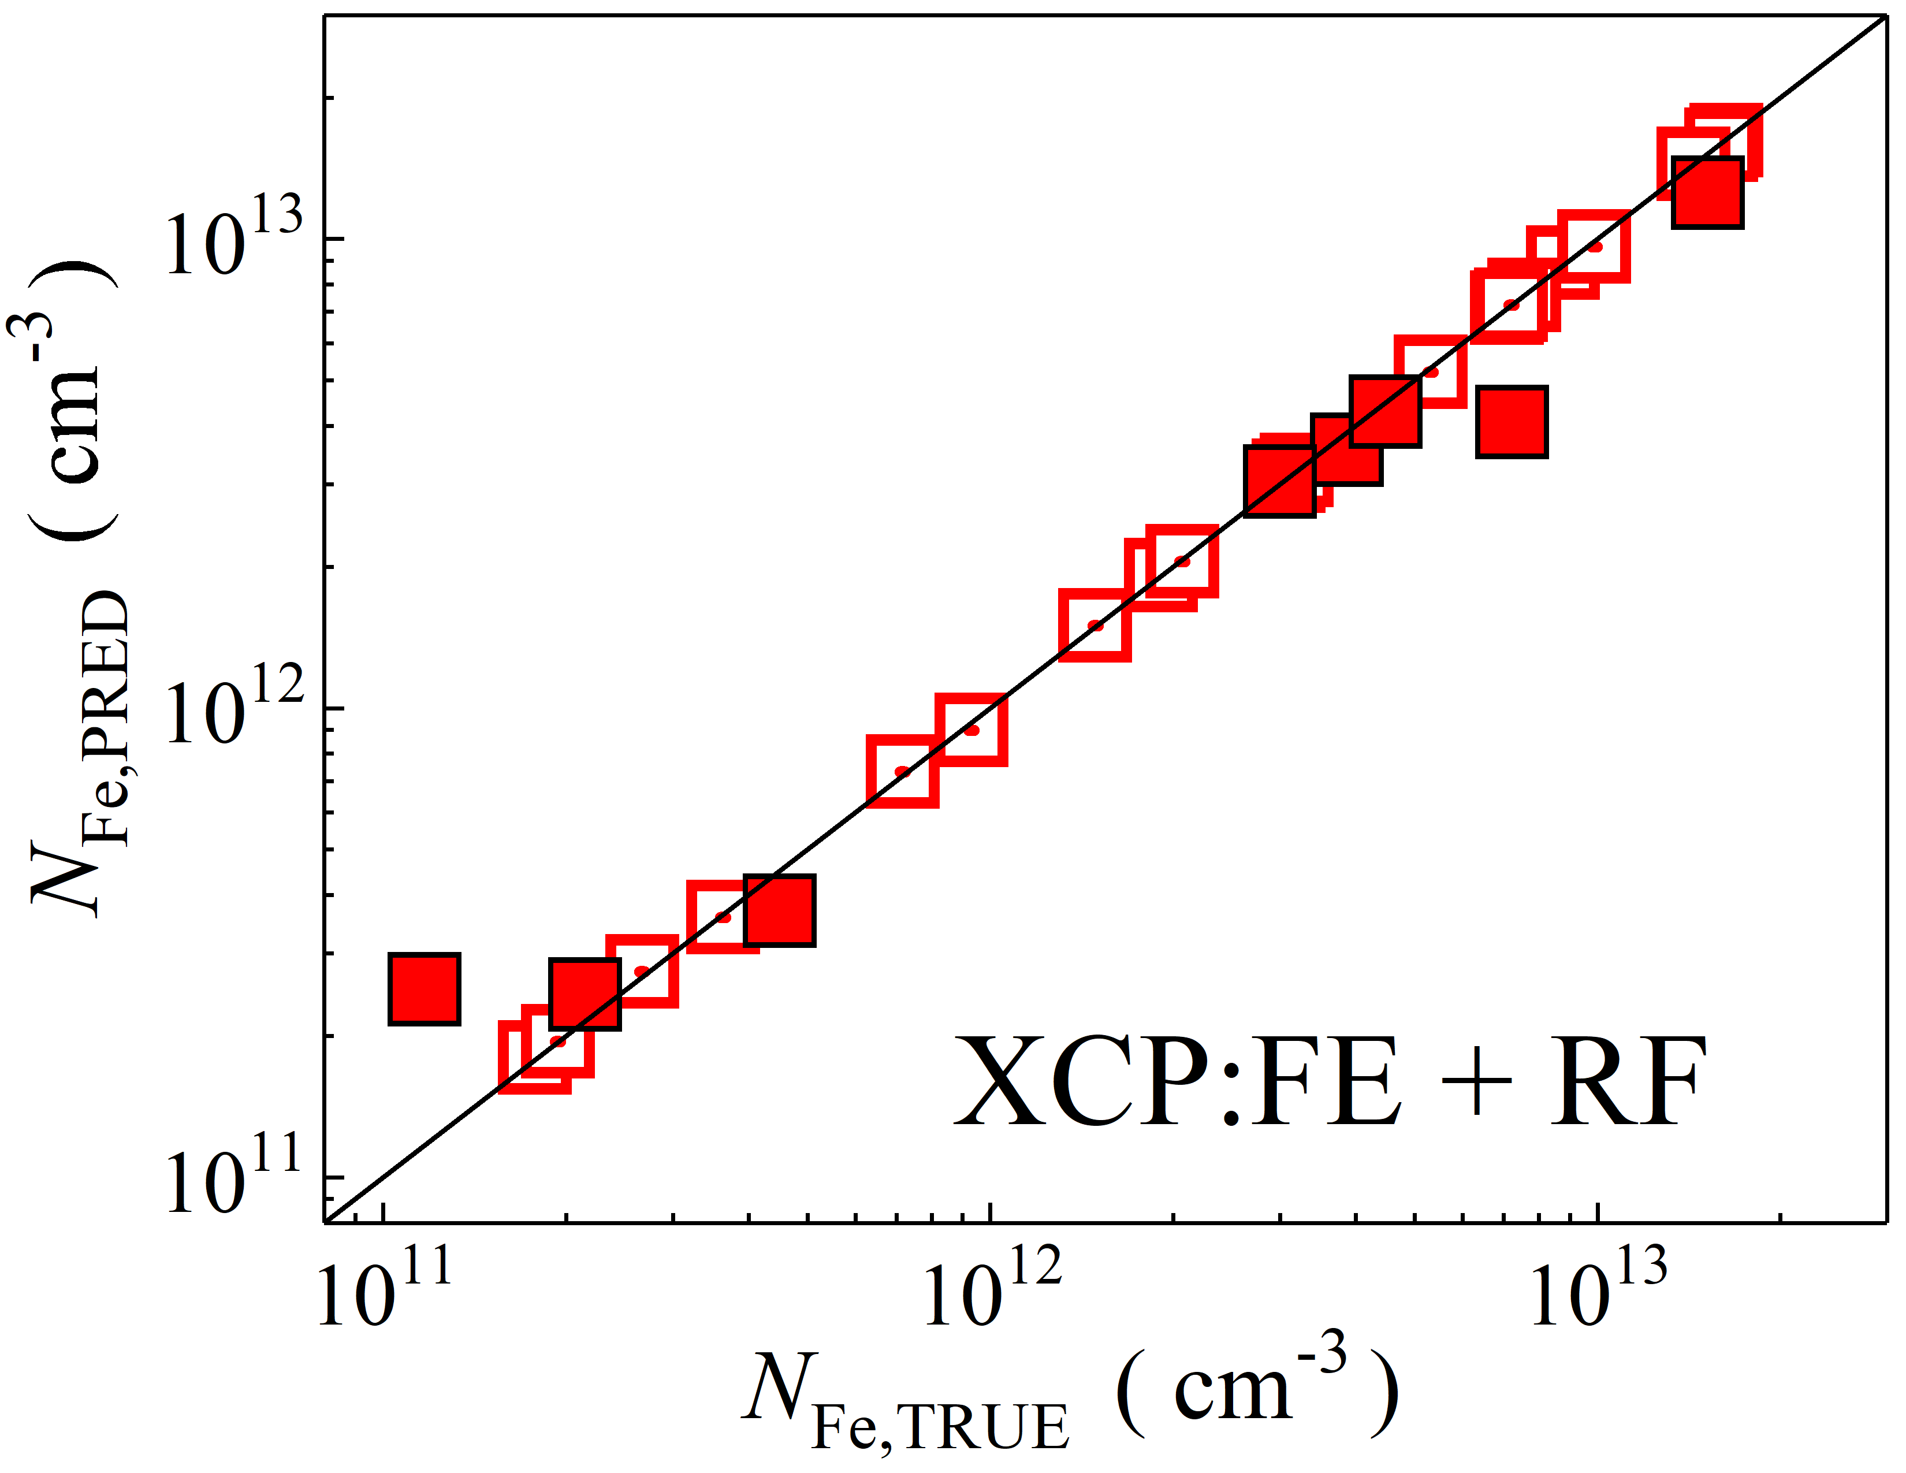

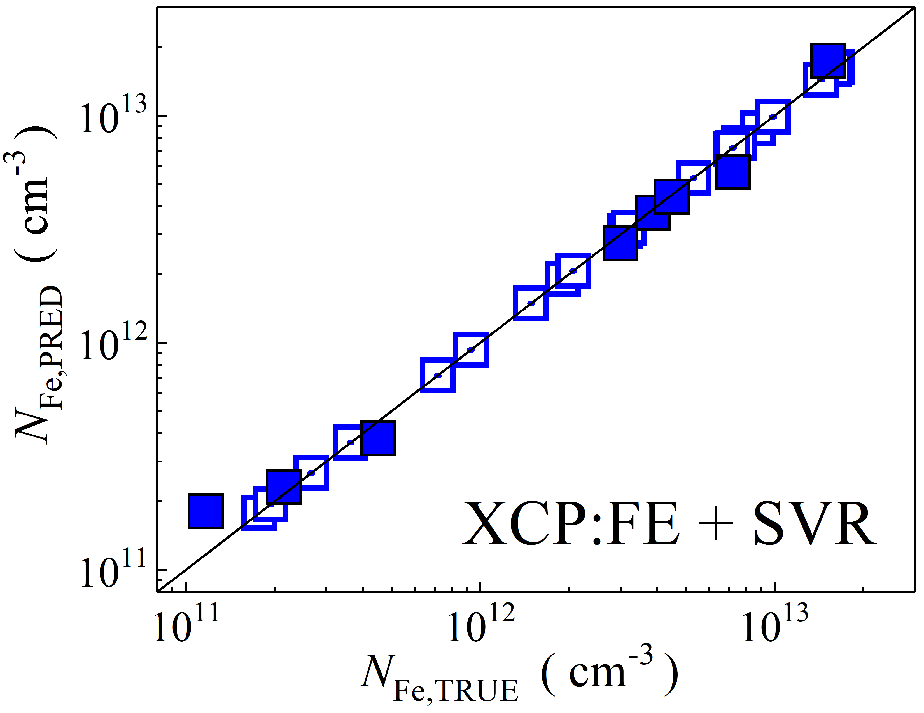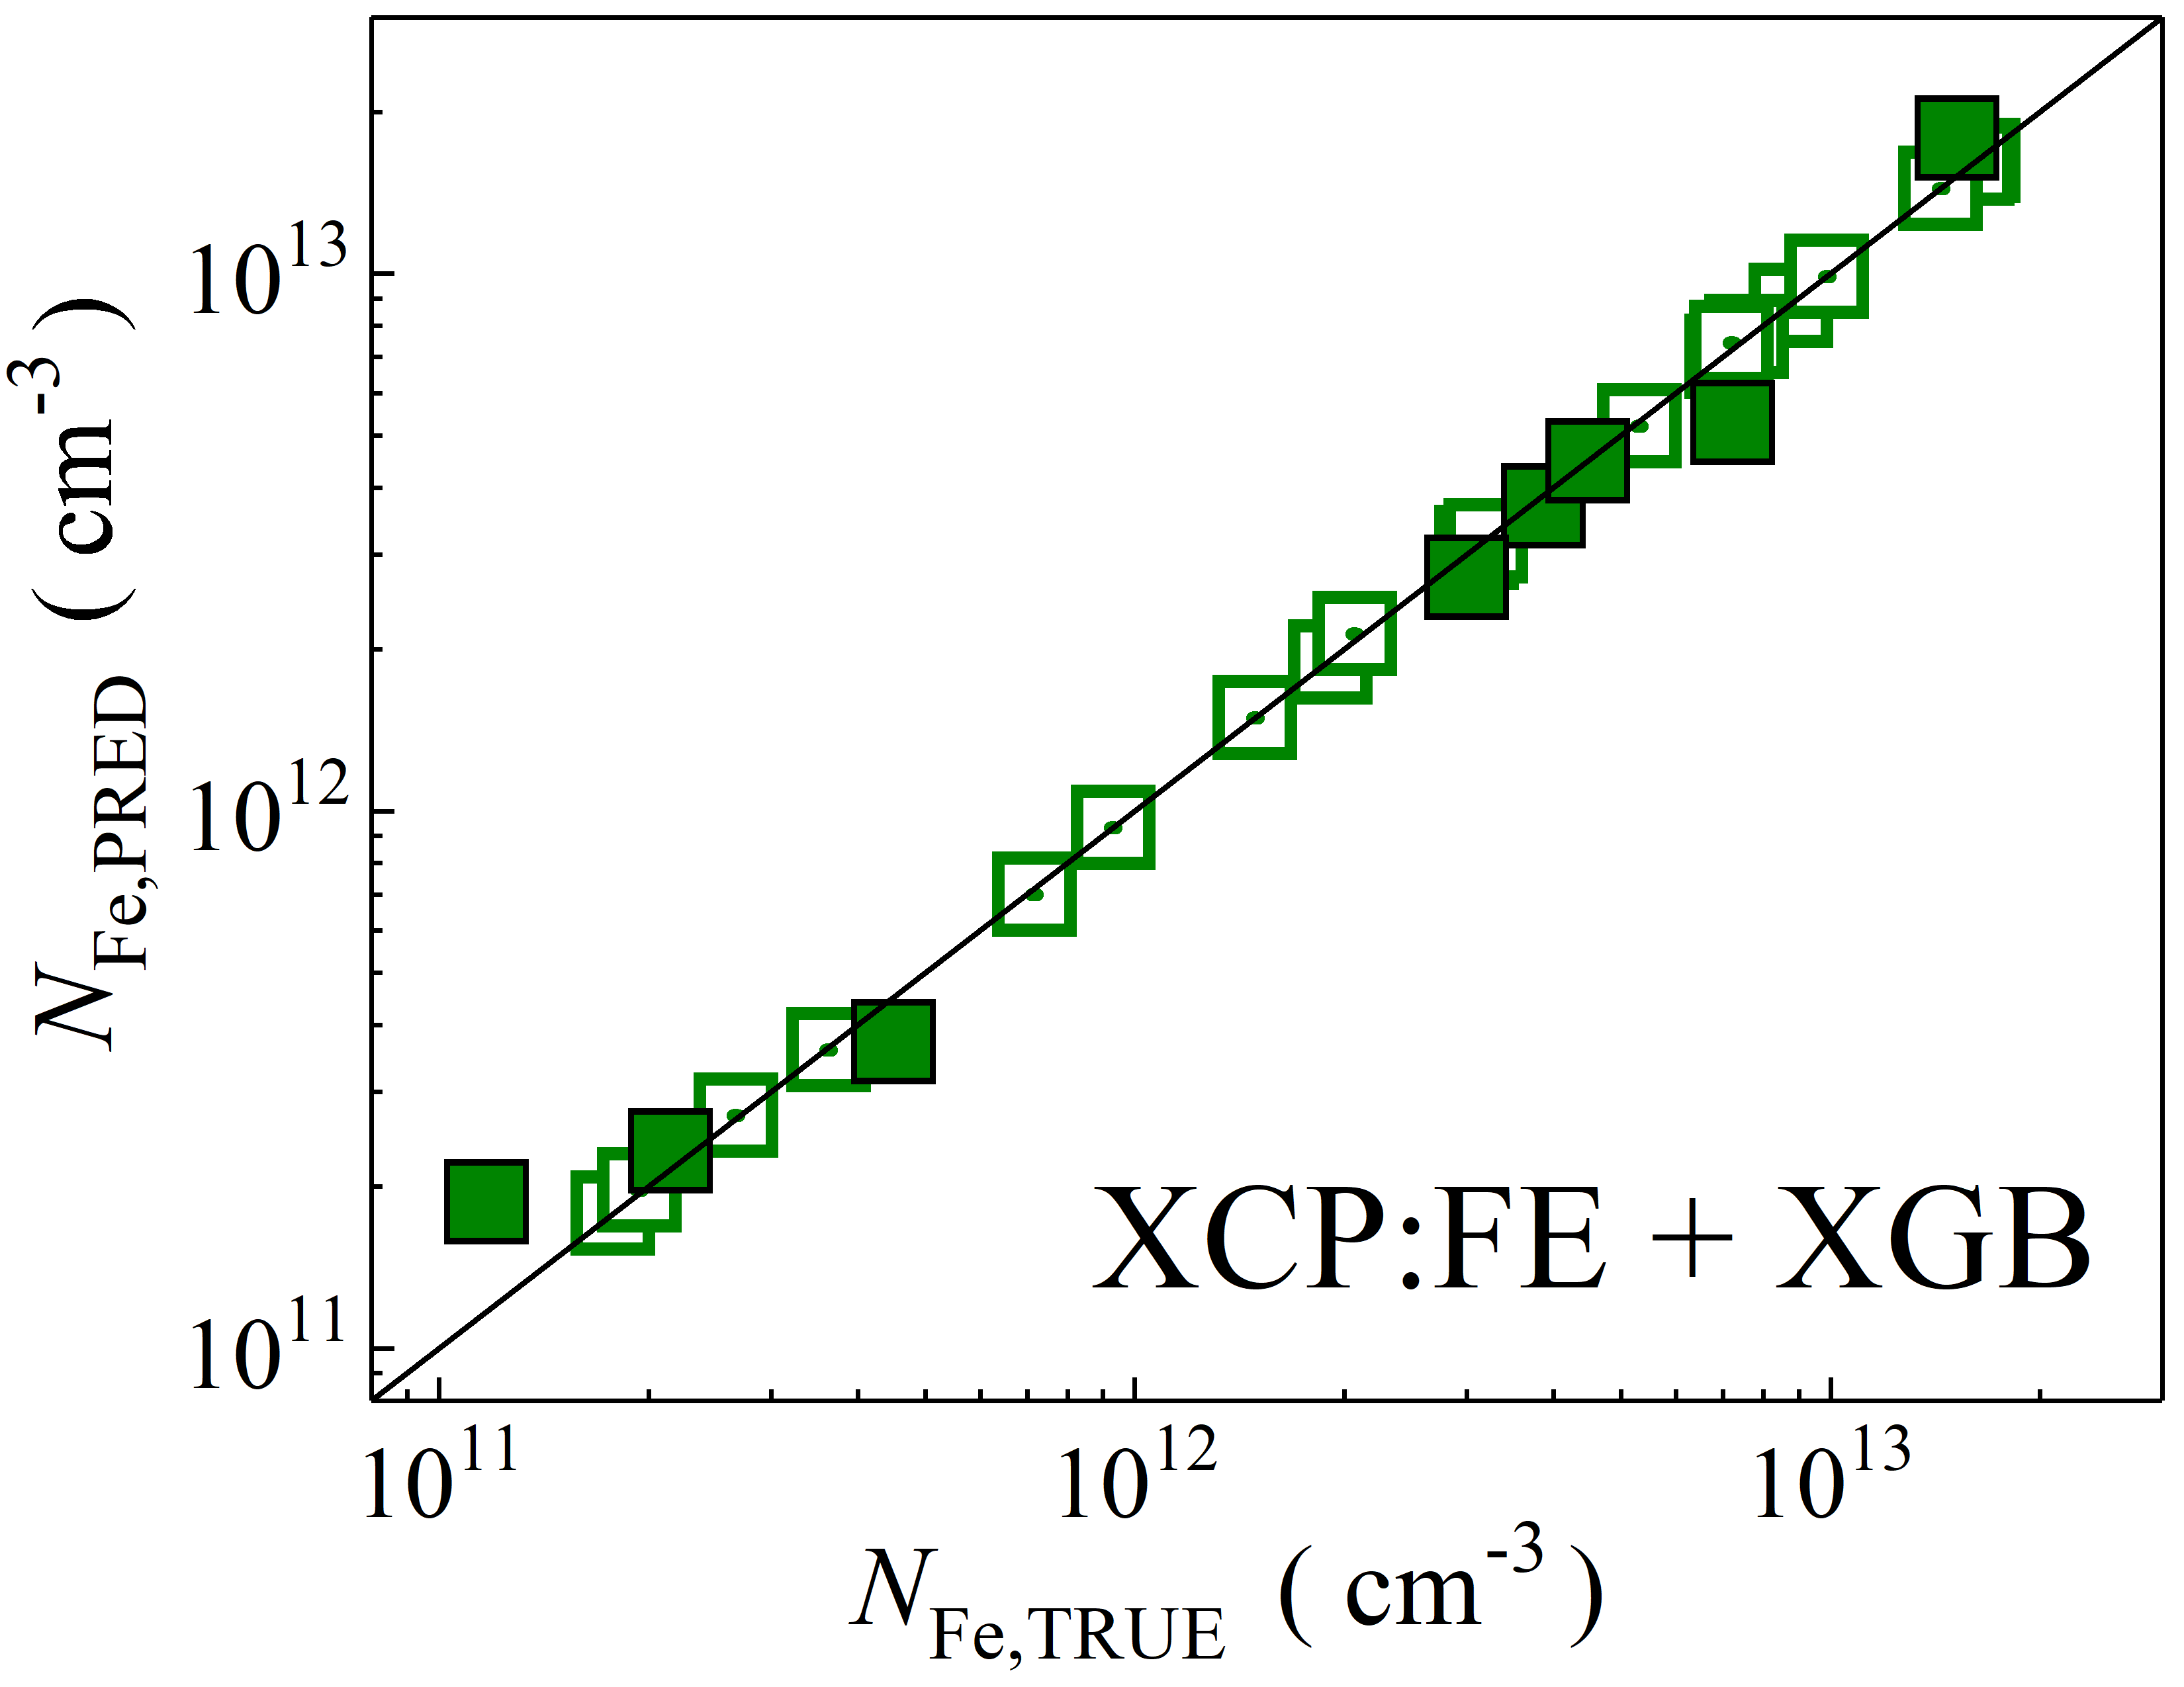

Fig. S32. Scatter plots compare reference iron concentrations $N_{Fe,TRUE}$ with ML-predicted values $N_{Fe,PRED}$ using feature vectors extracted from the feature extractor layer of Xception visual model. The ML algorithms include DNN (green and purple), GB (dark yellow and yellow), RF (red and blue), SVR (blue and pink), and XGB (green and red). Symbols represent different datasets: filled squares — test data from experimental measurements, and open squares — train data from experimental measurements. The black lines are the identified lines serving as the references.

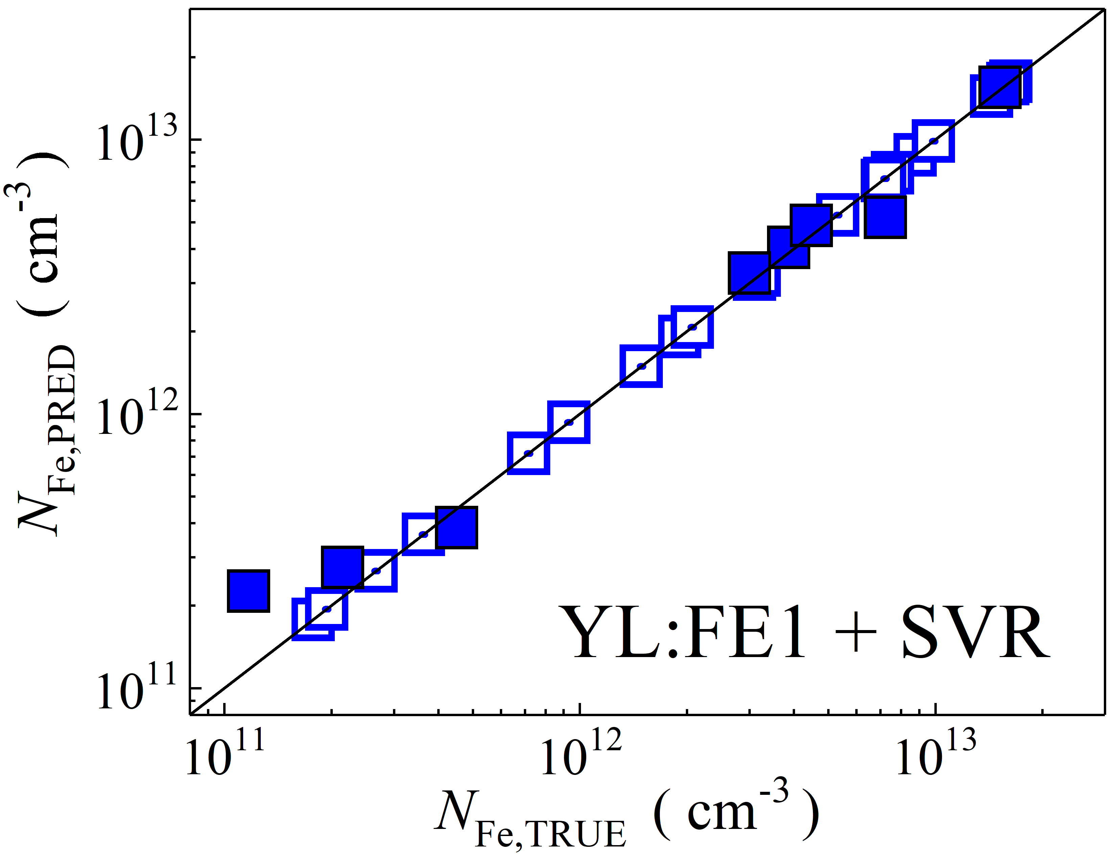

Fig. S33. Scatter plots compare reference iron concentrations $N_{Fe,TRUE}$ with ML-predicted values $N_{Fe,PRED}$ using raw feature extractor layer of YOLOv4 (CSPDarknet53) visual model. The ML algorithms include SVR (blue and pink). Symbols represent different datasets: filled squares — test data from experimental measurements, and open squares — train data from experimental measurements. The black lines are the identified lines serving as the references.

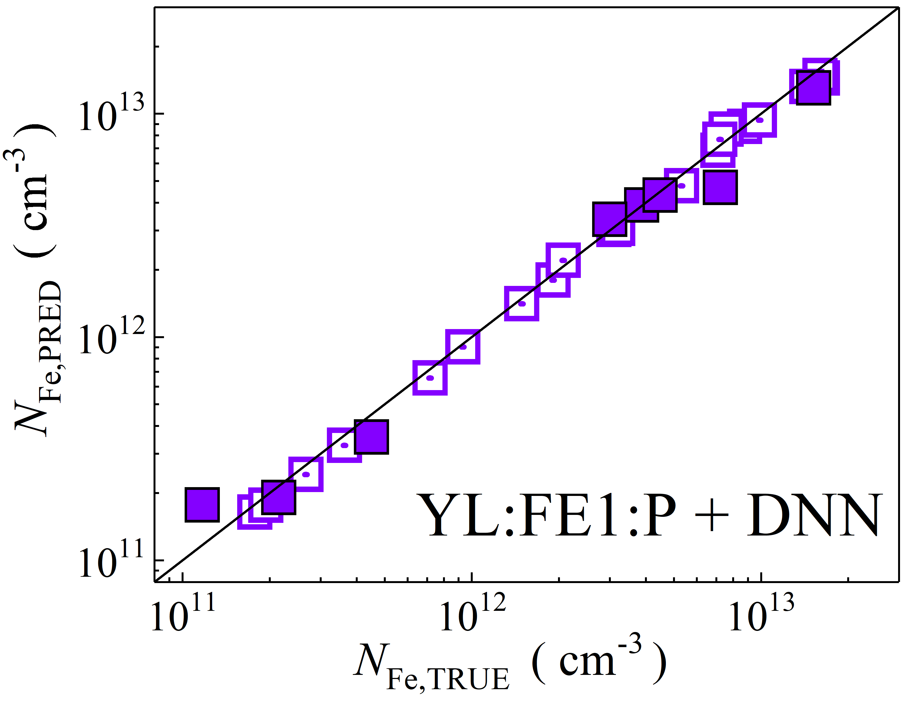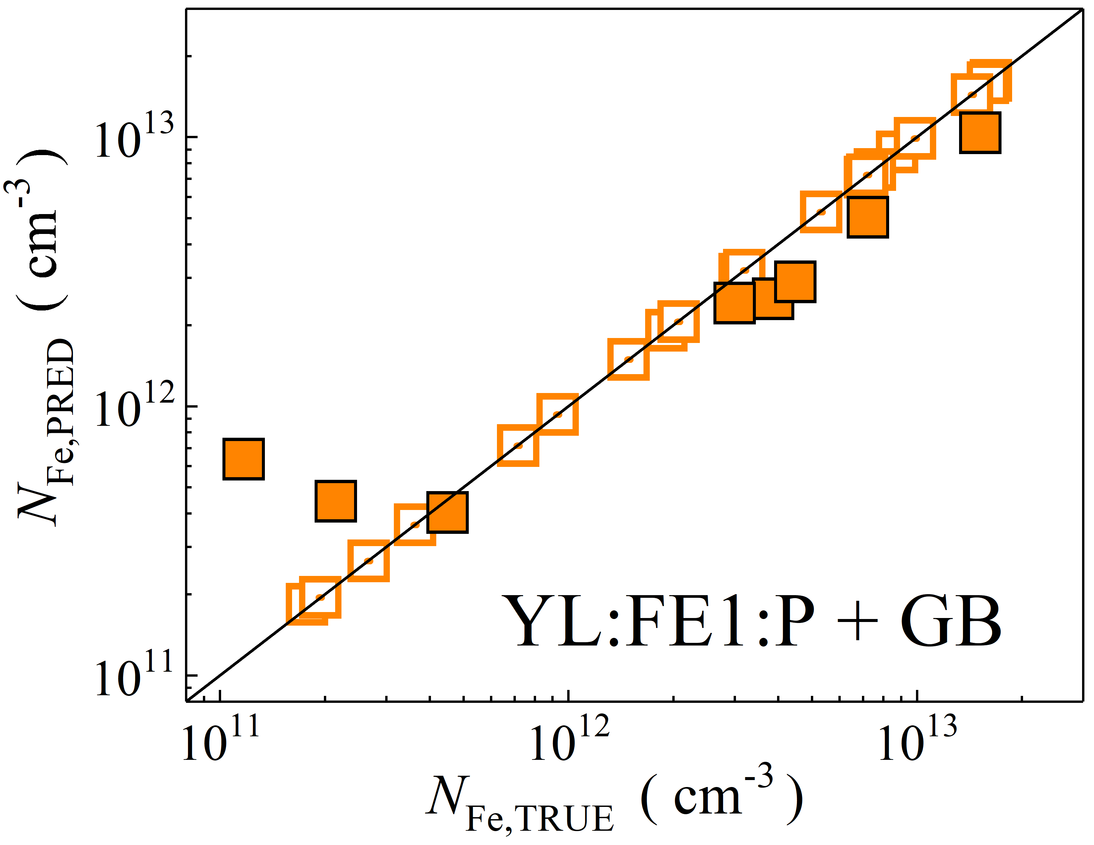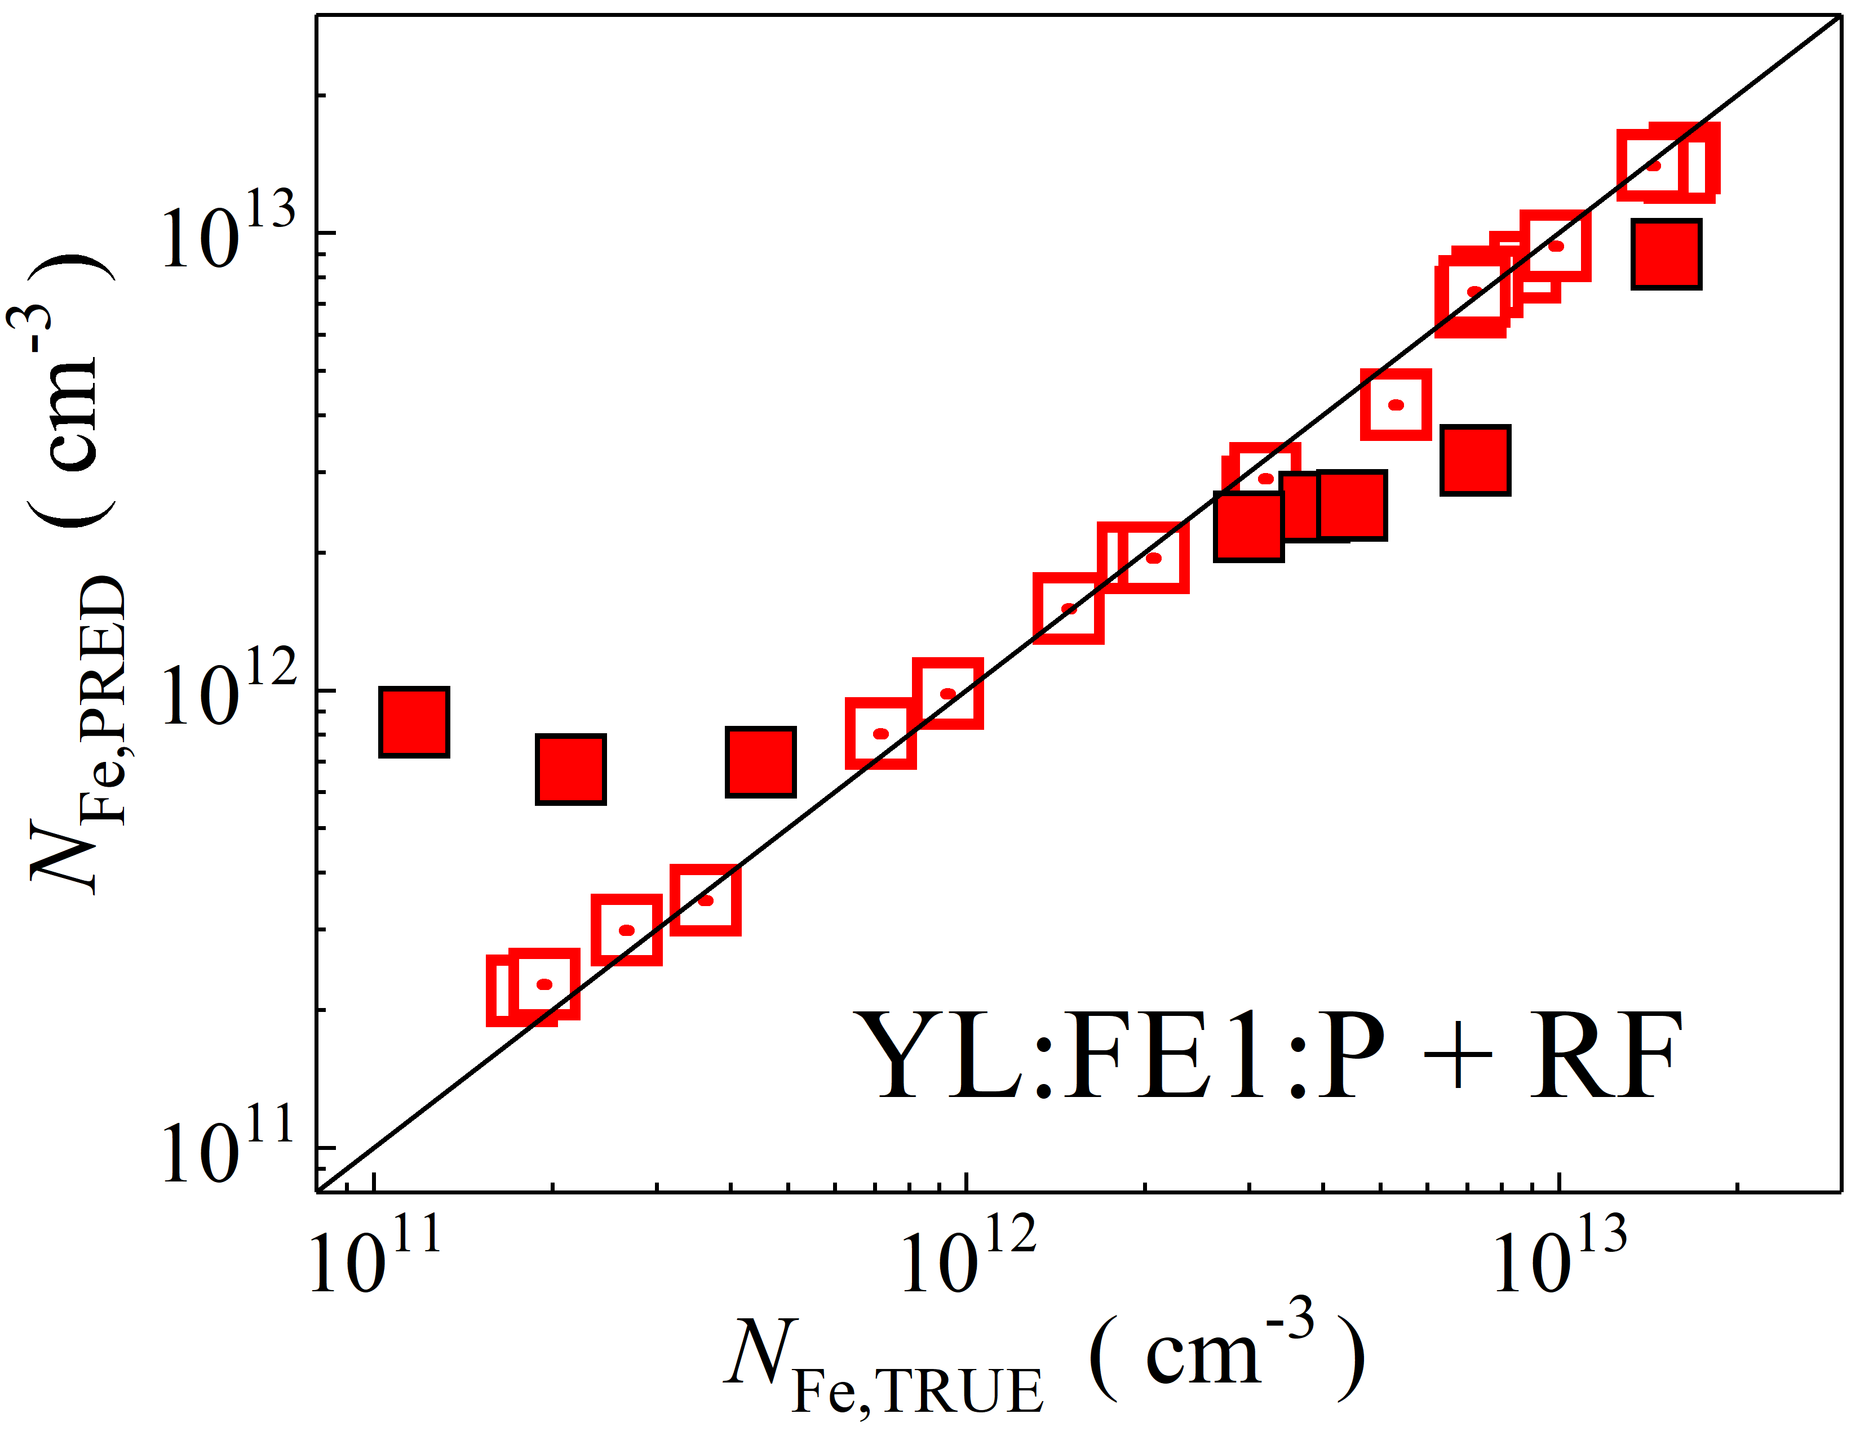

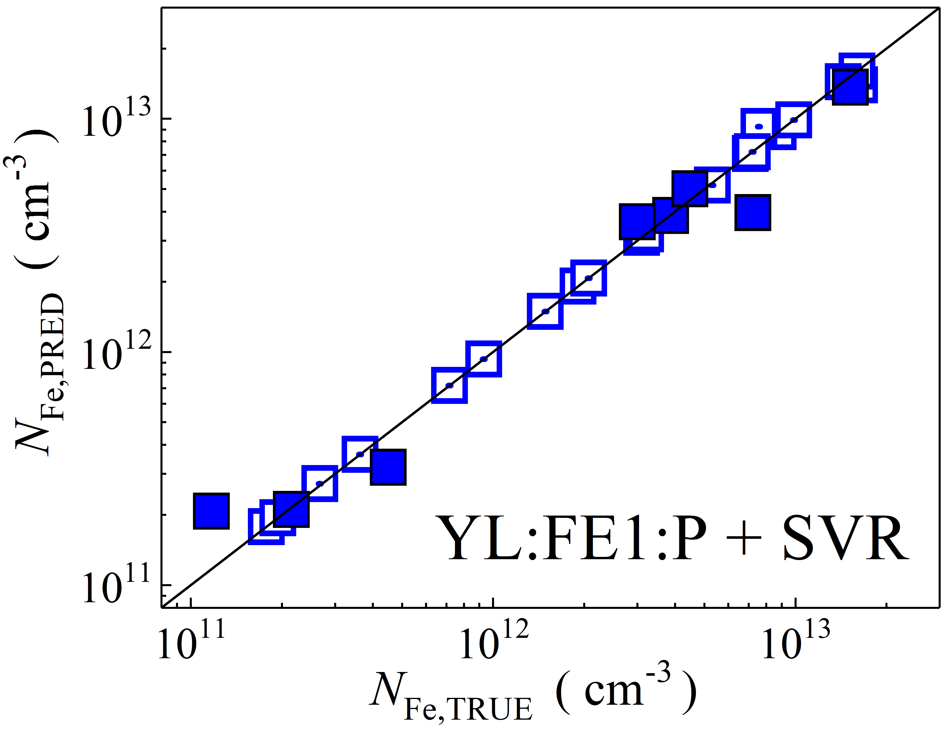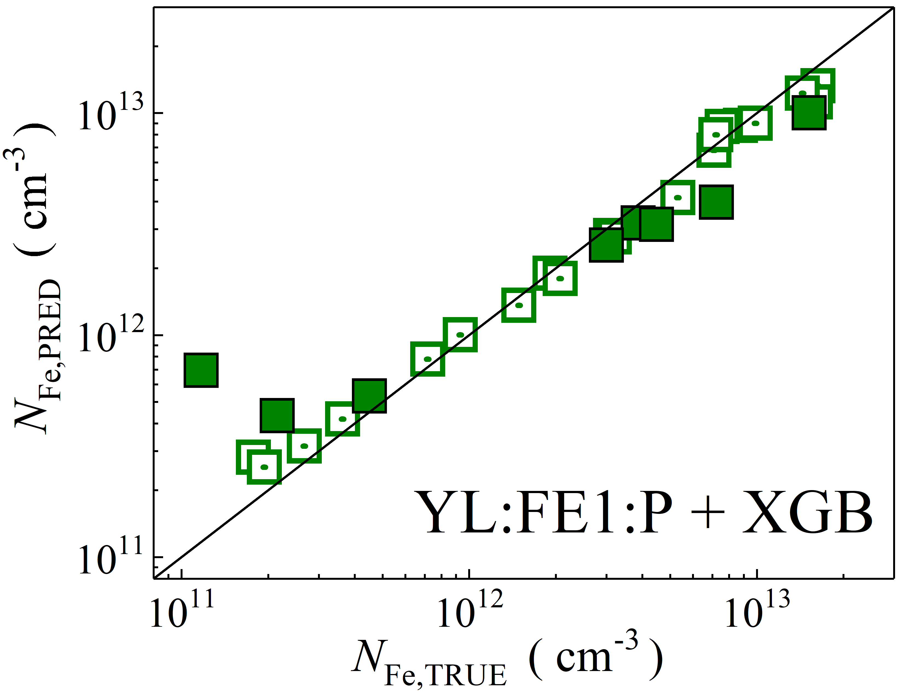

Fig. S34. Scatter plots compare reference iron concentrations $N_{Fe,TRUE}$ with ML-predicted values $N_{Fe,PRED}$ using raw feature extractor layer with PCA reduction of YOLOv4 (CSPDarknet53) visual model. The ML algorithms include DNN (green and purple), GB (dark yellow and yellow), RF (red and blue), SVR (blue and pink), and XGB (green and red). Symbols represent different datasets: filled squares — test data from experimental measurements, and open squares — train data from experimental measurements. The black lines are the identified lines serving as the references.

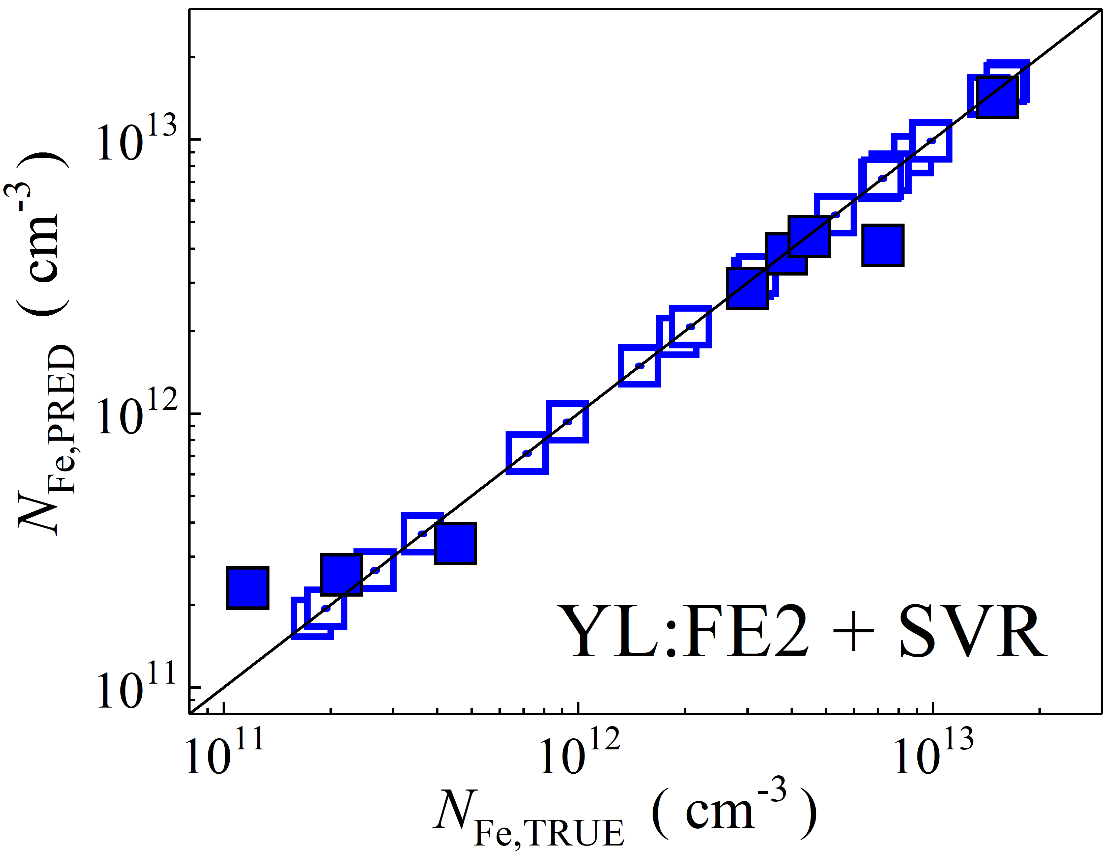

Fig. S35. Scatter plots compare reference iron concentrations $N_{Fe,TRUE}$ with ML-predicted values $N_{Fe,PRED}$ using raw feature extractor layer of CSPDarknet53 backbone visual model (top, penultimate layers). The ML algorithms include SVR (blue and pink). Symbols represent different datasets: filled squares — test data from experimental measurements, and open squares — train data from experimental measurements. The black lines are the identified lines serving as the references.

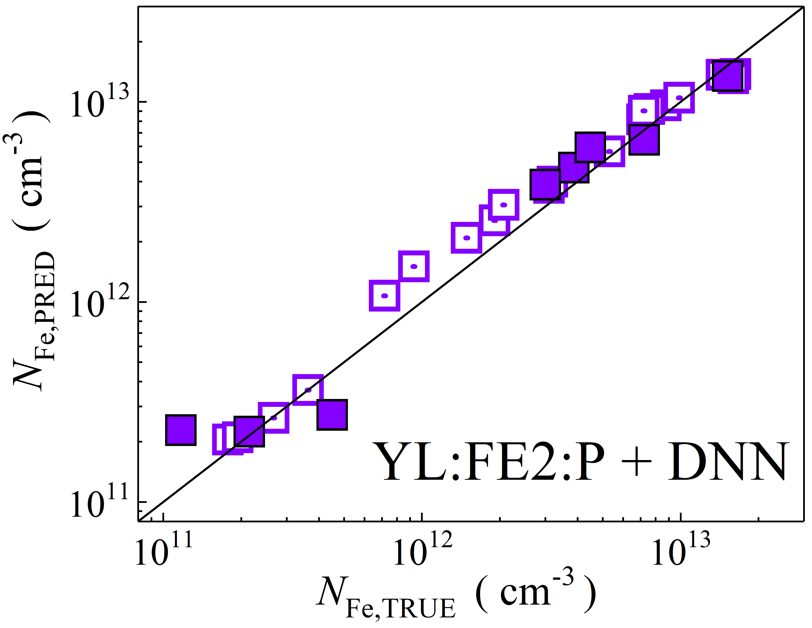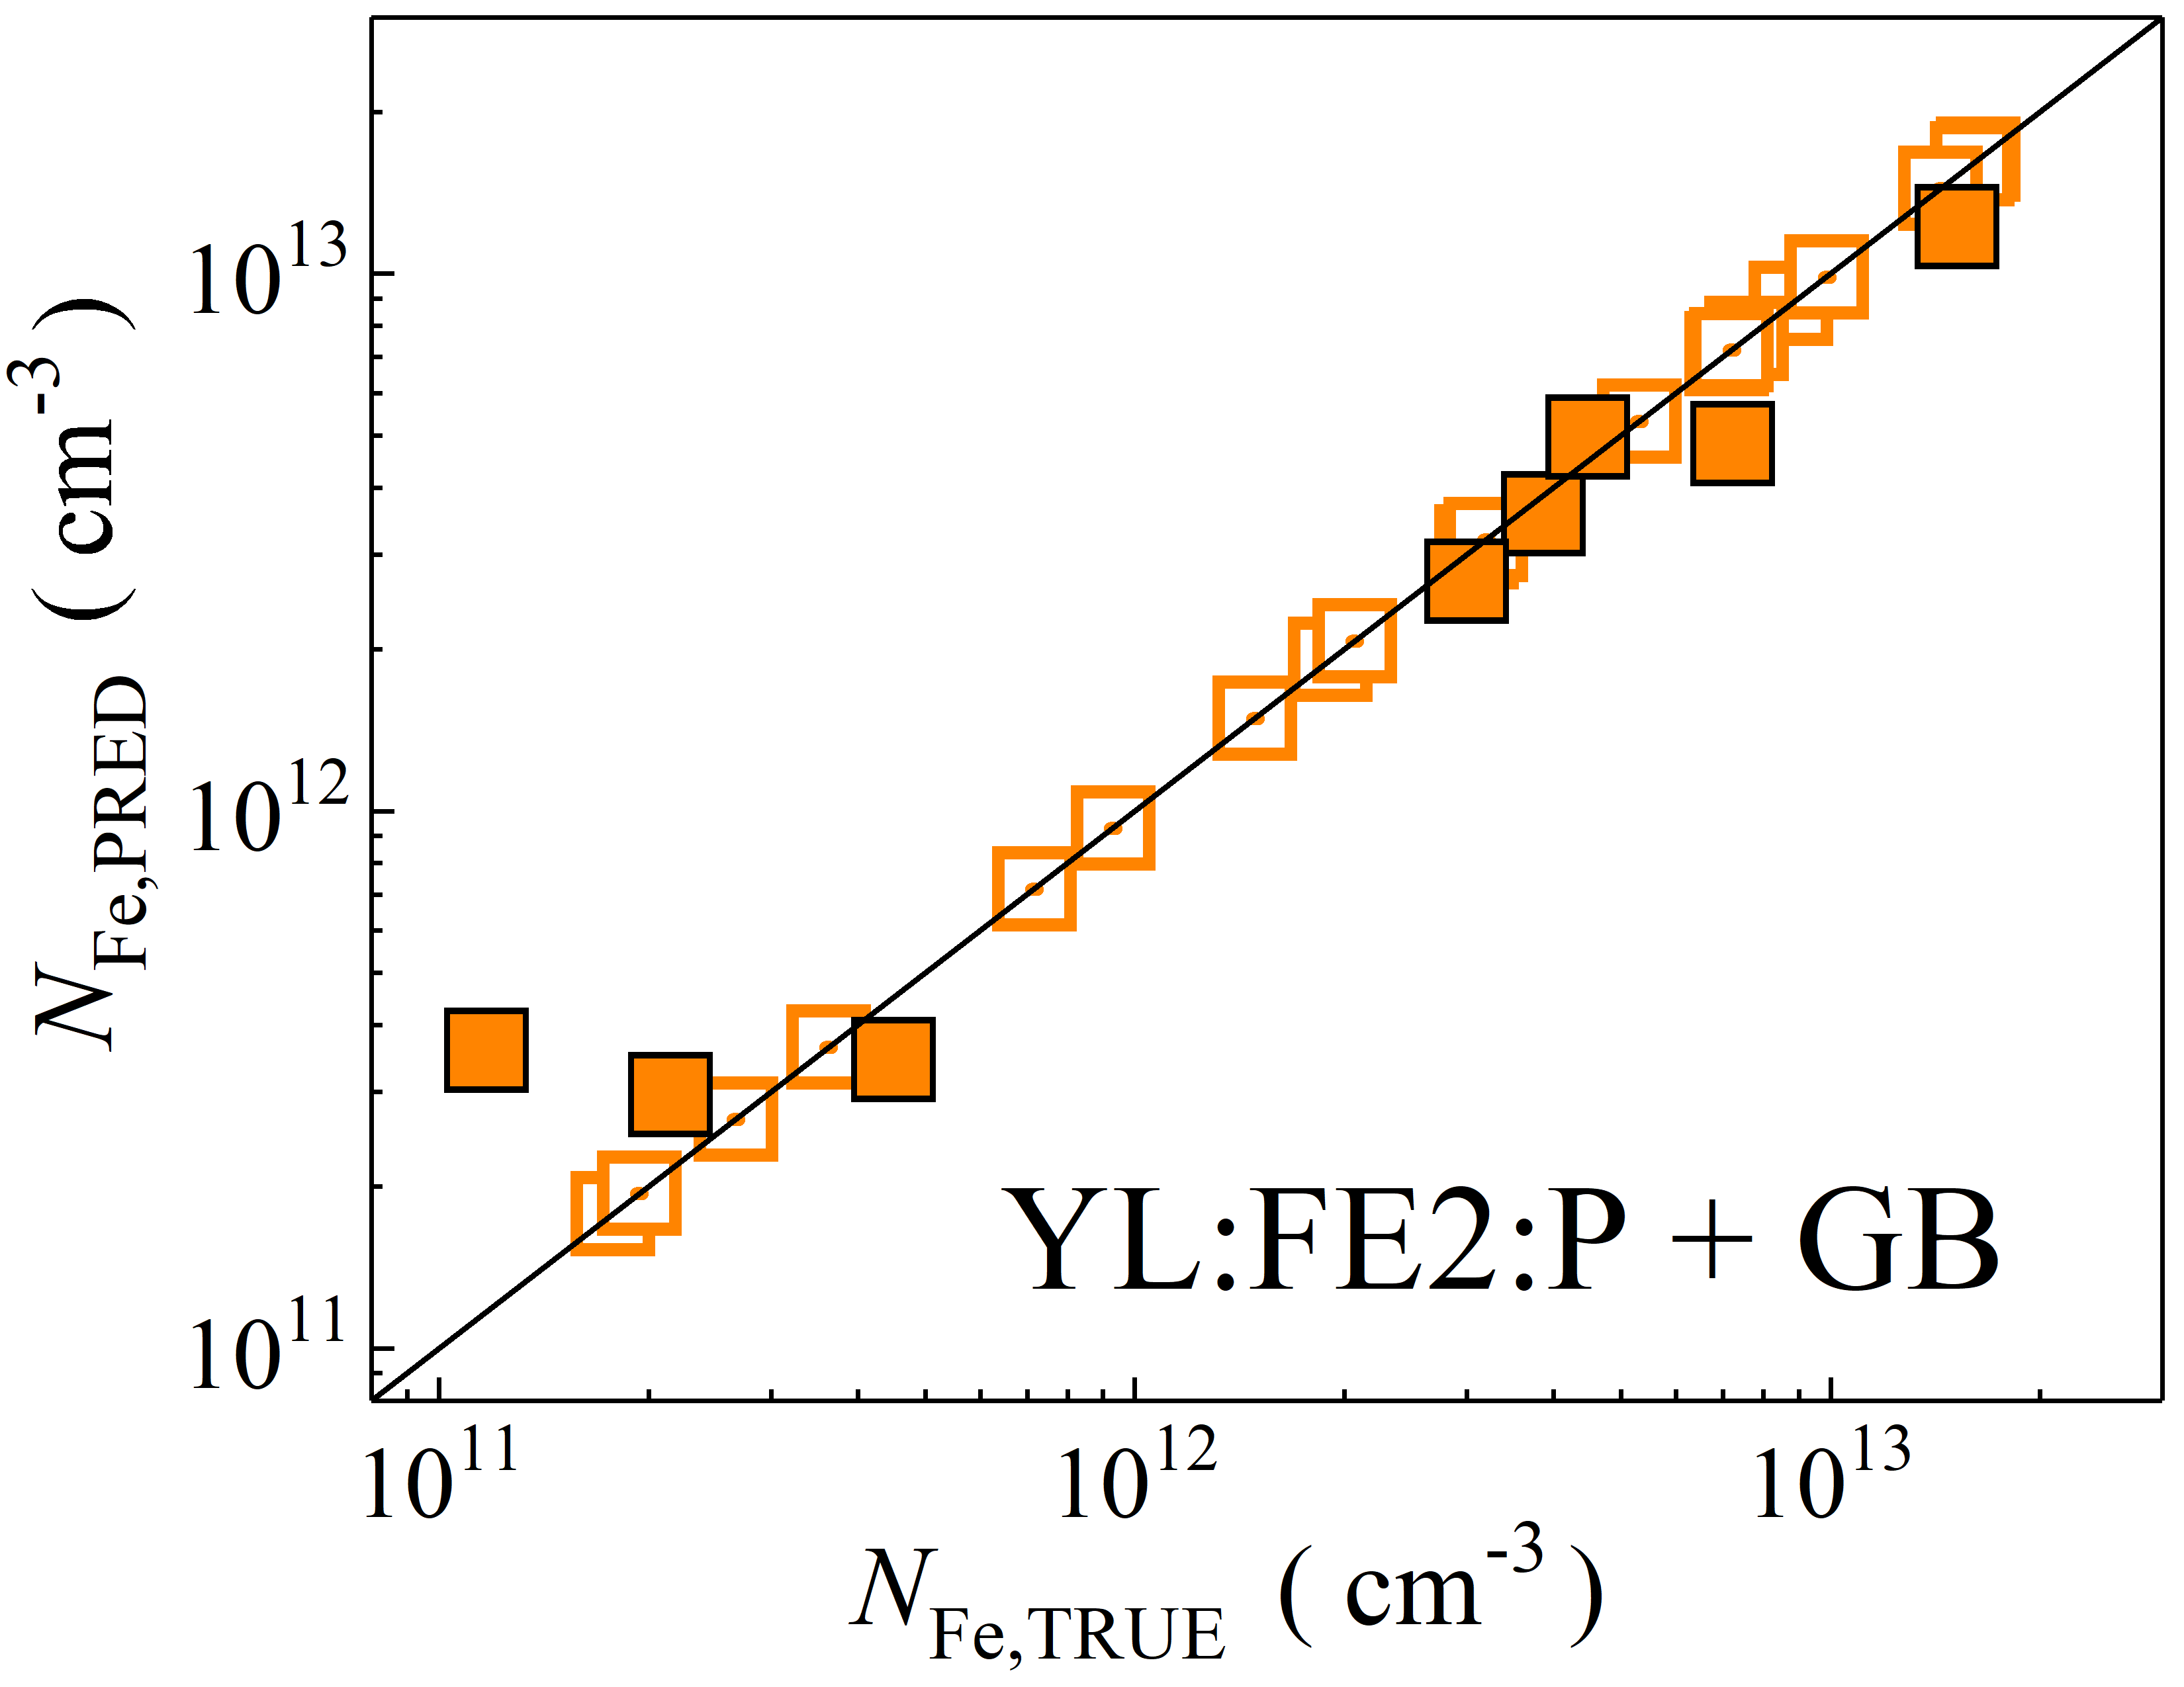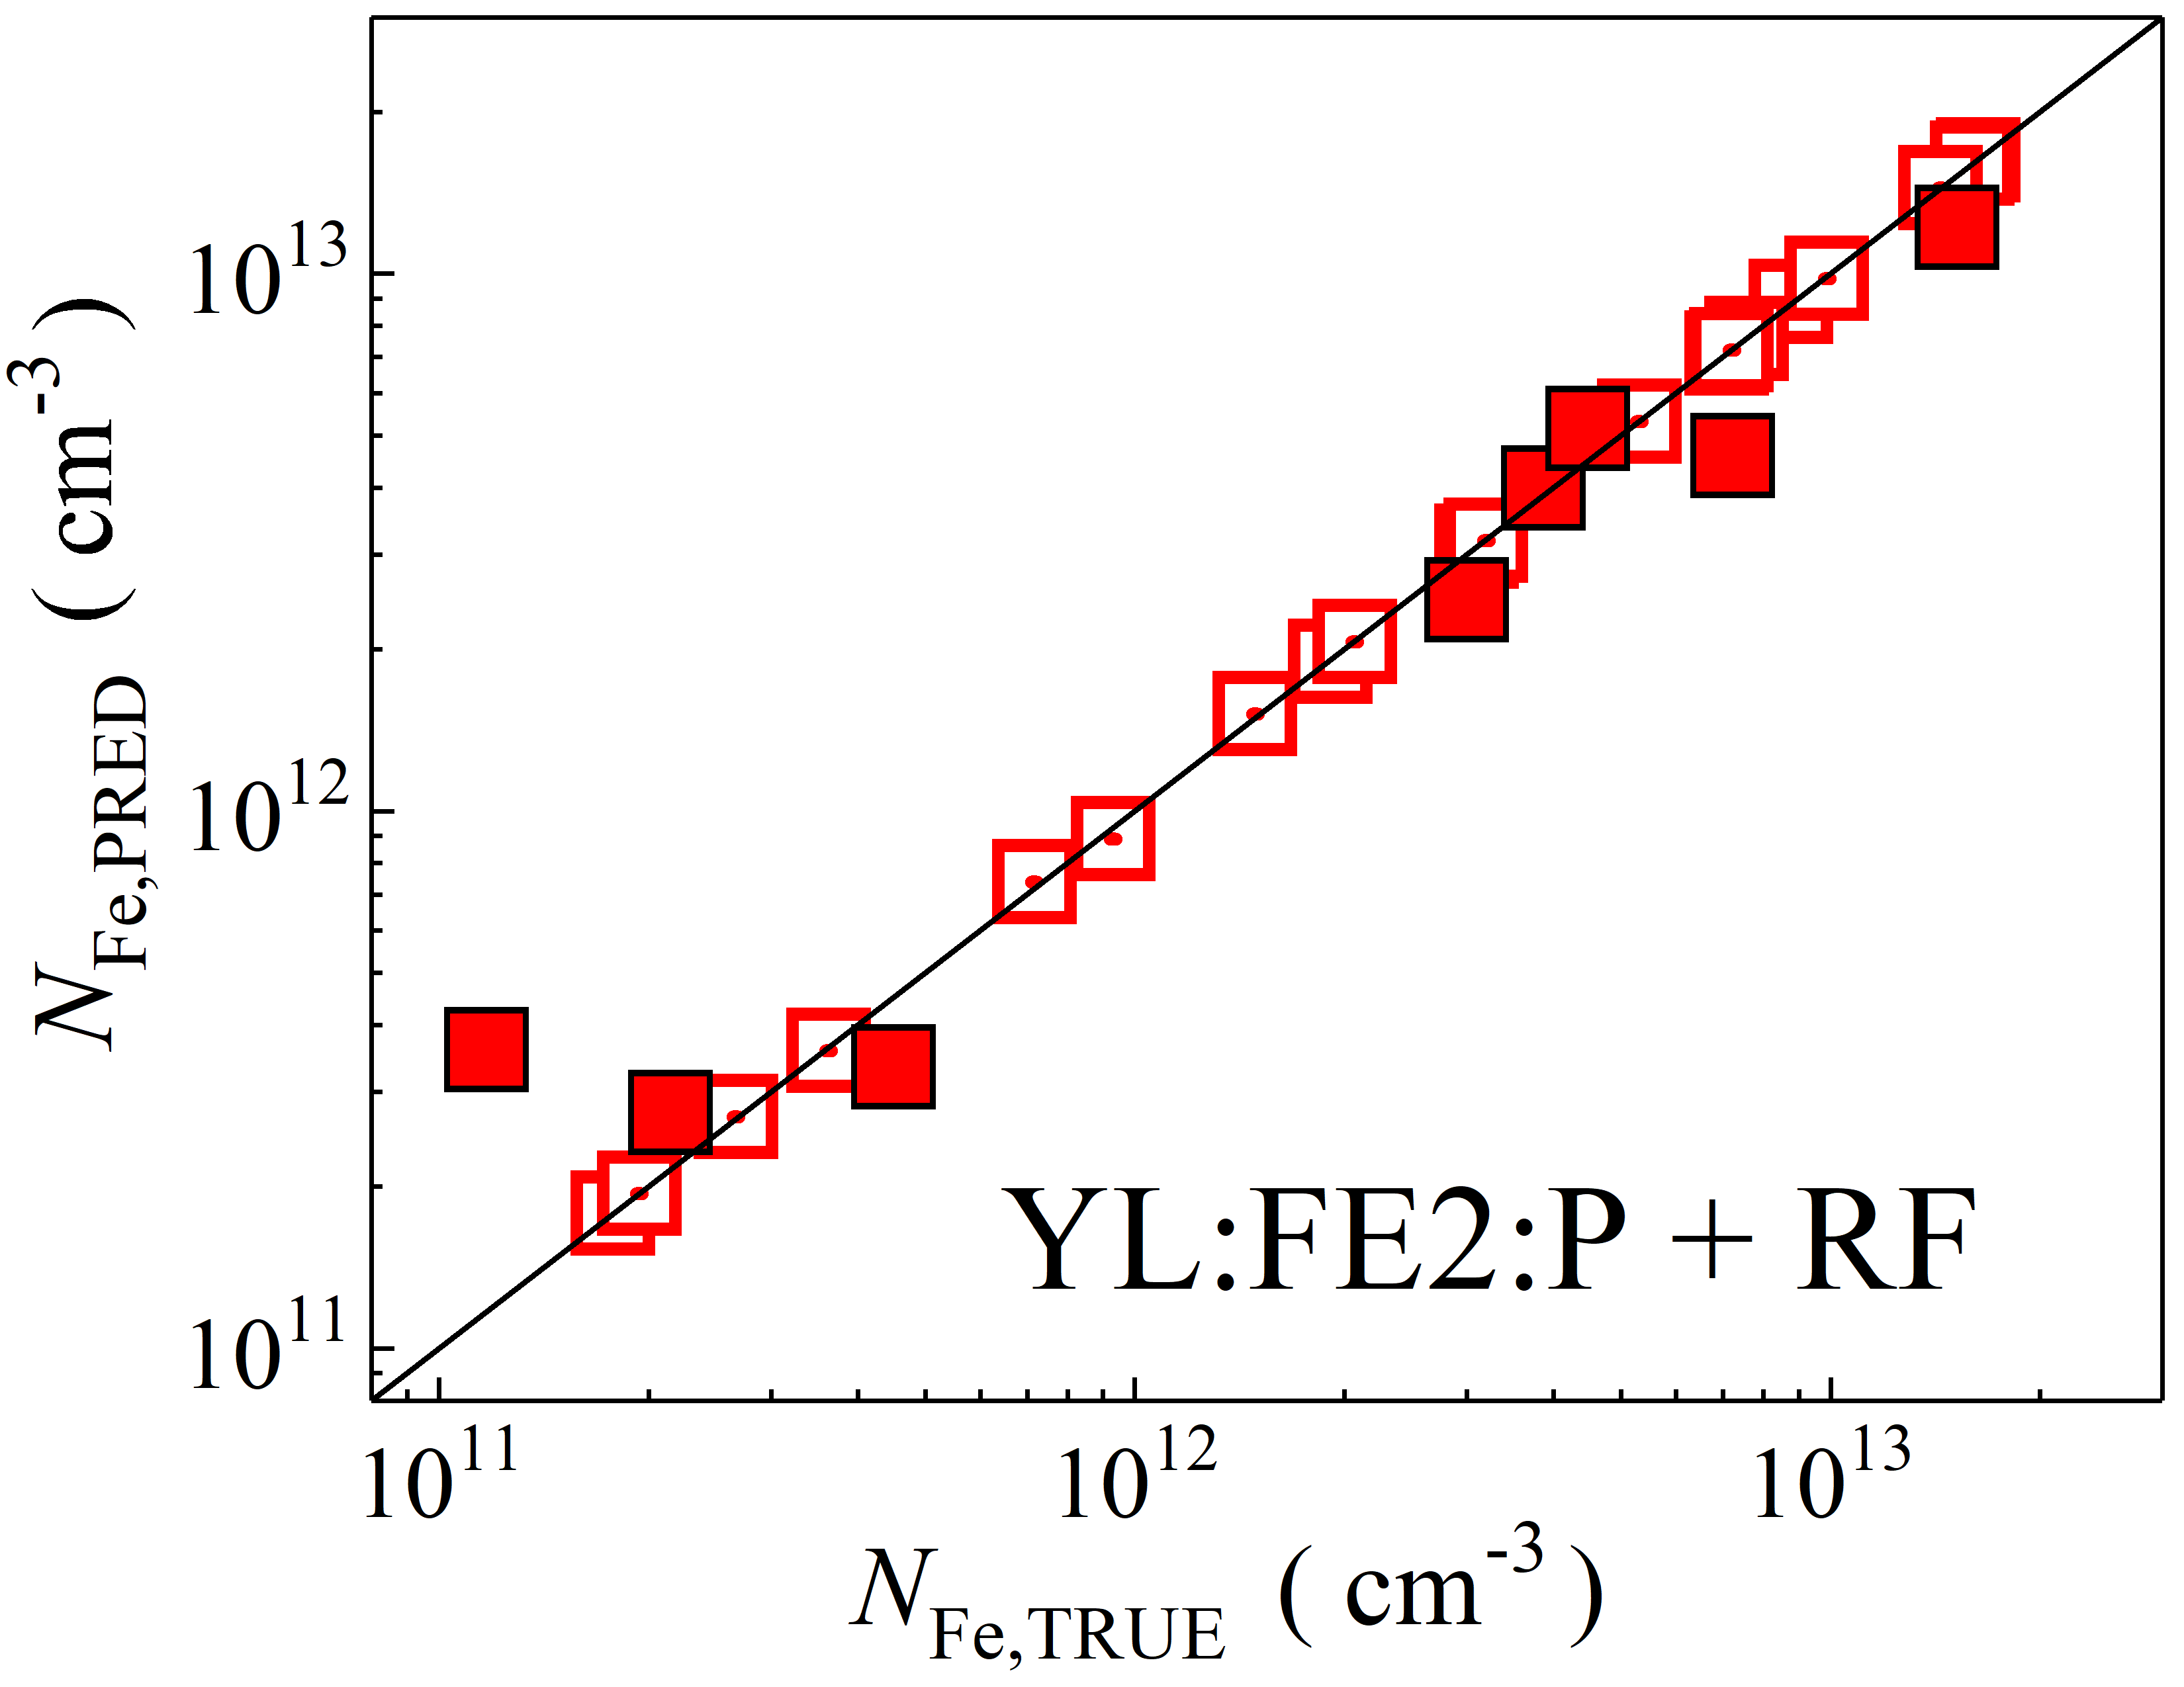

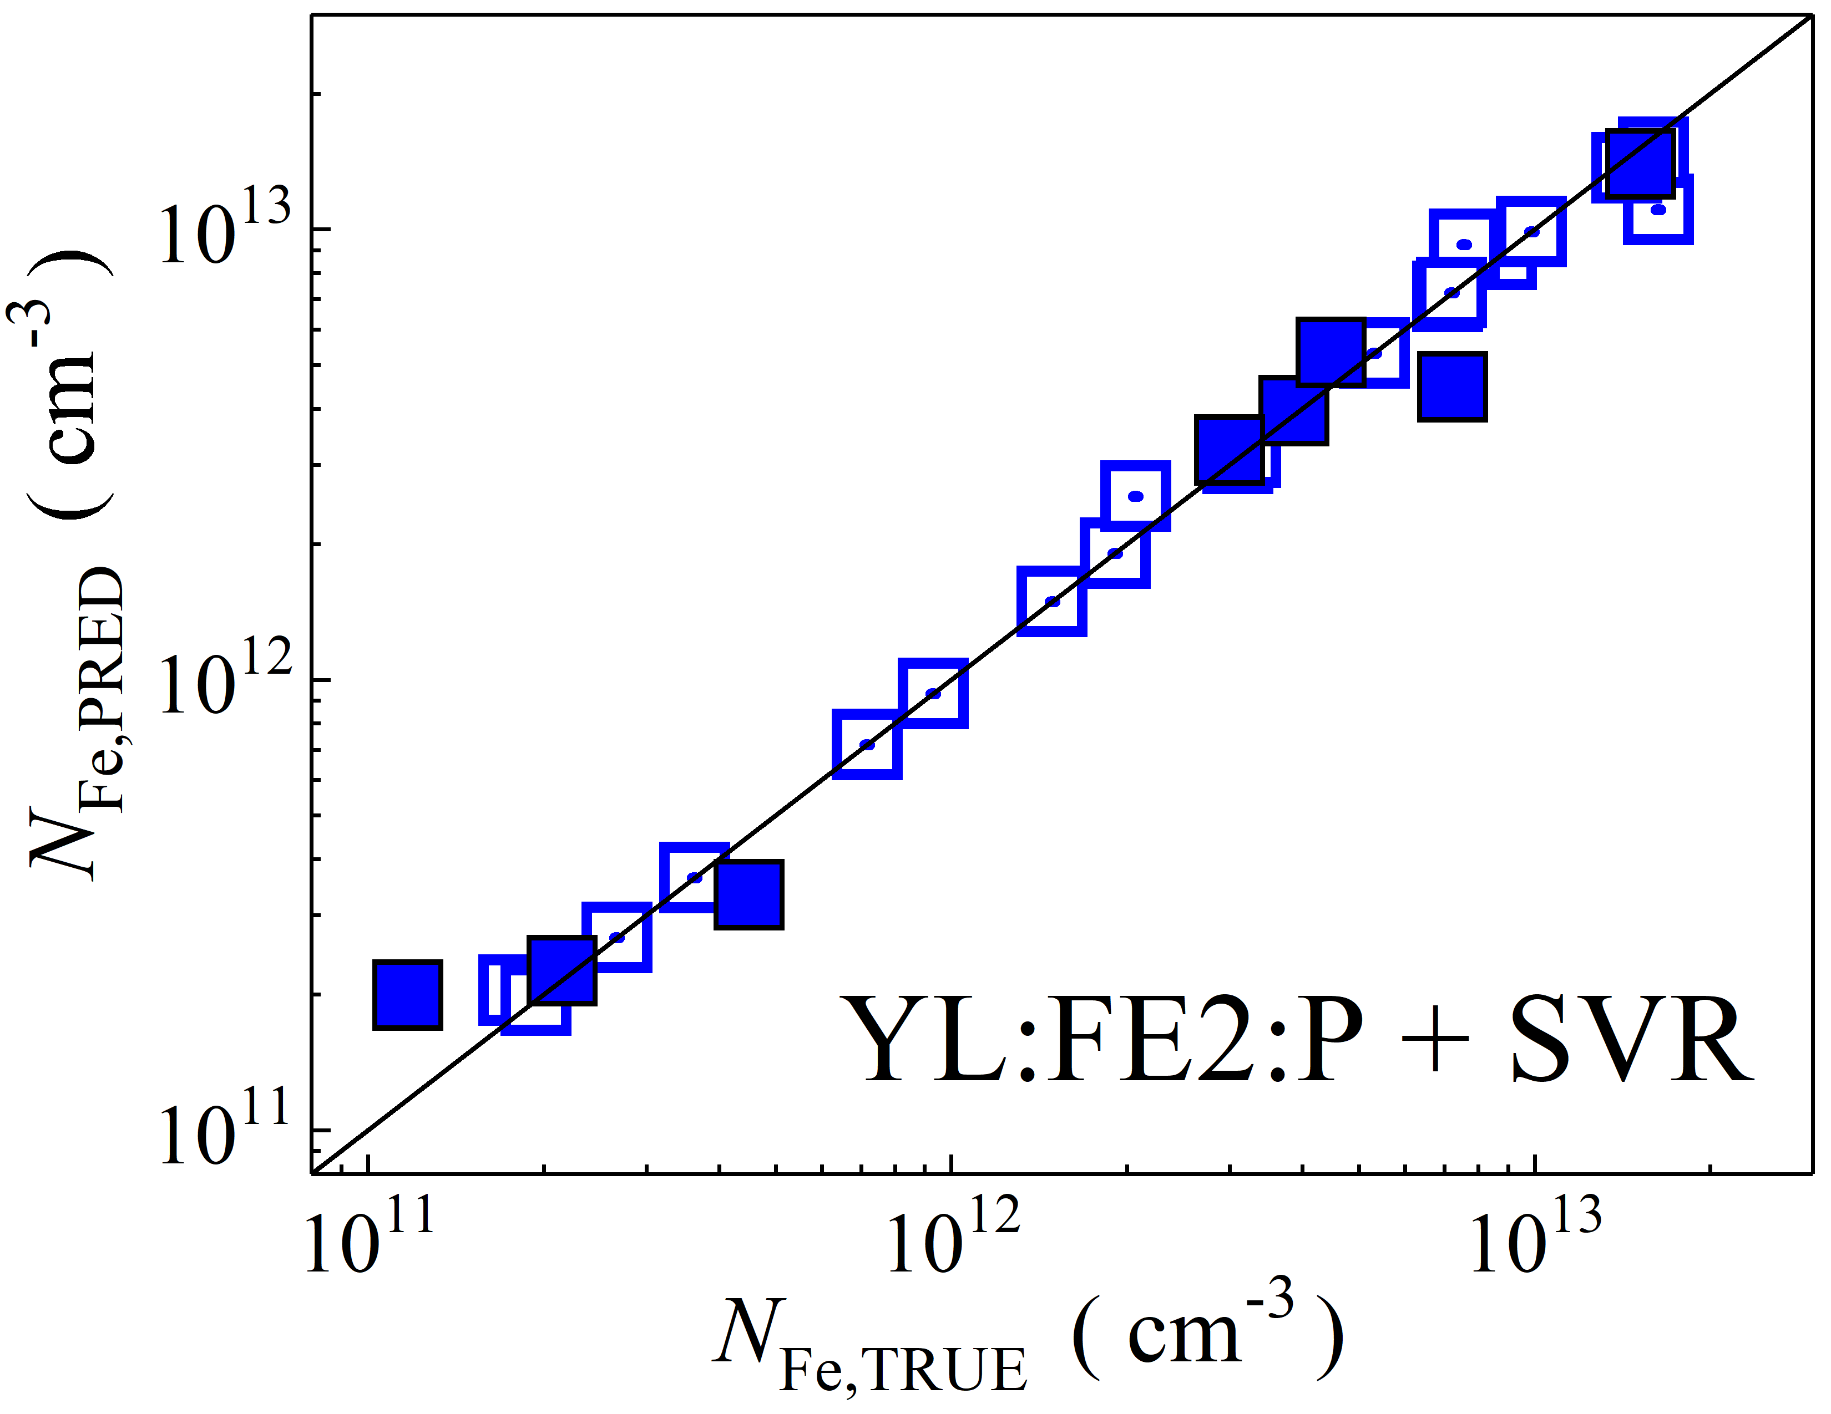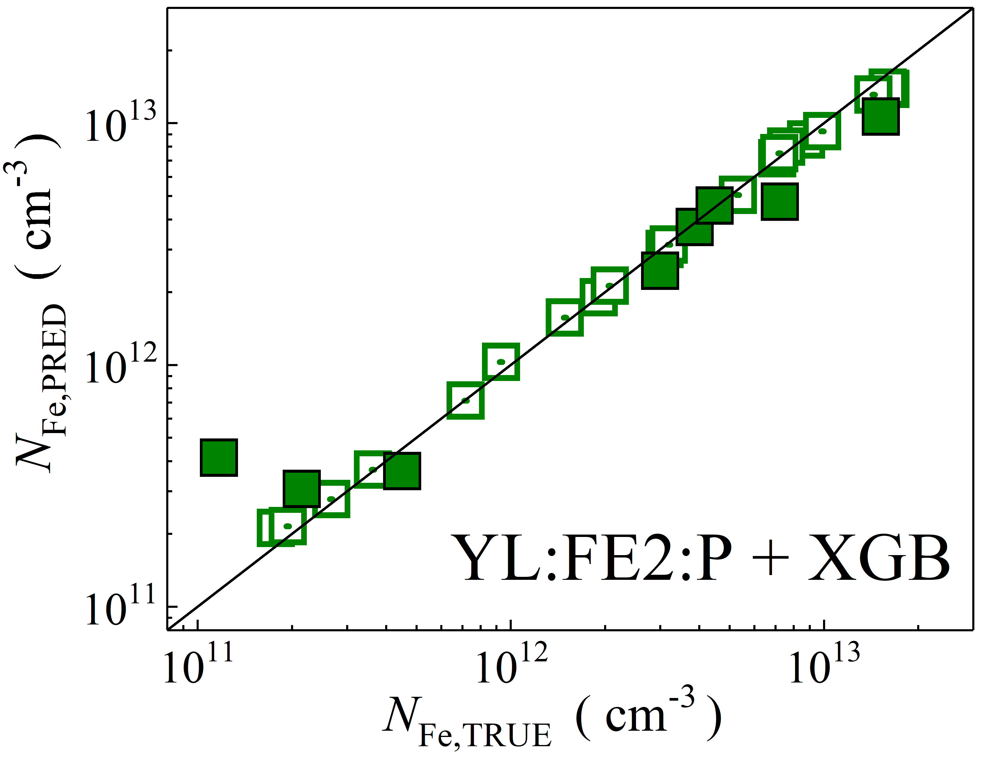

Fig. S36. Scatter plots compare reference iron concentrations $N_{Fe,TRUE}$ with ML-predicted values $N_{Fe,PRED}$ using raw feature extractor layer with PCA reduction of CSPDarknet53 backbone visual model (top, penultimate layers). The ML algorithms include DNN (green and purple), GB (dark yellow and yellow), RF (red and blue), SVR (blue and pink), and XGB (green and red). Symbols represent different datasets: filled squares — test data from experimental measurements, and open squares — train data from experimental measurements. The black lines are the identified lines serving as the references.

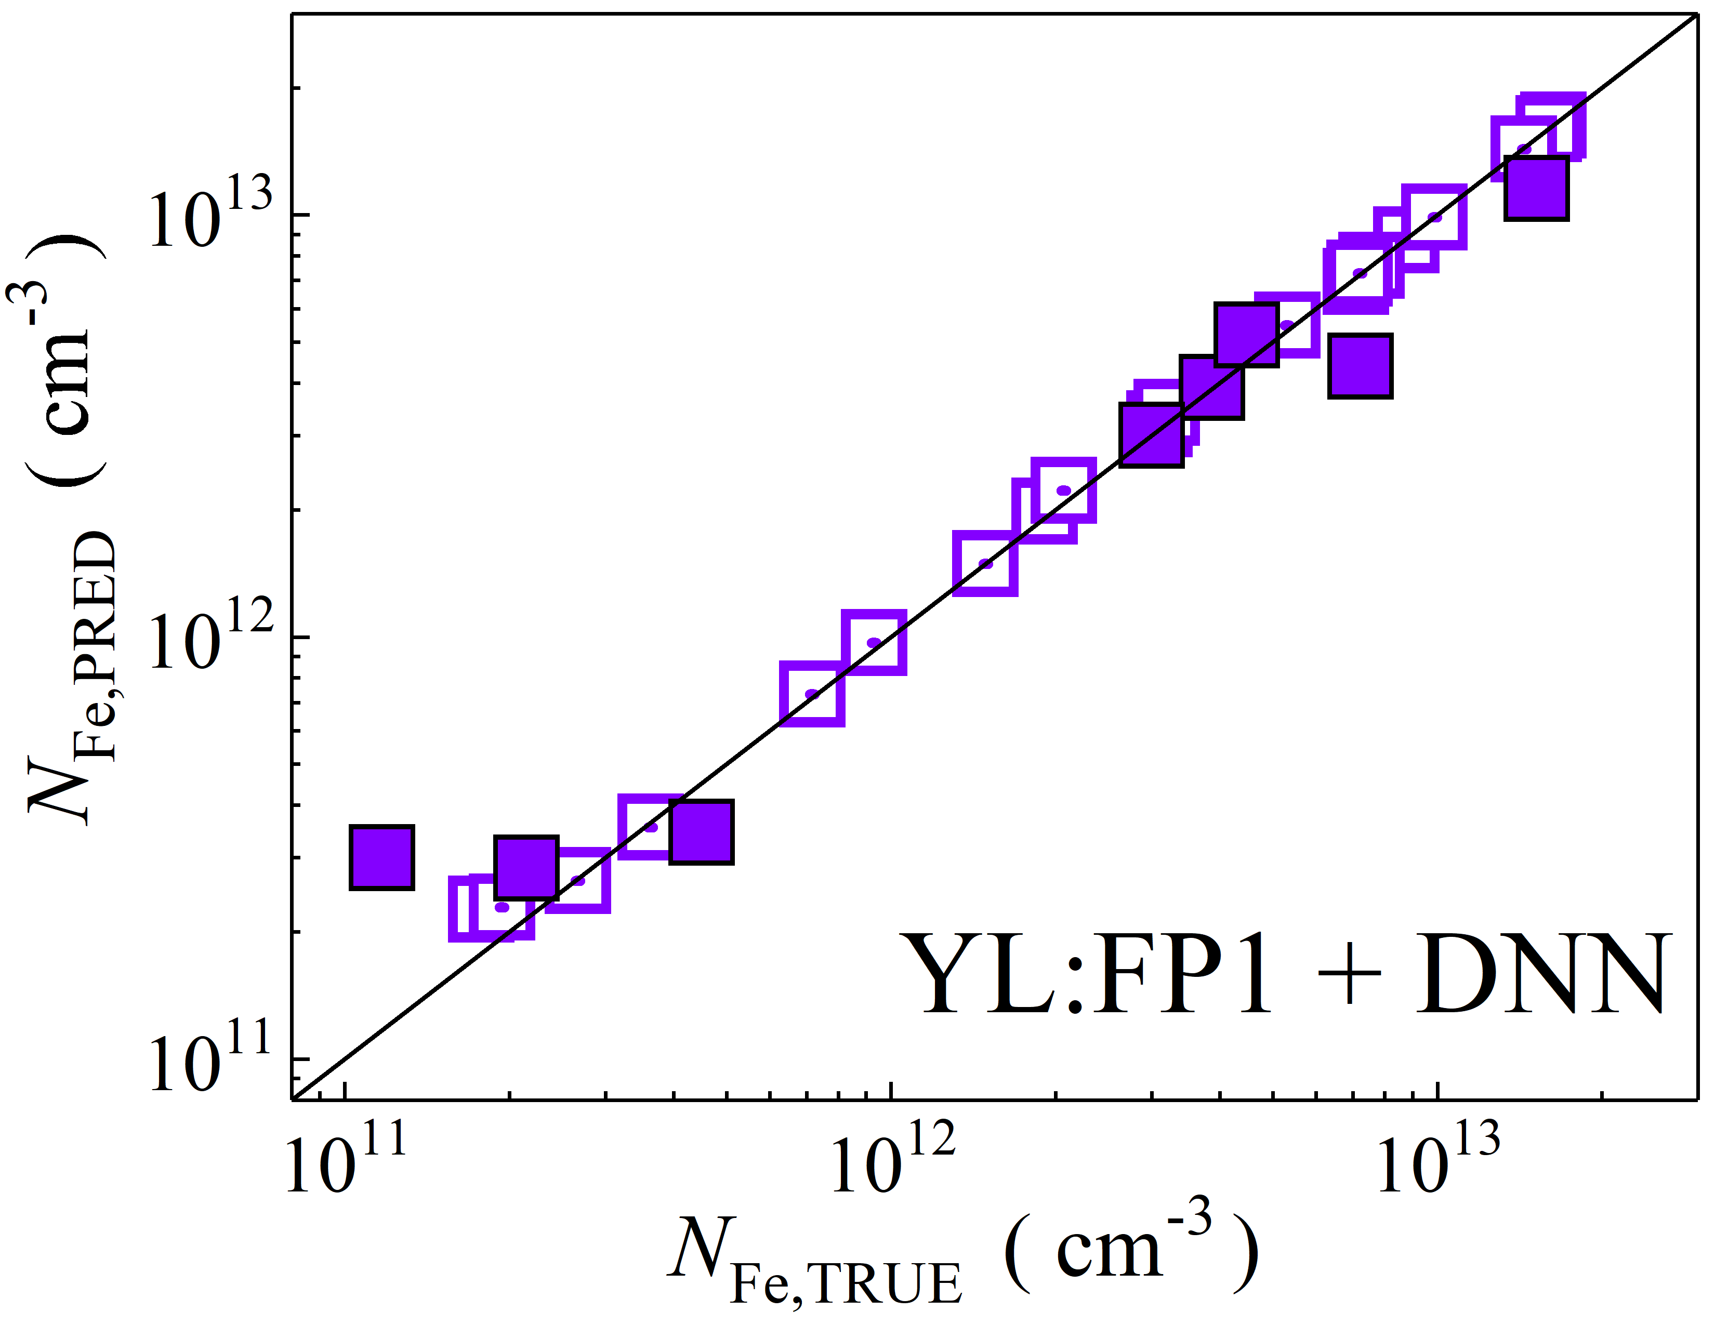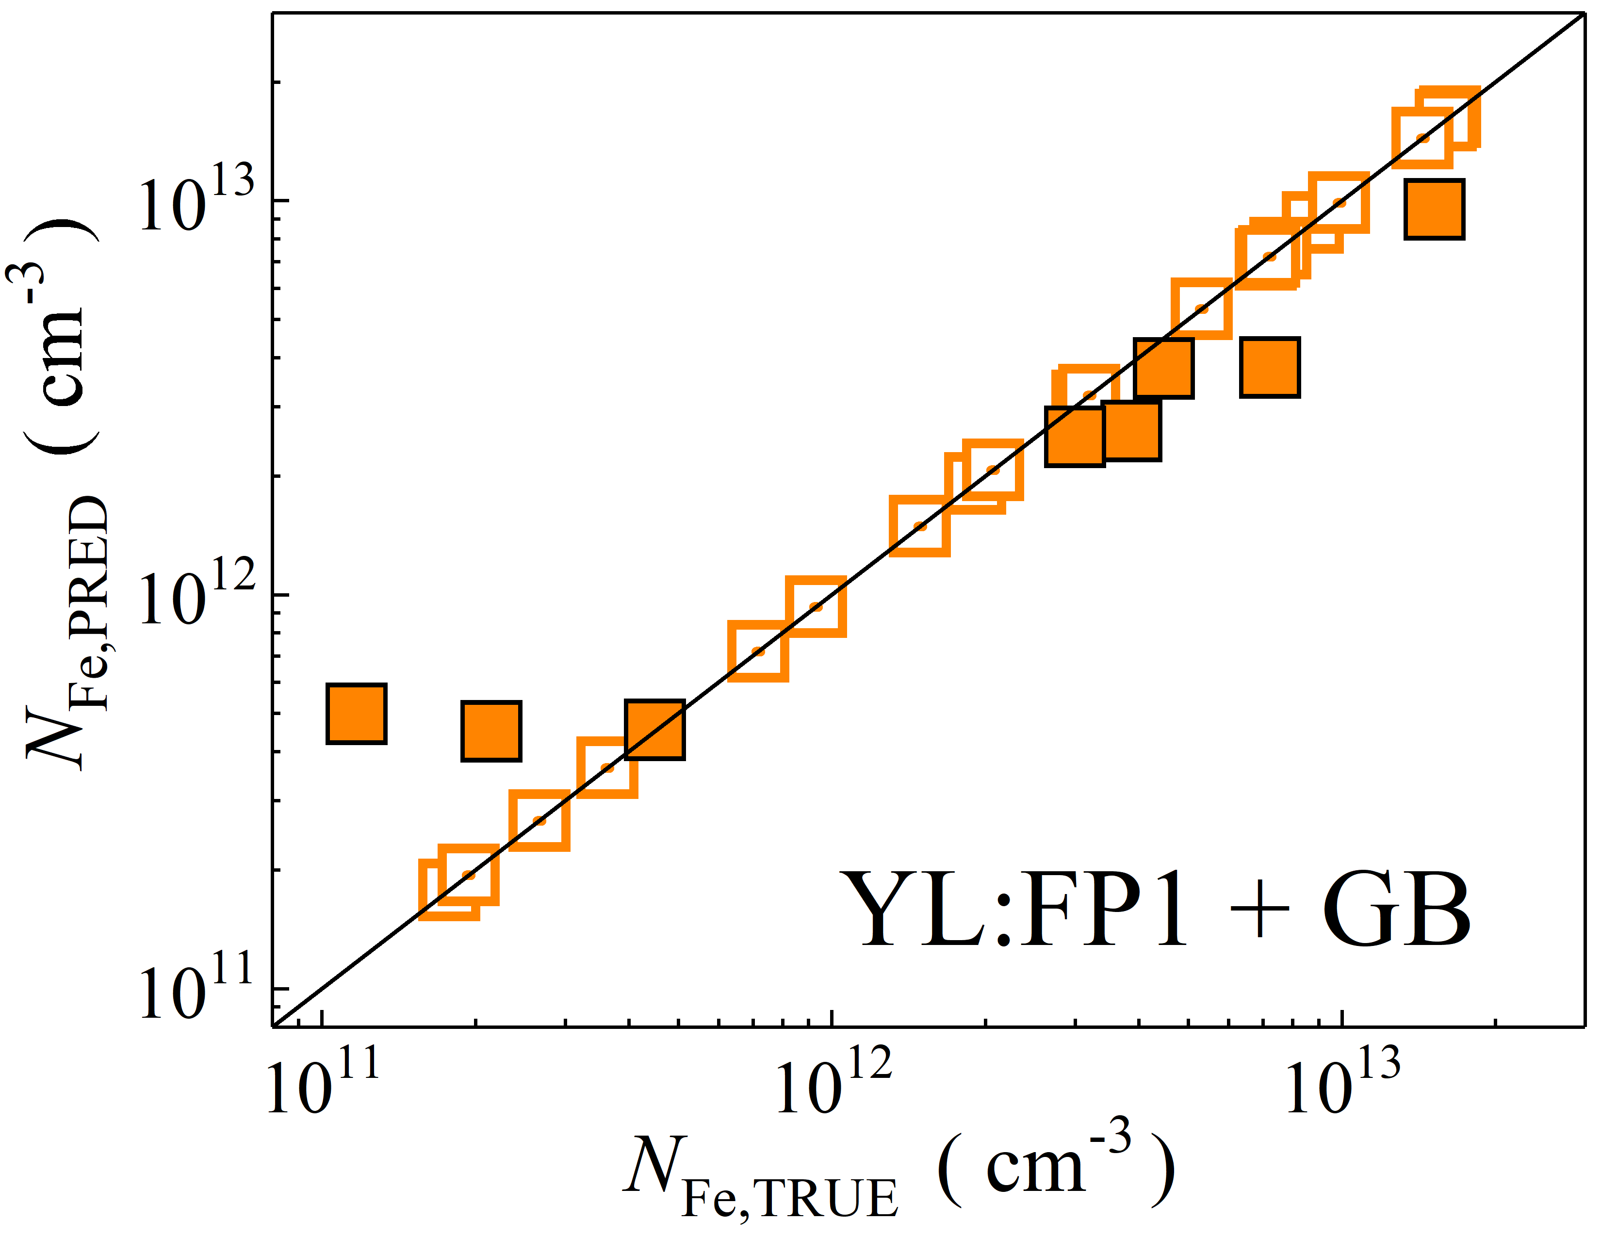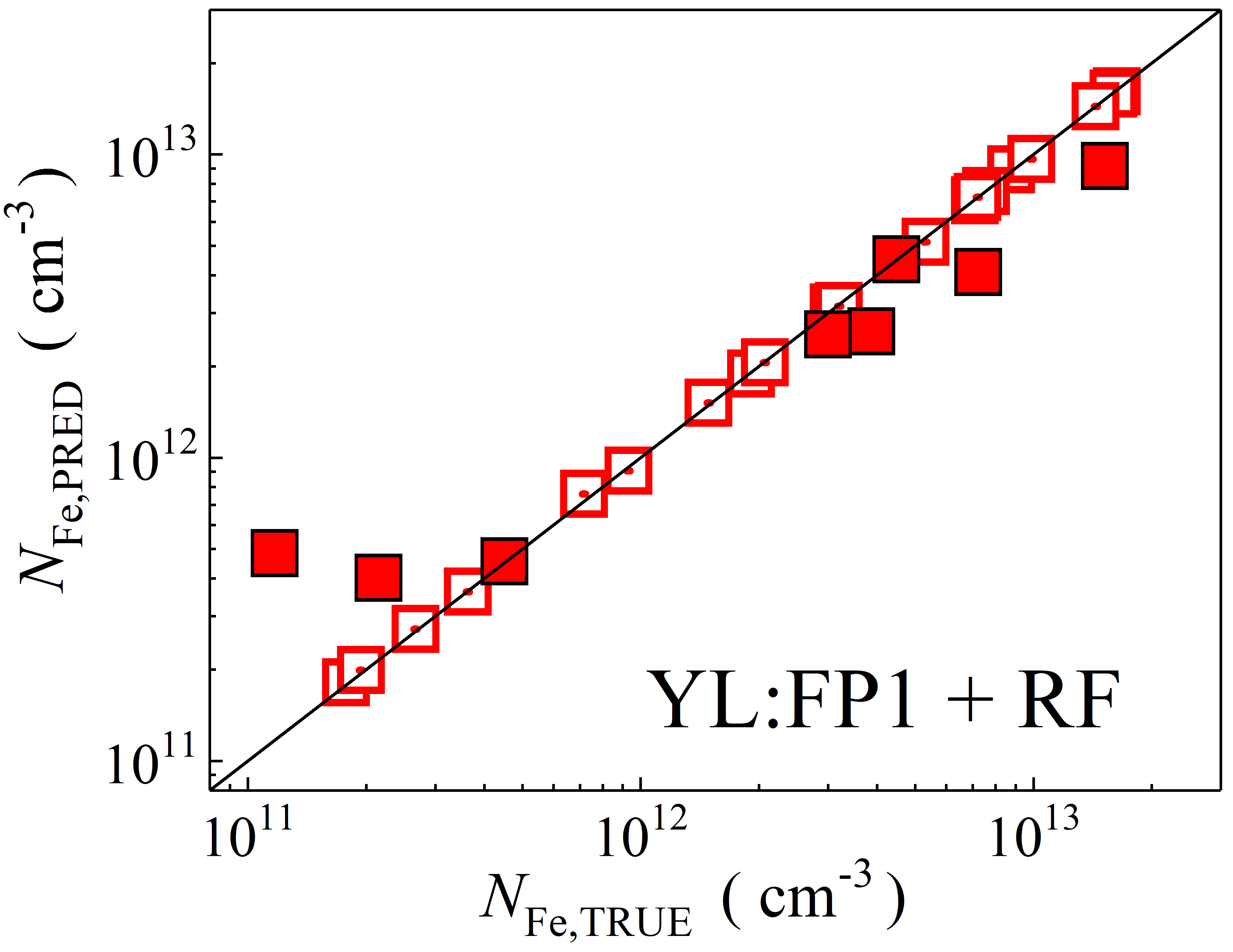

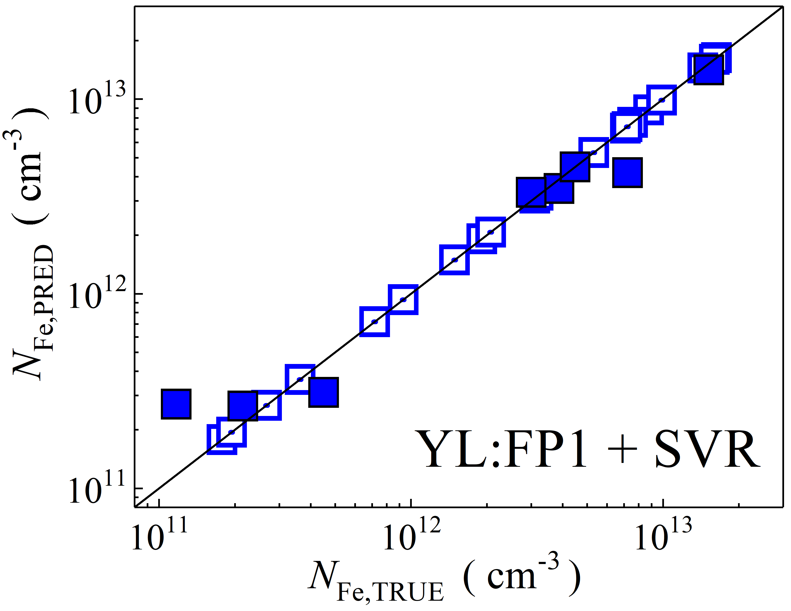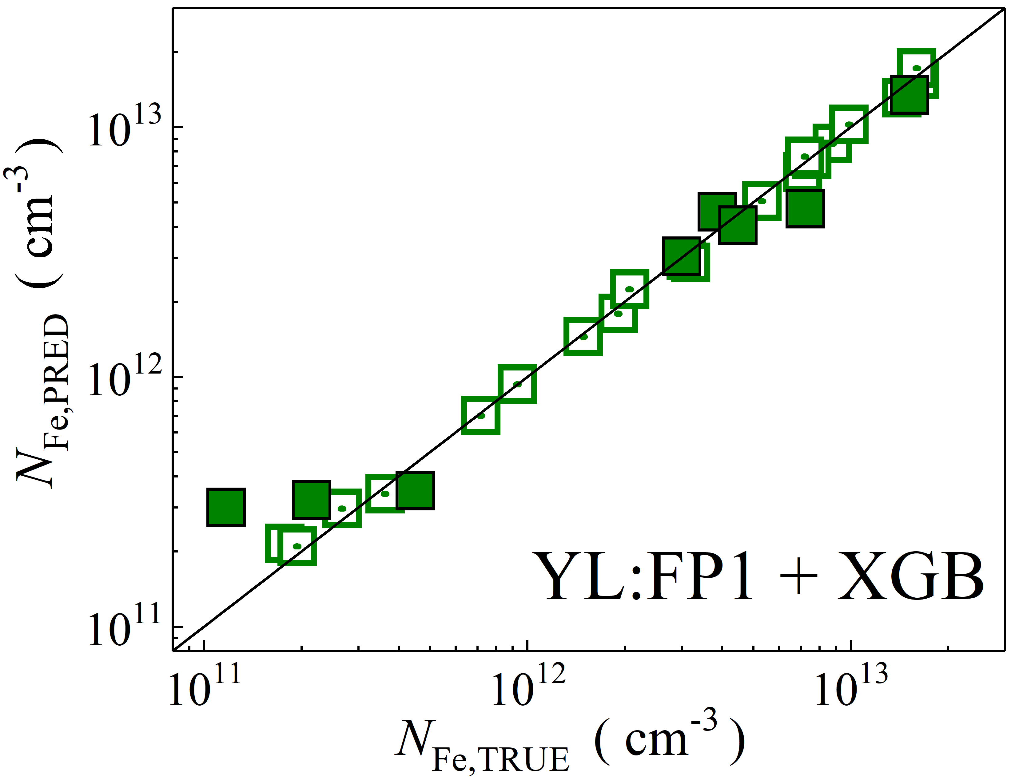

Fig. S37. Scatter plots compare reference iron concentrations $N_{Fe,TRUE}$ with ML-predicted values $N_{Fe,PRED}$ using global average pooled features from the top layer of YOLOv4 visual model. The ML algorithms include DNN (green and purple), GB (dark yellow and yellow), RF (red and blue), SVR (blue and pink), and XGB (green and red). Symbols represent different datasets: filled squares — test data from experimental measurements, and open squares — train data from experimental measurements. The black lines are the identified lines serving as the references.

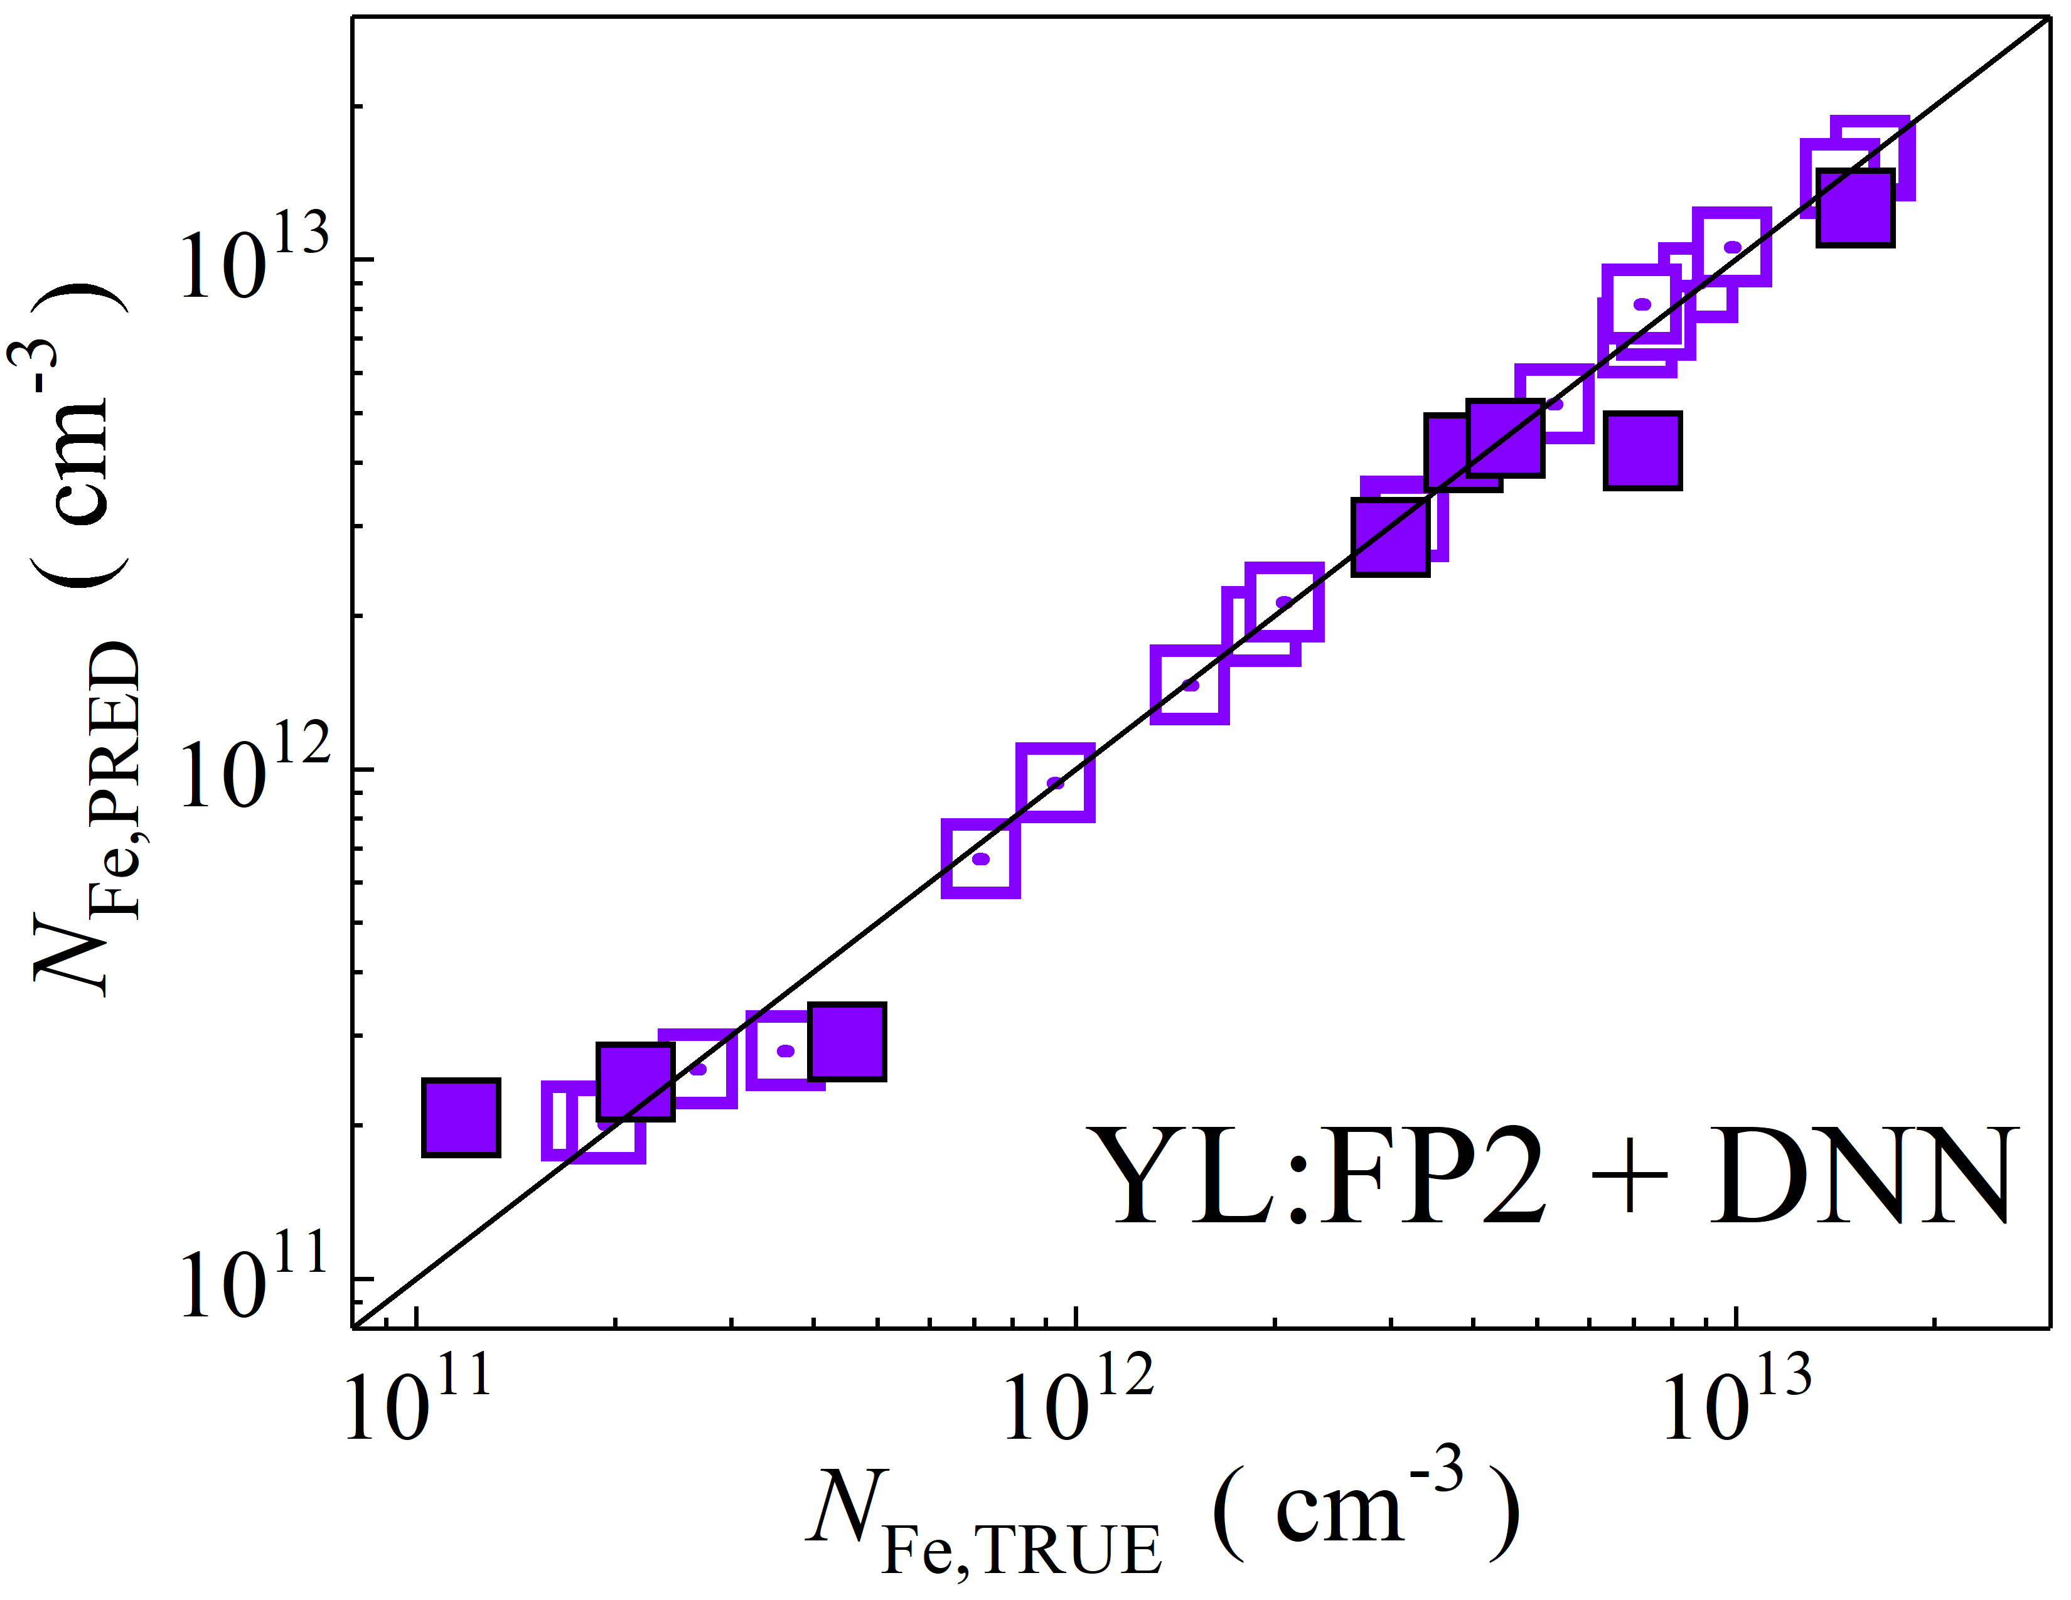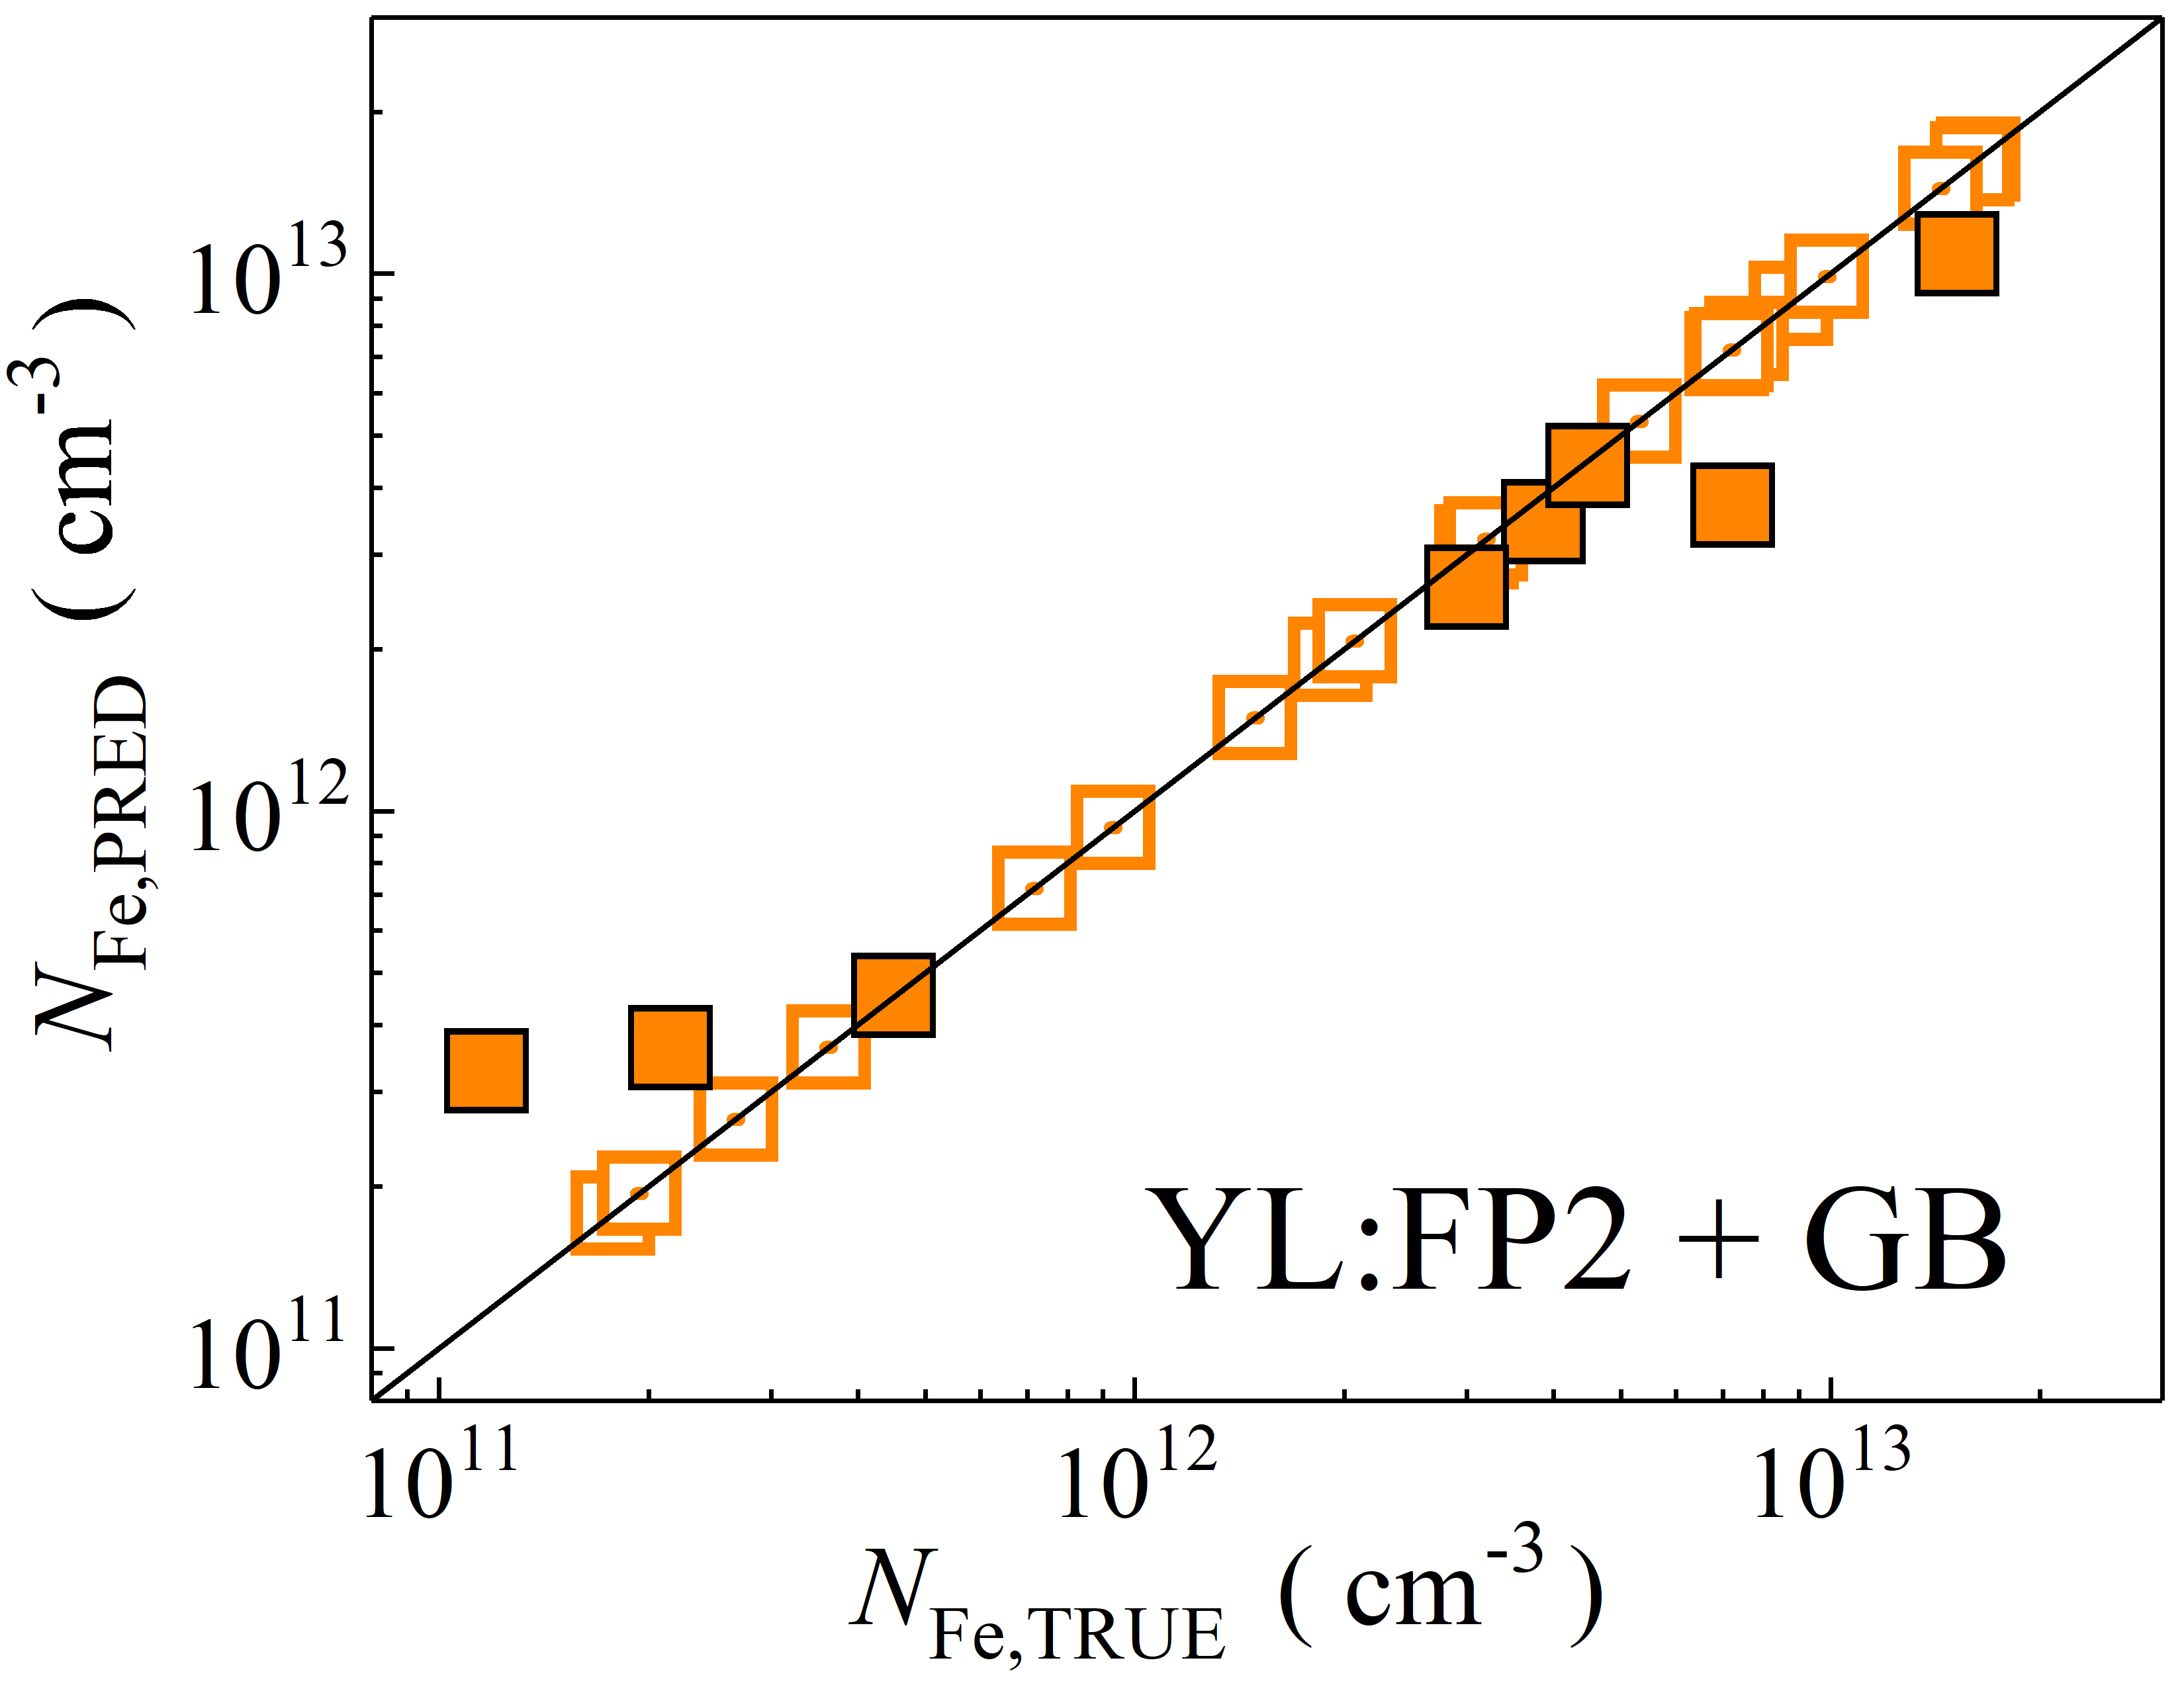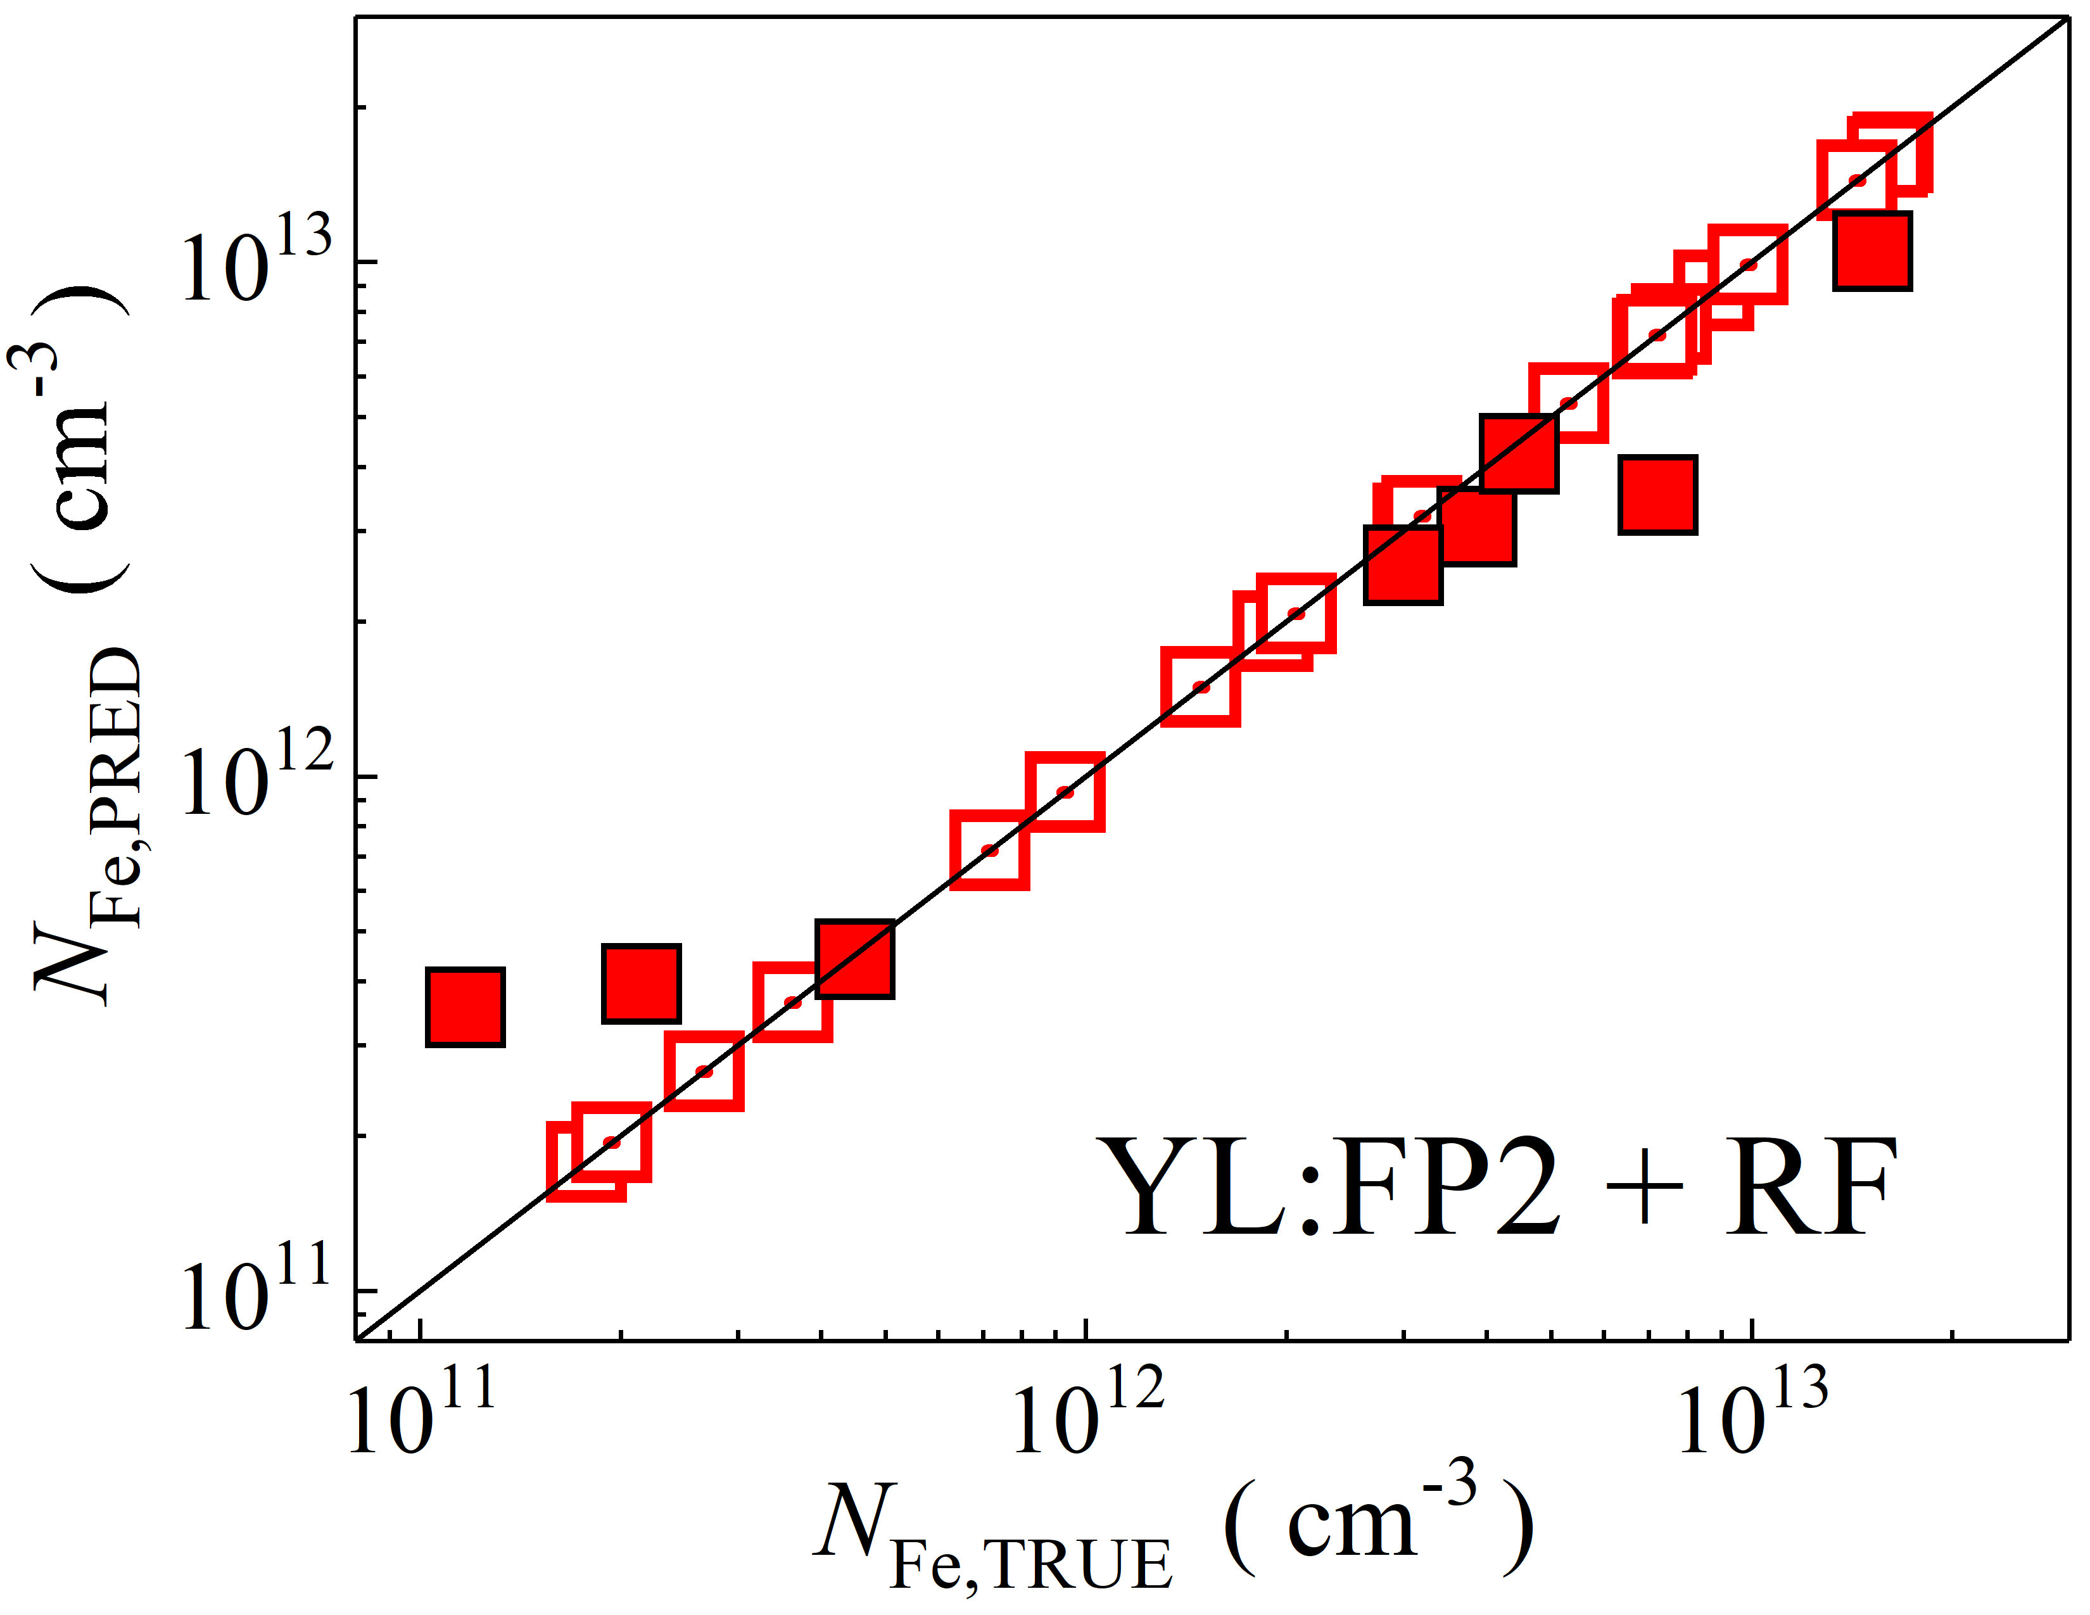

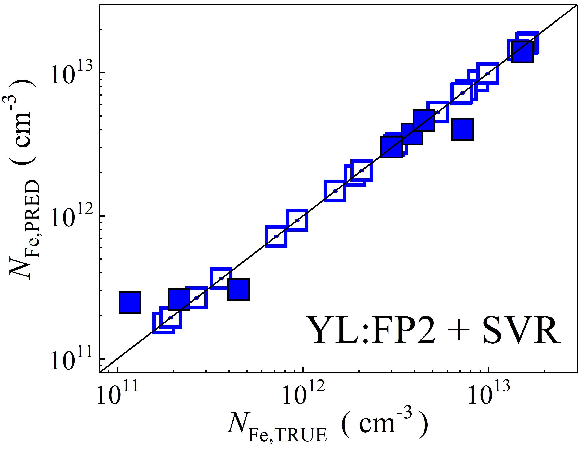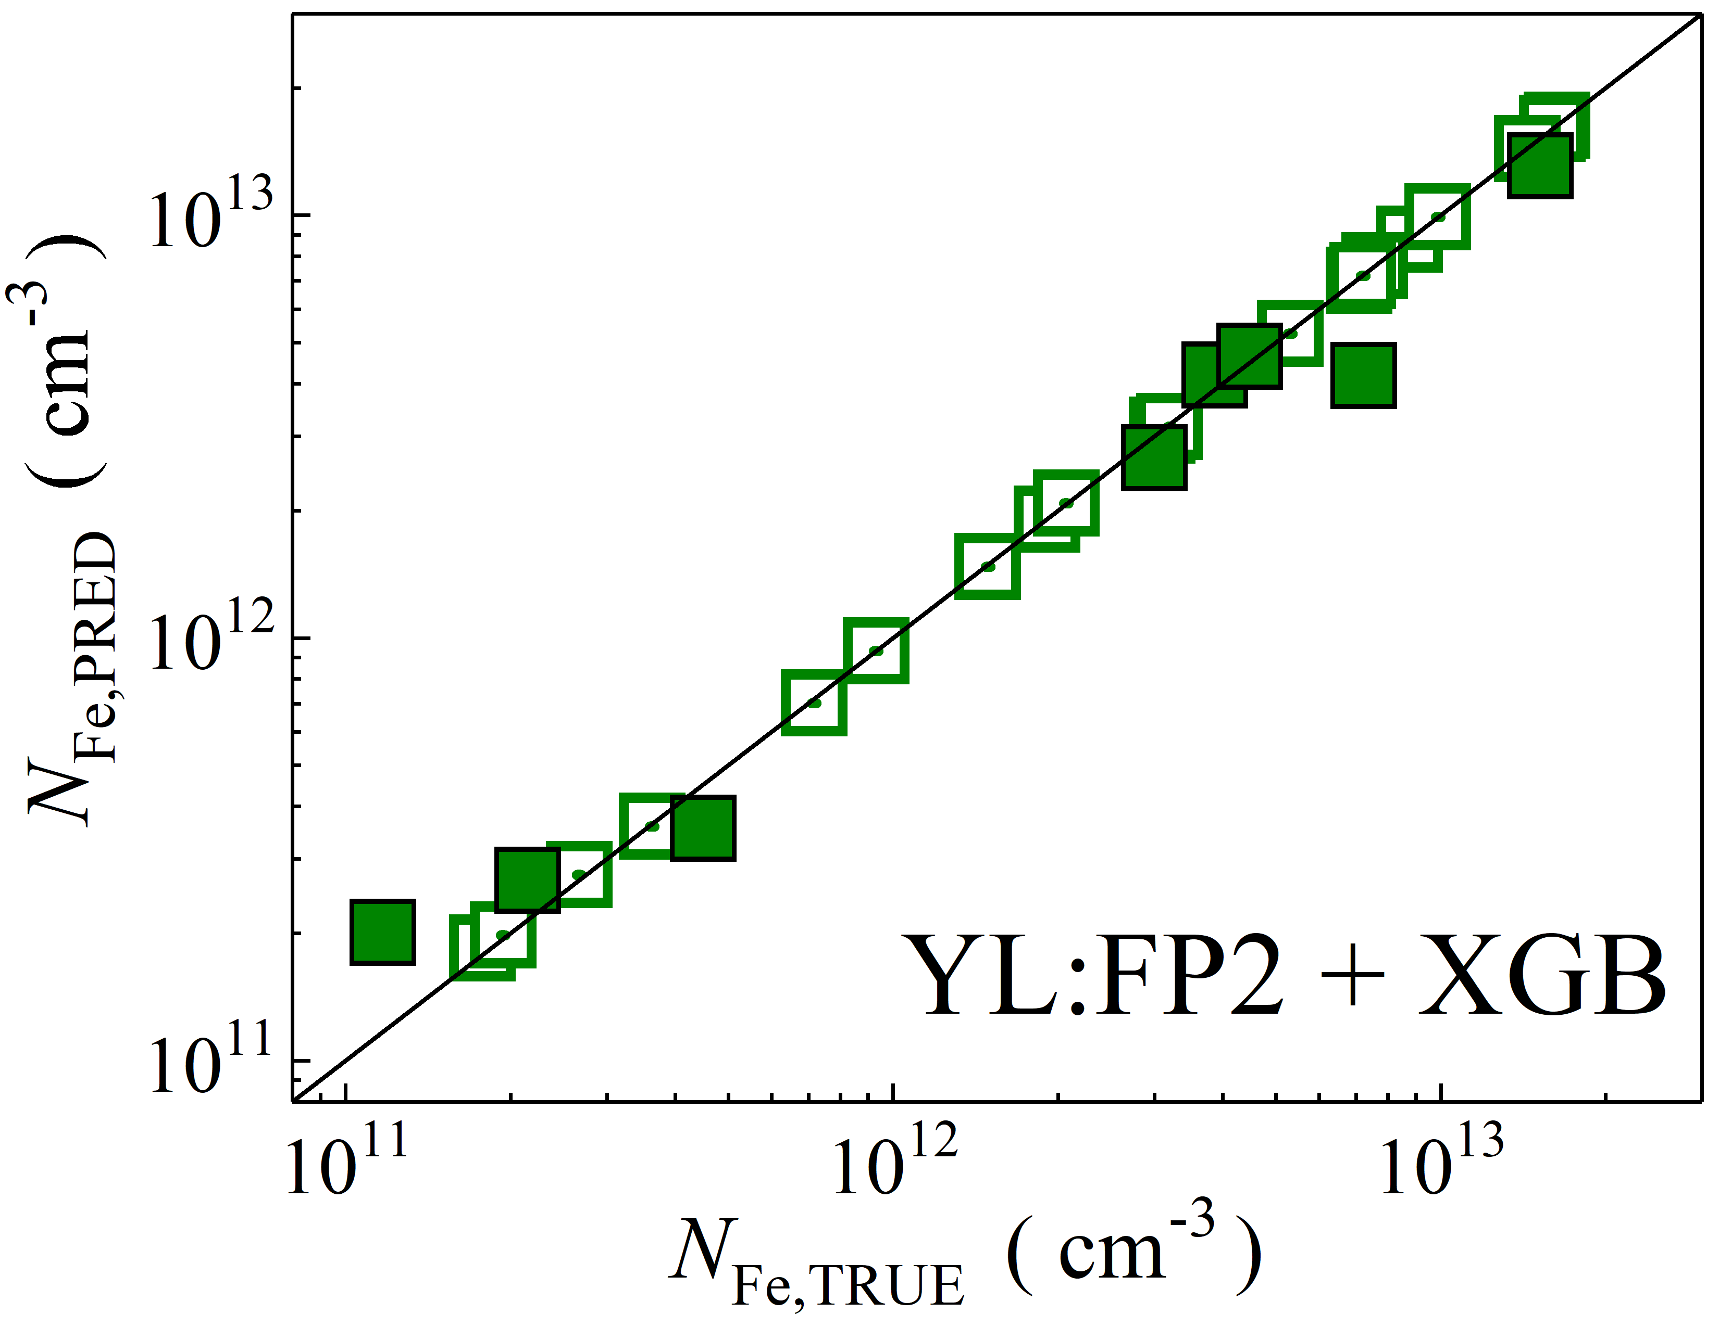

Fig. S38. Scatter plots compare reference iron concentrations $N_{Fe,TRUE}$ with ML-predicted values $N_{Fe,PRED}$ using concatenated pooled features from the top and penultimate layers of YOLOv4 visual model. The ML algorithms include DNN (green and purple), GB (dark yellow and yellow), RF (red and blue), SVR (blue and pink), and XGB (green and red). Symbols represent different datasets: filled squares — test data from experimental measurements, and open squares — train data from experimental measurements. The black lines are the identified lines serving as the references.

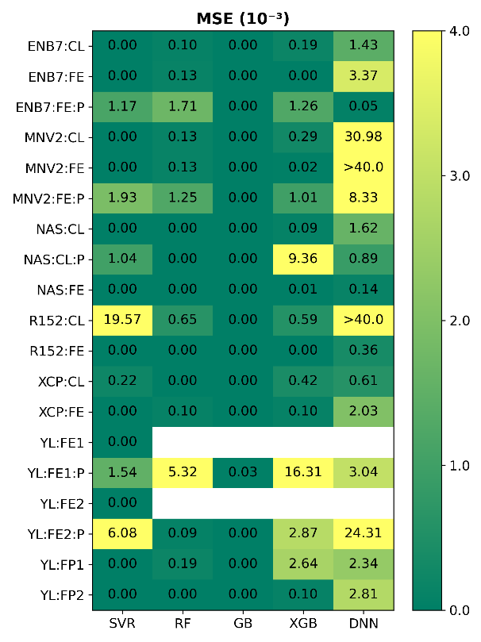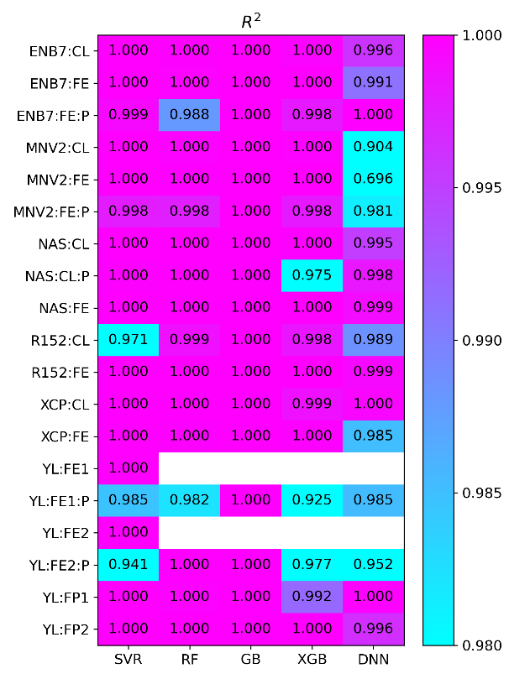

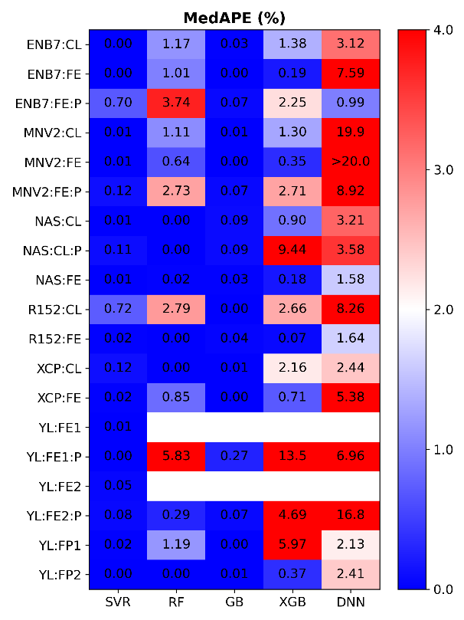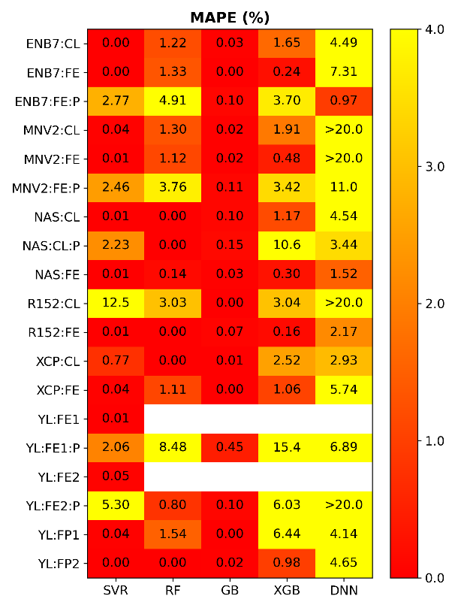

Fig. S39. Heatmaps of mean squared error (MSE, ×10-3), mean absolute percentage error (MAPE, %), coefficient of determination (R2) and median absolute percentage error (MedAPE, %) on the training dataset (experimental) for models trained on experimental data for different combinations of computer vision models (vertical axis) and machine learning algorithms (horizontal axis). Feature vectors were extracted from various layers of EfficientNetB7 (ENB7), MobileNetV2 (MNV2), NASNet (NAS), ResNet152 (R152), Xception (XCP), and YOLO (YL) visual models. [ExpTrain]

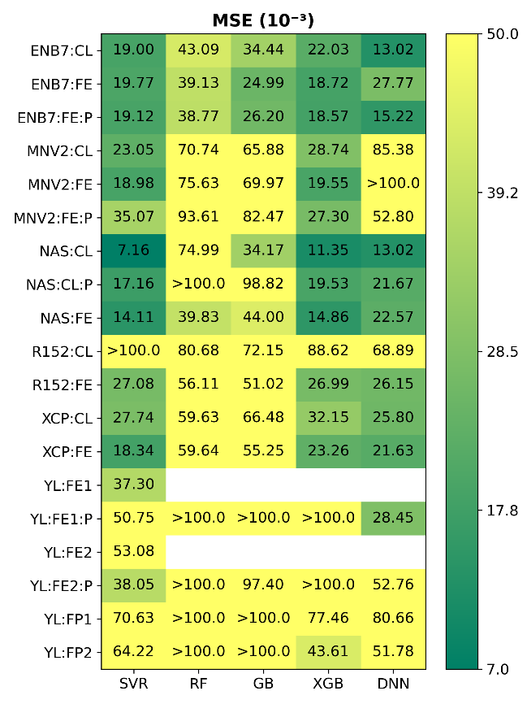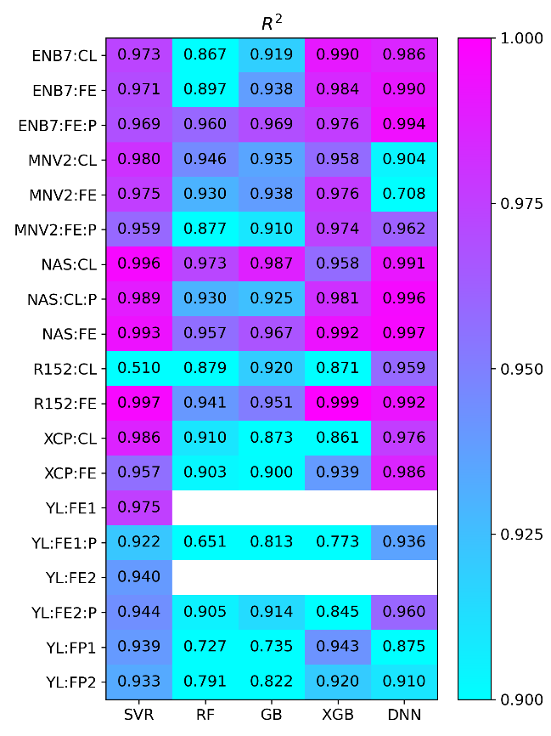

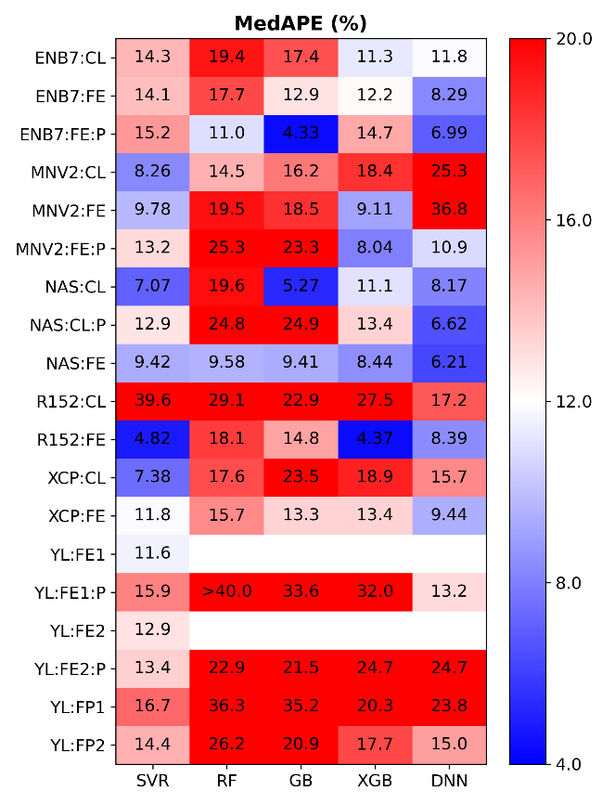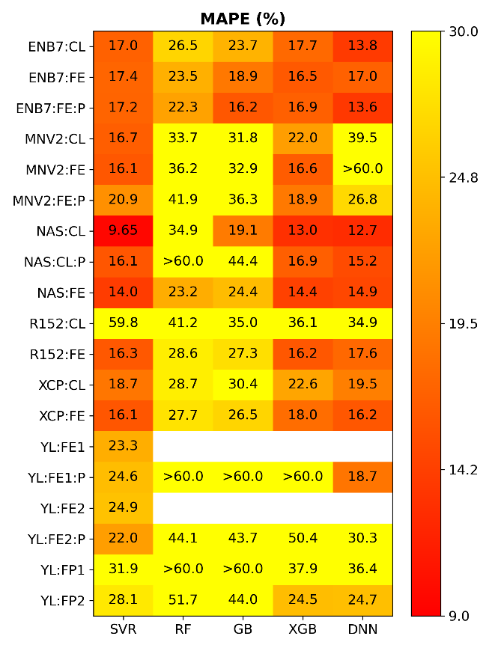

Fig. S40. Heatmaps of mean squared error (MSE, ×10-3), mean absolute percentage error (MAPE, %), coefficient of determination (R2) and median absolute percentage error (MedAPE, %) computed on the test dataset (experimental) for models trained on experimental data for different combinations of computer vision models (vertical axis) and machine learning algorithms (horizontal axis). Feature vectors were extracted from various layers of EfficientNetB7 (ENB7), MobileNetV2 (MNV2), NASNet (NAS), ResNet152 (R152), Xception (XCP), and YOLO (YL) visual models. [ExpTest]

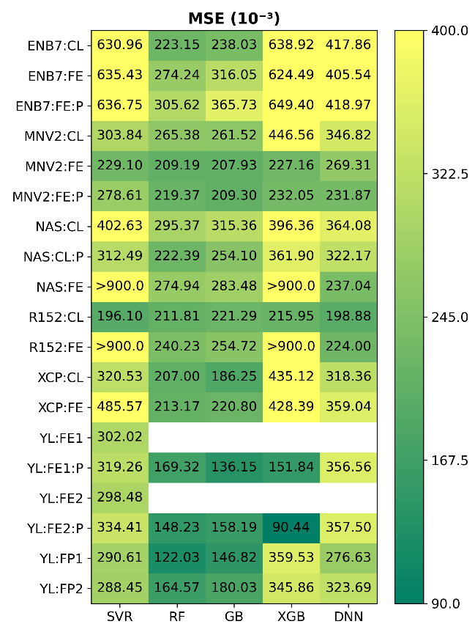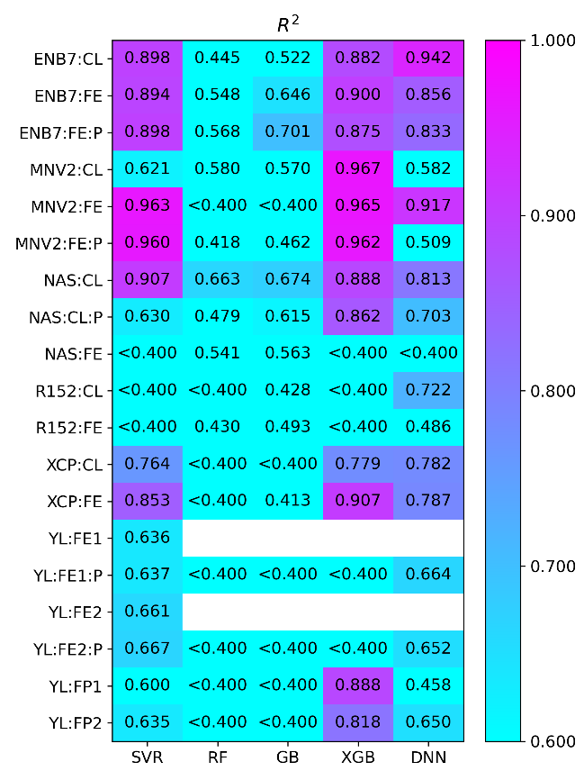

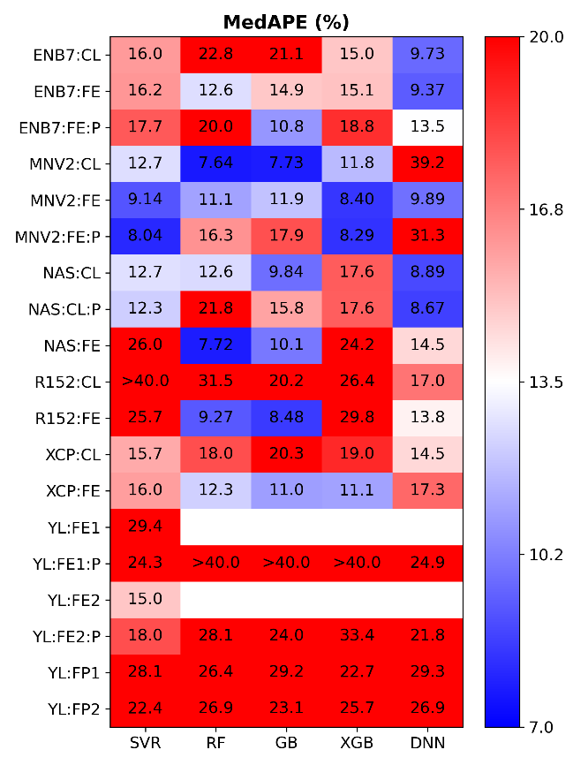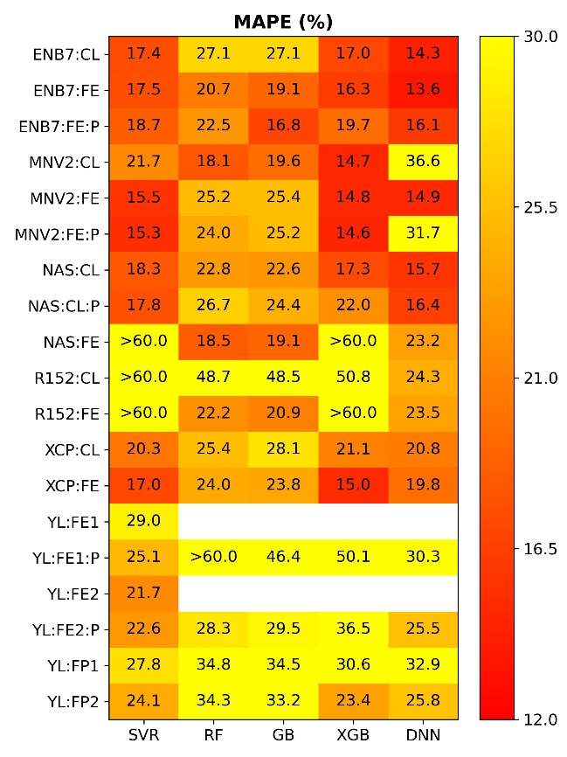

Fig. S41. Heatmaps of mean squared error (MSE, ×10-3), mean absolute percentage error (MAPE, %), coefficient of determination (R2) and median absolute percentage error (MedAPE, %) computed on the experimental dataset (experimental) using models trained on simulated data for different combinations of computer vision models (vertical axis) and machine learning algorithms (horizontal axis). Feature vectors were extracted from various layers of EfficientNetB7 (ENB7), MobileNetV2 (MNV2), NASNet (NAS), ResNet152 (R152), Xception (XCP), and YOLO (YL) visual models. [Exp]

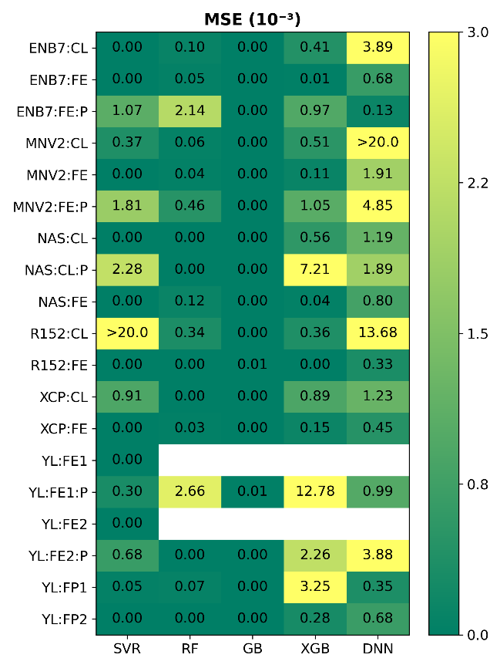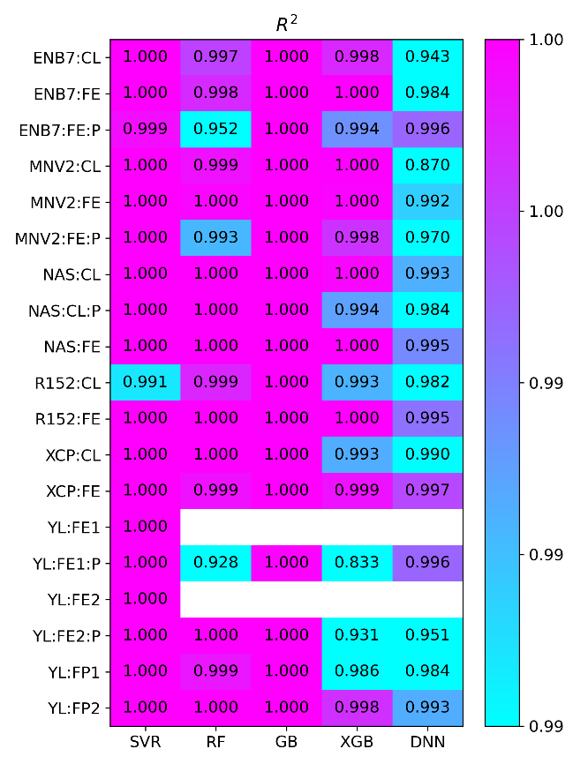

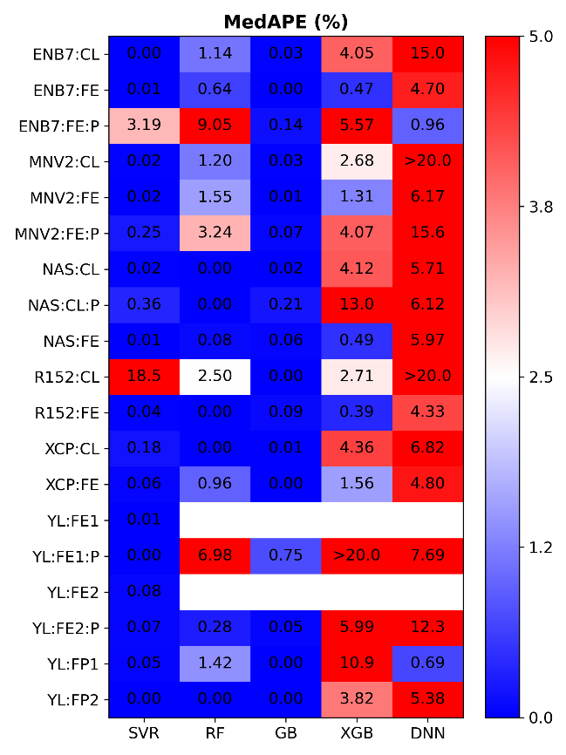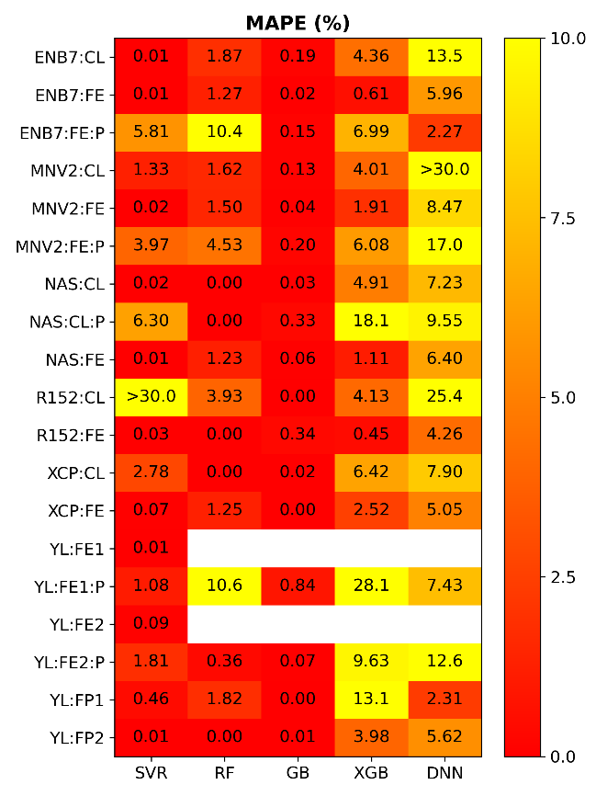

Fig. S42. Heatmaps of mean squared error (MSE, ×10-3), mean absolute percentage error (MAPE, %), coefficient of determination (R2) and median absolute percentage error (MedAPE, %) computed on the training dataset (simulated) for different combinations of computer vision models (vertical axis) and machine learning algorithms (horizontal axis). Feature vectors were extracted from various layers of EfficientNetB7 (ENB7), MobileNetV2 (MNV2), NASNet (NAS), ResNet152 (R152), Xception (XCP), and YOLO (YL) visual models. [Train]

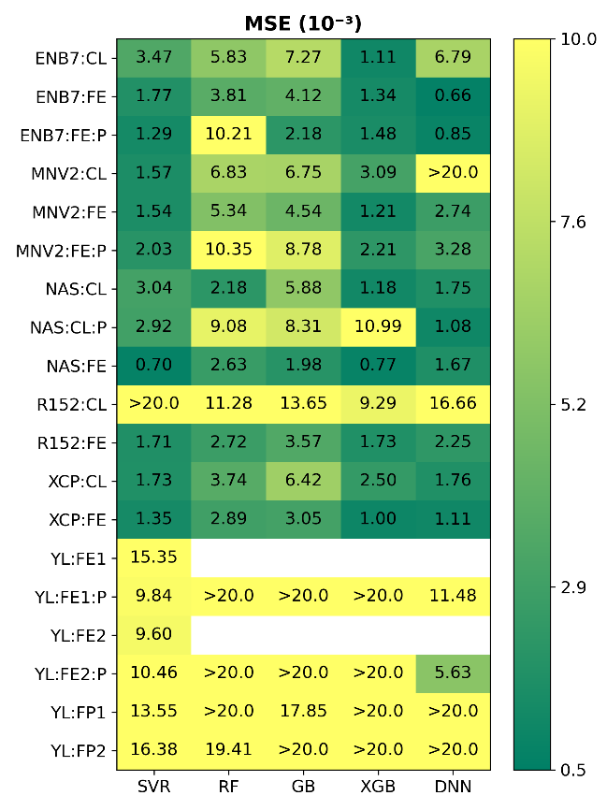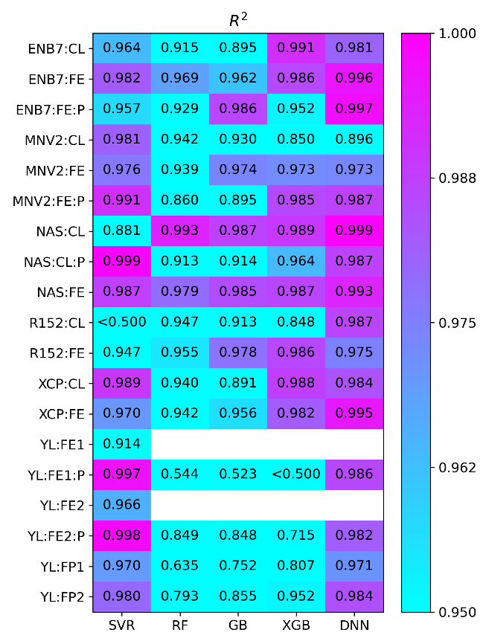

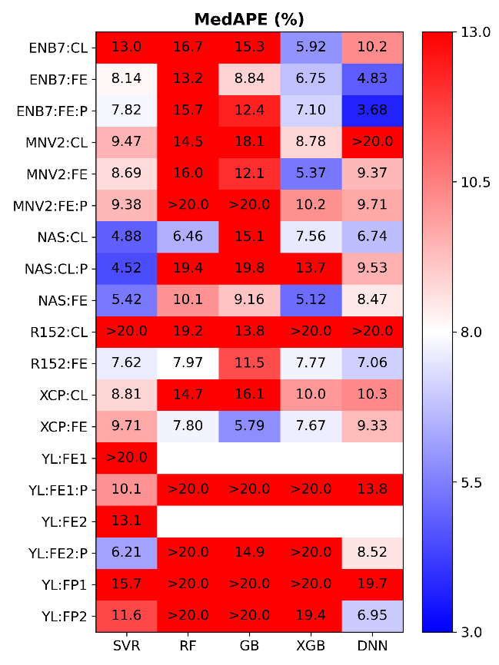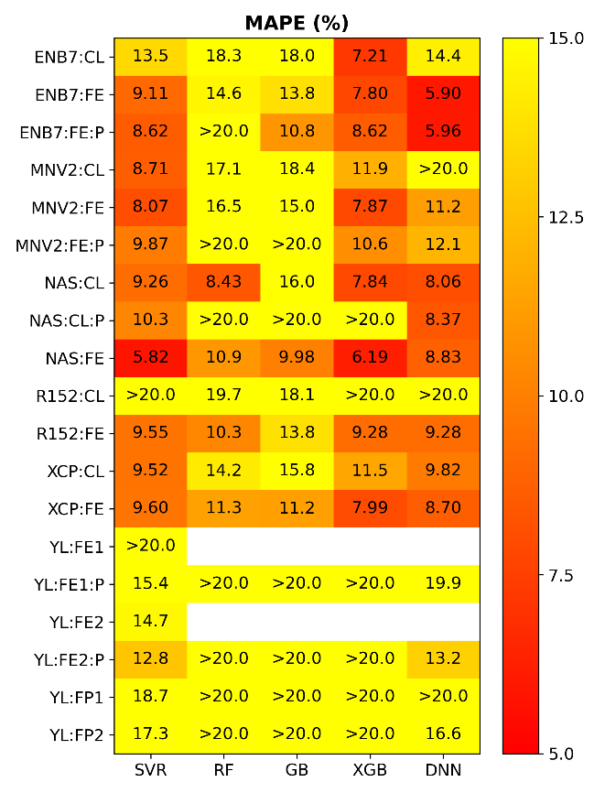

Fig. S43. Heatmaps of mean squared error (MSE, ×10-3), mean absolute percentage error (MAPE, %), coefficient of determination (R2) and median absolute percentage error (MedAPE, %) computed on the test dataset (simulated) for models trained on simulated data for different combinations of computer vision models (vertical axis) and machine learning algorithms (horizontal axis). Feature vectors were extracted from various layers of EfficientNetB7 (ENB7), MobileNetV2 (MNV2), NASNet (NAS), ResNet152 (R152), Xception (XCP), and YOLO (YL) visual models. [Test]